Развернутый план-конспект урока-плаката английского языка
в 4-А классе МОУ «Школа №3 г.Докучаевска».
Учитель: Писанец Н.Г.

Тема урока: “Fire helps, fire kills?”. (Огонь помогает, огонь убивает?)

Задачи урока:
а) основные (коммуникативные):
1) научить умению высказываться на заданную тему на уровне фразы, монолога, диалога и задавать соответствующий вопрос;
2) формировать грамматические навыки в построении предложений;
3) развивать умение выразительного чтения;
4) развивать умение вести диалог, микро диалога в предложенной или воображаемой ситуации;
б) сопутствующие:
совершенствовать фонетические и лексико-грамматические навыки в рамках вышеупомянутых речевых умений;
совершенствовать навыки аудирования;
в) развивающие:
1) развивать память и внимание учащихся;
2) развивать умение вести беседу по заданной теме;
г) воспитательно-образовательные:
1) способствовать формированию понимания необходимости бережного отношения к своей жизни;
2)научить осторожности при возникновении любых опасных ситуаций;
3) развивать умение принимать правильные решения при возникновении пожара;
Оборудование урока:
1) учебник «Английский в фокусе- 4» Вирджиния Эванс, Джэнни Дули, Ольга Подоляко, Юлия Ваулина (М.,2016г.)
2) серия тематических иллюстраций, специально подготовленных к уроку;
3), доска, постеры;
4) раздаточный материал; плакаты.

Структура урока:
I.Организационный момент. Ознакомление с темой урока. 1 мин.
II. Аудирование короткой исторической справки из жизни древних людей. 2 мин.
III. Речевая разминка: ответ учащихся на поставленный в ходе рассказа учителя вопрос. 3 мин.
IV. Активизация монологической речи путем описания действий людей, изображенных на картинках. 5мин.
V. Чтение тематического текста с пониманием содержания прочитанного.2 мин.
VI. Составления учащимися правил противопожарной безопасности ( с опорой на прочитанный текст и картинки). 5 мин.
VII. Тренировка навыков вопросно-ответной работы по заданной ситуации.10 мин.
VIII.Физкультминутка.2-3 мин.
IX. Составление и инсценировка коротких тематических диалогов. 5 мин. Развлеченье для ученья. Караоке-бар с пением тематической песни. 4 мин.
Х. Тренировка ассоциативного мышления с целью лучшего запоминания подаваемой информации.1мин.
ХI.Подведение итогов урока. Повторение ключевой информации, многократно подаваемой в течение урока. 2 мин.
ХII. Домашнее задание. Оценка достижений обучающихся.1-2 мин.
Развёрнутый конспект урока.
Ход урока.
- Организационный момент. Вступительная беседа о теме урока.
Teacher : Good morning, my little friends. Today we are going to speak about fire. What is fire? Is it our friend or our enemy? Is it good or bad?
2.Историческая справка о древних людях, научившихся добывать огонь много лет назад.Many-many years ago ancient people didn’t have any fire.
So, how could they live without fire? They were cold.
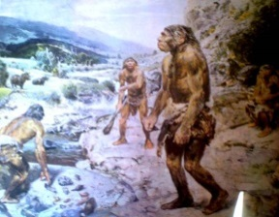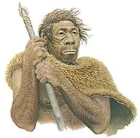

They were afraid of animals. They couldn’t put them off.
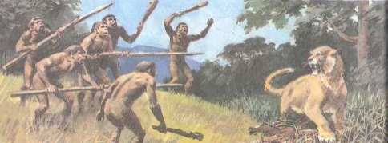

What did they do at night? It was very dark at night. Only the moon and stars in the sky helped them at night.



What did they eat?

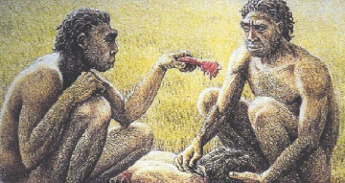
They ate raw meat, raw fish, raw vegetables and raw corn.

And then they discovered fire.

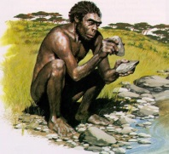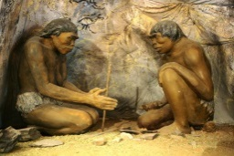
What did ancient people start doing?
They started heating their caves. They were not cold any more.

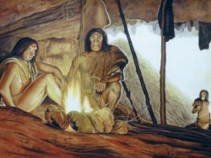

They could light their caves. It was not dark in their dwellings any longer.

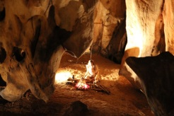

They could put off animals and mosquitos. They were not afraid of them any more.
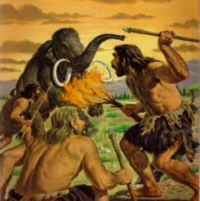

They started cooking their meals on the fire. They cooked meat, fish, vegetables.

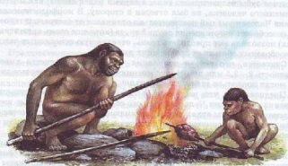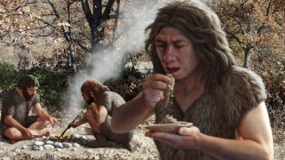

So fire helped people.

III. Речевая разминка: ответ учащихся на поставленный в ходе рассказа учителя вопрос.
Teacher: And now what can we do with the help of fire?
(Pupils compare the pictures of ancient people and our everyday life).
PPP: (supposed answers, using a graphic dictation. P1 is drawing a symbol, the others guess and answer).
With the help of fire we can …
- heat our houses;
- light our houses;
- cook our breakfast, lunch and dinner;
- bake our bread;
- fry meat, fish, potatoes;
- make our tea or coffee, etc.
IV. Активизация монологической речи путем описания действий людей, изображенных на картинках.
Teacher: So, we can’t live without fire. Fire is our friend .It helps us in our everyday life. But we must be very-very careful with it. Have a look! What is wrong in the pictures?

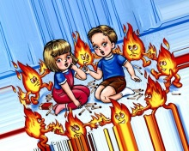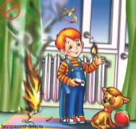
Teacher: What are the children doing?
P1: The children are playing with matches.

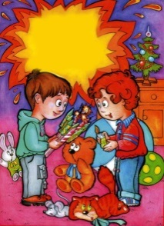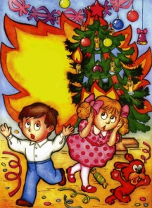

P2: The children are playing with fireworks.
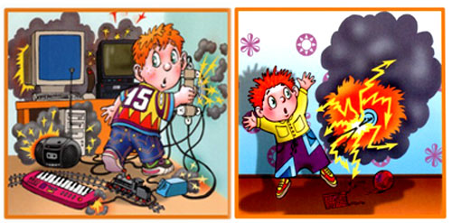
P3: The boy is not careful with electric devices.

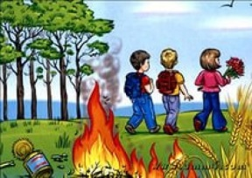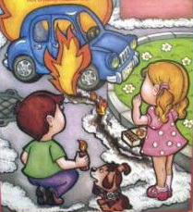

P4: The children are making fire in the forest.
P5: The children are making fire in the street.

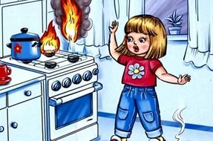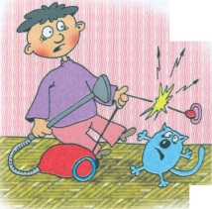

P6: The girl is cooking and her Mum is not at home.
P7: The boy is pulling the electric rope.

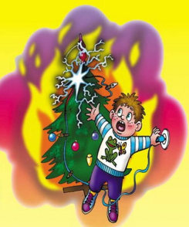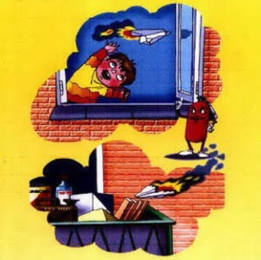

P8: The boy is switching the New Year lights on his own.
P9: The boy is burning the planes and flying them.

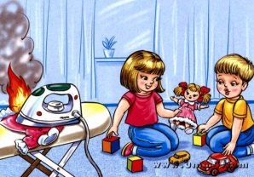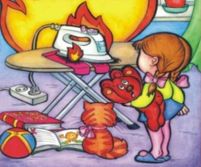

P10: The children are not careful with the iron.

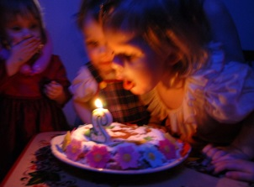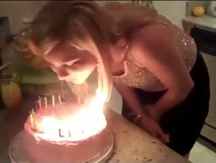

P11: The girls are not careful with the candles on the birthday cake.
V. Чтение тематического текста с пониманием содержания прочитанного.
Teacher: Now let us read a story about the Prince who lived many-many years ago and who, like all those children, was not careful with fire.

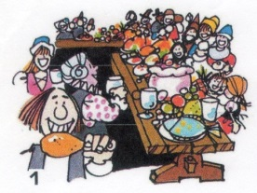
In 1600 a prince lived in a castle. His birthday was on August the 10th. In the evening he had a big party. All the people from the town went to the party.There was lots to eat and drink.
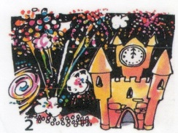
At the midnight the fireworks started. Rockets went up into the sky and all the people cheered, “Hooray! Hooray!” The people and the prince were very happy.
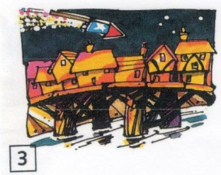
One rocket went up into the sky and down towards the river.
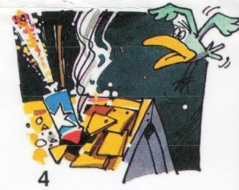
It landed on the roof of a house. The house was on the old bridge.

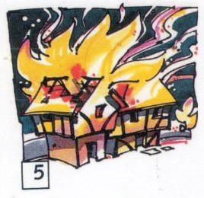
A fire started on the bridge. It went quickly from house to house. Soon it was a very big fire.
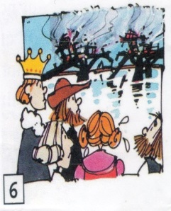
In the morning there was no bridge, no houses, no town. The prince and the people were very unhappy.
VI. Составления учащимися правил противопожарной безопасности ( с опорой на прочитанный текст и картинки).
Teacher: What would you like to say to our prince?
PPP: DON’T PLAY WITH FIREWORKS!
Teacher: And what would you like to say to all those children in the pictures?
PPP: Don’t play with matches!
Don’t make fire in the forest!
Don’t burn paper planes!
Be careful with the iron!
Be careful with the gas cooker!
Be careful with the New Year lights!
Be careful with the candles on the cake!
Be careful with all the electric devices!( Учитель в это время прикрепляет все эти правила ППБ на доске).
Teacher: So, the key words, when we speak about fire safety rules are DON’T and BE CAREFUL. Let’s make a Mind Map of Fire Safety.
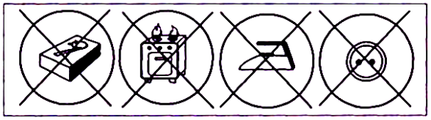
Teacher:We must be careful everywhere: at home, in the street, in the forest and at school. Do you know what to do when there is fire at school?
(Учитель предлагает детям вспомнить сказку, где очень хорошо описана эвакуация в случае возникновения пожара. Затем показывает детям изображение школьного коридора и ребенок с помощью игрушки-курочки показывает маршрут эвакуации класса в случае возникновения пожара в нашей школе).
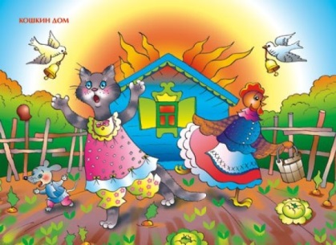
PPP: We must leave the classroom, turn right, go downstairs to the school-yard.
VII. Тренировка навыков вопросно-ответной работы по заданной ситуации.10 мин.
Teacher: Yes, we must be in the open air. And who comes to help us when there is fire at school?
PPP: Firemen!
Teacher: So, meet one of them! His name is…
(Любой из учеников по желанию выходит и надевает каску пожарного. Дети задают ему вопросы).
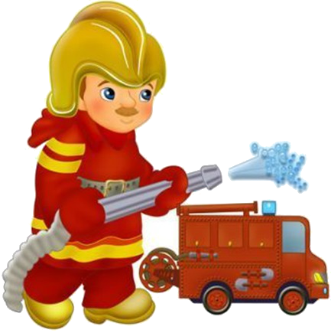
P1:What are you?
F: I am a fireman.
P2: Where do you work?
F: I work at the Fire Station.
P3: What do you do?
F: I put down fires.
P4: Do you save people?
F: Yes, I do. I save people, houses, shops, schools, animals, forests, birds’ nests.
Teacher : Let’s check up what he has got ?
(Учитель показывает детям картинки, а они задают вопросы).
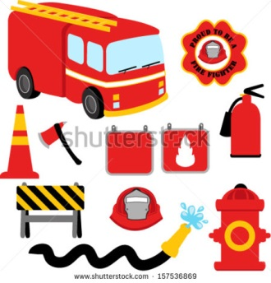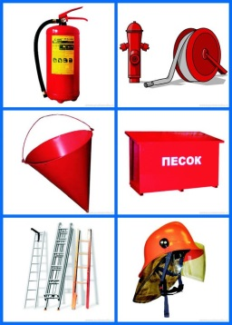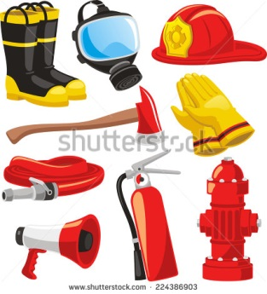

PPP: Have you got a fire extinguisher?
Have you got a medical box?
Have you got a mega phone?
Have you got a ladder?
Have you got an axe?
Have you got rubber gloves?
Have you got rubber boots?
Have you got a flash light?
Have you got a helmet?
Have you got a fire engine?
Have you got a hose?
VIII.Физкультминутка.
Teacher: What does a fireman do when there is fire in the town?
(Проводится физкультминутка с имитацией движений).

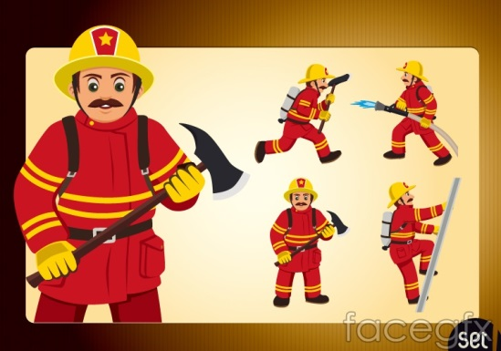
The fireman stands up.
He puts on his rubber gloves: left, right.
He puts on his rubber boots: left, right.
He runs to the fire engine: runs, runs, runs.
He unrolls the hose: unrolls, unrolls, unrolls.
He climbs up the ladder: up, up, up, up.
He puts down the fire: one, two, three, four, five.
He climbs down the ladder: down, down, down, down.
He rolls the hose: rolls, rolls, rolls.
He goes to the fire engine: goes, goes, goes.
He sleeps.
IX. Составление и инсценировка коротких тематических диалогов.
Teacher: Now we know what fireman do but what do people do when there is a fire in the town?
(Дети составляют мини-диалоги по предложенному образцу).

P1: Is it one-o-one?
P2: Yes, it’s the Fire Station. What’s happened?
P3: Please, help, Mr. Fireman. My house ( our school, the hospital, the park, the shop, etc. … is on fire.
P4: What is the address?
P5: Lenin Street, 25.
P6: OK. We are coming.
(При этом учитель размещает в разных углах доски произносимый в каждом мини-диалоге телефонный номер службы пожарной охраны).
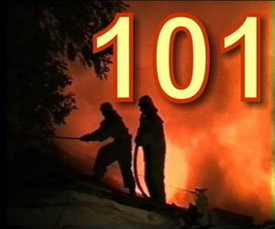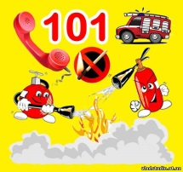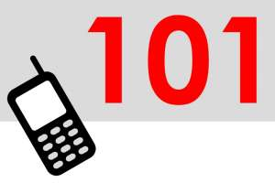


Teacher: And now welcome to our Karaoke-bar! Do you remember the song “I am a music man”? Let’s try to sing it in a different way! Follow the words sing along!

I am a fireman
I come from far away
And I can save
What can you save?
I save the forests ( houses, people, animals, birds’ nests, etc.)
Fire, fire, fire, stop!
Fire, stop! Fire, stop!
Fire, fire, fire, stop!
Fire, fire, stop!
Teacher: Thank you! I think our Mr. Fireman likes the song! Let’s ask him! Do you like the song, Mr. Fireman?
F: Yes, I do. Thank you very much!
Х. Тренировка ассоциативного мышления с целью лучшего запоминания подаваемой информации.
Teacher: Thank you, Mr. Fireman for you say STOP to fires! Children, look at the word STOP! Can you make any phone number out of it? You may use your scissors if necessary.
(Дети вырезают телефонный номер 101).
101
Teacher: Call 101 and firemen will come and put down any fire!
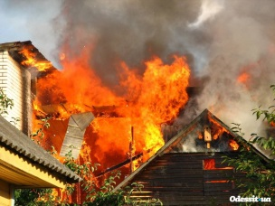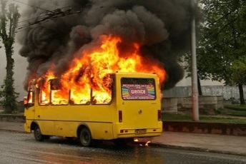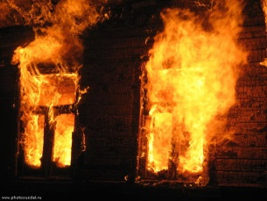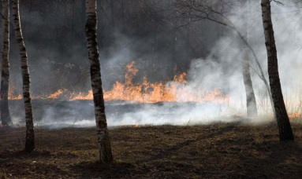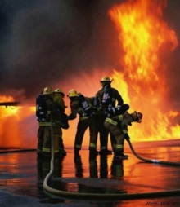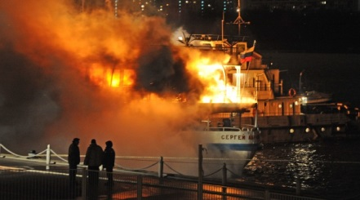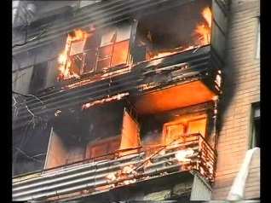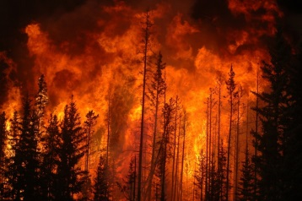
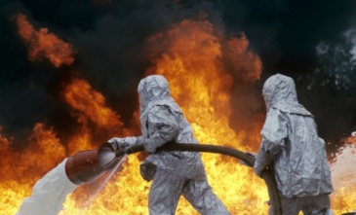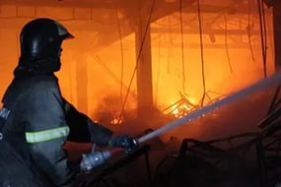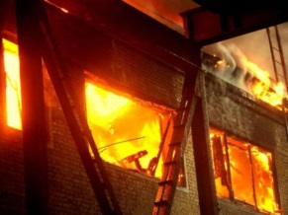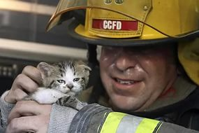

ХI.Подведение итогов урока. Повторение ключевой информации, многократно подаваемой в течение урока.
Teacher: There are very many monuments to fireman around the world. Just have a look!

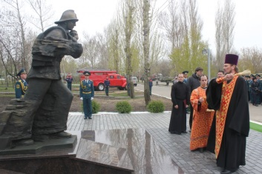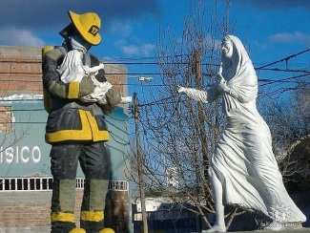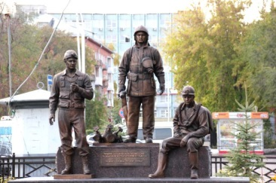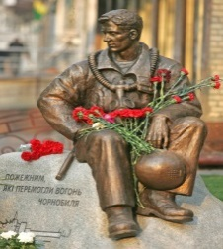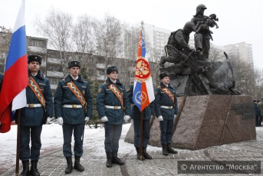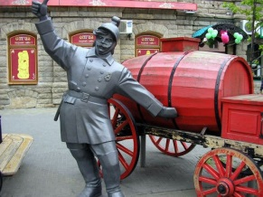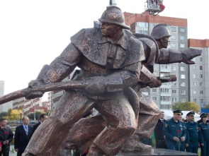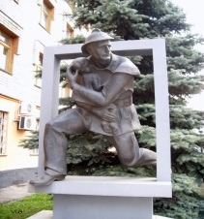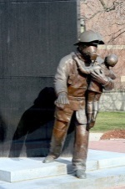

Teacher: Why do you think people erect all those monuments to fire fighters? What do they want to say to them?
Children: Thank you!
Teacher: Do you know how to say “Thank you!” to fireman in a proper way? To keep the fire safety rules. Do you remember our key words “DON’T” and “BE CAREFUL” ?
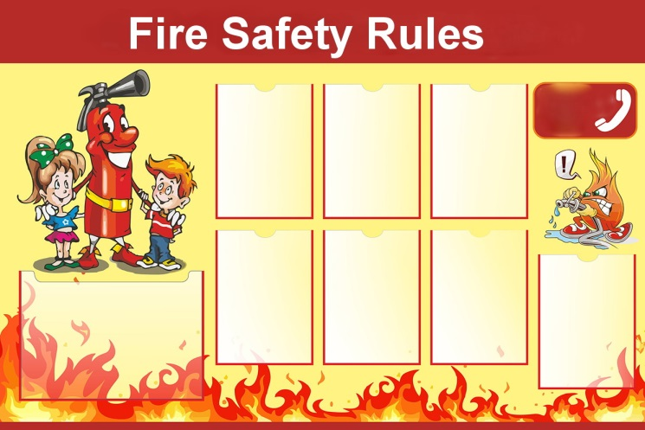
(Учащимся предлагается заполнить карманчики на стенде Правил ППБ).
1. Don’t play with matches!
2. Don’t make fire in the forest!
3. Don’t burn paper planes!
4. Be careful with the iron!
5. Be careful with the gas cooker!
6. Be careful with the New Year lights!
7. Be careful with the candles on the cake!
8. Be careful with all the electric devices!
ХII. Домашнее задание. Оценка достижений обучающихся.
Teacher: Your home task will be to make a project “Mind the Fire Safety Rules!”, to learn them and to keep them in your everyday life.

