Отдел образования, спорта и туризма Лепельского райисполкома

ПЛАН-КОНСПЕКТ УРОКА В 5 КЛАССЕ «ЗАВТРАК, ОБЕД И УЖИН В АНГЛИЙСКОЙ СЕМЬЕ»
УЧАСТНИКА V ОБЛАСТНОГО ЭТАПА КОНКУРСА ПРОФЕССИОНАЛЬНОГО МАСТЕРСТВА ПЕДАГОГИЧЕСКИХ РАБОТНИКОВ «УЧИТЕЛЬ ГОДА РЕСПУБЛИКИ БЕЛАРУСЬ – 2016»

Заяц Екатерина Александровна,
учитель английского языка ГУО
«Гимназия имени И.М.Ерашова г. Лепеля"
I квалификационной категории
8 (029) 217-39-04
e-mail:zayats.ks@mail.ru

2017 г.

Цель: предполагается, что к концу урока учащиеся смогут рассказать о приемах пищи в Великобритании c опорой на картинку и фразу.
Задачи: обеспечить в ходе урока повторение лексических единиц в рамках обозначенной темы;
способствовать совершенствованию навыков работы с текстом;
содействовать развитию навыков восприятия и понимания речи на слух, говорения (диалогической и монологической речи);
способствовать повышению уровня мотивации на уроке через использование сервисов Web 2.0.

План-конспект урока английского языка
Заяц Екатерины Александровны, учителя английского языка I квалификационной категории ГУО «Гимназия имени И.М.Ерашова г. Лепеля»
по теме «Завтрак, обед и ужин в английской семье»
в 5-м классе

№ | Этап урока | Содержание этапа | t | Прим
1 | Организационно-мотивационный  этап  цель: введение в речевую ситуацию с помощью картинки и вопросов | Hello, dear friends. Yesterday I saw an interesting picture. Do you know what it is? Do you want to learn any information about it?  Today at the lesson we’ll learn the information about meals in Great Britain, and at the end of the lesson you’ll be able to tell your classmates about British meals. | 3 | 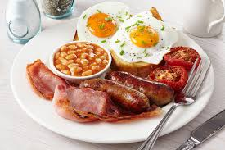
2 | Операционно-познавательный этап  Цель: повторение лексических единиц в рамках обозначенной темы, формирование языковой компетенции  Цель: снятие напряжения после работы с компьютером  Цель: с помощью наводящих вопросов подготовить учащихся к ознакомительному чтению  Цель: при помощи послетекстовых упражнений проверить степень усвоения материала, подготовить учащихся к диалогической речи  Цель: развитие коммуникативной компетенции при помощи диалогической речи в рамках обозначенной темы  Цель: снятие напряжения глаз  Цель: с помощью видео способствовать развитию навыков говорения | Tea and coffee  Milk or juice.  What would you like,  Little Bruise?  I’d like milk with  Toast and honey.  It’s yummy,  My dear mummy.  Do you know food well? Let’s check it up. Do your tasks on computers.  “Straight line”. (children stand in a line. If they hear countable noun they step right, uncountable – step left, don’t know- stand still)  Milk, rolls, biscuits, eggs, butter, sugar, coffee, sandwiches, cereal, rice, honey, toast, apple, orange.  How many times a day do you eat? What meals do we have? Where do you have breakfast/ lunch/ dinner? What do you eat for breakfast/ lunch/ dinner? Do British people eat the same?  Let’s read a text and lean information about British meals.  Before reading the text revise the words:  Consist – состоять  Different – различный  A while – немного (по времени)  Proverb – пословица  Read the text and complete the table and answer the question: How many meals do British people have?  Match two columns.  Correct the mistakes.  1. The English have three meals a day.  2. People in England never eat sandwiches.  3. Tea is the second meal of the day.  4. English people have soup for breakfast.  5. The English proverb says, “After supper sleep a while, after dinner walk a mile”.  Answer the questions:  1. How many meals a day are there in England?  2. When do people have breakfast?  3. What do people have for lunch?  4. What is the third meal of the day?  5. When do people have dinner?  Can you speak about British meals using the pictures?  Our eyes need some exercises. Close/ open them. Look to the left/right/ up/ down. Make a circle with your eyes. Close/open your eyes.  My friend Mr. Richardson sent me a video about meals in his family. Let’s watch it and say what they have for breakfast?  Answer the questions:  - What do the British eat for breakfast?  - What do the British eat for lunch?  - What do the British eat for dinner?  True or false:  - The British eat pasta for breakfast.  - The British don’t eat at home.  - Dinner is the main meal of the day. | 32 | Read all together, one by one, with empty words.  http://LearningApps.org/display?v=pb4cbzzkj17  http://LearningApps.org/display?v=p77f87cu517  http://LearningApps.org/display?v=p7gpar6xt17  Приложение 1.Работа в парах.  Приложение 2. Работа в парах.  http://LearningApps.org/1909763
  A | Supper | 1 | Between 4 and 5 o’clock
  B | Breakfast | 2 | At 1 o’clock
  C | Dinner | 3 | After dinner
  D | Lunch | 4 | At 8 o’clock
  E | Tea | 5 | At 7 o’clock
3 | Рефлексивно-оценочный этап  Цель: подведение итогов урока, обобщение материала, оценить степень достижения цели урока, планирование дальнейших действий | H/t:  1) “If you had no problems” – write a composition about British food.  2) “If you had problems with words” – WB p. 4 ex. 3,4  3) “If you had a lot of problems” – p.7, ex.1a,b (read the text and answer the questions)  Do you remember the picture that you saw at the beginning of the lesson? Do you know what is shown there?  Look at the cloud. Use one phrase to make up a sentence.  In the next lesson we’ll speak about Belarusian meals and compare it with British one. | 10 | https://play.kahoot.it/#/k/7cf4fc0d-5168-43c5-8669-83cf5a329ee5

Приложение 2
What meal do British people have at 8 o’clock?  They have… .  What do they eat for … ?  They eat …  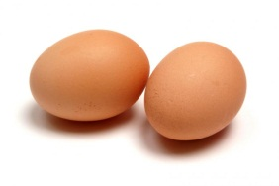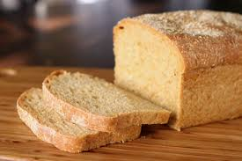  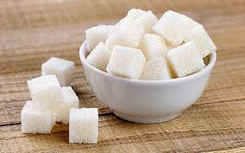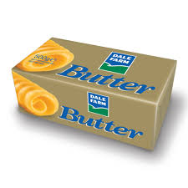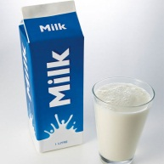 | What meal do British people have at 1 o’clock?  They have… .  What do they eat for … ?  They eat …  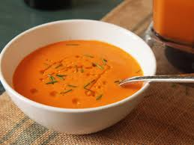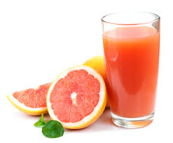  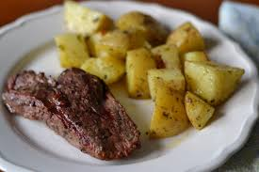
What meal do British people have between 4 and 5 o’clock?  They have… .  What do they eat for … ?  They eat …  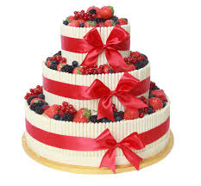 | What meal do British people have at 7 o’clock?  They have… .  What do they eat for … ?  They eat …  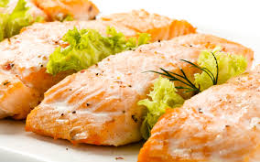  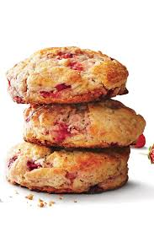

Приложение 1
ENGLISH MEALS
There are four meals a day in an English home: breakfast, lunch, tea and dinner or supper.
Breakfast is the first meal of the day. It is at about 8 o’clock in the morning, and consists of cereal with milk and salt or sugar, eggs, bread and butter with marmalade or jam. Some people like to drink tea, but others prefer coffee.

Lunch is at 1 o’clock. This meal starts with soup or fruit juice. People eat meat with potatoes, different vegetables. Englishmen always drink tea or coffee at lunch. Water is usually on the table.
Tea is the third meal of the day. It is between 4 and 5 o’clock. There is tea, milk, sugar, bread, butter, cakes and jam on the table.

Dinner is the fourth meal of the day. The usual time is about 7 o’clock, and all the members of the family sit down together. People usually eat soup, fish or meat with vegetables, fruit salad, ice-cream and biscuits. Then after a talk they have tea or coffee.

For supper they usually have a glass of milk and a cake or a cup of tea and a sandwich.
But there are people who like to have more things to eat for supper – cold meat or fish. Then they usually try to take a good walk after supper: “After dinner sleep a while, after supper walk a mile,” the English proverb goes.

Put a/ an or some:

1. ______ water
2. ______ apple
3. _____oranges
4. _______ juice
5. ______ cup of juice
6. ______ toasts
7.____ sandwich
8. ______ milk
9. _____ glass of milk
10.___ chocolate
11. _____ cake
12. _____ carrot
13.____ bananas
14. _____ tea
15. _____ bacon

Complete the text with some, a, or an:
1. I want ______ 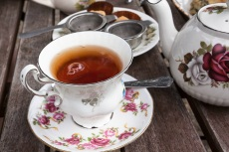 and ____ 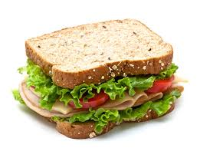.
2. There is _____ 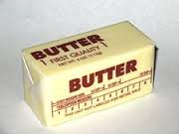 in the fridge.
3. Liz bought _____ 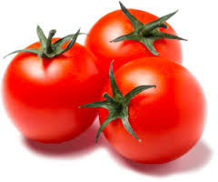 and _____ bottle of .
4. We had _____  for dinner.
5. I would like _____ 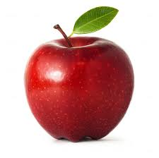 and _____ 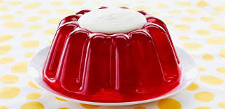.
6. There is _____ cup of 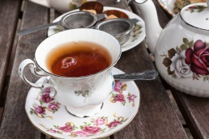 on the table.
7. There are _____  on the table.
8. I would like _____ for breakfast.

 | Time | Consist of… (food)
Breakfast
Lunch
Tea
Dinner
Supper

 | Time | Consist of…(food)
Breakfast
Lunch
Tea
Dinner
Supper

 | Time | Consist of… (food)
Breakfast
Lunch
Tea
Dinner
Supper

 | Time | Consist of… (food)
Breakfast
Lunch
Tea
Dinner
Supper

Match two columns.
A | Supper | 1 | Between 4 and 5 o’clock
B | Breakfast | 2 | At 1 o’clock
C | Dinner | 3 | After dinner
D | Lunch | 4 | At 8 o’clock
E | Tea | 5 | At 7 o’clock

Correct the mistakes.
1. The English have three meals a day.
2. People in England never eat sandwiches.
3. Tea is the second meal of the day.
4. English people have soup for breakfast.
5. The English proverb says, “After supper sleep a while, after dinner walk a mile”.

Answer the questions:
1. How many meals a day are there in England?
2. When do people have breakfast?
3. What do people have for lunch?
4. What is the third meal of the day?
5. When do people have dinner?

VIDEO

Answer the questions:
- What do the British eat for breakfast?
- What do the British eat for lunch?
- What do the British eat for dinner?
True or false:
- The British eat pasta for breakfast.
- The British don’t eat at home.
- Dinner is the main meal of the day.

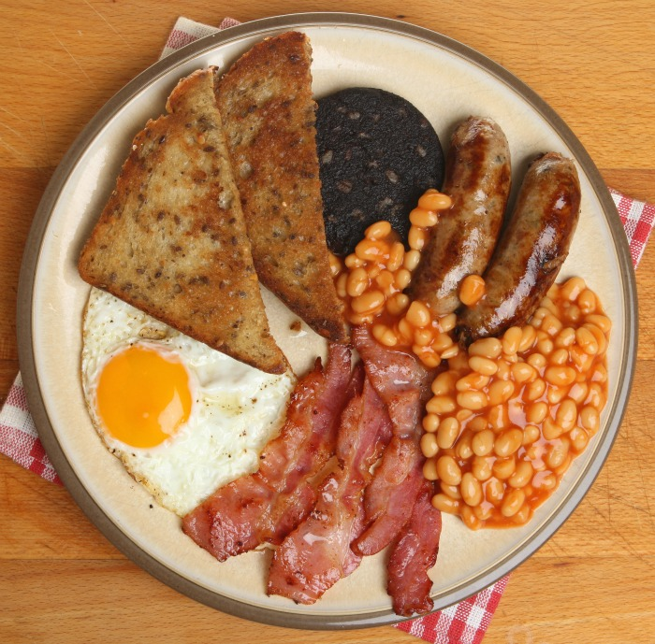

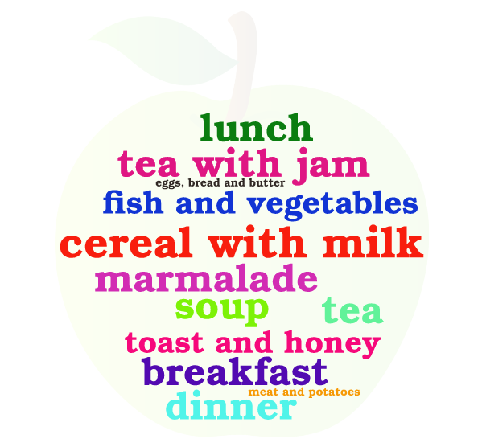

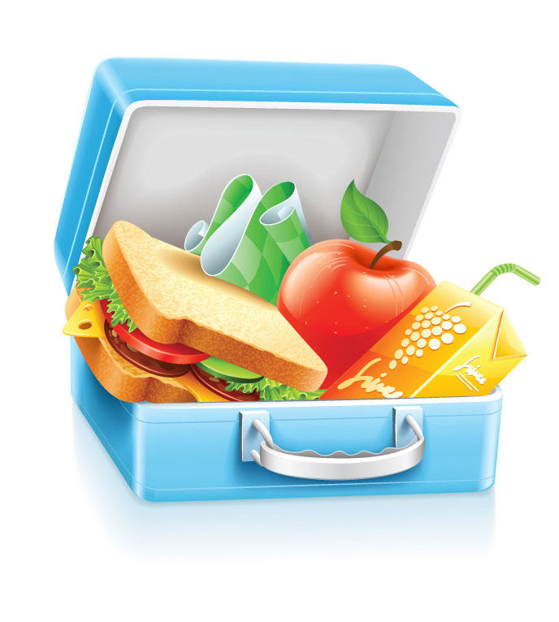

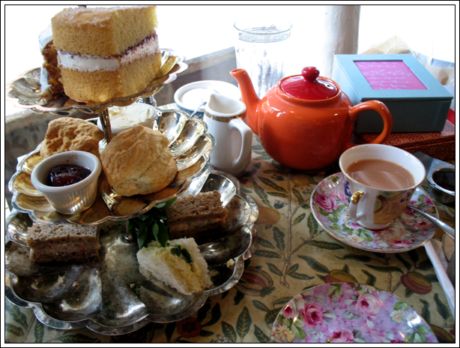

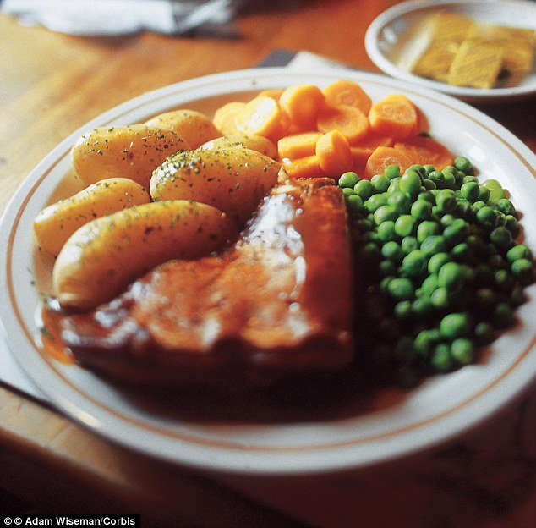

… is the first meal of the day.
People usually eat … at … o’clock in the morning.
They eat …, …, … for breakfast.
They drink … .
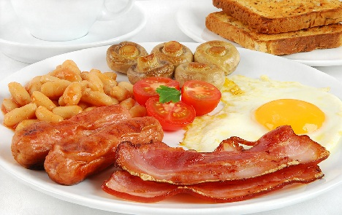

… is the second meal of the day.
People usually eat … at … o’clock in the afternoon.
They eat … .
They drink … .
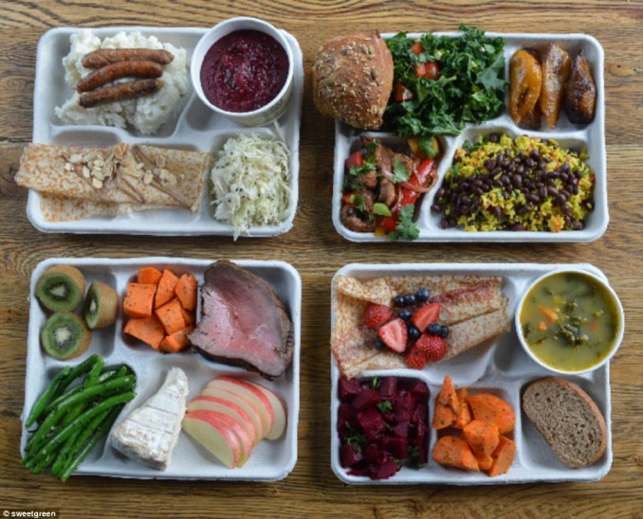

… is the third meal of the day.
People usually eat it between… and … o’clock p.m.
They eat … .
They drink … .
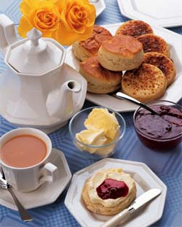

… is the fourth meal of the day.
People usually eat … at … o’clock p.m.
They eat … .
They drink … .
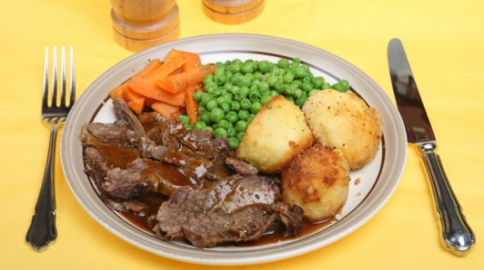

… is the fifth meal of the day.
People usually eat … after dinner.
They eat … .
They drink … .


