The theme: “ Differences” Form 6
The aims of the lessons:
- Educational: to teach the new words of the theme and comparatives.
- Development: to develop pupils’ skills in reading, talking about differences and similarities.
- Bringing up: bring up pupils to be attentive and polite.

Types of the lesson: getting new information.
Equipment of the lesson: picture, grammar table, cards, textbook.
Procedure of the lesson.
- Organization moment.
- Brainstorming.
- Have you got a personal computer at home?
- Do you like playing computer games ?
- How often do you play it?
- Are you going to sell your computer?
Teacher: Today at the lesson we’re speaking about Ben and Lisa’s computers. They are going to sell their computers. Let’s compare them. First of all we’ll take the new words.

- Presentation of the new words.
Listening and pronunciation of words:
Big, cheap, expensive, fast, short, new, old, powerful, long, slow, small, tall, young.

- Doing the exercise 1.
- Look at the adjectives in the list and find:
- two words with two opposites: short-long or tall
old-new or young
b. three pairs of opposites: expensive- cheap
new- old
fast- slow
- One word without an opposite: powerful

- Presentation. “It’s faster and more powerful”
Reading the two adverts. Comparing Ben and Lisa’s computers.

- Focus on grammar. Explaining of comparatives using grammar table.
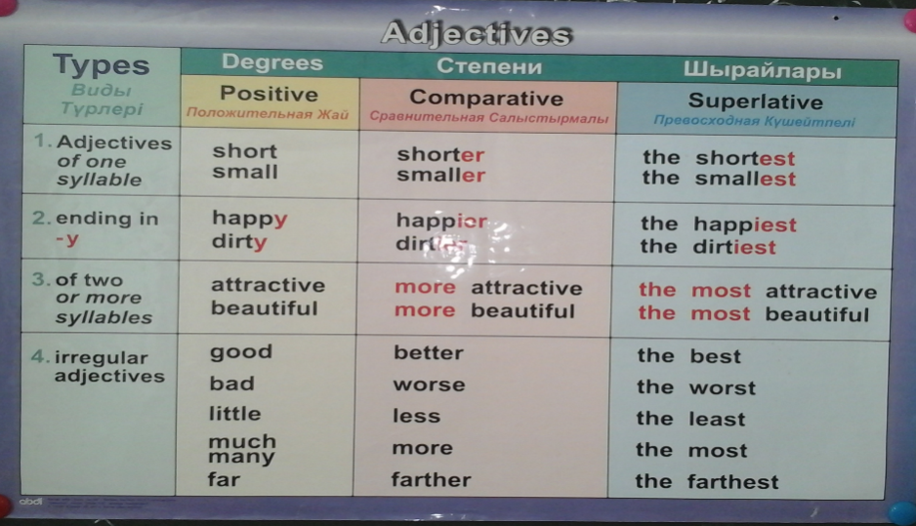
- Doing exercise 2.
- Find which are Ben’s and Lisa’s computer.
- It’s slower.- Ben’s computer.
- It’s faster and more powerful.- Lisa’s computer.
- Complete what Ben and Lisa say.
- Practice. 1. Writing the comparative form of adjectives.
Beautiful- more beautiful
Big-bigger
Dangerous- more dangerous
Long- longer
Difficult-more difficult
Important- more important
Short- shorter
Small-smaller
Intelligent- more intelligent
Young- younger
Interesting- more interesting
Tall – taller

- Complete sentences:
Japanese\ difficult \ English.
Beth \ tall \ Kim\
Tom’s hair \ long \ Dean’s\
Love\ important \ money\
Lucy \ old \ Robbie\
Kim’s skirt \ short \ Beth’s\

- Conclusion.
- Homework. Exercises1-3 from WB

