Object: English | Date: | Form: |  | Lesson№1
Theme of the lesson | What did they invent
General aims | To teach the grammar.  To enlarge vocabulary  To develop writing skills.
Results of educating | Students will know about the grammar and will enlarge vocabulary and writing skills.
Main ideas | New approaches to teaching and learning.  Learning to think critically.
Methods | Pair works. “Hot chair”.
Resources | English book, assessment papers.
The courses | Teachers actions |  | Pupils actions |  | Time
Organizational moment | Good afternoon, my dear pupils! |  | Good afternoon, teacher! |  | 2
Warm up | Puzzle with matches.  Watching DVD video. |  | Will take the odd matches. |  | 2
Presentation | I want divide you for two groups.  Numbers: even number and odd number. |  | I think they’ll great to each other. |  | 3
Practice | Open your books and answer the questions.  Describing what he/ she was doing at certain time in the past  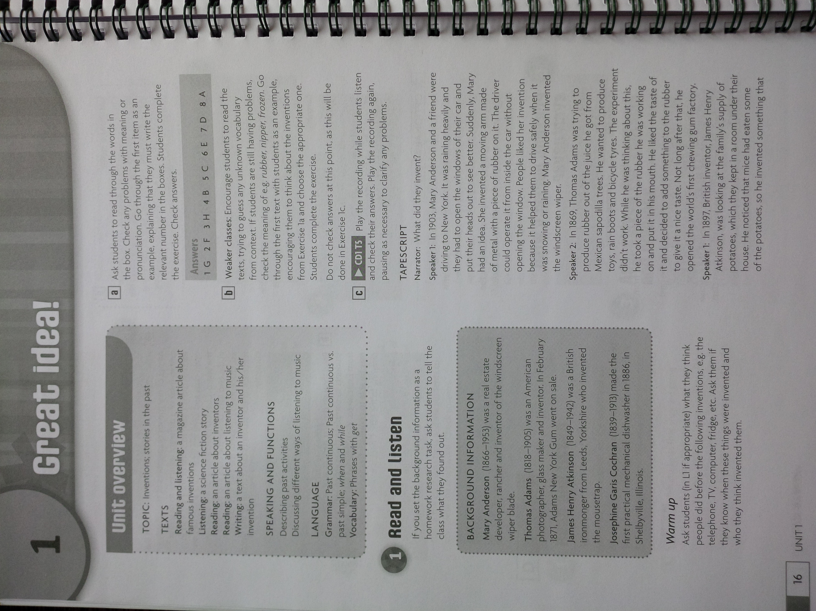 |  | Will work with the book.  Will answer the questions.  Will work with friends. |  | 25
Evaluation | What did they invent?  Make up sentences using these words: rain, try, think, work, look at, write, dream |  | Will answer the questions.  Will make up sentences. |  | 8
Assessment | Assessment for learning.  Questions and tasks. |  | Will take their suitable marks. |  | 3
Home task | Ex: 4.5 |  | Will write home task to their diary. |  | 2

