Биболетова М.З. 4 класс Unit 1
Ex.1 Напишите о погоде по образцу. It’s hot and sunny.
1/ Облачно и ветрено.______________________________________________
2/ Дождливо и холодно. ________________________________________
3/ Снежно. ______________________________________________
4/ Тепло и солнечно.____________________________________________
5/ Жарко. __________________________________________________
Ex.2 Выбери и обведи нужное слово (словосочетание).
1/ I will ski / will dive next summer.
2/ We like to toboggan / fly a kite in winter.
3/ The weather is / will be hot today.
4/ Tiny will / won’t make a snowman in December.
5/ Jill have / will have a picnic next week.
6/ Jim will visit / visit his grandmother tomorrow.
Ex.3 Прочитай и вставь пропущенные слова (словосочетания).
weather have a picnic autumn hide-and-seek fly a kite warm

It’s ___________. The ____________ is windy but ________. Jim and Jill ______________in the park. They ________________ and play _________________.
Ex.4 Прочитай вопросы и кратко ответь на них.
Do you like autumn? – Yes, I do.
1/ Can you fly a kite? - ___________________
2/ Will you toboggan next winter? - __________________
3/ Has Jill got a brother? - ______________________
4/ Do you like to make a snowman? - ________________________
5/ Does Jill like picnics? - ________________________
6/ Will they play hide-and-seek tomorrow? - ______________________
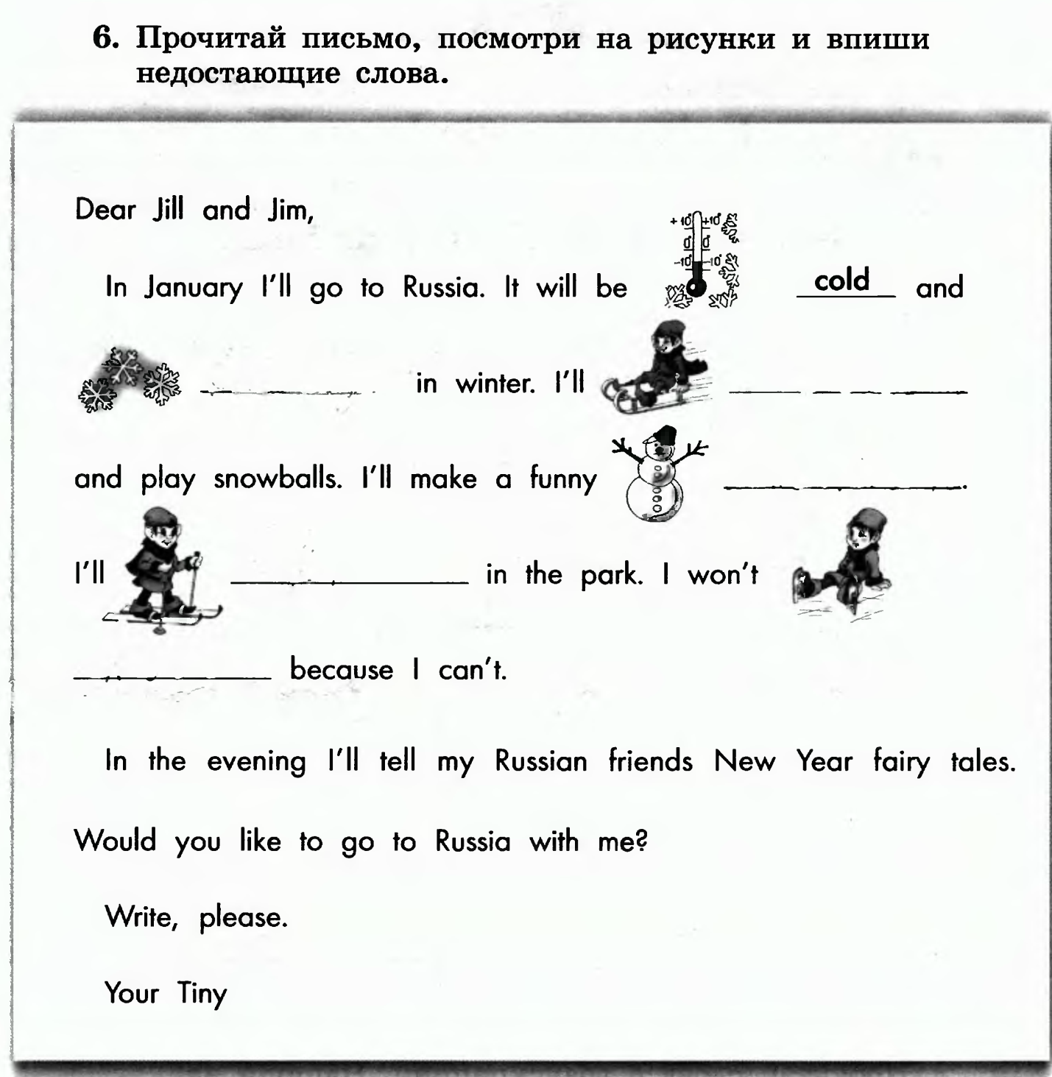
Дополнительно! Ex.6 Ответь на вопросы.
1/ What’s the weather like in winter in Russia?____________________________________________________________
2/ What can you do when it’s sunny and warm?____________________________________________________________
3/ What is your favourite season?__________________________________________________________
4/ What’s the weather like today?_______________________________________
5/ Can you toboggan in autumn? _______________________________________
6/ What can you do anytime? (в любое время) ___________________________
_________________________________________________________________

Биболетова М.З. 4 класс Unit 1
Ex.1 Напишите о погоде по образцу. It’s hot and sunny.
1/ Облачно и ветрено______________________________________________
2/ Дождливо, но (but) тепло ________________________________________
3/ Снежно и холодно ______________________________________________
4/ Солнечно, но не жарко____________________________________________
Ex.2 Выбери и обведи нужное слово (словосочетание).
1/ I will ski / will dive next winter.
2/ We like to toboggan / fly a kite in summer.
3/ The weather is warm. Tiny will/won’t have a picnic.
4/ Tiny is/will make a snowman next winter.
5/ Jill have / will have a picnic next week.
6/ Jim will visit / visit his grandmother tomorrow.
Ex.3 Прочитай и вставь пропущенные слова (словосочетания).
weather have a picnic hide-and-seek fly a kite warm

It’s autumn. The ____________ is windy but ________. Jim and Jill _________ _____in the park. They ________________ and play _________________.
Ex.4 Прочитай вопросы и кратко ответь на них.
Do you like autumn? – Yes, I do.
1/ Can you fly a kite? - ___________________
2/ Will you toboggan next winter? - __________________
3/ Has Jill got a brother? - ______________________
4/ Do you like to make a snowman? - ________________________
5/ Does Jill like picnics? - ________________________
6/ Will the weather be hot and sunny in summer? - ______________________

Ex.6 Ответь на вопросы.
1/ What’s the weather like in winter in Russia?____________________________________________________________
2/ What can you do when it’s sunny and warm?____________________________________________________________
3/ What is your favourite season?__________________________________________________________
4/ What’s the weather like today?_______________________________________
5/ Can you toboggan in autumn? _______________________________________
6/ What can you do anytime? (в любое время) ___________________________
_________________________________________________________________

