The Ministry of Education and Science of the Republic of Kazakhstan

OPEN LESSON
Theme: “My school lunch box”

Form: 4 B
Date: 11.02.2017y
Teacher: Baranova A.G.
School # 86

Karaganda 2017y
Long-term plan unit: Module three: All about school |  |  | School:#86
Date:27/01/ 2017 |  |  | Teacher’s name: Baranova A.G.
Grade: 4B |  |  | present: |  | absent:
Theme of the lesson: |  |  | My school lunch box
Learning objectives(s) that this lesson is contributing to |  | - use basic present forms of the verb to have [positive and negative] to give basic personal information , use countable and uncountable nouns and some , any constructions  - pronounce basic words and expressions intelligibly  - produce words in response to basic prompts  - make basic personal statements and simple statements about objects
Lesson objectives |  | All learners will be able to:  - listen and repeat the words, follow the instruction according to the task  - Make up correct 1 positive and 1 negative sentence about the things they like and dislike, have/has got and haven’t/hasn’t got  Most learners will be able to:  - recognise and name some words according to the topic, follow the instruction according to the task  - Make more than 2 sentences correctly using different sentence structure  Some learners will be able to:  - recognise and name most of the words according to the topic, follow the instruction according to the task  Make more than 4 sentences about their lunch box and read some of the words from the topic
Success criteria |  | Students will have succeeded in this class if they:  - Name at least 10 out of 14 words correctly  - Followed the instruction of the teacher immediately with support  - Say at least 2 sentences about what they like /dislike, have/haven’t got and has/hasn’t got correctly
Value links |  | Respect and cooperation by:  - Listening to the teacher  - Listening to each other  - Take turns  - Encourage each other  Helping each other
Cross curricular links |  | Biology, music,
Equipment |  | Ppt presentation, interactive board, flash cards, posters, cards with tasks, books, pictures, a computer
Previous learning |  | My big school bag: talking about things you’ve got and quantity, usage of articles a/an, words: some/any
Lesson plan
Planned timings | Planned activities  Teacher’s actions Pupils’ actions |  |  |  |  | Evaluation | Resources
BeginningWarming-up  (2 min)  Phonetic exercise (reading skills)  (2min)  Guess the theme of the lesson  (1 min) | 1)Greeting (make the positive atmosphere in the class)  The teacher switch on the video and after it ask questions  2) At first let’s practice our English sounds! Listen and repeat after me.  [ʌ]but,mum,run  [e]pen,hen,red  [a:]car,park,dark  [о:]corn, morning,short,horse  Tongue –twister  Billy Button bought a buttered biscuit.  3) The teacher shows pictures on the board and asks pupils to guess what they are going to talk about this lesson (the theme of it) |  |  | 1)Pupils watch the video, sing the song and after it using the example ask each other how they are doing.  2) Pupils repeat after the teacher English sounds and train to pronounce the tongue –twister.  3) Pupils look at the board and give their ideas about the theme of the lesson and its aims. |  | Formative (great, how clever you are!!)  The teacher gives a star for pupils who guessed the theme and aims of the lesson | Interactive board with the video  stars
Middle  Vocabulary work  (2 min)  Work with flash cards  (3 mon)  Writing  (3 min)  (2 min)  Auding  (3min)  Grammar work  (2 min)  (3 min)  (7 min)  Speaking drills  (3 min)  pair work  (speaking)  (8 min) | 1)Teacher switch on the record 1.59  2)The teacher shows pictures with words, and then ask some pupils show them at the blackboard (mime the words)  3)Ex 1 page 30 (activity book) pay attention to the words writing  4)The teacher advice to watch the video and sing a song, remind the grammar construction: Do you like?  -Yes, I do! –No, I don’t.  5)Listen, sing the song and put tick or cross  6)The teacher using the slide explaining the grammar rule: verbs have/has got, haven’t/ hasn’t got and the usage of some, any  7)Give the instructions to the ex 3 on page 43 (student’s book)  8)ex 5 p 31 (activity book). Give instructions about evaluation. (10 words correctly- excellent mark, 8 words correctly –good, less than eight -3, less than 3 words – bad)  9) The teacher tell the rules of the game “In my lunch box” using the technology of the “snowball” game  Ex7 p43  10)The teacher gives pictures with products to pupils who are sitting together (pair work) and they should work together. |  |  | Pupils listen to the words, read and repeat after the speaker, then read them one by one themselves. Page 42 Ex1  Pupils tell the words which the teacher shows them. Then they guess looking at the presentation of one of the pupil  Pupils should find 11 words from this ex, circle and name them.  4) Pupils sing the song and revise the grammar rule. They sing karaoke telling the words themselves.  5)pupils listen to the song, sing it, and fill in the table what the singer like or doesn’t like 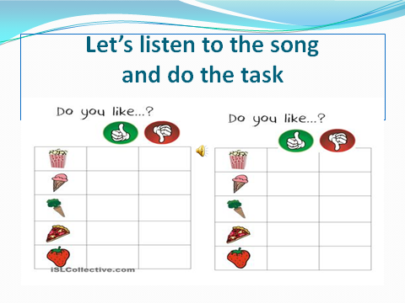  6)Pupils listen to the rules and write down in their copy-books. 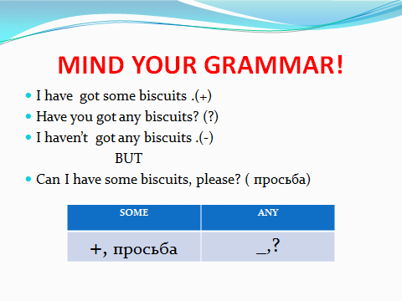  7) Listen to the record and fill in the blanks putting tick or cross  8) pupils should using the rule fill in blanks with has, got, hasn’t, have, haven’t, hasn’t, ‘ve, ‘s, got and explain why the use exactly this word  9)pupils should tell a sentence and then revise the words of the previous speakers  10) pupils using pictures with products stick them on their own lunch box and make some sentences about the products in it. Then find the healthiest lunch box.  |  | Formative (great, how clever you are!!)  Stars  stars  Stars  Children put marks in a table by themselves using the criteria told by the teacher  They check each other’s work and put marks according the instruction of the teacher  stars  Marks putting by themselves according the criteria | A computer and CD disk  Flash-cards  Activity book  Record with the song and video  Cards with words
End  (2min)  (2 min) | Feedback: The teacher explains how to fill the box with questions  Home task : ex2,6, page 30-31 in act book: words |  |  | Pupils write their ideas about the lesson:  I know….  I can….  I’m not sure….  It’s difficult …. |  | During the whole lesson pupils fill in the table putting marks themselves or to each other. At the end of the lesson they count and sum up marks .The teacher put marks in their diary and school journal | cards to fill in for feedback and evaluation

Additional information (after the lesson)
Differentiation  How do you plan to help pupils?  What tasks do you plan to give the most successful pupils? | Evaluation – how do you plan to follow the progress of your pupils?  (the idea of evaluation) | Cross curricular links  Biology, music,
Feedback?  Were the aims of the lesson achieved?  What have pupils learned today?  What was the atmosphere of learning?  Was my differentiated way of work good??  Did I follow the time?  What changes I would like to add in my plan of the lesson and why? | Write here your notes after the lesson
summative evaluation
Name two the most successful moments (either teaching or learning)
1:
2:
Name two moments which helped to make the lesson better (either teaching or learning)
1:
2:
What new information I have got about the class and its separate pupils. How it will influence my next lesson?

Distributing material:

Nandita
products | has got (√) | hasn’t got (×)
a chicken sandwich
any chocolate bars
some salad
an orange
a yoghurt
some crisps
3 biscuits
an apple
any cake

Feed back
Your ideas about the lesson
I know
I can
I’m not sure
It’s difficult
Evaluation card
ex5 (writing) | lunch box (speaking) | stars | a table (reading, listening) | nandita (listening) | total

