«Бекітемін» _____________ № 249 мектеп-лицей директордың бастауыш
сыныптар жөніндегі орынбасары
Ж. Жарылқаған

Teacher: |  |  | Seralieva Dinara Kuanyshbayevna
Date: |  |  | February, 23
Grade: |  |  | 1«V»
Theme: |  |  | Springtime in Kazakhstan
Main idea: |  |  | Students will learn the letter “Ii”  Students will learn the spring words
Aim of learning: |  |  | Students will be able to learn the letter “Ii”  Students will be able to write and read the letter “Ii”
Сriteriа
All students: |  | Majority of students: |  | Certain students:
Students will be able to understand how to write the letter Ii;  Students will be able to understand the meaning of the new words |  | Students will be able o understand the meaning of the new words and they can make up words; |  | Students will be able to understand how to read the new words;  Students will be able to learn new active vocabulary  and they can make up words;  Students will be able to understand the meaning of the words and can differ them
Stages | Time | Teacher’s activity |  | Student’s activity |  | Evaluation | Resources
I. Organization moment  Checking up the home task | 2 | -greets with the students  -checks up the attendance of students  -pays students’ attention to the lesson  - makes a good atmosphere: |  | -greet with the teacher  -act on duty  -prepare for the lesson |  | wishes  wishes | circle  alphabet  Cards with pictures
I. Organization moment  Checking up the home task | 3 | Teacher will ask new words of the last lesson by standing in a circle |  | Students will say the words one by one standing in a circle |  | wishes  wishes | circle  alphabet  Cards with pictures
\II. Introduction  Lead-in | 6 | Teacher will help to choose the picture from the basket |  | Students will choose one picture from the basket and connect it with the letter  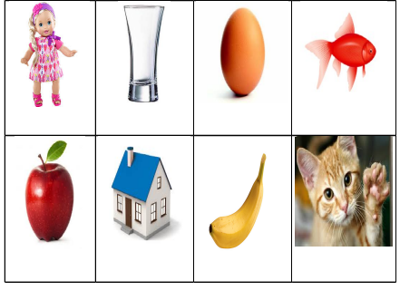 |  | wishes  wishes | circle  alphabet  Cards with pictures
III. The main stage  Working in pair  Working in a group | 8  6  8  7 | Teacher will introduce them the letter “Ii”  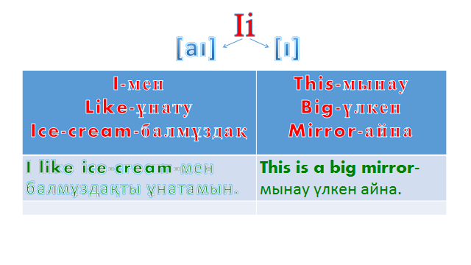 |  |  | They should write the letter from the board  Ii ……………………………….  Ii………………………………..  I………………………………..  i……………………………….. | Smiles  wishes  smiles  Stickers | English book  English book  Pictures With cards  Unscramble words
III. The main stage  Working in pair  Working in a group | 8  6  8  7 | Teacher will introduce the students with new avtive vocabulary  New words  - Snowdrop-бәйшешек  - Birds-құстар  - Bees-аралар  - Flowers-гүлдер  - Leaves-жапырақтар  - Trees-ағаштар  - Rain-жаңбыр  - Rainbow-кемпірқосақ  Association  Teacher will give them a word without picture and they should to find them  - Birds  - Rainbow  - Flowers  - Leaves  - Bees  - Snowdrop  - Trees  Unscramble letters  Teacher will give to the students parts of the words and they should find other parts of the words |  | Students will repeat after the teacher and listen from the audio player  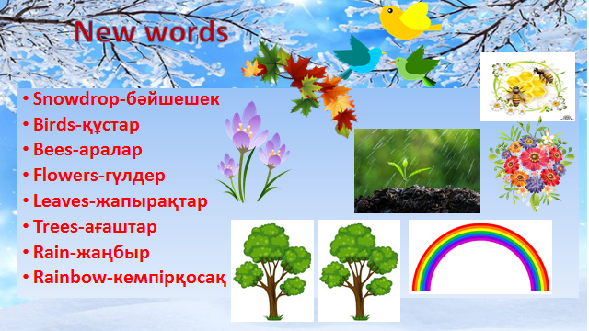  Students will find the pictures and will say it in English  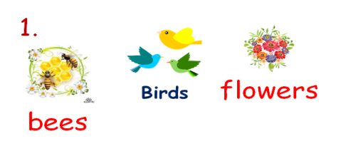  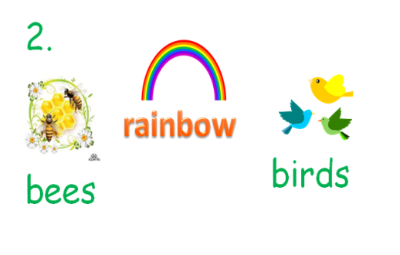  Students should make up words  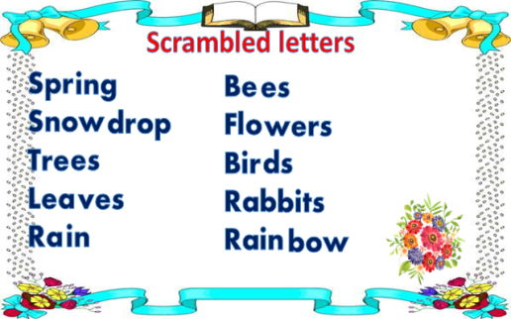  Pupils will repeat after audio player |  | Smiles  wishes  smiles  Stickers
IV. Conclusion  Homework  Evaluation | 5 | Teacher will conclude the lesson standing in a circle with pupils |  | Students should say what they learned at this lesson. |  | wishes | circle
V. Reflection / рефлексия
What moments were successful?
Не сәтті болды?

What moments were unsuccessful?
Не сәтті болмады?

What can be improved?
Нені жақсартуға болады?

What kind of skills could I develop? Мен өз дағдыларымда нені дамыта алдым?
What can be changed? Нені өзгертуге болады?

