Nurzhau common secondary school

Open lesson

How do you go to school?

Form : 3 «Ә»
Teacher: Mazhitov Aibek

2016-2017 year
Short term plan
Theme: Unit 6. Lesson 1. How do you go school? | School: Nurzhau common secondary school
Date: 21.02.17 | Teacher name: Mazhitov Aibek
Class: 3 «Ә» | Number present: 14 |  |  | Absent: -
Learning objectives(s)  that this lesson is  contributing to | To learn to speak about types of transport and to be able to say how to children go to school;  To train new words and to develop the pupil's habits in oral speech, writing and reading;
Lesson objectives: | All learners will be able to:  pronounce the new words with teachers support
Lesson objectives: | Most learners will be able to:  pronounce the new words and use the prepositions by,to in sentences with little support
Lesson objectives: | Some learners will be able to:  ask questions using question structure “How do you go to….? and describe your favourite transports using the new words without support
Language objectives: | Key words and phrases: a bus, a car, a trolleybus, a metro, a bike, a tram, a plane, a ship, a train
Language objectives: | Useful classroom language for dialogue: How do you go to school?
Previous learning: | Ex 3.p 45.Workbook
Plan
Planned  timings | Planned activities (replace the notes below with your planned activities) |  |  |  | Interaction | Resources
Start  Middle | I. Phonetic drill Tt [t]  [t] - hat  [t] – T -shirt  A hat, a coat, a T-shirt and boots are clothes  er her term serve  ir [З:] girl bird circle circus  ur Thursday turn burn  II.Brainstorming.  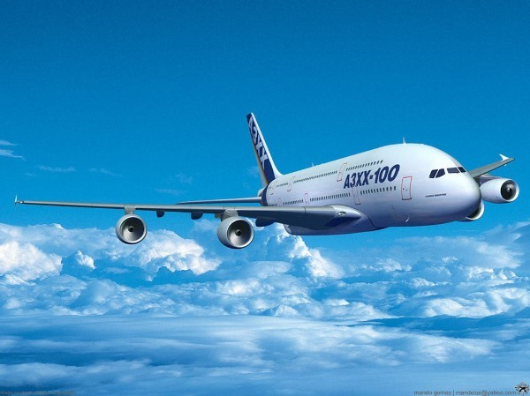    Look at the blackboard, and think what about the picture. What do you see in the blackboard?  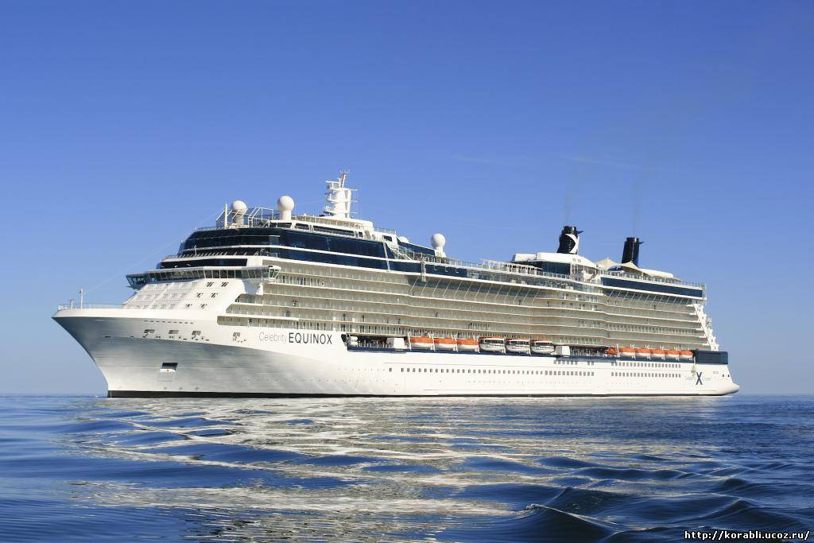  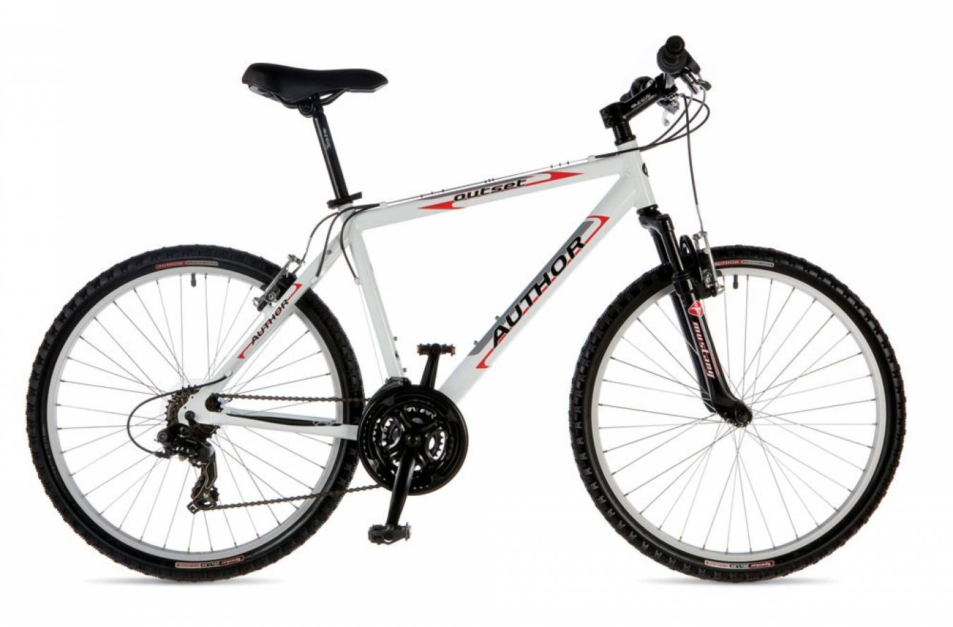  III.Today our theme is “How do you go to school?” It is a new topic for you and I want to show the new words which you have to learn.  - Look at the pictures, then try to guess what these words mean:  a bus – автобус a bike - велосипед  a car – көлік a tram - трамвай  a trolleybus – троллейбус a plane - ұшақ  a taxi – такси a train - пойыз  a metro - метро a ship – кеме  -Then we learn the adjectives  fast – slow тез – баяу comfortable -uncomfortable ыңғайлы-ыңғайсыз  IV. Now I`ll divide you into two groups  First answer the questions.  -How do you go to school?  -I go to school by bus.  V. «Dialogue in stickers». Work in pairs.  1st group – make dialogue using words in stickers  2nd group – make dialogue using the pictures of transport.  VI. Play a game “Find the sound”  Pupils listen to transports sound, then try to guess what transports sound  a plane, a bus, a car, a trolleybus, a tram, a taxi  VII. «Think, group, share ».Work in pairs  1st group – find the fast and slow transports  2nd group – find the public and private transports  VIII. Play a game “ Transport world”  Put the pictures of transports in the right form in three column. |  |  |  | T-P  T-P  T-P  T-P  P-P  P-P  P-P  T-P  P-P | presentation slides  pictures of  transports  https://www.youtube.com/watch?v=_Cgu04jq2bI  presentation slides  stickers  pictures of  transports  video sounds of transportation  A4 paper  pictures  pictures of  transports
  Land | Water | Air
  a bus, a car,  a tram, a bike | a ship, a bot | a plane,  a helicopter
End | IX.Creative work.  Now, pupils let’s draw your favourite transporst and then describe.  Ex: My favourite transport is a plane. It’s a big, long, fast and comfortable. |  |  |  | T-P | A4 paper  coloured pencils
Reflection | Did you like the lesson?  Was it useful for you?  You all worked very well. I’m pleased with your аnswer. Now pupils, at the and of our lesson let’s write your opinions for this lesson.  If you liked this lesson put the stickers in apple tree.  If you didn’t like this lesson put the stickers in lemon tree. |  |  |  |  | stickers
Homework | Ex 1.p 46. |  |  |  | T-P | Workbook
Additional information
Differentiation – how do you plan to give more support?  How do you plan to challenge the more able learners? |  | Assessment – how are you  planning to check learners’  learning? | Cross-curricular links –English,Kazakh  Health and safety check ICT links  Values links
more able pupils will assess others, help them in team and final speaking about your favourite transports in a village. Less able students are given many chances to repeat the words to learn and objectives are created to support them |  | group leader’s assessment

