Lesson plan

Date: _____
Form: 9
Theme: Hobby

Type of the lesson: combined lesson
Form of the lesson: generalization and practicum
Total time: 40 min
Methods and forms of work: individual (to make up monologue), group (work in groups, discussing, brain-storming, work with video) and frontal (solving problem situations).
Equipment of the lesson: computer, projector, English book for 9 grade by Ayapova T., Uakpayev D., Abildayeva Z., “Build your vocabulary” by John Flower; Intermediate Communication games by Jill Hadfield, cards, visual aids, handouts, Power Point Presentation.
Type of the lesson: systematization learned material according the theme “Hobby”
Aims of the lesson:
Educational:
- to enable students to use present participle and constructions;
- to develop pupil’s speaking skills on the theme “Hobby”.
Developing:
- to develop pupils’ abilities in speaking, writing, reading skills;
- to express their own opinions;
- to improve their pronunciation, memory, to enrich students’ outlook.
Up bringing:
- to motivate the students in learning the foreign language;
- to create an English speaking atmosphere and work in groups.
Forms of work: individual, group, work in pairs
Equipment: desk, cards, computer, projector, presentation Power Point, schemes, etc.
Procedure of the lesson
№ | Stages | Teacher | Timing
1 | I. Organization moment  Collaborative mood  Aim: to prepare pupils to work and to set them on the effective work during the lesson. | - Good morning boys and girls. I am very glad to see all of you. Sit down , please.  - Who is on duty today?  - Pupil 1:I am on duty today.  - What date is it today?  - Pupil 1: Today is the ___________.  - What day of the week is it today?  - Pupil 1: Today is __________.  -Who is absent today?  - Pupil 1: All are present.  - Ok! Thank you. Let’s smile to each other and start our lesson. In order to know, what we will do during the lesson, let’s look at the blackboard, match pictures with words and identify the goal of today’s lesson. Appendix 1 | 1
2 | Warm-up  Aim: to help students get in the mood for class.  Speech exercise  Aim: to practice specific speaking skills. | -At first, let`s do a phonetic exercise. Listen to the me and repeat after me all together. I want you to be attentive and active now. Appendix 2  I like running. Look at me.  I like jumping. Do it with me.  I like dancing. Look at me.  I like swimming in the sea.  -And now let’s discuss about our theme. Dear pupils do you agree or disagree with this statements: Murat, please…  - «Hobbies differ like tastes».  - «Active life and interesting hobbies make you feel happy». Appendix 3 | 3
3 | Checking-up the home task  Aim: to consolidate and reinforce the learning done in school, and to allow children to practice skills taught in lessons. | -I think it is a high time to check your home task. Let’s remember what you have learned at home. Look at the smart board.  1) Fill in the missing words (Method “Finish phrase”)  a. Jane goes to work …………………. bus.  b. My birthday is …………………. March.  c. We are going to meet …………… 4:00 p.m.  d. Students must go to school …………….. weekdays.  e. Do you do play tennis ……………….. the weekend?  f. His birthday is ………………… November 5th .  g. We have art lesson ……………. Mondays.  2) Read this sentences and say ‘Yes’ if you agree or ‘No’ if you disagree with this statements. (Method “YES , NO”)  a. Prepositions are words which link nouns, pronouns and phrases to other words in a sentence. (YES)  b. One of the traditional part of speech into which words are classified. It is a closed class, in that few new prepositions ever enter a language. (YES)  c. Prepositions usually describe the position of something, the time when something happens and the way in which something is done, although the prepositions "of," "to," and "for" have some separate functions. (YES)  -And now, please change our copybooks and check your classmates works. Appendix 4  -So, let’s sum up your home task. What is preposition? What is preposition’s function? | 3
4 | Presenting new lesson  Aim: to activate current knowledge.  Work in pairs  Individual work | -So, let`s continue our lesson. While working today you will evaluate yourselves using this cards. Appendix 5  - In order to know the theme of our lesson let’s do this rebus.  Appendix 6   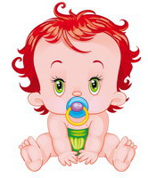(the third letter in this word is extra).  (Pre-watching activity)  -I want to ask you a question. What is a hobby? Can you give a determination?  - Pupil 1:A hobby is an activity that you like to do.  - Yes, you are very clever. A hobby is that you enjoy or like to do in your free time on a regular basis or every time.  - Dear pupils let’s complete the diagram:  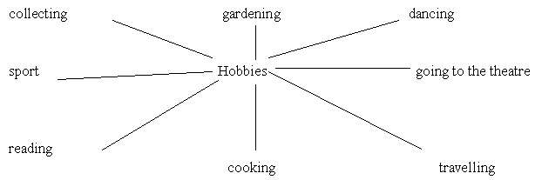 | 2  3  3
5 | Watching the video  Aim: to activate and reinforce of listening, grammar, vocabulary, pronunciation skills through to video. | -Watch the video and say what hobbies are unusual that the British have.  ‘3 Unusual Hobbies to Try (Or Not)’ Appendix 7 https://www.youtube.com/watch?v=vUK2BaRp29s  (After watching activity)  - Let’s answer following questions:  - How many top unusual hobbies do they have?  - What is extreme ironing?  - What is yarn bombing?  - What they can with cassette tapes? | 4
6 | Reading  Aim: the expansion of the conceptual base about the hobby due to the inclusion of new elements in it.  Group work | -OK, very good. The next task for you. You are to read short texts and guess what hobby is it? Is it clear?  Such people like to visit different cities, towns and historical places. Some people even visit other countries. They can travel by car, by plane, by train, by bus or on foot. This hobby helps them to learn history, geography and traditions of different people and countries.-Pupil : Travelling  People like to spend their free time near the rivers or lakes . They often go there with their friends or relatives . They can have a picnic there. They go usually there in summer but some people like to go there in winter too . Also they can boil fish broth ( soup ) after going there. -Pupil 1:Fishing  This hobby is interesting and useful. People try to find or buy different things such as stamps, badges, coins, pictures and dolls. Their collection can be thematic. This hobby helps people to make new friends and to learn some new things about countries and lands, animals and birds, famous people and historical events. -Pupil 3: Collecting  This hobby is popular with the people of all ages. People like to go to the stadium or to the sports ground. They are strong and healthy. Their hobby helps to develop their mind and body and teaches them to plan their time.-Pupil 2: Sports  People like to go to the library. Some of them have a good collection of books at home. And they are really proud of it. They can have different books: fiction, historical novels, books about animals and birds, books about different countries. Their hobby helps them to relax, to learn the world and understand people better. -Pupil 4 : Reading Appendix 8 | 3
7 | Relaxing  Aim: to relieve fatigue and tension | -Do you like sport? Let’s show our guests how we play different sport games.  - How do you play basketball?  - How do you play volleyball?  - How do you play tennis?  - How do you ski?  - How do you play football?  - How do you run? | 2
8 | Writing  Aim: to understand writing as a series of tasks, including finding, evaluating, analyzing, and synthesizing primary and secondary sources.  Individual work | 1) - The next exercise you will do in your exercise books. Look at the blackboard. There are some letters. The task is to make up the words on topic «Hobbies». Open your text books and write down these words.  den- gar-ing (gardening)  ing-vell-tra (travelling)  sp-ts-or (sports)  lec-ting- col (collecting)  ad-re-ing (reading)  da-ing-nc (dancing)  sh-fi-ing ( fishing)  ing-lk-wa ( walking)  -Well done. You are very clever pupils.  2)-  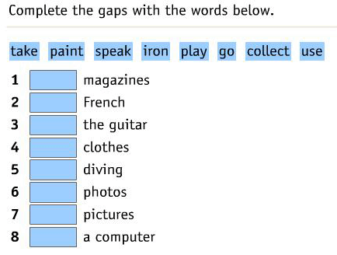  -And now, please change our copybooks and check your classmates works.  Appendix 9 | 3  3
9 | Fixing  Aim: learning the students a new way of acting in solving problems.  Individual work | -In order to fix your knowledge you should make up stories about your hobbies using the information from these texts and the plan.  The plan:  - My hobby is …  - It helps me…  - I can…  - My hobby is very interesting because …  - I think it is … | 3
10 | Reflexion  Aim: to self-evaluate the results of learning activities | -Dear pupils! In order to evaluate the results of learning activities let’s do next task. You should tick your colourful paper into this pictures:  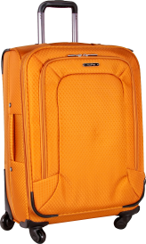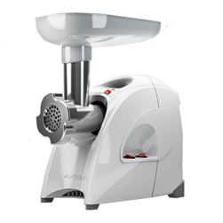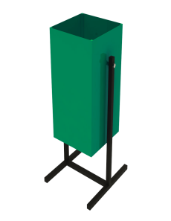  Appendix 10 | 2
11 | Giving marks  Aim: to ascertain the degree of achievement to the aim and objectives and results of works that has been completed | -Let’s evaluate our jobs. In order to do it, let’s see your tables.  -Pupil 1: I think I was good, because I did all the tasks without any mistakes.  Teacher: … is excellent, because you were active, you had no mistakes at all.  -Pupil 2: I think I was good, because I had some mistakes… .  Teacher: … your mark is four, because you were active, but you had mistakes in writing and speaking. | 2
12 | Giving home task  Aim: to increase the knowledge and improve the abilities and skills of the students | 1)- Your homework will be to write an essay about your hobbies using the plan on the topic “ My hobby”  The plan:  - My hobby is …  - It helps me…  - I can…  - My hobby is very interesting because …  - I think it is …  2)- and do this crossword Appendix 11  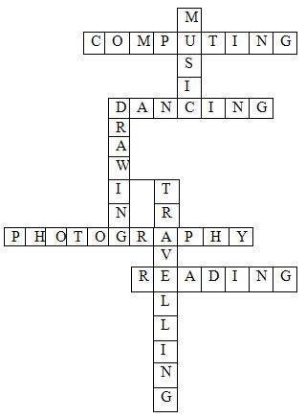 | 2
13 | Conclusion | -Now, it is time to make a conclusion of our lesson. So, today we’ve spoken about our hobbies. Did you like the lesson? Why? What was new for you?-It was my pleasure to work with you today. I am glad to see that you have done a good job. Stand up! The lesson is over. You may be free! Good buy. | 1

Appendix 1





Appendix 2
I like running. Look at me. 
I like jumping. Do it with me. 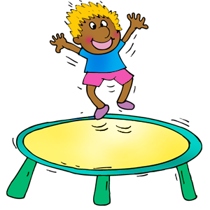
I like dancing. Look at me. 
I like swimming in the sea. 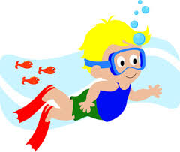

Appendix 3
- «Hobbies differ like tastes»

- «Active life and interesting hobbies make you feel happy»

Appendix 4
1) Fill in the missing words
a. Jane goes to work …………………. bus.
b. My birthday is …………………. March.
c. We are going to meet …………… 4:00 p.m.
d. Students must go to school …………….. weekdays.
e. Do you do play tennis ……………….. the weekend?
f. His birthday is ………………… November 5th .
g. We have art lesson ……………. Mondays.

2) Read this sentences and say ‘Yes’ if you agree or ‘No’ if you disagree with this statements.
a. Prepositions are words which link nouns, pronouns and phrases to other words in a sentence.
b. One of the traditional part of speech into which words are classified. It is a closed class, in that few new prepositions ever enter a language.
c. Prepositions usually describe the position of something, the time when something happens and the way in which something is done, although the prepositions "of," "to," and "for" have some separate functions.

Appendix 5
Evaluation card
Criteria | Reading skills | Speaking skills | Writing skills | Listening skills
Mark of
pupil

Mark of teacher


Appendix 6
Rebus

(the third letter in this word is extra)

Appendix 7
‘3 Unusual Hobbies to Try (Or Not)’

Nicely it's kind of what I had in mind when i sat down to do this scrapbooking stamp collecting doily making yeah we've all been there done that so here's a list of more unusual hobbies that will keep you out of the craft store first extreme ironing rock climber fell short aka steam started this over a decade ago when he came home to a pile of ironing to beat the board and he decided to do it on the edge of a cliff into western Gulf helping to this point and sometimes they just used the times they laugh times they ignore you but it's always fun to see how people respond to it and in the end of the day is a bit of fun people enjoy by ironing underwater upside down on a climbing wall and while plunging toward the ground at a terminal velocity of a hundred and fifty miles per hour next up yarn bombing and bombing is when somebody goes out in the community and they just kind of randomly pick a site in they do something with you are you can be needed directly onto anything outside like a tree or attached to a fence this is a project it'll be hanging from a tree in this is a form of yarn bombing it's a hobby anyone can enjoy it takes you back to your child likes Elton working with craft tutorials you're not worried about are you fine artist is this gonna go to gallery I love putting things out in the community in the right of where we're making nobody really knows who did it
third on the list revamping cassette tapes to be learning how to make one of
the guys that but the coin purse and you can make books party decorations or even
art and it's not just the unschooled tape it's getting a second life we ended up
wanting to pass significant large piece in the home Chris McCullough created
this cassette James Brown took points to do riding the hobby horse off the beaten path on the to do it.

https://www.youtube.com/watch?v=vUK2BaRp29s

Appendix 8

Such people like to visit different cities, towns and historical places. Some people even visit other countries. They can travel by car, by plane, by train, by bus or on foot. This hobby helps them to learn history, geography and traditions of different people and countries.

People like to spend their free time near the rivers or lakes . They often go there with their friends or relatives . They can have a picnic there. They go usually there in summer but some people like to go there in winter too . Also they can boil fish broth ( soup ) after going there.

This hobby is interesting and useful. People try to find or buy different things such as stamps, badges, coins, pictures and dolls. Their collection can be thematic. This hobby helps people to make new friends and to learn some new things about countries and lands, animals and birds, famous people and historical events.

This hobby is popular with the people of all ages. People like to go to the stadium or to the sports ground. They are strong and healthy. Their hobby helps to develop their mind and body and teaches them to plan their time.

People like to go to the library. Some of them have a good collection of books at home. And they are really proud of it. They can have different books: fiction, historical novels, books about animals and birds, books about different countries. Their hobby helps them to relax, to learn the world and understand people better.

Appendix 9

1)
den- gar-ing (gardening)
ing-vell-tra (travelling)
sp-ts-or (sports)
lec-ting- col (collecting)
ad-re-ing (reading)
da-ing-nc (dancing)
sh-fi-ing ( fishing)
ing-lk-wa ( walking)

2)-

Appendix 10

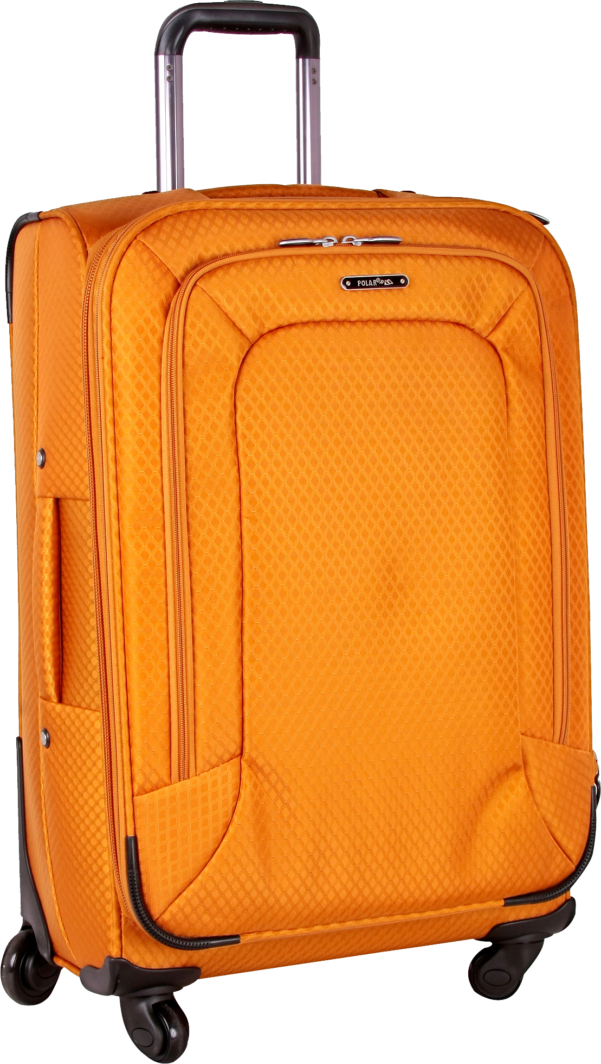

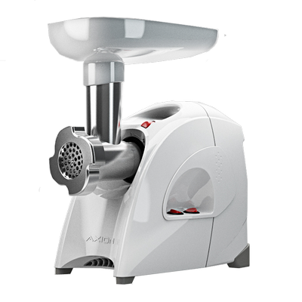

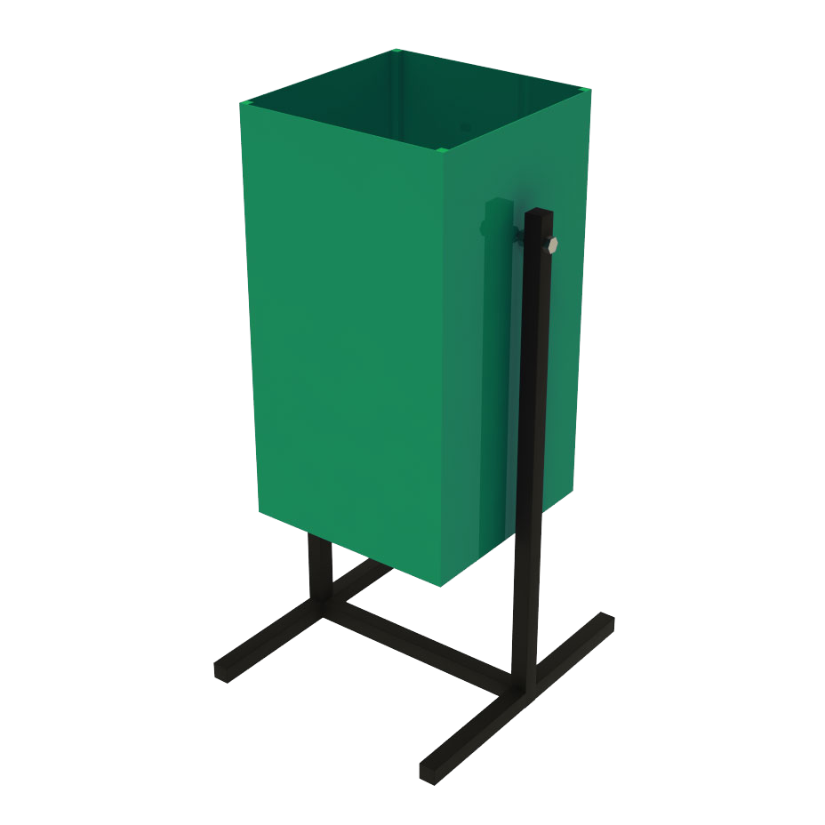

Appendix 11

Across |  |  | Down
Оқу |  |  | Сурет салу
Билеу |  |  | Музыка
Фотоға түсіру |  |  | Саяхаттау
Компьютермен ойнау

