Сценарий игры « Зов джунглей»
Цель - расширение познавательного интереса учащихся к предмету «Английский язык» через внеурочную деятельность
Задачи игры
Практические:
Закрепить употребление в речи учащихся лексику по теме “Животные”.
Развивать навыки монологической речи, чтения и аудирования и грамматические навыки (степени сравнения прилагательных) , оборот there is/|are
Развивающие:
Развивать творческие способности учащихся.
Развивать внимание и память учащихся.
Воспитательные:
Воспитывать личностные качества: чувство взаимопомощи, ответственности.
Воспитывать умение работать в коллективе и принимать совместные решения.
Познавательные:
Расширять общий кругозор учащихся.
Ход игры
Today we are having a Jungle play among the students of 5th and 6th grades
In our play 2 teams take place. Let’s greet them -
The 1st team-Leopards
The 2nd team -Tigers
Let’s welcome our jury- ___________________________________________________________
They will give you scores for every part of our play
В каждом раунде выигрывает команда, которая делает задание первой ,каждый правильный ответ – 1 очко. Наша игра состоит из 5 конкурсов.
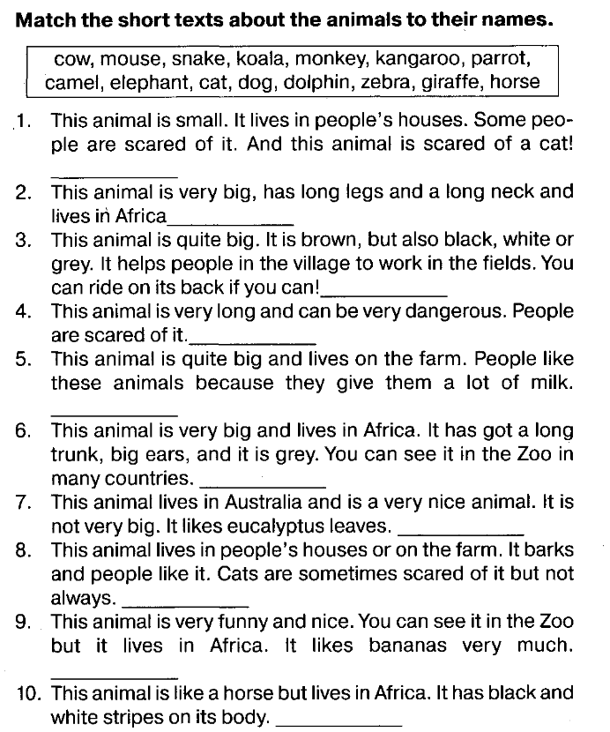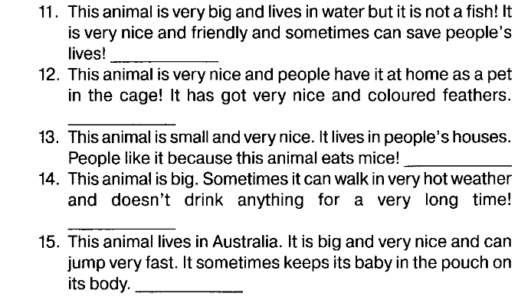

The 1st contest of our play is Visitka.
Every team comes to the stage and tells about the animals they represent.
The 2 task “ Guess the animal”
The students have to match the animals (there are 2 extra) and their descriptions using the right form of adjectives. The time is 5 min
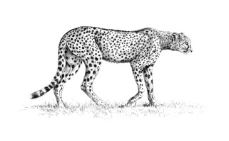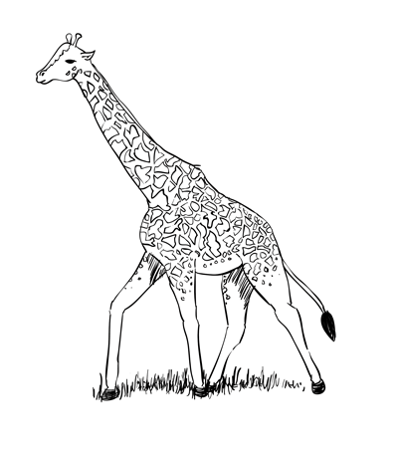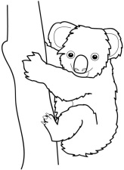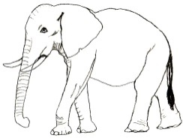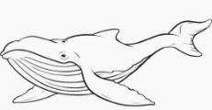
It is _________(fast) animal in the world. It can run at a speed of 115 kilometres per hour.
It is __________(large) animal in the world. It can weigh 150 tonnes and grow 30 metres long.
It is _______ (big)animal on land. It can weigh 8 tonnes and can grow 7 metres long.
It is ________(lazy) animalin the world. It can sleep 22 hours a day.
The 3 d contest The sounds. Listen to the sounds and guess 7 animals
Animal | I can  hear | I can’t  hear
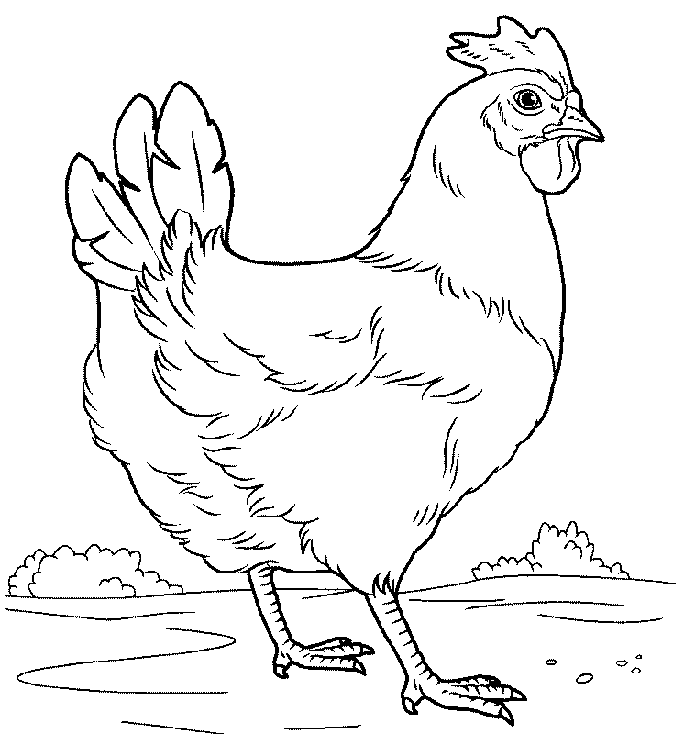hen
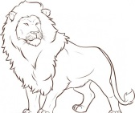lion
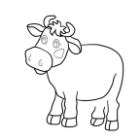cow
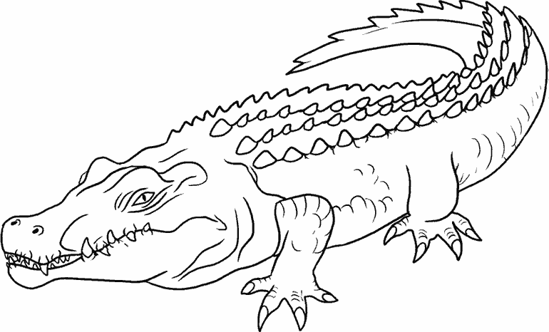crocodile
tiger
snake
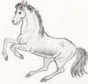horse
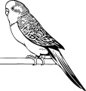parrot
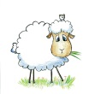sheep
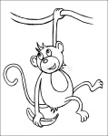monkey
kangaroo
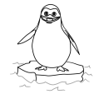penguin
The 4th contest- Animal biography
Read the texts about the animals for 3 minutes and try to remember as much information as you can and fill this information in the tables.
1 | 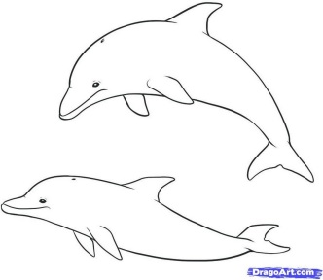 | Dolphins are mammals. Dolphins are not fish, but they live in water.  They can swim very well. They haven’t got legs. They have got fins and a tail to help them swim. They weigh from seventy to five hundred kilos. Dolphins are very clever. They easily learn how to play games.  They are very friendly. Dolphins live in warm seas. They eat fish and live for about fifty years.
2 | 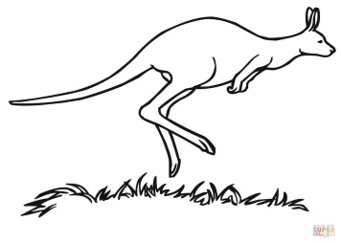 | Kangaroos are mammals. They live in Australia. They weigh about 60 kilos. Kangaroos have got two back legs, two short front legs and a long tail. They can jump very high. They sleep during the day and eat leaves. Thy live for about 20 years.
3 | 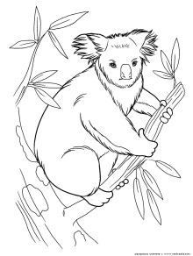 | Koalas are mammals. Koalas can climb very well. They have got thick grey fur and a big black nose. They have got sharp claws. Koalas live and sleep in the top of eucalyptus trees in Australia. They don’t drink water they eat only eucalyptus leaves. They weigh from 5 to 16 kilos. Koalas live for about 15 years.
1 |  | Dolphins are mammals. Dolphins are not fish, but they live in water.  They can swim very well. They haven’t got legs. They have got fins and a tail to help them swim. They weigh from seventy to five hundred kilos. Dolphins are very clever. They easily learn how to play games.  They are very friendly. Dolphins live in warm seas. They eat fish and live for about fifty years.
2 | 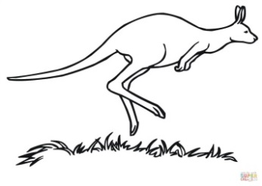 | Kangaroos are mammals. They live in Australia. They weigh about 60 kilos. Kangaroos have got two back legs, two short front legs and a long tail. They can jump very high. They sleep during the day and eat leaves. Thy live for about 20 years.
3 |  | Koalas are mammals. Koalas can climb very well. They have got thick grey fur and a big black nose. They have got sharp claws. Koalas live and sleep in the top of eucalyptus trees in Australia. They don’t drink water they eat only eucalyptus leaves. They weigh from 5 to 16 kilos. Koalas live for about 15 years.

 | Dolphin | Koala | Kangaroo
Kind of animal
They can

They have got
They live

They eat

They live for

The 5 th contest « How many?
Посчитай животных и составь предложения, используя There is \ There are:
1 | There is one rabbit
2
3
4
5
6
7
8
9
10
11
Например: There is one rabbit

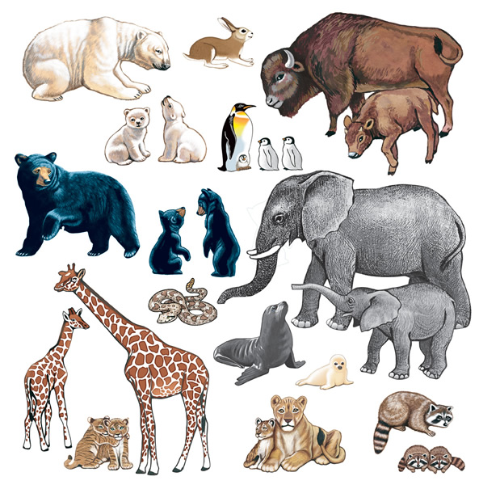
Подведение итогов
And now let’s listen to the jury.
Жюри вместе с детьми считает балы и подводит итог игры.

МБОУ «Семецкая СОШ»

Внеклассное мероприятие по английскому языку

Игра «Jungle play»
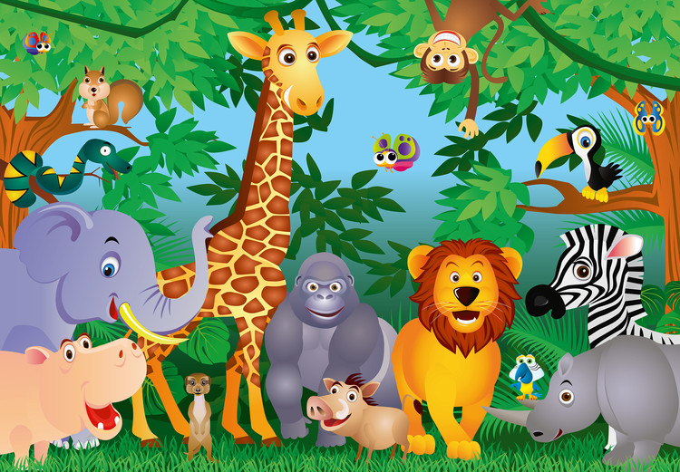

Подготовила учитель английского языка
I-й квалификационной категории
Ноздря Ирина Евгеньевна

Семцы – 2017

Использованная литература
1.www. sparklebox.co.uk
2.картинки животных с интернета
