Long-term plan unit: Unit 7: food and drinks |  |  |  | School: NIS, Taldykorgan
Date: 28/03/ 2016 |  |  |  | Teacher names: Mukhametsharova A.K.
Grade: 1C (1 group)
Theme of the lesson: |  |  |  | Things I like
Learning objectives(s) that this lesson is contributing to |  | 1.UE9 use basic present simple forms [positive and negative] to give basic personal information  1.S3 pronounce basic words and expressions intelligibly  1.S5 produce words in response to basic prompts  1.S1make basic personal statements and simple statements about objects
Lesson objectives |  | All learners will be able to:  - listen and repeat the words, follow the instruction according to the task  - Make up correct sentence about the things they like and dislike  Most learners will be able to:  - recognise and name some words according to the topic, follow the instruction according to the task  - Make more than 1 sentence correctly using different sentence structure  Some learners will be able to:  - recognise and name most of the words according to the topic, follow the instruction according to the task  - Read and write some of the words from the topic
Success criteria |  | Students will have succeeded in this class if they:  - Name at least 6 out of 9 words correctly  - Followed the instruction of the teacher immediately with support  - Say at least 2 sentences about what they like and dislike correctly
Value links |  | Respect and cooperation by:  - Listening to the teacher  - Listening to each other  - Take turns  - Encourage each other  - Helping each other
Cross curricular links |  | Kazakh language and literature, Russian language and literature (naming things in Kazakh, Russian and English)
ICT skills |  | PPT -By teacher, interactive websites
Previous learning |  | Story time – Practice the phrases: The witch has a black cat not a white dog.  Revision of the words – colours, nature vocabulary, animals.
Plan
Planned timings | Planned activities (replace the notes below with your planned activities) |  |  |  |  |  | Resources
Beginning  - min | Get students ready to the class by greeting them, asking questions about weather:  - What is the weather like today?  - What was the weather like yesterday?  Teacher put on some pictures on the board to show objectives and criteria, also teacher says what kind of rules learners should keep at the lesson.  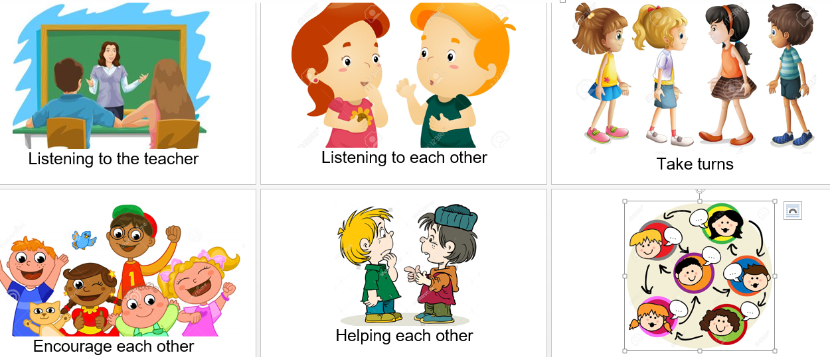  Warm up activity  - Show learners halves of the food and make them guess what the pictures are. Encourage to name them in Kazakh /Russian language  (milk, soup, fish, ice cream, cookies, juice, pizza, salad, banana )  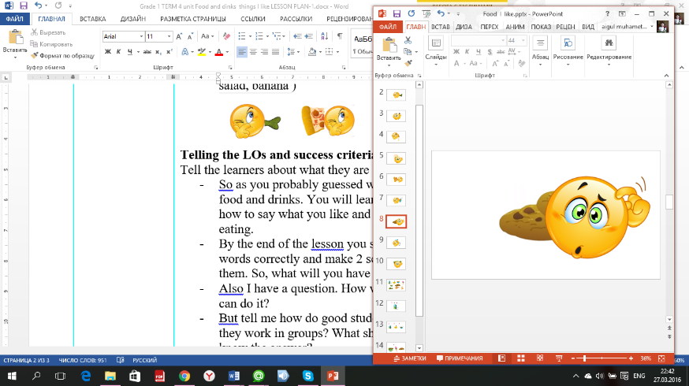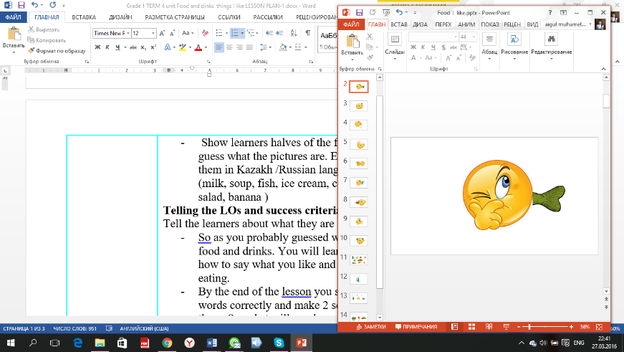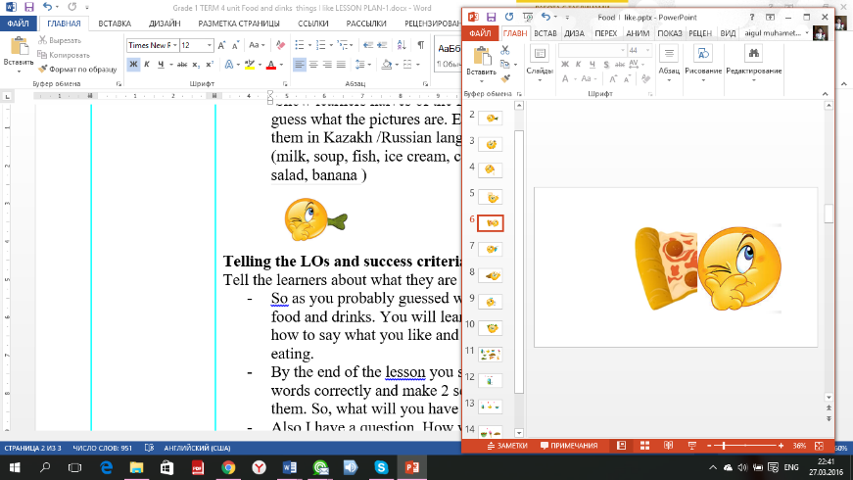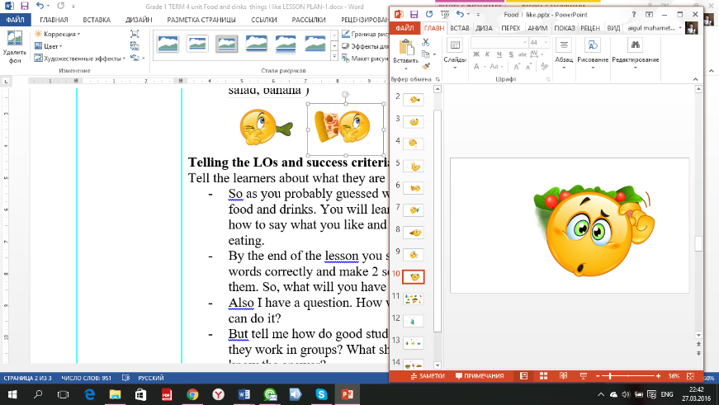  Telling the LOs and success criteria:  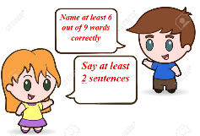  Tell the learners about what they are going to do today:  - So as you probably guessed we will learn today – food and drinks. You will learn 8-9 new words and how to say what you like and what you don’t like eating.  - By the end of the lesson you should name me 6 words correctly and make 2 sentences with some of them. So, what will you have to do?  - Also I have a question. How will I know that you can do it?  - But tell me how do good students behave when they work in groups? What should you do if you know the answer? |  |  |  |  |  | Pictures  PPT slides 2-10  board, marker
Middle  3 minutes  3 mins  5 mins  5-7 mins  5 mins  7 mins | - Teacher drills pronunciation of the words correctly. Once they repeat after the teacher, then they repeat individually.  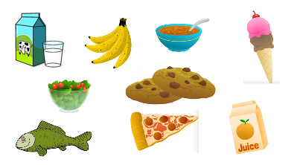  - Teacher shows one example about the letters then learners should guess themselves other food names according to the letter  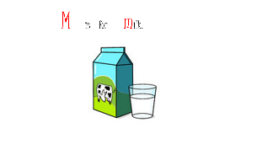  - SONG. Do you like …? Listen to the song and repeat the gestures teacher shows. Then sing and dance the song together. Teacher asks questions about the song:  - Play a game “What is missing?”  Before playing, teacher divides the learners into 2 small groups and gives the capital letters of the food for each group. Teacher shows pictures of food on the board and students name them all with their eye open. After teacher says to close the eyes, teacher takes one card away. Students open the eyes and name what is missing. When learners guess the word teacher asks some questions about the picture:  - How many are they?  - What color are they?  - Do you like it?(yes, no)  - Are they yummy?  - Are they yucky?’  - What is the capital letter of …….?  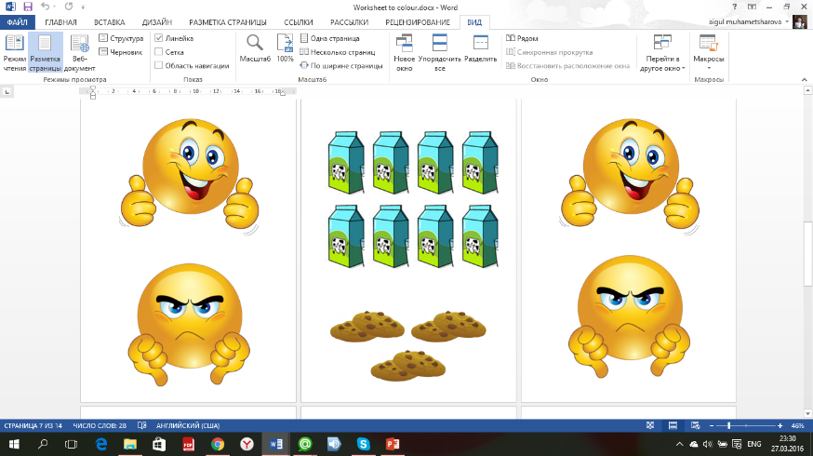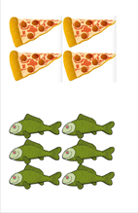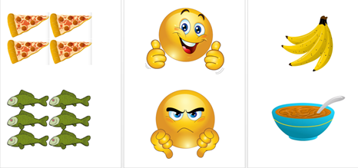  - Drill the sentences prompts I like \ I don’t like  Go back to the Pictures which every small group guessed and make up sentences together with students.  - Do you like….? Yes, I do. it’s yummy  - Do you like ….? No, I don’t. it is yucky!  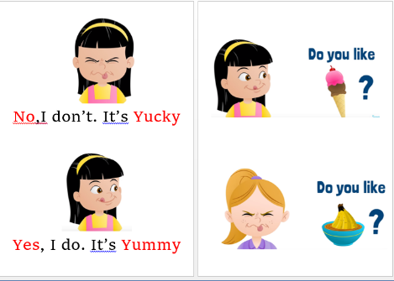  - Speaking (FA) Before starting the activity turn back to Los.  Call 2 students to go out to the board. There will be all the cards on the table. Explain what the pictures mean. Train one example. They take one card saying the beginning of the sentence I like / I don’t like, then they turn over the card and finish the sentence.  For example: I like ..banana. I don’t like ..cheese.  (differentiation) Teacher keeps the conversation by asking questions: Is it yummy or yucky?  Peer assessment: others listen when somebody says a sentence and corrects or helps to say. Choose one more able student to assess others by giving a sticker. But the teacher takes the final decision.  - LISTEN AND UNDERSTAND THE SEN -TENCES. To summarize the lesson teacher gives learners worksheets and asks to sit down. Teacher explains the instruction and learners should follow. The task is find the food and colour. |  |  |  |  |  | PPT-11 slide  PPT- 12-15 slides  cards on the board  https://www.youtube.com/watch?v=frN3nvhIHUk  letters and supporting pictures ‘Yummy and Yucky’  flashcards and rubrics  Worksheet
End  3 minutes  2 mins | Feedback (stairs)  Ask learners to rise their worksheets and check how many words they could identify and if they are able to:  - Name 6 words of food correctly  - Say a sentence correctly  - Say 2 sentences correctly  Home task – learn the words (cards, make sentences)
Additional information
Differentiation – struggling learners will be given more prompts to help them speak. More able learners will be encouraged to make their speaking more complex. |  |  | Assessment - by the teacher, self assessment may be done by the students as the teacher asks questions about what they have learnt when they draw and do crafting. Also the result of the flower will show which words they remember

