«Бекітемін» № 249 мектеп-лицей директорының бастауыш
сыныптар жөніндегі орынбасары _______ Ж.Жарылқаған
Lesson Plan
LESSON: Toys |  | School: №249
Teacher name: Seralieva Dinara |  | Date: 15.11.2016
Class: 1 “в,г,е,в” |  | Number present: ___ absent:____
Learning objectives: | UE7 use personal subject pronouns to identify things .  S3 pronounce basic words and expressions intelligibly
Lesson objectives: | All learners will be able to:  Say the names of toys
Lesson objectives: | Most learners will be able to:  Identify the toys and present them
Lesson objectives: | Some learners will be able to:  Use the structure “have got” and make a sentences.
Language objectives: | Learners can: to talk about toys.
Language objectives: | Key words and phrases: doll, kite, bike, car, plane, train.
Language objectives: | Discussion points: I`ve got a kite. It`s blue.
Previous learning: | My room
Plan
Planned timings: | Planned activities: (replace the notes below with your planned activities) |  | Resources:
Start  5 minute | 1.Greeting  -Hello children!  -Hello teacher!  -How are you today?  -I`m OK, thanks.  -Thank you sit down ,please. |  | Flashcards  Pictures and words
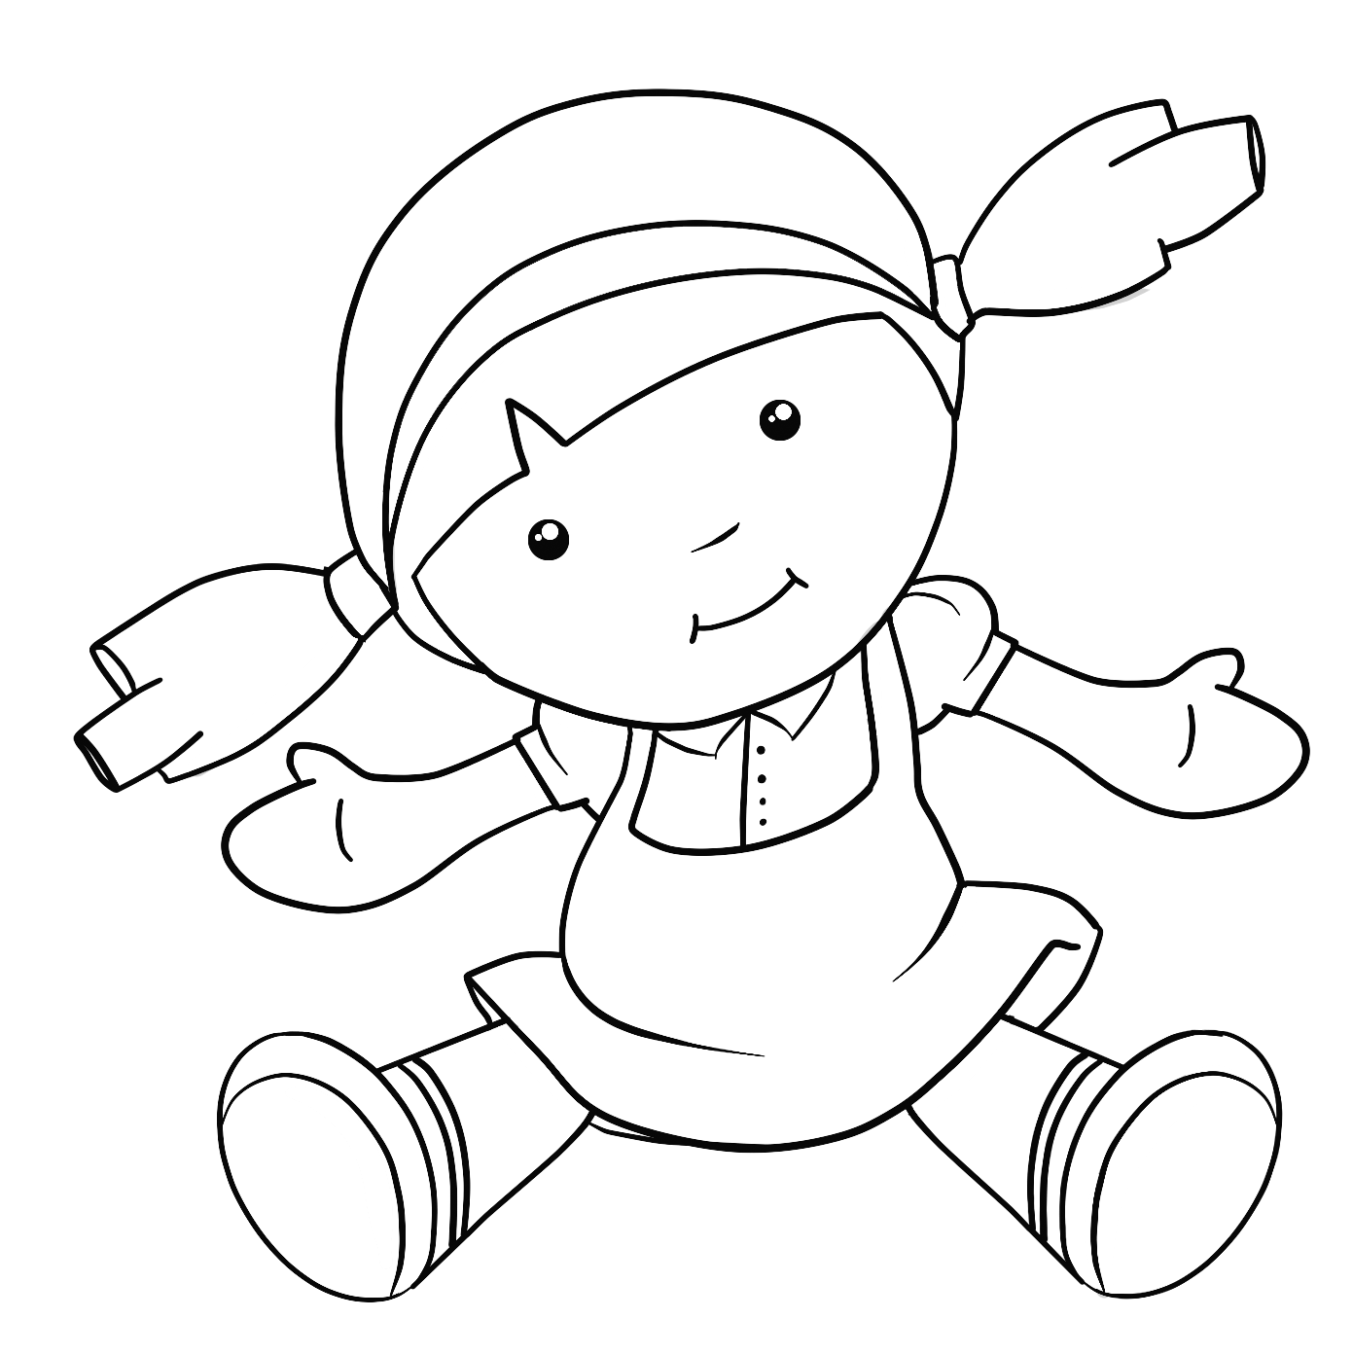  Middle  20 minutes | Beginning the lesson.  Ask the pupils to tell you two things they have in their rooms.  Teacher: What`s in your room?  Pupil: A bed and a desk. Etc  Presentation and practice. Use the TPR  doll kite  Toys  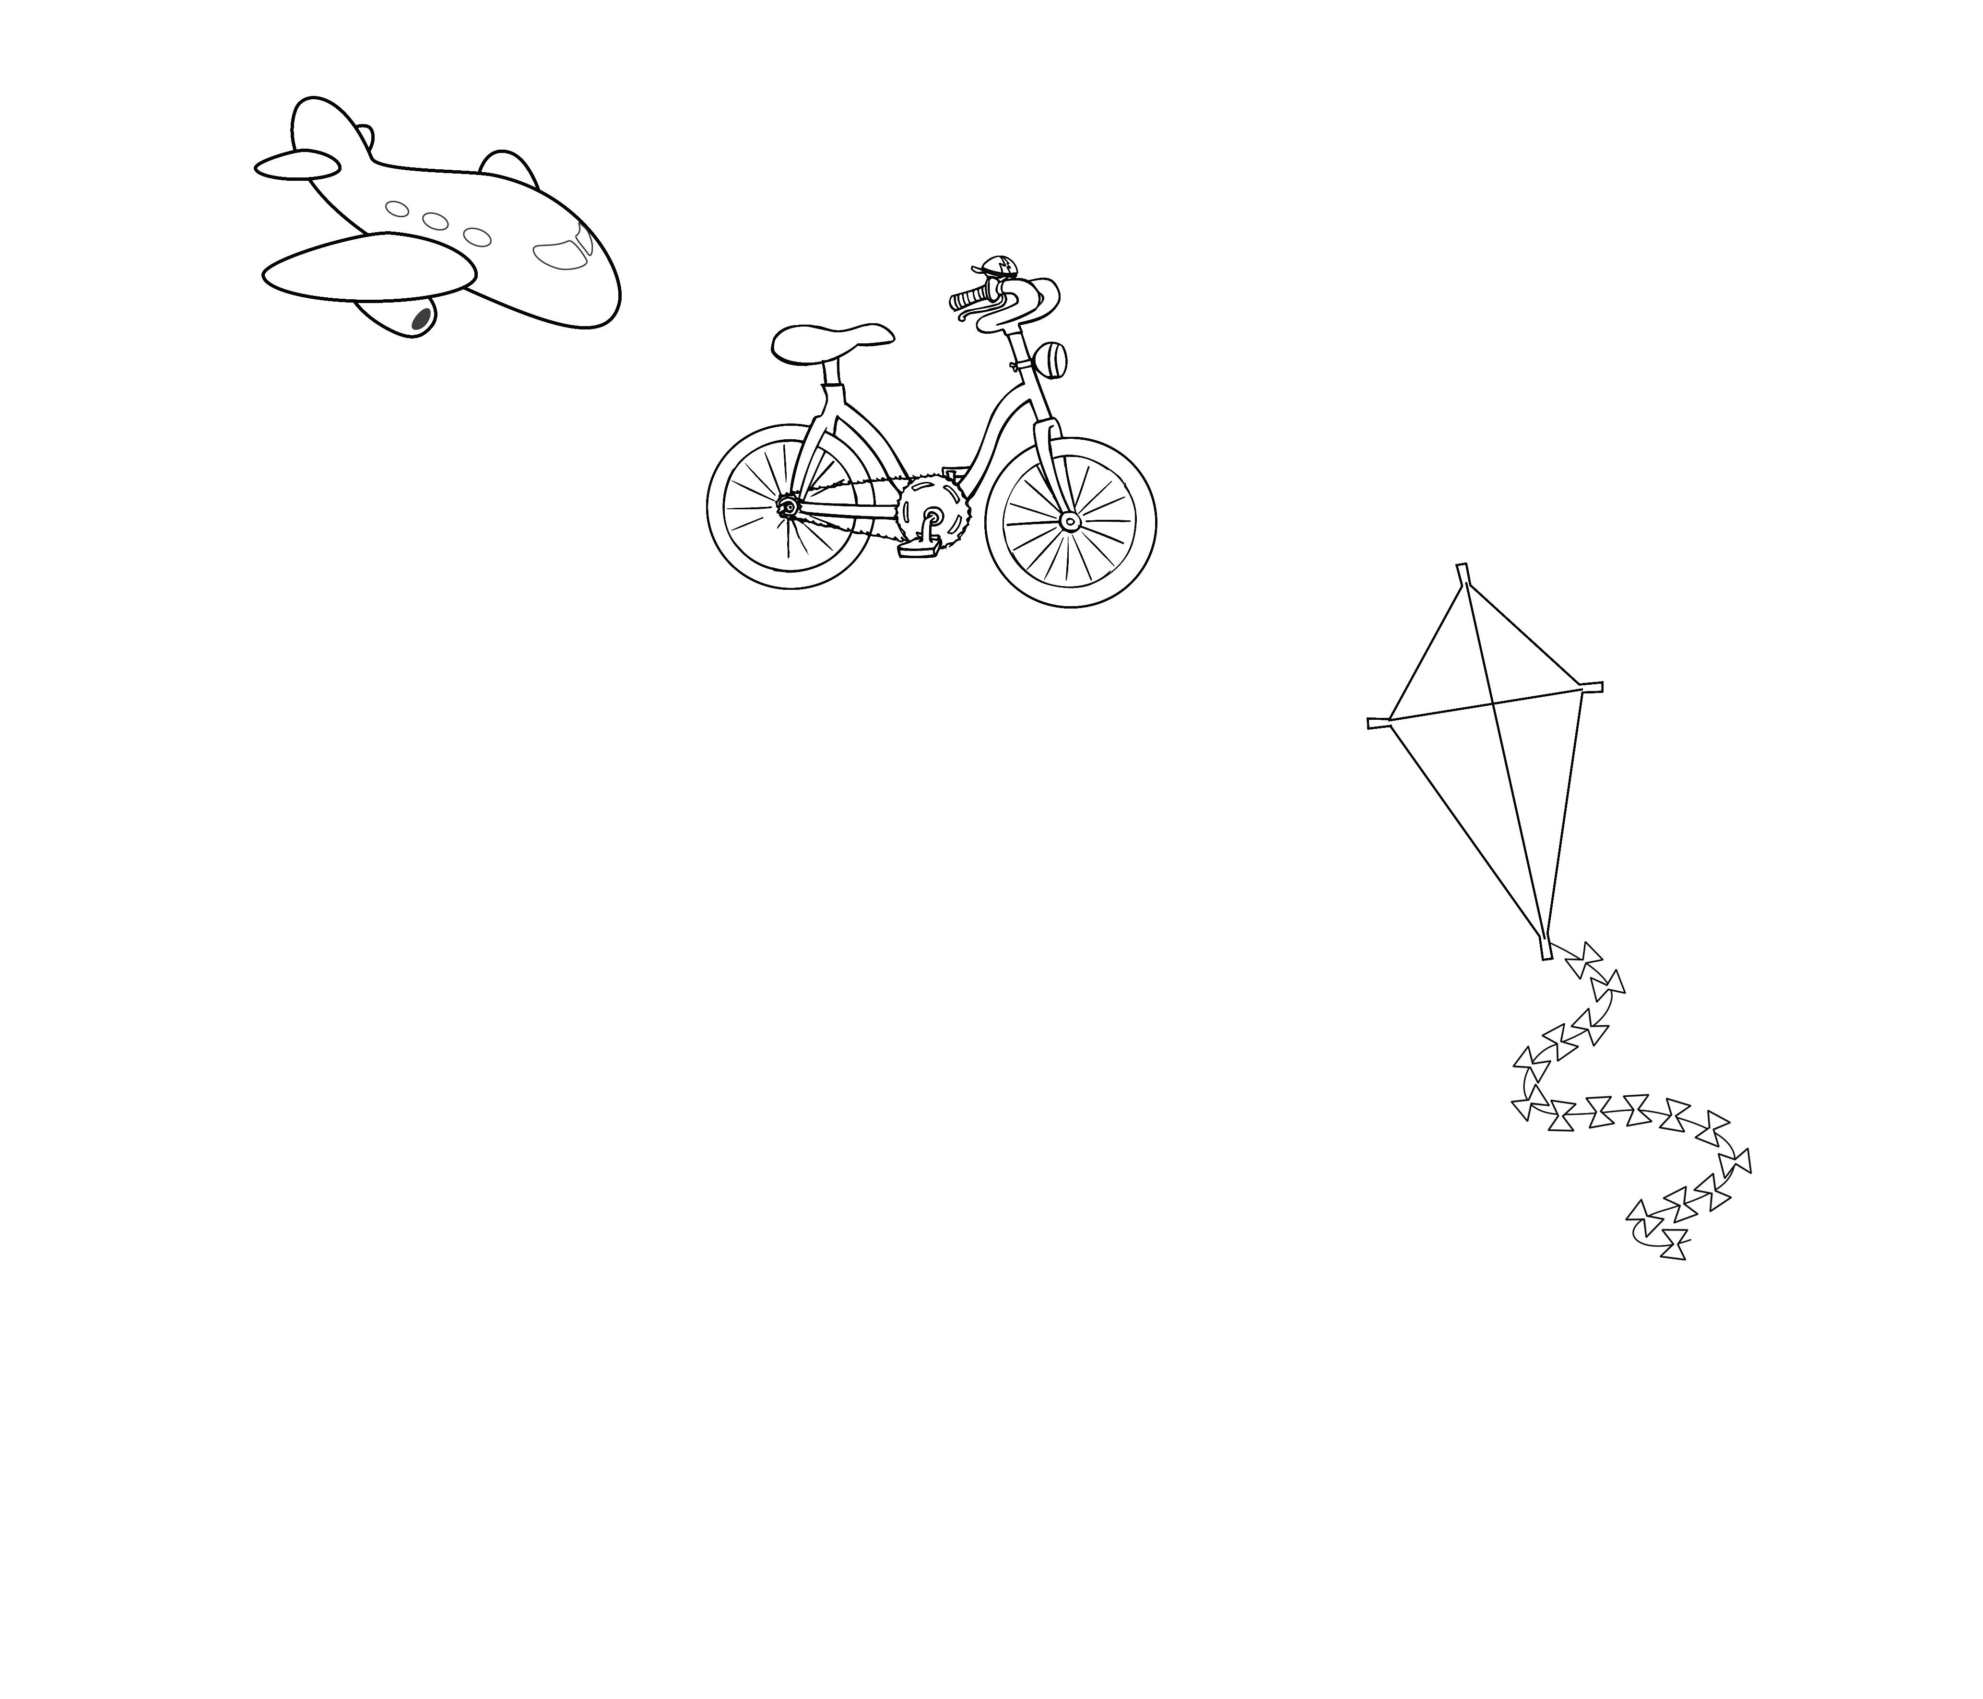  и bike bike  car plane  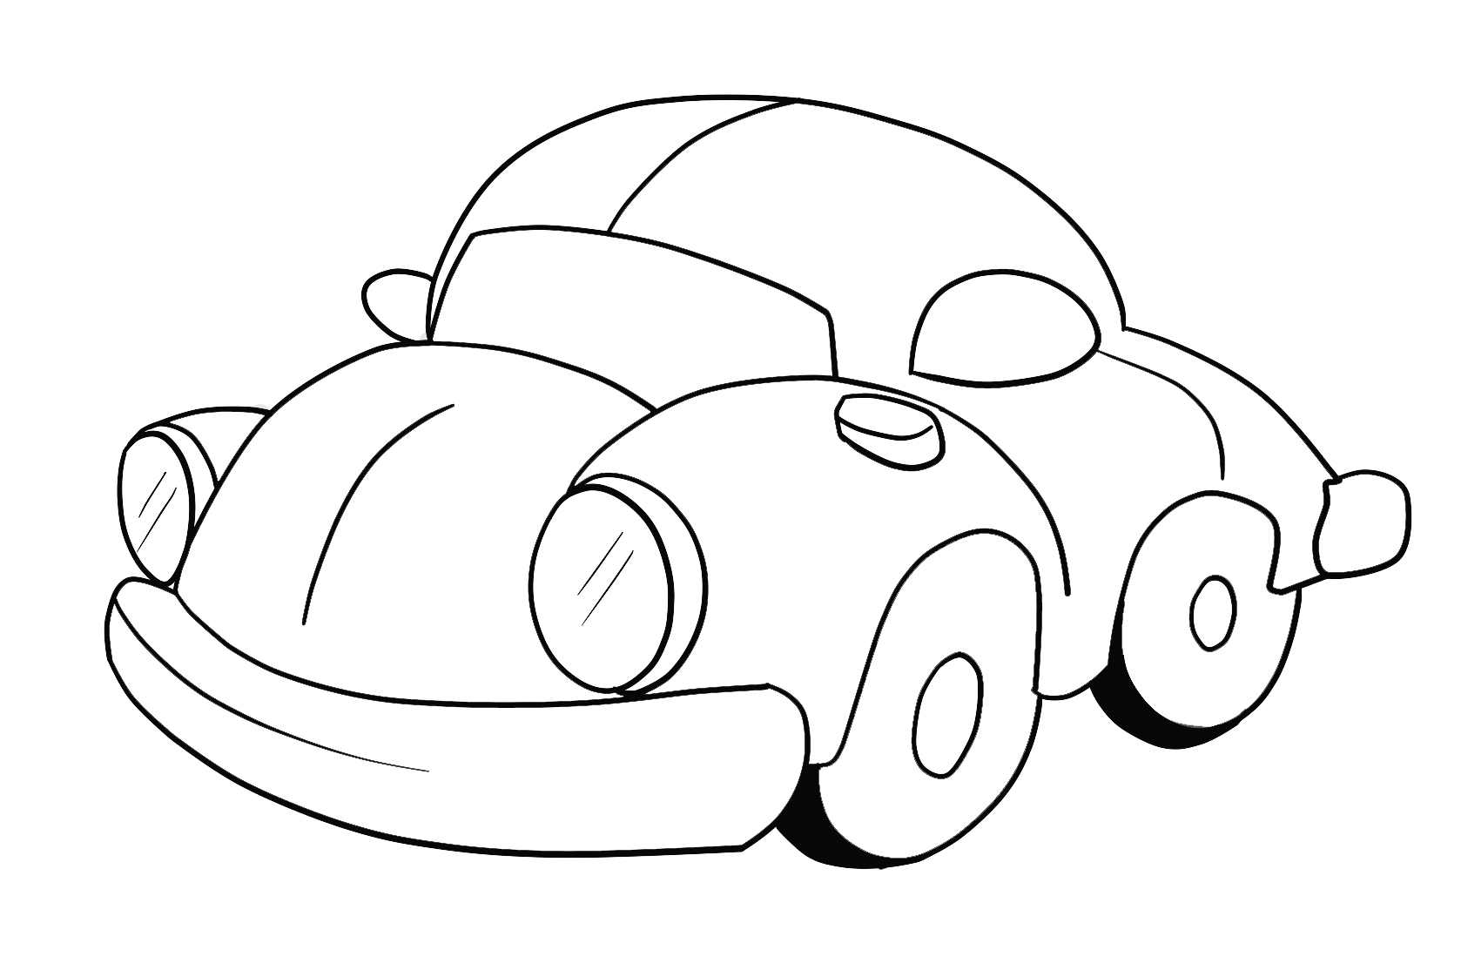  Listen ,point and repeat.Put up the My Room poster on the board. Point to the items (doll, kite,bike,car,plane,train).one at a time, and say the corresponding words.The pupils repeat, chorally and individually.Point to each item in random order.Ask individual pupils to say the word.  Audio script  Doll, kite, car, bike, plane, train.  Draw.Colour.Point and say.  Refer the pupils to the pictures and elicit the items.Explain the activity the pupils draw and colour the pictures.Allow the pupils some time to complete the activity.Then,the pupils point to the items and present them.  For weaker classes. The pupils can simply point to the items and name their colour.  Suggested answer key.  (I`ve got a doll.)It`s yellow.  (I`ve got a train.)It`s blue.  (I`ve got a kite.)It`s green.  Sing the My toys song!  Point to the doll and the bike and say. I`ve got a doll, and I`ve got a bike!  I`ve got a doll,  I`ve got a bike!  I`ve got a doll,  And I`ve got a kite!  I`ve got lots and lots of toys,  Come and play with me!  I`ve got a car,  I`ve got a plane!  I`ve got a car,  And I`ve got a train!  I`ve got lots and lots of toys,  Come and play with me!  Let`s listen!  Set the scene by asking the pupils questions about what they can see in the pictures.  Teacher: Look at Lily`s room! What colour is Lily`s bed?  Class: Pink.  Teacher: Lily`s got a lot of toys! What`s this?  Class: A doll etc.  Audioscript  - Lily: Look at my room Andy! Andy: Wow!  - Lily: I`ve got a lot of toys.  - Lily: I`ve got a doll and I`ve got a car!  - Lily: And look! I`ve got a pink bike too! |  | Track 32 CD1  Track 32 CD1  Track 35 CD1  Track 35 CD1  Track 36 CD1
End  10 minutes | Put the My room poster on the board.Invite pupil to come to the front of the classroom.Ask him\her: What have you got? Encourage him\her to point to on item on the poster and answer .e.g: I`ve got a (bike).Repeat with as many pupils as you think is necessary.  - Giving home task  Do page 37 from the Activity Book  - Assessment  Marking with smiles.  The lesson is over. Goodbye!
Additional information
Differentiation | Assessment: |  | Cross-curricular links.  ICT links  Values links
More support  Create mixed ability groups | Ask some pupils to take out their story cutouts.Ask them to shuffle them. Play the dialogue with pauses.  Select a short exchange from the dialogue for the pupils to act out in pairs. |  | Communicative skills
Reflection:
Reflection Were the lesson objectives/learning objectives realistic? What did the learners learn today? What was the learning atmosphere like? Did my planned differentiation work well? Did I stick to timings? What changes did I make from my plan and why?

Summary evaluation
What two things went really well (consider both teaching and learning)?
1:
What two things would have improved the lesson (consider both teaching and learning)?
1:
What have I learned from this lesson about the class or individuals that will inform my next lesson?

