Demonstration lesson
Предмет: Английский язык
Тема урока : «Celebrities»
Цели урока:
Образовательная: to teach students to speak and read on the tasks of the lesson; to extend and consolidate vocabulary on the theme " Celebrities "; to develop pupils’ speaking, listening and reading skills;
Воспитательная: to encourage students to express their thoughts and ideas, to teach them to work in groups and individually, to keep their attention and activity;
Развивающая: to develop students’ speaking, reading and listening skills based on the theme of the lesson, to develop their logical thinking.
Наглядные пособия: карточки, картинки, фото.
ТСО: проектор, компьютер, интерактивная доска.

The plan of the lesson

I. Organization moment.
II. Brainstorming.
III. Main part.
1. Textstudy Сelebrity Profile # 28
2. My favourite celebrity (checking up homework)
3. Grammar Degrees of comparison of adjectives
- Studying the tables
- Practice SB Ex 6 p 91 Form the superlative form
- Look at the photos and compare (using the slides)
- Compare your friends in the group
IV. Consolidation of the lesson. Playing the game “Clever Heads”
V. Conclusion. Giving feedback and assessment.

Procedure of the lesson

I. Organization moment. Greeting. Getting ready for the lesson. (2 min)
II. Brainstorming. (3 min)
Look at the blackboard. Do you know these people? Who are they?
(Pictures of Alegrova, Leps, Khabensky, Arngolts, Bondarchuk, Kurnikova, Vodyanova, Yagudin, Rymbayeva and cards with words actor, actress, singer, film director, tennis player, musician, model, athlete are on the blackboard) E.g. Pugacheva is a Russian singer.








Announcement of aims and plan of the lesson
Today we are going to speak and read about celebrities, we’ll listen to your stories about your favourite celebrities, we’ll revise Degrees of comparison of adjectives and do some tasks, and at last we’ll play the game ‘Clever Birds’.
III. Main part.
1. Textstudy Сelebrity Profile # 28 (10 min)
- Translate into Russian
- We all know Katniss Everdeen in the Hunger Games but who is the actress who plays Katniss, Jennifer Lawrence?
- Fast Facts
- Did you know? Jennifer has never had acting classes.
- Reading and translation the text (using the cards or interactive board)

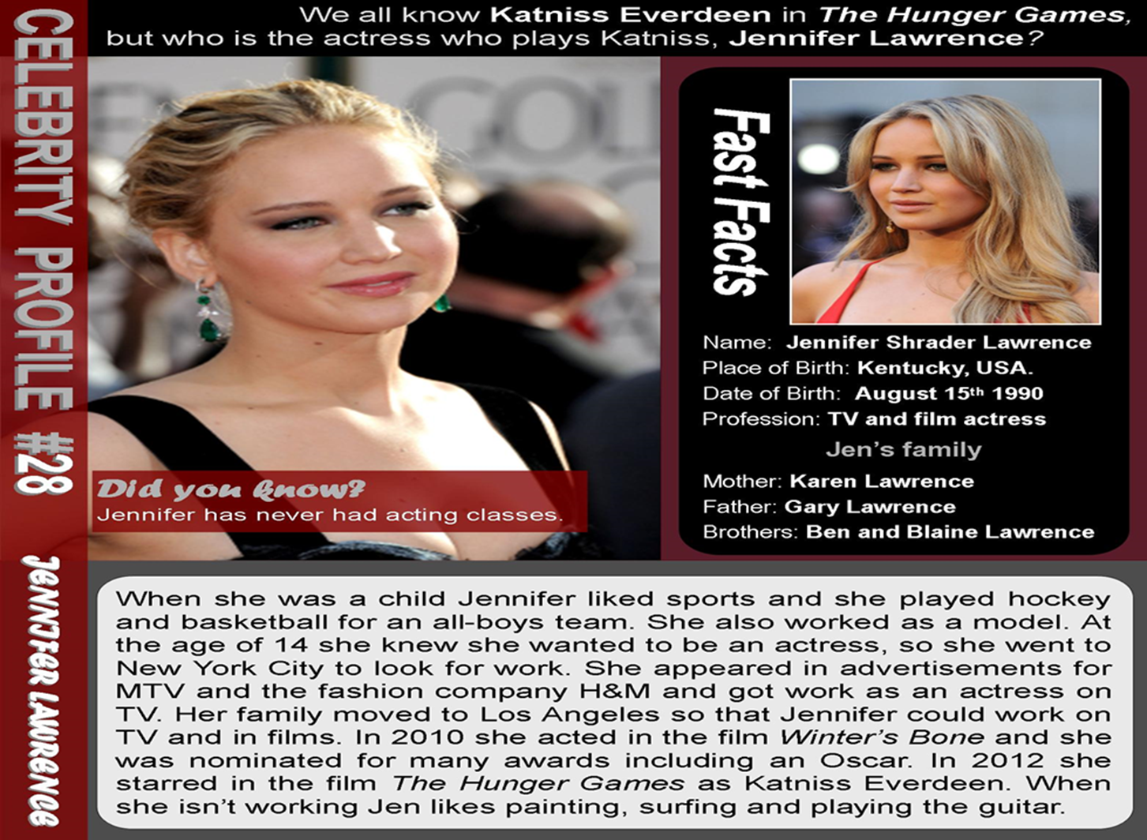
1. Check your understanding: ordering.
Write a number (1-7) to put these sentences about Jennifer Lawrence’s life in the correct order.
…………. She moved to Los Angeles.
…………. She moved to New York.
…………. She appeared on TV for the first time.
…………. At school she played basketball for a boys’ team.
…………. She was nominated for an Oscar.
…………. Jennifer was born in Kentucky.
…………. She played Katniss Everdeen in The Hunger Games.
2. Choose the right answer.
1. What sports did Jennifer play at school?

a. basketball
b. surfing
c. hockey
d. tennis

2. What films has Jennifer Lawrence starred in?

a. Titanic
b. Transformers
c. Winter's Bone
d. The Hunger Games

3. What cities has she lived in?

a. London
b. Los Angeles
c. Miami
d. New York
4. What jobs has she done?

a. actress
b. model
c. fashion designer
d. waitress

5. What does Jennifer do in her free time?

a. play hockey
b. painting
c. surfing
d. play the guitar

6. What are her two brothers called?

a. Karen
b. Ben
c. Gary
d. Blaine

2. My favourite celebrity (checking up homework) (10 min)
- Diana Princess
- Pushkin A.S.
- Gomez Selena
- Depp Johnny

- Christie Agatha
- Shakira
- Lee Bruce
- Jolie Angelina
- Spears Britney

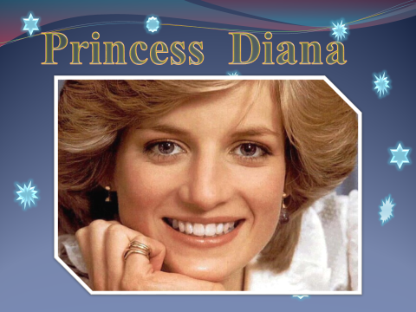

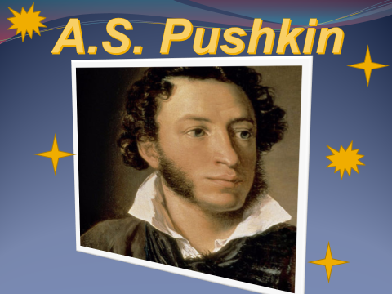


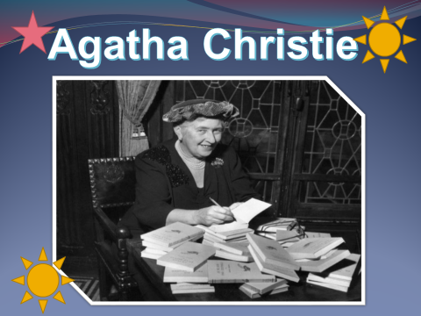

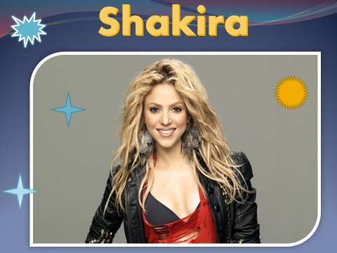

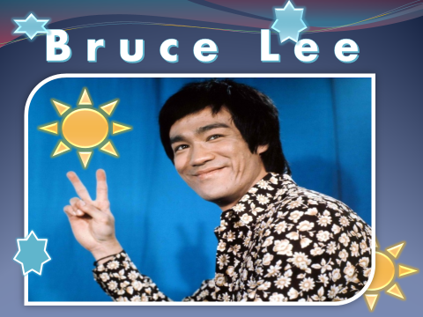
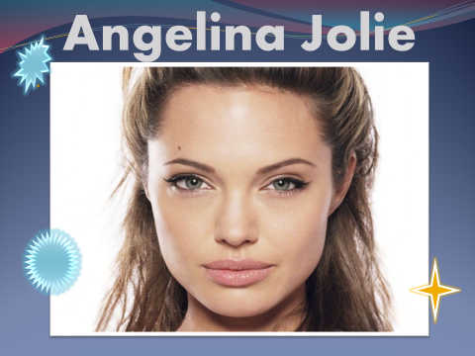

3. Grammar Degrees of comparison of adjectives (10 min)
- Studying the tables (using the slides)

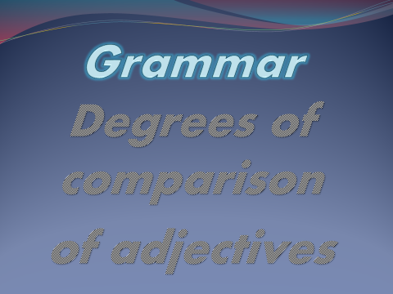
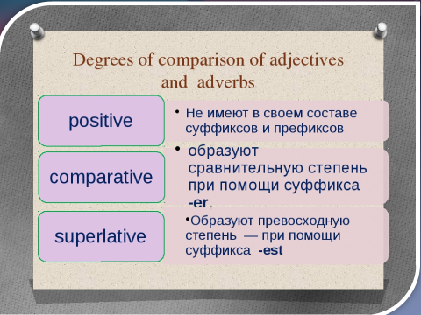
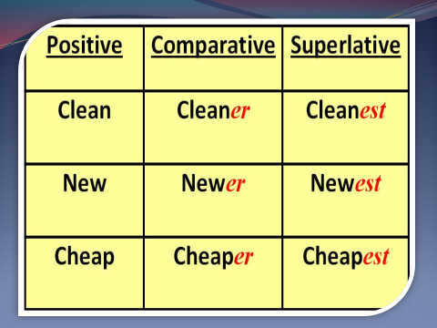
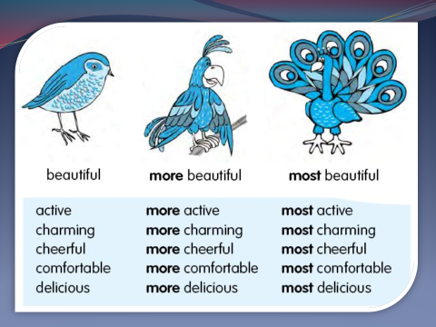

- Practice SB Ex 6 p 91 Form the superlative form
- Look at the photos and compare (using the slides)







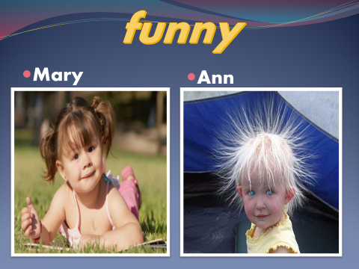
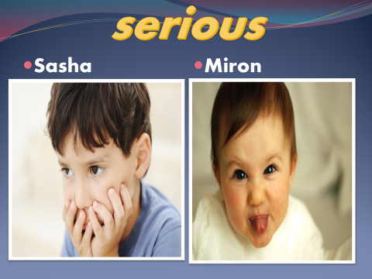
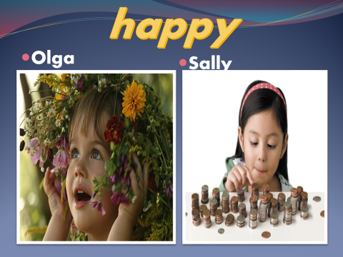

- Who is more popular? Who is the most popular, in your opinion?
- Who is more talented? Who is the most talented, in your opinion?
- Who is younger?
- Who is more handsome? Who is the most handsome, in your opinion?
- Who is more beautiful? Who is the most beautiful, in your opinion?
- Who is funnier? Who is the funniest, in your opinion?
- Who is more serious? Who is the most serious, in your opinion?
- Who is happier? Who is the happiest, in your opinion?
- Compare your friends in the group
- Who is the most serious boy / girl in your group?
- Who is the funniest boy / girl in your group?
- Who is the cleverest boy / girl in your group?
IV. Consolidation of the lesson. Playing the game “Clever Heads” (10 min)

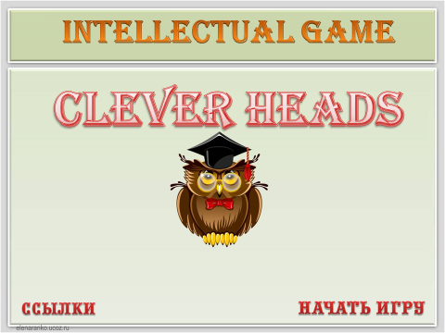
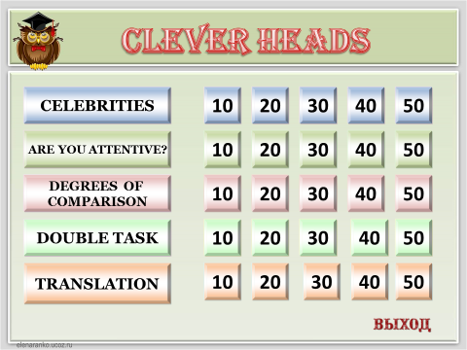

V. Conclusion. Giving feedback and assessment.

