Школа-гимназия

Городской семинар
Урок развития речи

Strong in spirit
(about Stephen Hawking)

(экспериментальный 5 а класс, по учебнику “Messages 1”)

Подготовила: Джулдасбаева С.А.
учитель английского языка

2014 год, февраль

Урок развития речи по английскому языку

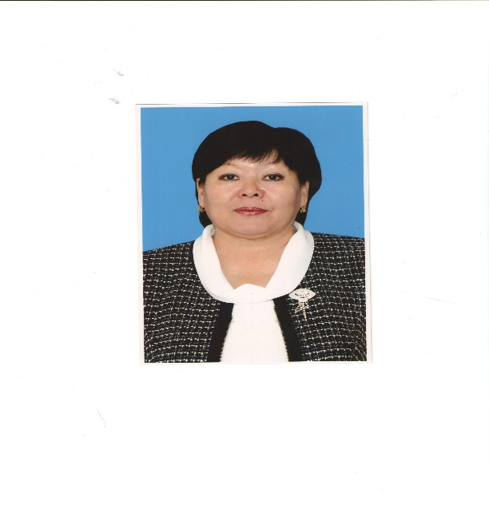
« STRONG IN SPIRIT » (about Stephen Hawking)

Джулдасбаева Сара Адамбаевна
Жанаозенская школа-гимназия
г. Жанаозен
Мангистауская область

Цель урока: образовательные: формирование навыков монологической и
диалогической речи, аудирование, чтение;

воспитательные: воспитать у учащихся чувство доброты,
сострадания, ответственности, бережное отношение к себе и
к окружающим;

развивающие: развить мышление, темп, умение выразить
свои идеи, мысли, пополнить лексический запас, расширить
кругозор учащихся.

Оборудование: Интерактивная доска, компьютер, слайды, картинки,
фотографии, плакаты, музыка, маркеры

Тип урока: урок развития речи

Ход урока

1. Организационный момент

Teacher: Good afternoon, boys and girls! I am glad to see you.
Today we’ll have very unusual lesson. We are going to speak and discuss about different people. Each of them has his own personal qualities of character. And each of you have your own personal character. First look at this slogan:
“However difficult life may seem, there is always something you can do and succeed at.”

Teacher: What does it mean? Do you understand it? OK! I see that it is very difficult for you to understand. At the end of our lesson we’ll return to this slogan.
Let’s continue our lesson, boys and girls, and divide us into two groups (the 1-st and the 2-nd). Look at this photo! (учитель на доску вывешивает портрет Стивена Хокинга)

- Do you know him?
- Who is he?
- What is he?
- What is his name? (пауза)
Well, pupils let’s look other his photos (играет музыка и учащиеся просматривают слайды о Стивене Хокинге, всего 23 слайда)
[Привлеките внимание читателя с помощью яркой цитаты из документа или используйте это место, чтобы выделить ключевой момент. Чтобы поместить это текстовое поле в любой части страницы, просто перетащите его.]

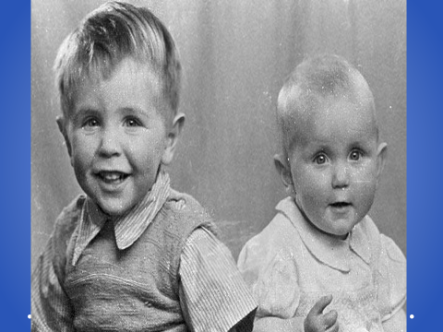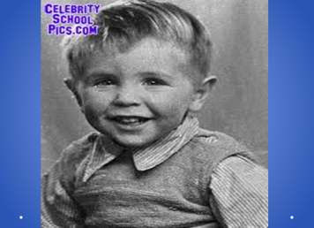
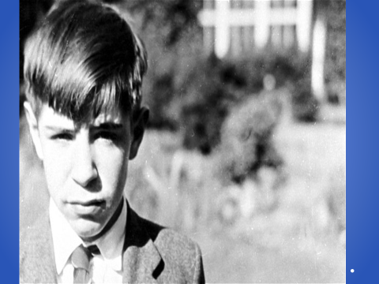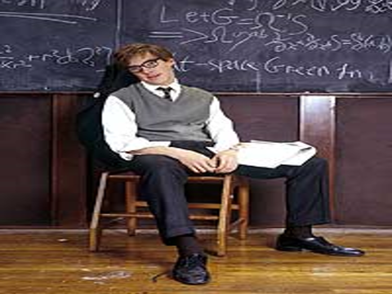
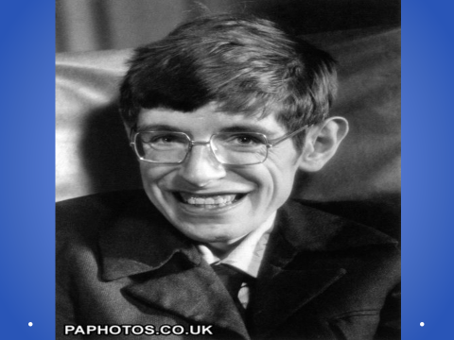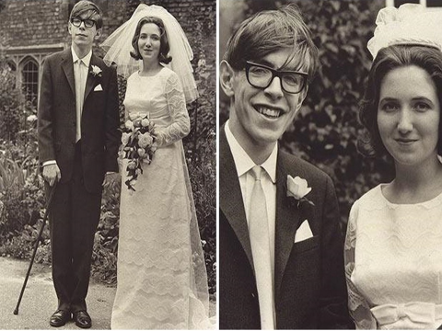

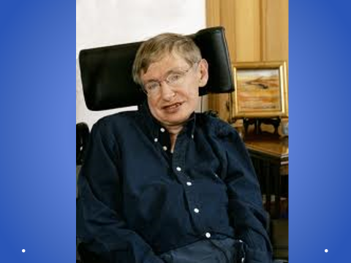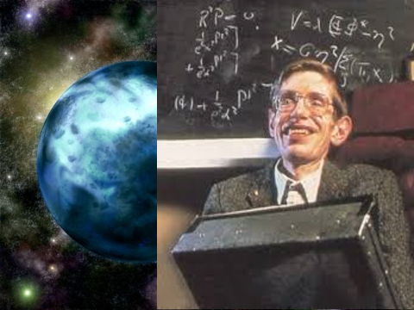

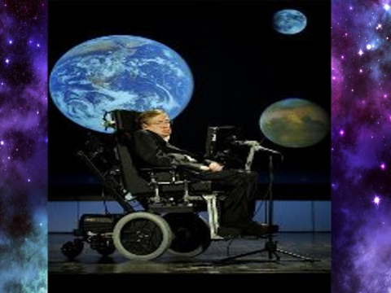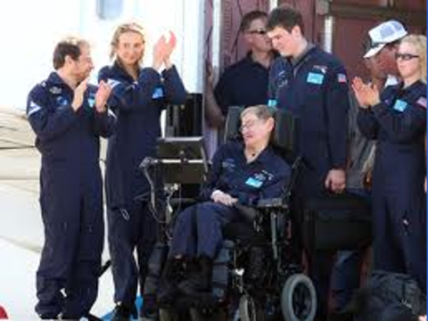

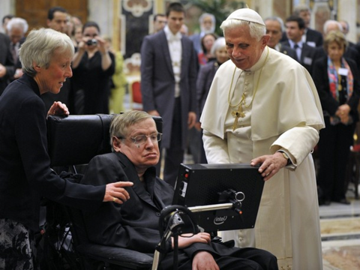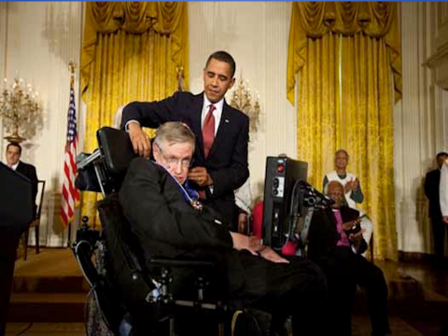
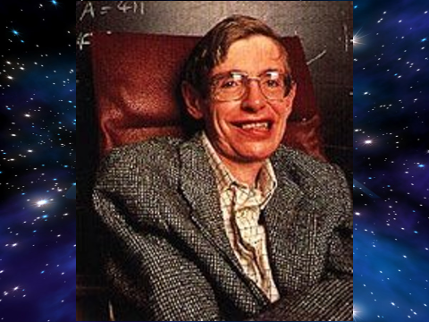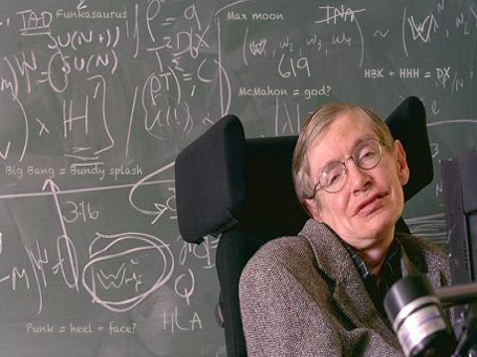

Before reading the text look at the active board I’ll give you new words listen and repeat after me.
New words:
scientist [saiәntist] – учёный (ғалым)
be married [bi:mærid] – быть женатым (үйленген)
ambitious [æmʹbiʃәs] – честолюбивый (атаққұмар)
determined [ditɜ:mind] – решительный (батыл)
dictate [dikteit] – диктовать (айтып отыру)
a secretary [sekritәri] – секретарь (хатшы)
an author [ʹɔ :Өә(r)] – автор (автор)
cosmic [ʹkozmik] – космический (ғарыштық)
mystery [ʹmistәri] – тайна (құпия)

neuromuscular disease [njuʹroʹmʌsk julә dizi:z] – невромышечная болезнь (жүйке бұлшық ет ауруы)
a nurse [nә:s] – медсестра (медбике)
сommunicate [kәʹmju:nikeit] – сообщать, передавать (қарым - қатынас жасау)
a wheelchair [wi:ltʃeә] – кресло на колёсах (мүгедектерге арналған арба)
portable [ʹpo:tәbl] – передвижной (қозғалмалы, жинақталатын)
universe [ju:nivɜ:s] – вселенная (әлем, ғарыш)
Let’s read the text about Stephen Hawking (учащиеся читают по одному предложению вслух)
Stephen Hawking is a famous British scientist. He is often on TV and in magazines. He lives in Cambridge. He is married and has got three children. You can sometimes see him in the streets and shops of Cambridge. He loves shopping
especially buying clothes for his daughter. Stephen Hawking is an ambitious and determined man. He can’t write so he dictates his ideas to a secretary. He is the author of a best-selling book called A Brief History of Time . It is about the
beginning of the world and other cosmic mysteries. Stephen has got a neuromuscular disease he can’t move and he can’t talk. A nurse helps him to dress, eat and wash. She is with him 24 hours a day. He can communicate with a special computer. He uses this computer to teach at the University of Cambridge, where he is a professor of mathematics. He has got a special wheelchair with a portable computer.
Answering the questions.(P1-P2, P3- P4,P5 – P6,P7 -…..).
(каждая из команд поочередно задает вопрос другому
The 1 st team –Where does Stephen Hawking come from?
The 2 nd team-Great Britain, Cambridge.
-Why can’t he move or talk? (2)
-He has got a neuromuscular disease. (1)
-Why has he got a nurse? (1)
-He can’t move and talk. (2)

-What does he use to communicate? (2)
-Computer (1)

-What does he teach? (1)

-Mathematics. (2)
-How does he write his books? (2)
-He dictates to a secretary. (1)
T: So boys and girls let’s conclude and describe him (учитель вывешивает на доску фото Стивена Х, ученикам раздаются листочки, где они пишут его характерные качества, читают вслух и прикрепляют магнитом у портрета)
What kind of person is he ?


( good, hard-working,kind,strong,determined,sad,ambitious,happy,friendly,…)
T.: Yes, you are right pupils. Stephen Hawking has a lot of good qualities of character.
Now let’s look other pictures ( играет музыка, учащиеся просматривают слайды,(всего 13 слайдов) где изображены бездомные молодые и здоровые люди не имеющие семьи, работы , интереса к жизни , ведут вольный образ жизни)


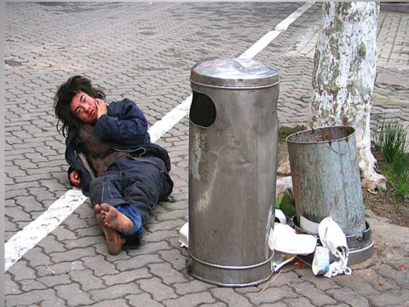
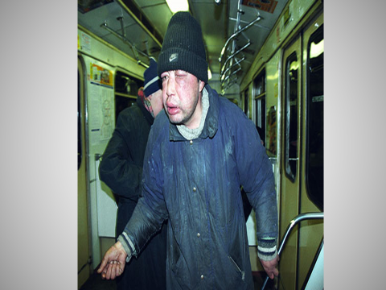
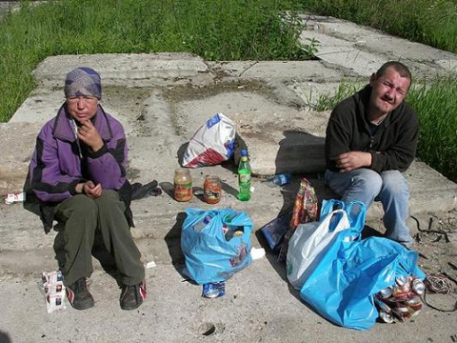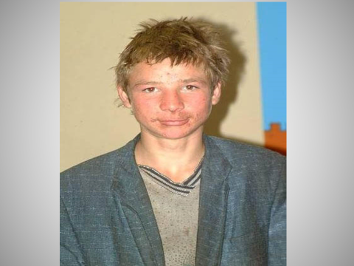

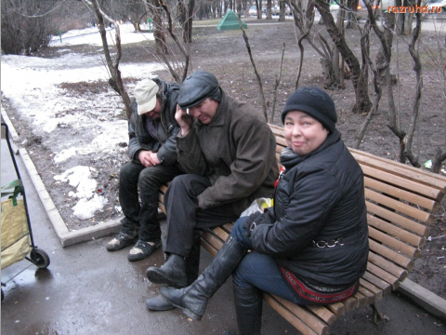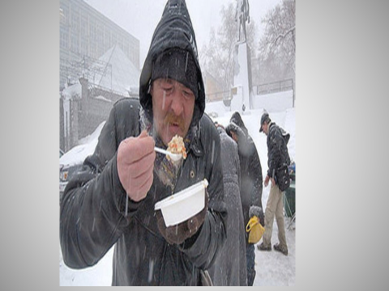

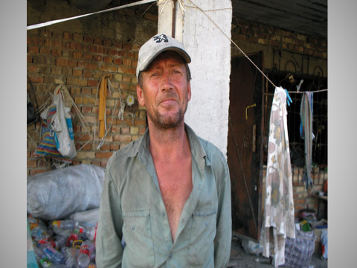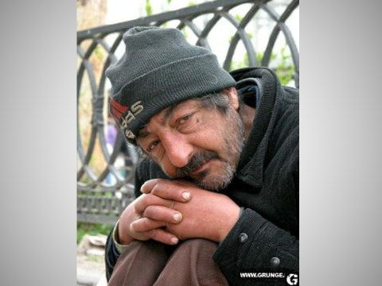

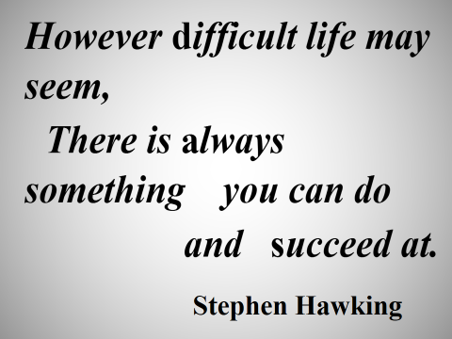

T.: What can you say about them? What are the slides about ?
P1 –They all are young people.
P2- unhappy
P3- homeless
P4- They haven’t got their own family
P5-They do not work
P6- The slides are about the homeless people
T : Unfortunately it’s true. They all are young people. They can work, move, do something, but they don’t do it. You can meet them everywhere, in the street, in the park, in the underground. These people haven’t got any future.

Well, boys and girls let’s return to our slogan “However difficult life may seem, there is always something you can do and succeed at”. Stephen Hawking is a determined man, scientist, professor, a kind father, a good husband. He is a strong in spirit man, and successful person.

Writing a letter.
T.: Dear my friends, at the end of our lesson let’s write a letter to Stephen Hawking. I hope that he will be happy when he receives your letter. Write him your wishes. ( играет музыка, детям раздаются разноцветные стикеры, где

они пишут свои пожелания Стивену Хокингу и прикрепляют на ватман «A letter to Stephen Hawking.)
T.: So boys and girls, thank you for your preparation and your activity at the lesson. Our lesson is over, you may be free. Good bye !

