№11 secondary school

Open lesson

Theme: «Seasons»

Done by: Khodzhaeva A.
Checked by: Sherniyazova S.
Aktau-2016 year.

Date: 21.04.2016
Form:3 «A»
Theme: «Seasons »
The aim of the lesson: 1. Оқушыларды fr қосарланған әріптерінің оқылу
ережесімен таныстыру .
2 . And және but шылауларымен таныстыру
3. Шапшаң болуға, жүйелі сөйлеуге, сөздерді дұрыс
жеткізе білуге тәрбиелеу.
4.Сабақ тақырыбы бойынша сөйлеу білігін дамыту
«Seasons » әнін жаттау
Visual aids: interactive board, pictures
Plan of the lesson:
1. Organization moment
2. Checking up the homework
3. Phonetic drill
4. To explain the new theme
5. New words
6. Physical exercise
7. Doing exercises
8. Homework
9. Marking
10. Conclusion

1. Organization moment
-Good morning pupils!
-How are you today?
-Very well thank you, sit down!
-Who is on duty today?
- What date is it today?
-Children, what day is it today?
- Who is absent?
-Good, boys and girls. Let’s begin our lesson.
2. Checking up the homework
-Children, let’s check up your home task.
-What was your home task for today?
-Who is ready?
-Who wants?
-Are you ready?
-Your home task was to learn by heart new words, yes?
Weather,sunny,rain,windy,cloudy,snow,cool,cold,warm,hot.



3. Phonetic exercise
-Now pupils today we have a new phonetic-drill.
The diphthong fr give the sound [fr].
fr [fr]
frog fruit
Frisbee fridge
Friday free
Friend fruit salad

-At first I`ll read, you’ll then repeat after me all together.
4. To explain the new theme
-Today we have a new theme about «Seasons »
How many seasons do you know? What is your favourite season/ why?
There are 4 seasons in a year. They are: spring, summer, autumn, winter.
1. It is spring now. March, April and May are spring months. It is cool or warm in spring. The weather is fine. You can see flowers in the fields.
2. It is summer. June, July, August are summer months. It is hot in summer. The weather is fine. The days are long and the nights are short. The fields and trees are green. There are many flowers in the fields.
3. It is autumn. September, October, November are autumn months. It is cool in autumn. The weather is bad. It usually rains in autumn. The trees are yellow and red. You can see apples on the apple trees.
4. It is winter. December, January and February are winter months. The weather is cold in winter. It snows in winter. The days are short and nights are long. The streets, the trees and the fields are white with snow.

Remember
The weather is warm and sunny 

I like playing football,but it’s raining now.


5. New words
Nowpupils open your vocabulary and write down new words
season -[si:zn] – маусым
spring -[ spriŋ]– көктем
summer- [ sʌmə] – жаз
autumn -[ͻ:təm] – күз
winter -[wintə] – қыс
frog-[frᴐg] –бақа
frisbee-[‘frisbi]-ұшатын тәрелке
friend-[frend]-дос
fruit-[fru:t]-жеміс-жидек
free-[fri:i]-бос

6. Doing exercises
-Let’s doing exercises. Open your books at p.121 ex.4 Write:and/but
1. The weather is hot sunny.
2. I like flying a kite, it is not windy.
3. The weather is cool cloudy.
4. She likes snowboarding, it is not snowy.
5. The weather is cloudy windy.
6. He likes riding his bike, it is raining now.
7. The weather is cool, sunny.
8. He likes swimming, it is cold today
Ex:5 Listen and sing. Seasons
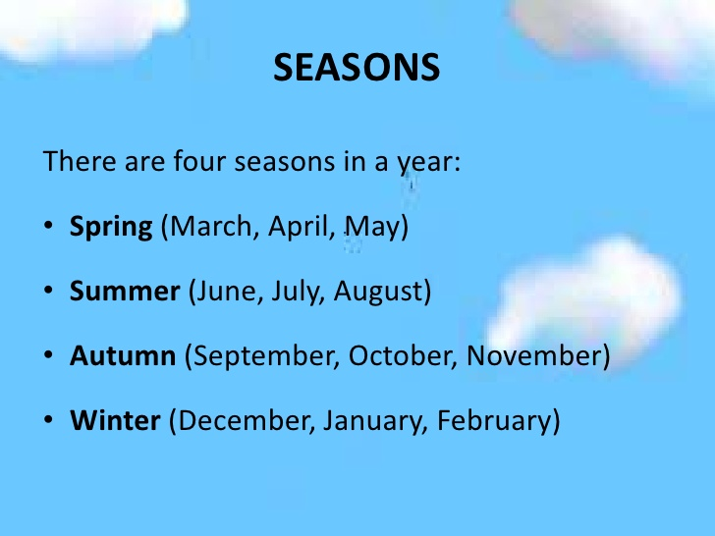
7. Physical exercise
-Let’s doing physical exercise.
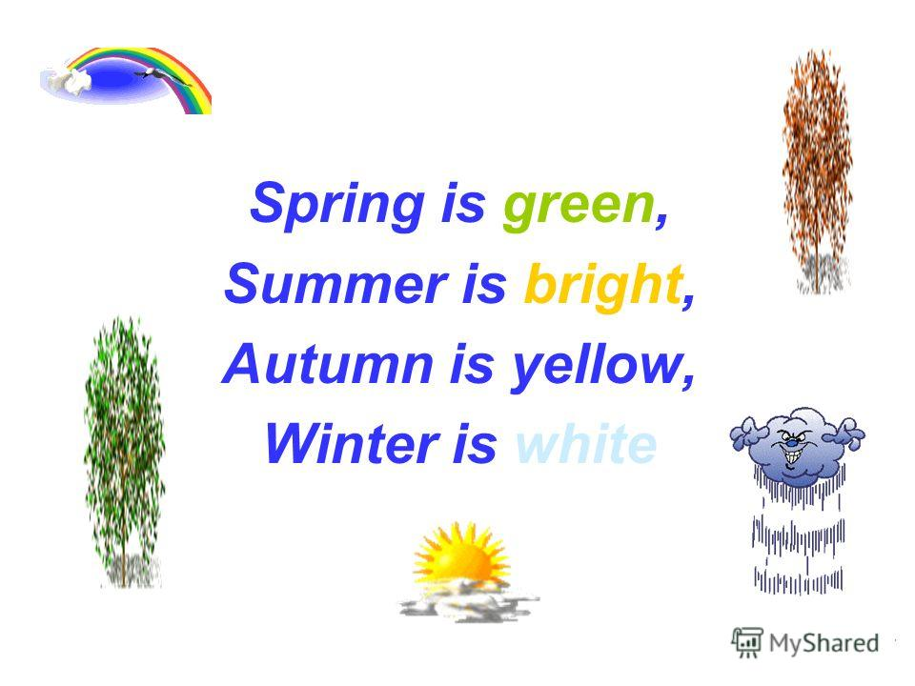
Crossword
S | E | A | S | O | N | S
U | C | U | P | W | C | U
M | O | T | R | I | O | N
M | L | U | I | N | O | N
E | D | M | N | T | L | Y
R | G | N | G | E | S | F
S | R | W | R | R | T | O
N | E | I | A | W | O | G
O | E | N | I | A | R | G
W | N | D | N | R | M | Y
Y | C | Y | Y | M | Y | A

8. Homework
-Now pupils take your home task for the next lesson
- Your homework is to learn by heart the new words.
-Ex; 6 p.123
9. Marking
-Your marks are : -excellent
-good
-satisfactory
10. Conclusion
-Now pupils, do you understand today`s our new theme?
- So, children, what do you do today at the lesson?
-Stand up
-The lesson is over
-Good bye
-You are free.

