Date:The 25 of December.
Day: Friday.
From:2 v.
The Theme of the lesson: Do you help your mum?
The aim of the lesson: 1.оa қосарланған дәріптерінің оқылу ережесімен
танысу.
2. Тыңдау және оқу дағдысын жетілдіру.
3. Оқушыларды Present Simple және сұраулы сөйлем
түрі мен оларға қысқа жауап беру, I, you, we, they
есімдіктерімен таныстырады.
Visual aids: books, pictures, physical drill, cards, interactive board, poem the mum, play the game.

Plan of the lesson.
Welcome to our open English lesson!
Stand up children’s! Make a circle.
Рука –hand
Теплота – warmth
Раскрою – яhands
Подарю тебе warmth
И вместе с ним smile
Улыбнисьнегрусти
Open English lesson
Сgood afternoonначни.
Teacher: Good afternoon, children’s!
Children’s: Good afternoon, teacher!
Thank you, take you sit.

2. Marking absents.
- Who is on duty today?
- Who is absent today?
- What date is it today?
- What day is it today in the week?
- What season is it now?
- What month is it now?
- What is the weather like today?

Physical drill.
Head and shoulders,
Knees and toes
Knees and toes
Head and shoulders,
Knees and toes
Knees and toes
Eyes, ears, mouth and nose!

3. Main stage: at checking – up home task.
Now, I will check your home task last lesson to learn new words.
What was your home task for today? Who is study? Who wants say the first?
Watch TV – теледидар қарау
Do sport – спортпен шұғылдану
Help – көмектесу
Busy – қолы босамау
Get up – ұйқыдан тұру
Go to school – мектепке бару
Do homework – үй тапсырмасын орындау

Took – took –took
Open your book.
I will give mark 5 and 4.

4. Let’s begin our new theme: Do you help your mum?
Open your copybook write down date and day in the weekand today our new theme and diphthong.

OA




goat[ gout ] – ешкі road [ roud ] – жол




coat [‘kout ] – күртеше boat [‘bout ] – қайық




coal [‘koul ] – көмірloaf [ louf ] – бөлке нан


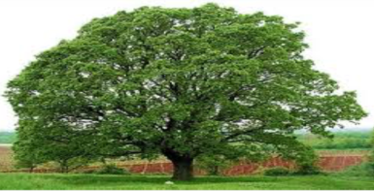

oak [ ouk ] – еменsoap [ soup ] – сабын

Look at the interactive board. Listen to me. Repeat after me new words.



Lazy – жалқау Walk the dog – итпен бірге серуендеу




Clean the room – бөлмені жинау Play with friends – достарымен ойнау

Remember
Есімдіктер I,you,we,they...
Do көмекші етістігі негізгі етістіктің алдында тұрады.Do- көмекші етістігі жәй осы шақта қолданылады. Қарапайым сөйлемді сұраулы немесе болымсыз сөйлемге айналдырған кезде қолданылады. Сұраулы сөйлемдер do көмекші етістігі арқылы жасалып, ол сөйлемнің басында қолданылады.
For example: Do you clean the room? - Yes, I do.
Do we walk the dog? - Yes, we do.
Do they play with friends? - No, they don’t.
Do we go to school every day?
We go to school every day.
We don’t go to school every day.

5.Doing exercises…
The first card
Play the game: “Hot potatoes”.
Hot, hot, hot potatoes
Potatoes to you friend
Hot, hot, hot potatoes
In you little hand.

Answer my questions.
- Do you clean your room? -Yes, I do.
- Do you help your mum? -Yes, I do.
- Do you walk your dog every day? -No, I don’t.
- Do you watch TV every day? -No, I don’t.

The second card
Read and translate the text.
This is Sam. He is a lazy boy.
I don’t get up early.
I don’t clean the room.
I watch TV and play with my friends every day.
Sam, can you help me, please?
No, mum. I am busy.
I don’t walk my dog.
But I go to school and do my homework.
Mum, can you help me, please?
No, I can’t. I am busy now.

The third card
Show and name the figures.

Circle – дөңгелек Triangle – үшбұрыш

Square – төртбұрышStar – жұлдыз

How many blue circles? - Four blue circles.
How many orange squares? - Three orange squares.
How many pink stars? - One pink star.
How many green triangles? - Two green triangles.

What is it? It is a figure.

The fourth card
Guess the numbers.
Совсем один ты бродишь там.Numbers
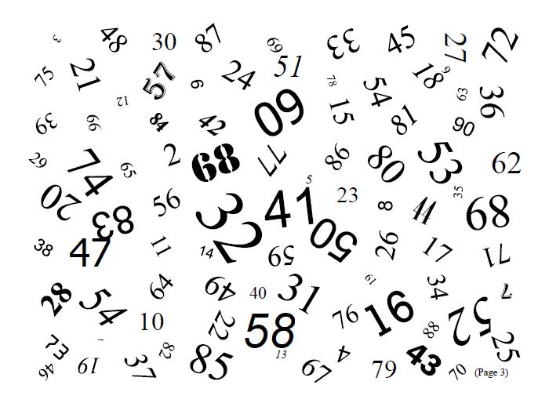
Одна, один – иначе one.
Две изюминки во рту.
Двойка по – английский – two.
Скорей иди сюда! Смотри:
У кошки три котенка – three.
У машины колесо
Их всего четыре – four.
Никогда не забывай
Что пятерка, это – five.
В примере неизвестен икс.
Шесть по – английский будет – six.
Молод я и зелен
Семь лет мне – значит seven.
Моей сестренке восемь лет
А восемь по – английский – eight.
Девять – ты запоминай
По – английский простаnine.
Уже пошел десятый день
Десять по – английский – ten.
- Thank you, children’s. Well done children’s.
Open you diary write down home task for today. Exercise 5.Read these new words.

6. Do you help your mum? - Yes, I do.

Poem the mum
Әрқашан күн сөнбесін
Аспаннан бұлт төнбесін
Қасымда болсын анам
Болайын менде аман.
Пусть всегда будет солнце
Пусть всегда будет небо
Пусть всегда будет мама
Пусть всегда буду я.
Let it always be sunshine
Let it always be blue sky
Let it always be mummy
Let it always be me.

7. Conclusion.
I hope you understand today’s lesson. How do you feel today?
I will give mark 5 and 4. See you next lesson. The lesson is over, good byechildren’s!

