Demonstrative lesson.
Mixed lesson.

Form: 2,3,4
Date: 23,01,2017
Duration: 45 min
The theme of the lesson: 2form: Clothes.3form: Weather. 4form: Astana

The aims of the lesson:
Objectives:
Educational
1. to be able to speak about the season, clothes, weather, colour, capital.To check up their knowledge on this theme
Practical aims
1. to develop pupils skill’s in listening,writing and speaking abilities
2. to check up the knowledge of lexic
Developing aims:
1. to improve students' motivation and participation
in classroom activities
2. to stimulate students' to a learning foreign language

Type of the lesson: unusuall lesson
Visual materials: cards, wallpapers, pictures

The procedure of the lesson.

Organization moment:
Greeting.
Teacher’s activity Pupils’ activity
- Good morning, children! - Good morning, good morning
- Goodmorning too you
- Good morning dear teacher
- We are glad to see you
-How are you?
- I’m very well, thank you! And you? - We are fine.
- Sit down, please
- Who is on duty today? - I’m on duty today.
- Who is absent? - All are present.
-What day is it today? -Today is…Monday
-What date is it today? - Today is the 23rd of January
Warm-up
2. Phonetic drill.
Spring is green
Summer is bright
Auturm is yellow
Winter is white

Beginning of the lesson:
Form2: Well, let’s begin our lesson. Today, we will revise our last material and speak about clothes.You must learn it by heart the new words at home.
Task 1:Look at these pictures, you must write the names of clothes: dress , sweater, trousers, shoes, hat ,jeans boots, skirt ,trainers, coat.
Form 3. Task 1: Look at the blackboard write the new words about the weather.
Weather- [‘weὸǝ]-ауа райы
Season- [‘si:zǝn]-жыл мезгілі
Hot- [hɔt]-ыстық
Cold- [kәuld] -салқын
Sunny- [sɅni]-шуақты
Windy- [windi]-желді
Rainy- [reini]-жаңбырлы
Cloudy- [ klaudi]-бұлтты
Snowy- [snǝui]-қарлы
Foggy- [fɔgi] -тұманды

Form 4. New lesson: comparative adjectives.We use the word “more” –(күрделі сын есім)
New words: difficult - [‘difik(ǝ)lt]- қиын
modern -[‘mɔdǝn]-жаңа
exciting - [ik’saitiƞ]-әсерлі
popular - [‘pɔpju:lǝ]-әйгілі
wooden - [wudn]-ағаштан жасалған
industrial - [in’dᴧstriǝl]-өндірістік
eg: more difficult□
moremodern □
Task 1: complete the card.
adjective | Comparative form
interesting
 | more fantasticer
exciting
dangerous
 | more important
beautiful

Form 2. Now, children do we know names of clothes? Yes, this is …...
Answer my questions, what’s this? It is a dress.
What colour is dress? It is green .

Oh good job!
Task 2. Look at the pictures and make up sentences.
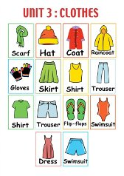eg: I’m wearing a hat.

Form 3.Now, children look at the blackboard, repeat after me new words.
All together and ones more.
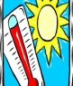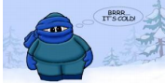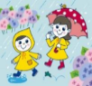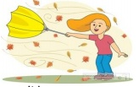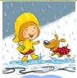
Task 2

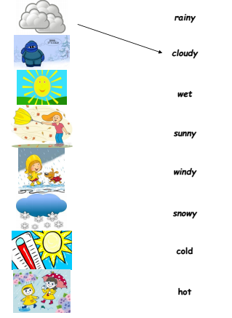

Form 4. .Now, children are you ready?.
Look at the book p. 76
I’ll read the text and I will translate it. History. Astana now and then.
Task 2.Answer the questions.
1.What does “Astana” mean in Kazakh?2.Which river is there in Astana?3.When did it become a town? 4.When did it get its name “Astana”?5.Is Astana an interesting place to visit now and why?
And find the comparative adjective in text.
Ex 5. p77 complete the sentences.
Form 2 and 3. Play game.
Form3 form 2
It’s rainytoday. I’m wearing araincoat.
It’s hot today . I’m wearing a hat.
………………… ………………………

Warm-up
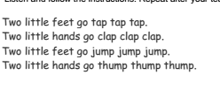
Form2. task3.
Match the words to the seasons.
umbrella, T-shirt, swimsuit, coat, sweater, scarf, sun hat, shorts
Summer Winter
_________ _________
_________ _________
_________ _________
_________ _________
_________ _________
_________ _________

Form. 3 Task 3

Form 4 Task 3
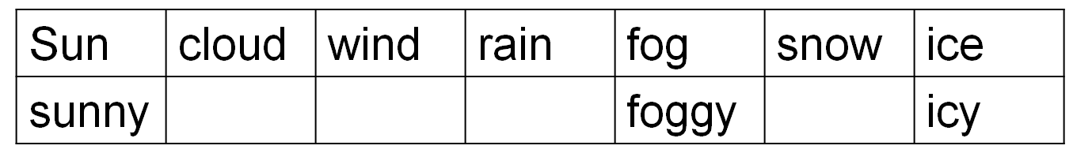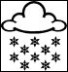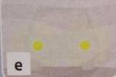

Hometask.
Form 2.Your hometask To learn by heart new words.
Form 3. Your hometask To learn by heart new words.
Form 4. Your hometask To learn by heart new words and ex 1.2 in the work book

Evaluation.
Today you’ve worked very hard, thank you for your participate.
Your marks for today…..

Conclusion:
The lesson is over . You me be free.
Good bye ,children. Good bye teacher!

Kirov secondary main school

