Theme : Animals.
Lesson’s plan for 7th grade
Aims and objectives: to revise new vocabulary on the topic of animals, to enrich the pupils’ knowledge with new facts, to improve the pupils English using useful words and expressions.
Visual aids: pictures with animals, cards with words.
Procedure of the lesson
1.Organization moment: a/Aims of the lesson
b/dialogue between pupils
c/checking home task
Our travell to the ZOO.
The I stop Phonetic drill:
We are off to the ZOO,
We are going to see the kangaroo
And feed the big brown bear.
II stop reading the text “About animals”.
III stop you prepared home task your riddles about animals,
IV stop Write and read
A wolf, a rabbit, a squirrel, a fox, a monkey, an elephant, a tiger, a rhino, a bear, a zebra, a giraffe.
V stop Work with groups:
Complete semantic maps with words:”a fox” and “a wolf”
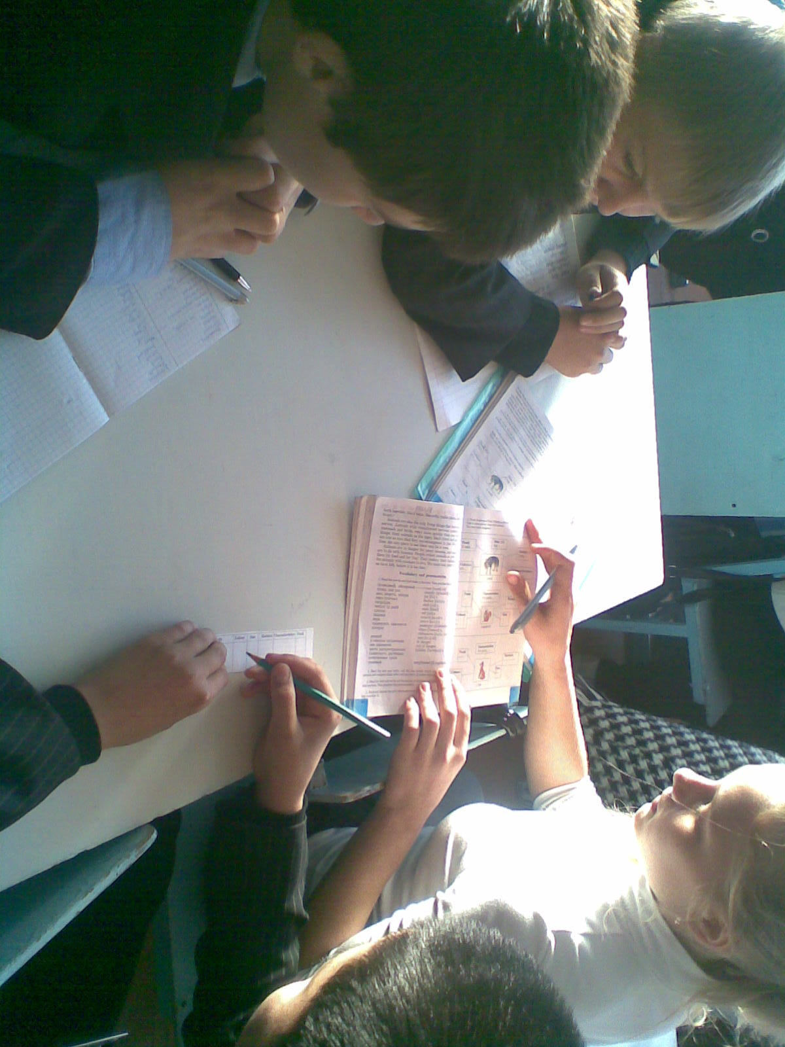
VI stop Grammar
Make the plural forms of these nouns:
Wolf- wolves
Rhino- rhinos
Tiger – tigers
Elephant – elephants
Fox- foxes
VII stop Our game: “Find the words about animals”
VIII Conclusion you worked actively today and we completed everything that was planned.
And say What did you learn today ?Thank you very much. Home task ex 4 p.57

