Тема урока: «Leisure Activities » Класс: 6 Дата: 14.03.17г.
6 «a» класс (5-й год обучения)
УМК – Rainbow English 6
Учитель: Круду А.П.
тип урока: комплексное применение знаний и способов деятельности.

Цель урока: Формирование коммуникативной компетенции (обобщение и систематизация знаний обучающихся по теме «Досуг».)
Задачи урока:
- Образовательные:
  - углубление и расширение знаний обучающихся по теме «Досуг», применение и изменение полученных знаний в практической деятельности;
  - активизация лексического материала по теме «Досуг»;
  - закрепление грамматических навыков (keen on/ fond of/ interested in);
  - формирование умения воспринимать на слух и понимать краткие сообщения.
- Развивающие:
  - развитие познавательного интереса у обучающихся, умения обобщать, анализировать полученную информацию, сравнивать;
  - развитие памяти, речи, логического мышления;
  - выполнение заданий творческого характера, требующих от обучающихся системного, исследовательского, нетрадиционного подхода к их решению.
- Воспитательные:
  - формирование лингвистической, тематической, социокультурной компетенции;
  - воспитание культуры общения учащихся средствами иностранного языка.
Ведущие технологии (развивающая):
- Обучение в сотрудничестве
- Диалогическое обучение
- Игровые
Оборудование: проектор.
Ожидаемый результат: ученики должны поделиться накопленными знаниями по теме «Досуг »; получить новые сведения; проверить уровень своих знаний в ходе выполнения различных заданий; развить навыки диалогического общения.
ХОД УРОКА
1. Организационный этап
Teacher: Good afternoon, boys and girls. I am glad to see you. By the way, I have got something. Look. What is this? Right, this is a chessboard. Can you play chess? When do you play chess or other board games? - When we have free time. (слайд 1)

II. Целевая установка и активизация лексических навыков говорения
На экране слайд, где представлено письмо, после чтения идет его обсуждение и обучающиеся должны определить тему урока.
Teacher: Today I have received a message from my friend Nick. He is too upset. He is waiting for his friends and he doesn't know what to do. He asks my advice. Can you help me to give the advice? (слайд2).
Hello my friend,
Today I'm feeling tired. I don't know what to do. Today is my birthday. We decided to go on a picnic with my friends. But it is raining. We can't go on a picnic we have to stay at home. I haven't any ideas what to do. Please write me what I can do at home with my friends.
With love,
Nick
What can you offer Nick to do? (слайд 3) Обучающиеся называют занятия, проводимые в свободное время.
Pupil: You can …
- listen to music/dance
- play computer games/surf the net/play board games
- read books/watch video/ do crosswords
- go camping/ go to the cinema/to the theatre
- play different sports game/ go cycling
- roller-skating/ skateboarding
Teacher: Thanks, we'll write to Nick when our lesson is over. What do you think we are going to speak about at our lesson? (слайд 4)
Pupil:
- We will speak about free time activities.
- We’ll compare Russian and British leisure activities.
- We’ll try to write about fantasy holiday
Teacher: By the way, can you give a synonym to the word pastime (развлечение, времяпрепровождение, времяпровождение, занятие)? There are many kinds of pastimes. We may call them free time, pastimes, hobby in English. (cлайд 5)What pastimes do you know? Надписи прочитать и перевести
Develop my mind and body/Meet friends/Help learn new information/Solve life problems
Help us be strong and healthy

III. Речевая разминка.
Teacher: What are Russian and British people keen on (увлекается)?
Pupil:
- What pastimes make us strong and healthy?
- What pastimes can develop your mind?
- What pastimes help you learn the information about people and countries?
- What activities help relax after school?
Teacher: You must have some time for rest, games and hobbies after work. Pastimes make our life more interesting. “Work done, have your fun”. It is a proverb. Can you translate it? (Ответ учащихся “Сделал дело – гуляй смело”) What other proverbs do we know?(слайд )
1. Work done, have your fun.
2. The most wasted day is that in which we did not laugh.
3. There is no time to lose.
4. Lost time is never found again.
(слайд 8)
- Сделал дело – гуляй смело.
- Напрасно потраченный день тот, в котором мы не смеялись.
- Нельзя терять ни минуты.
- Потраченного времени не вернешь.
Check yourselves.
Контроль. Match the English and Russian proverbs. The key:1-d,2-а,3-с,4-b (слайд 9)

IV. Проверка домашнего задания
Teacher: Your home task was to answer 2 questions. What do you do in your free time?
What are the popular pastimes in Russia?….
First let’s listen to Nick.
What is his/her favourite pastime?
The second is Victoria.
The 3rd person is Marina. На доске расчертить таблицу и заполнять по прослушанному сообщению
По картинкам, изображенным на слайдах, учащиеся рассказывают, как проводят досуг в России и о своих увлечениях.
Teacher: Listen attentively. Then you will tell, what are most popular Russian pastimes in winter and in summer?
Pupil: The Russians love reading. This hobby is very interesting and popular with people of different ages. It is useful and helps you to learn the information about people and countries. People can take the books from the library or have the library at home. Sometimes books can help us to solve the problems of life and to plan our life and time .They also like going to the cinema and the theatre.
Pupil: In winter Russian teen are keen on skiing, ice-skating and ice hockey is also popular. In summer, the Russians love gardening and playing different games. It is useful because you can develop your mind and body. And it is interesting because you can meet different people take part in competitions and make friends. Some people go in for swimming or running, others prefer different games. This hobby helps us to be strong and healthy.
Pupil: Russian people do a lot of things in their free time. On weekdays, they like reading and listening to music. At the weekends, they are fond of going to the cinema. They love watching films. Also they are keen on playing tennis or badminton. As for me, I also like……. . In summer, I am fond of hiking or walking in the forest with my friends.
Teacher: What are the Russian favourite pastimes?
Pupil: THE RUSSIAN (cлайд 11)
Russian people like 1) reading books. Many of them prefer 2) going on picnics and spend their weekends in the country. They also like 3) hockey, 4)football, 5) tennis .These sports and games are very popular in Russia. 6) Gardening is the most common hobby. The Russian spend much time 7) watching TV and 8) playing computer games/surfing the net.
Teacher: Well done, thanks.

V. Развитие навыков аудирования
Teacher: How do you British people spend their free time? We will watch the video. Get ready to answer: What is the 1st, the 2nd,the 3^{rd,} the 4th popular pastime in Britain?
На экране слайды……. (Видеосюжет об увлечениях подростков в Британии. После просмотра видеосюжета идет его обсуждение и выполнение заданий.)
Контроль. What are the British favourite pastimes? (cлайд 11)
Pupil:
the 1stpopular pastime in Britain is……………..
The 2nd popular pastime in Britain is………………….
the 3rd popular pastime in Britain is………………….
the 4th popular pastime in Britain is………………..
Some people prefer….. ………………..
……………..is one of the most popular hobbies, especially among young people.
…………. is the main leisure activity.
People spend much time …………….
Many people in Britain go…………..
Football is the national sport in Britain.
… is also a popular pastime.

Teacher: Let’s compeer Russian and British (сравнение увлечений).
- What are most popular hobbies?
- What hobbies are similar?
- What hobbies are different?

VI. Физминутка. Let’ have a rest! Stand up!
Whether the weather is hot
Whether the weather is not
We‘ll weather the weather
Whatever the weather
Whether we like it or not.
Teacher: What can we do if the weather is bad(cлайд 12)/good(cлайд 13)
Pupil: If it rains, I will play chess at home.
If it snows, I will make a snowman.
If it foggy and wet, I will stay at home and read a book.
Teacher: What will you do if it is warm and sunny in summer/in spring/ in winter?
Teacher: What do you usually do if you are happy/sad/tired?

Use:
stay at home
like to be alone
draw funny pictures
have a cup of tea
eat tasty things
cry
shout
go to bed
read a book/magazine/newspaper/
listen to music
listen to a walkman
play jokes
arrange a party
have a picnic
play the piano/the guitar
dance
go to the disco
play football/tennis/computer games
play scrabble/chess/draughts/monopoly/lotto/
play with my pet
talk with my friends
solve puzzles
do crosswords
take part in interesting activities/sport competitions

VII. Грамматика
Письмо. Test. Fill in Present Simple or Future Simple. (слайд 14)
- If it ( to rain), I (not to play) tennis on Friday.
- If it (to snow), Tom ( to go skateboarding) to the mountains .
- If it (to be)stormy, we (not to visit) our Granny next weekend.
- John (to see) the Statue of Liberty when he (to arrive) in New York.
- My father (to work) in his garage until he (to get) tired. Check yourselves.
The key:(слайд15)1 rains, don’t play ,2 snows, will go , 3 is, will not visit, 4 will see, arrives, 5 will work, gets
VIII. Reading dialogues
Teacher: When the weather is good we spend our free time outdoors and when the weather is bad we stay at home. (Сопровождается слайдом) по 2 человека из команды.
Teacher: Are you an outdoor or indoor person? Complete the dialogue.
Dialodue 1
A: I ’m bored. I don’t know what to do in my free time.
B: Really? There are so many interesting things you can do.
A: Yes, but I ’m not an outdoor person. I like to stay at home in my free time.
B: Then you can ...
A: It’s not a bad idea. I’ll think about it. What other hobbies can I start?
B: Well, ...
A : Thank you very much. I’ll think about ...
Dialodue 2
A: I ’m bored. I don’t know what to do in my free time.
B: Really? There are so many interesting things you can do.
A: Yes, but I ’m not an indoor person. I like to ……………in my free time.
B: Then you can ...
A: It’s not a bad idea. I’ll think about it. What other hobbies can I start?
B: Well, ...
A : Thank you very much. I’ll think about ...

IX. Обобщение и систематизация изученного материала
Teacher: Look at the list of leisure activities. You will work in pairs and tell what you like or dislike doing. Find the task «Suggesting accepting and refusing». There are 3 situations.
Situation 1. It’s stopped raining – the sun is coming out! (Suggest doing something).
Situation 2. You go out of the house and it starts raining. (Go back in and suggest an indoor activity))
Situation 3. It is a nice spring day. You go out of the house. (Suggest going somewhere/ doing an outdoor activity)
You have 2 minutes. Let's listen to the dialogue when the weather is good. Let's listen to the dialogue when it starts raining.
X. A game “My Fantasy Holiday”. Read the rules of the game.
This year I am going to___________(A) for my summer holiday.
I am going to be there with ___________________________________(B).
I love_________(C)! I am planning to ___________________ (D) and I am going to eat
________________________(E). I am going to send you a photo of____________________(E)
Учащиеся проверяют свои ответы, используя слайд
Teacher: At home you will write, let’s remember how to write the letter correctly. (слайд 15)
VI. Домашнее задание.На экране слайд. Домашнее задание Teacher: Your homework is on the slide. You have to write an email to Nick about your hobby.
XI. Подведение итогов, выставление оценок. Your work was excellent. Our lesson is over, thank you very much for your work. Did you like the lesson? What have you learnt today?
Pupil: Now we can speak about our free time, our hobbies and interests, games and free-time activities, board games.
Teacher: Our lesson is over. Thank you for taking part in the conversation.

Приложение 1
THE RUSSIAN
Russian people like . Many of them prefer 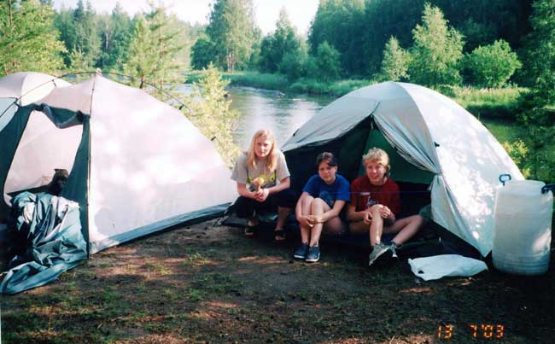 and spend their weekends in the country. They also like 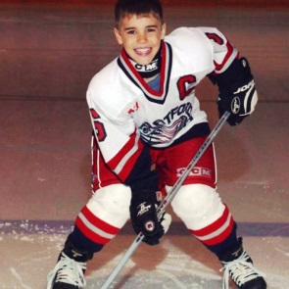 , 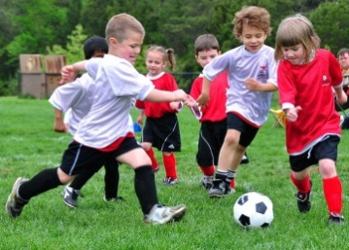, 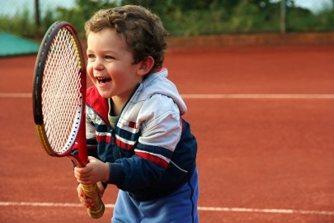.
Football, hockey, tennis are very popular in Russia. 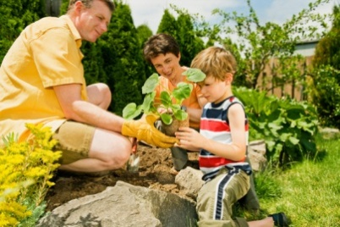is the most common hobby. The Russian spend much time 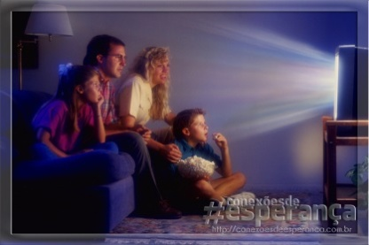 and.

Приложение2
THT ENGLISH
Some people prefer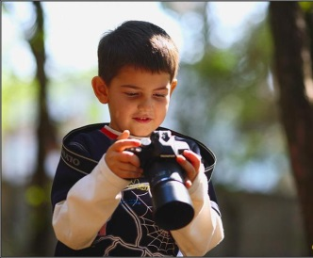. They like taking off palaces, castles, churches and old houses of historical interest. Others are interested in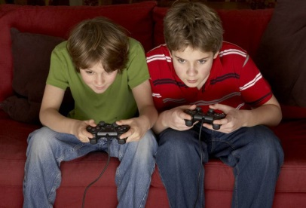.
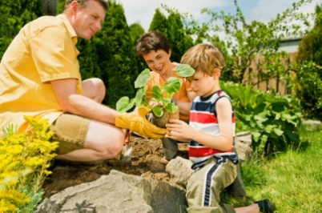is one of the most popular hobbies, especially among older people. Television is the main leisure activity. People spend much time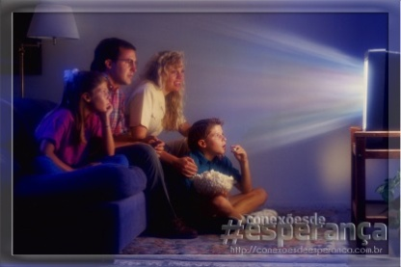. Many people in Britain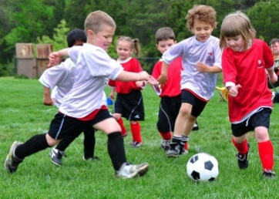. Football is the national sport in Britain. 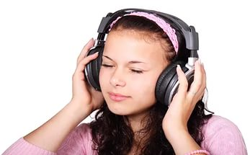is also a popular pastime.

