Form 3 Teacher | Date: 23.10.2017 Baimagambetova Aida
The theme: | "Sport game"
The aim: | 1)To introduce pupils with new words and grammar theme "Present Simple"  2) To developing pupils understanding, writing, listening, reading. 3)To teach pupils to creatively work and get information about the theme.
The results: | Pupils must be able to know and used the grammar rule of Present Simple tense.
The visual aids: | English Second steps(Student’s book, Teacher’s book) Books, CD, pictures.
The procedure of the lesson:
 | Teacher’s activity | Pupils activity
Inroduction  Phonetic drills: (2 мин)  Listening | Organization moment. Greeting -Good morning children -How are you?  Song: I wake up. Now we should repeat the pronunciation of some sounds which will be necessary at our lesson. Magic ch  Chair-children-teacher-chalk | Good morning dear teacher, We are glad to see you.  Pupils sing a song.  Pupils repeat the pronunciation.  Read. Chair-children-teacher-chalk
Checking home task. | Let's continue our lesson with the checking up your homework. What was your homework for today? Are you ready children? If so, let's start. Please, raise up your hands who is ready? Wb p9 Ex2 | Pupils answer.
Presentation  Practise  Production | We have a new lesson today. The theme of our lesson is “Sport games” Look at the picture and answer the question. What kind of sport is it? 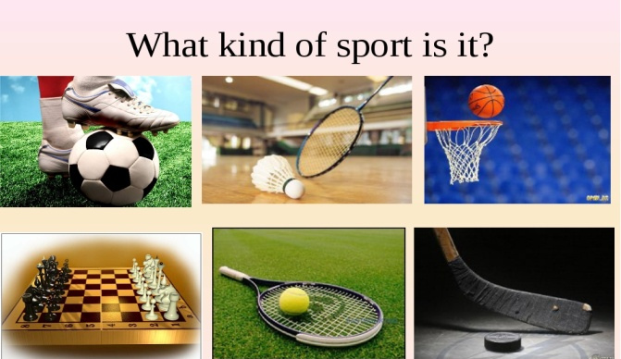  Vocabulary Let’s take new words Football |ˈfʊtbɔːl| - футбол Basketball|ˈbɑːskɪtbɔːl|- баскетбол Baseball |ˈbeɪsbɔːl| - бейсбол Chess |tʃɛs|- шахмат Rugby|ˈrʌɡbi|- рагби Hockey |ˈhɒki| - хоккей  Make up sentences. 1.hockey? he Does play 2. plays football He. 3. play Does he chess? 4. chess.He plays  Ex 4.Read. My talented family.  This is my mother she plays the piano.This is my father.He plays chess. This is my brother. He draws very well. This is my sister.She plays the piano and she sings very well.This is me.I play with my toys.  Ex 5.Choose the correct answer. Does his mother play chess? a)Yes she does b)No she doesn't Does his father play chess? a)Yes he does b)No he doesn't  Crossword  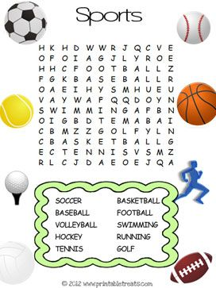 | Football,basketball,hockey,chess.  Repeat after teacher.  Football |ˈfʊtbɔːl| - футбол Basketball|ˈbɑːskɪtbɔːl|- баскетбол Baseball |ˈbeɪsbɔːl| - бейсбол Chess |tʃɛs|- шахмат Rugby|ˈrʌɡbi|- рагби Hockey |ˈhɒki| - хоккей  Does he play hockey? He plays football. Does he play chess? He plays chess.  They make question and answer.  Children read the text correctly.  b)No she doesn't  a)Yes he does
Conclusion | Your marks are…  Home task: Wb p9 Ex2 The lesson is over.Good bye. | Good bye, teacher.  Pupils write homework.

