«Бекітемін» № 249 мектеп-лицей директорының бастауыш
сыныптар жөніндегі орынбасары Ж.Жарылқаған
Lesson plan
Long-term plan unit: 2 |  |  |  |  | School: 249 school-lyceum
Date: |  |  |  |  | Teacher name: Seralieva Dinara
CLASS: 2 |  |  |  |  | Number present: |  | absent:

Theme of the lesson: Around school
Learning objectives(s) that this lesson is contributing to |  |  |  | 2.L4 recognise with support short basic  questions about what something is  2.UE14 use basic prepositions of location and position e.g. in, at, next to, near, on, to describe where people and things are use basic prepositions of time: on, in to talk about days and time use with to indicate accompaniment  2.S3 ask questions in basic exchanges about people, objects and classroom routines
Lesson objectives |  |  |  | Learners will be able to:
- recognise main verbs
- recognise basic prepositions of location and position
- answer the question Where is..?
Success criteria |  |  |  | Learners have met this learning objective 2.L4, if they can recognize familiar words and expressions intelligibly
Value links |  |  |  | Labor and creativity
Cross curricular links |  |  |  | Cooperation Respect
ICT skills |  |  |  | Smart board
Previous learning |  |  |  | Classroom objects
Plan
Planned timings | Planned activities (replace the notes below with your planned activities) |  |  |  |  |  |  | Resources
Beginning | ORGANIZATIONAL MOMENT  Teacher: Good morning!  How are you?  Learners answer the question How are you?, looking at the picture.  WARMING UP  Listen to a song “What's This?” |  |  |  |  |  |  | https://www.youtube. com/watch?v= TARreOtrWUg
Middle | REVISION  Game: Learners hide one picture of school rooms. Each learner asks the rest “What's this?” and the rest guess and answer “It’s a...”  For these activities, have initial letters of words. Learners match words and letters  PRESENTATION  Learners present a floor plan of their school. Learners name different images e.g. car park, hall, toilet, gym, office, classrooms canteen library etc. which they cut out and stick on their diagram according to school layout.  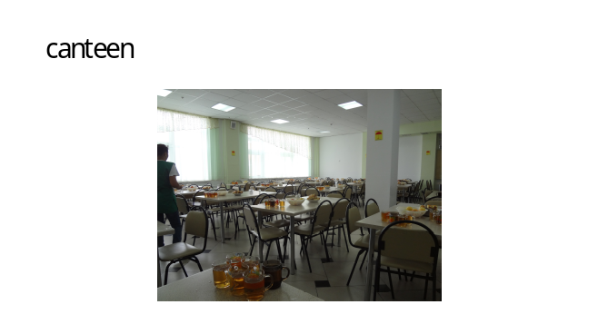  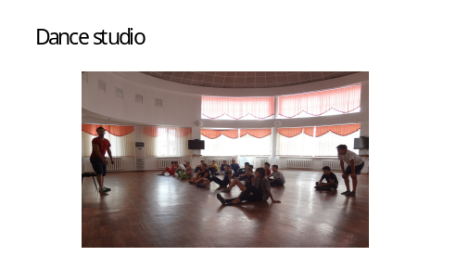  PHYSICAL TRAINING  I can jump I can run  I can sing I can dance  I can swim I can’t fly  I can climb and say good bye.  PRACTICE  - Writing  Students write the words on floor plans.  - Speaking  A) Answer the questions  - What can we do in the canteen?  - We can eat in the canteen  - What can we do in the library?  - We can read in the library  (read,eat,dance,run)  B) Dialogue  - What can you do?  IV. Listening Formative assessment  Students listen and put + or -  a) We can eat in the library  b) We can dance in the canteen  c) We can run in the gym  d) We can eat in the canteen  e) We can eat in the classroom  f) We can jump in the hall |  |  |  |  |  |  | Cards  Floor plan worksheet  https://www.youtube. com/watch?v=hx8i-Wq_jtc  Worksheets
End | Well what did we do in our lesson?  - Evaluation of the lesson  Give the home task Learn the words  Children sing a Good bye song |  |  |  |  |  |  | https://www.youtube. com/watch?v= Xcws7UWWDEs
Additional information
Differentiation – how do you plan to give more support? How do you plan to challenge the more able learners? |  |  | Assessment – how are you planning to check learners’ learning? |  |  | Health and safety check  ICT links
- More support will be given to weaker learners by giving them a modified worksheets in some tasks with greater support |  |  | - Through formative assessment  - Through observation of the stage of speaking |  |  | - Health promoting techniques  - Breaks and physical activities used.  - Points from Safety rules used at this lesson.  - Use video 10 minutes
Reflection  Were the lesson objectives/learning objectives realistic?  What did the learners learn today?  What was the learning atmosphere like?  Did my planned differentiation work well?  Did I stick to timings? What changes did I make from my plan and why? |  | Use the space below to reflect on your lesson. Answer the most relevant questions from the box on the left about your lesson.
Summary evaluation

What two things went really well (consider both teaching and learning)?
1:
2:
What two things would have improved the lesson (consider both teaching and learning)?
1:
2:
What have I learned from this lesson about the class or individuals that will inform my next lesson?

