Бекітемін______
Lesson 1
Date:05.09.17
Grade: 8b

Unite:1 | MY COUNTRY IS KAZAKHSTAN
Theme:1 | Kazakhstan. Topical vocabulary.
The Aim:  Vocabulary:  Org. moment:  Warm-up:  Checking up h/w:  The main part:  H/w: | The learner will Teaching pupils talking about Kazakhstan,work with the new words ;  Central Asia-орта Азия  Caspian Sea- Каспий теңізі  Siberiа -Сібір  Republic -Республика  Continental -континенталды  Sovereign- егеменді  to extend-ұзарту  flat -пәтер  plain -жазық  desert -шөл  to border\ sudden-шекара  to cover-қақпа  to suffer -зардап шегу  corn- жүгері  millet-тары  cotton-мақта  eagle-бүркіт  stripe -жолақ  to frame-құрылым  hoist-көтеру  The procedure of the lesson:  T: Good morning, dear children! Sit down! Who is on duty today? What date is it today? Who is absent today?  How are you today? What’s the weather like today?  Words connected with countries (фронтальный опрос).  Ex. I p. 4 (copybooks)  Today we are going to learn new words on the theme “Kazakhstan” and know how to use them.  Ex. I p. 118 Learn to read the proper names.  Ex. II p. 118 Say the following numbers  Example: 1900 – one thousand nine hundred  Ex. III p. 118 Read the new words and guess what they mean.  Ex. IV p. 118 Look up the following words in your dictionary.  Ex. V p. 118 Read the new words and write them down into your vocabularies consulting their meaning with the dictionary.  Read the sentences to know how to use these words.  Now write your own sentences using the new words  Example:  Kazakhstan is situated in the Central Asia.  Ex. VII p. 114 Study the difference in colours.  To learn the new words, Ex. 4 p. 5.  What was the theme of our lesson? What interesting things have you learnt today? Let’s review the new words.  The marks for the lesson are…  The lesson is over! Good-bye!

Бекітемін______
Lesson 2
Date:07.09.17
Grade: 8b

Unite:1 | MY COUNTRY IS KAZAKHSTAN
Theme:2 | The Climate in Kazakhstan
Grammar :  The Aim:  Vocabulary:  Org. moment:  Warm-up:  Checking up h/w:  The main part:  H/w: | Word formation.  N+Suffix-y;  Adj+Suffix-ly  The learner will Teaching pupils talking about climate in Kazakhstan,work with the new words ;  Advantage-артықшылығы  Advantageous-тиімді  Influence-әсер ету  Cold-салқын  Windy-жел  Warm-жылы  Sunny-күнді  Foggy-тұман  The procedure of the lesson:  T: Good morning, dear children! Sit down! Who is on duty today? What date is it today? Who is absent today?  How are you today? What’s the weather like today?  Words connected with countries (фронтальный опрос).  Ex. 5 p. 5 (copybooks)  Today we are going to learn new words on the theme “The Climate in Kazakhstan ” .  Ex. I p. 7 read the text .  Ex. II p. 7 practise reading and saying the words.  Example: Cool and wet  Cold and windy  Read the new words and write them down into your vocabularies consulting their meaning with the dictionary.  Read the sentences to know how to use these words.  Now write your own sentences using the new words  +y  Wind+y=windy  Fog+y=foggy  +ly  Late+ly=lately  Quick+ly=quickly  What was the theme of our lesson? What interesting things have you learnt today? Let’s review the new words.  The marks for the lesson are…  The lesson is over! Good-bye!  Learn the new words
  Noun+suffix=Adjective
  Adjective + suffix-ly= Adverb

Бекітемін______
Lesson 3
Date:________
________
________

Grade: __ __ __

Unite:1 | MY COUNTRY IS KAZAKHSTAN
Theme:2 | Astana – The capital of Kazakhstan
Grammar :  The Aim:  Vocabulary:  Org. moment:  Warm-up:  Checking up h/w:  The main part:  H/w: | Present Continuous and Past Continuous Tenses.  The learner will Teaching pupils talking about Astana ,work with the new words ;  Fortification- Бекіну  Outpost- форпост  anti-tsarist- антарктическая  to establish- орнату  magnificent-керемет  prosperity- өркендеу  sea level- теңіз деңгейі  transfer- аударым  particular- атап айтқанда  host- хост  Museum-мұражай  Theatre-театр  Nation-ұлттық  Education-білім беру  Establishment-ұйымдастыру  Secondary school-орта мектеп  International-халықаралық  Attractive-тартымды  Recognition-тану  Facilities-қызметтер  The procedure of the lesson:  T: Good morning, dear children! Sit down! Who is on duty today? What date is it today? Who is absent today?  How are you today? What’s the weather like today?  ask new words  Today we are going to learn new words on the theme “Astana -The capital of Kazakhstan ” .  Ex. 2 p. 10 read the text . “Astana”  Ex. II. 2) p. 11 Answer the question  Example: When was Akmola founded?  What was Akmola famous for at the that time ?  Read the new words and write them down into your vocabularies consulting their meaning with the dictionary.  Read the sentences to know how to use these words.  Now write your own sentences using the new words  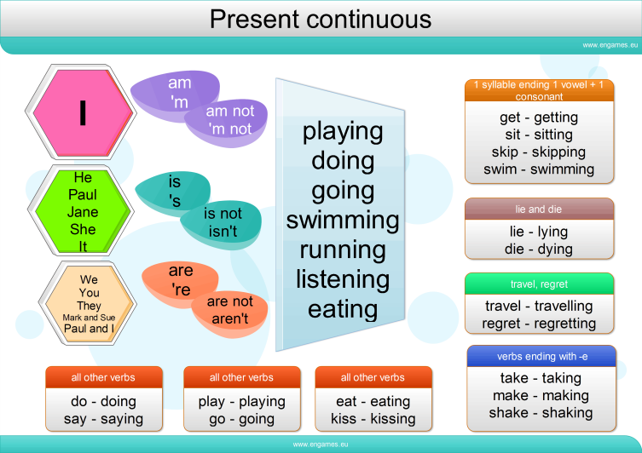  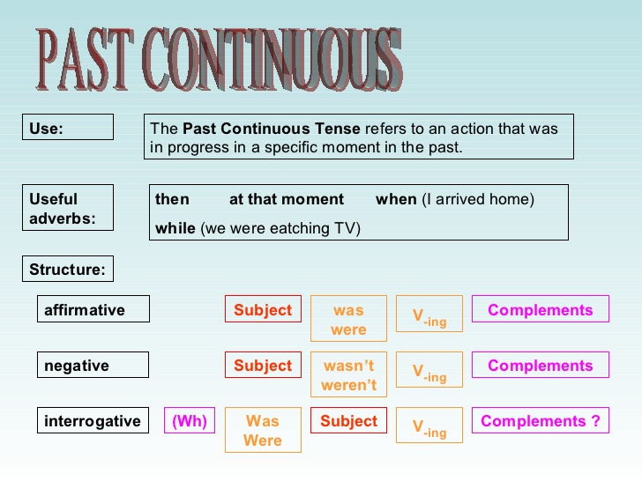  Exercises for Present Continuous and Past Continuous Tenses.  What was the theme of our lesson? What interesting things have you learnt today? Let’s review the new words.  The marks for the lesson are…  The lesson is over! Good-bye

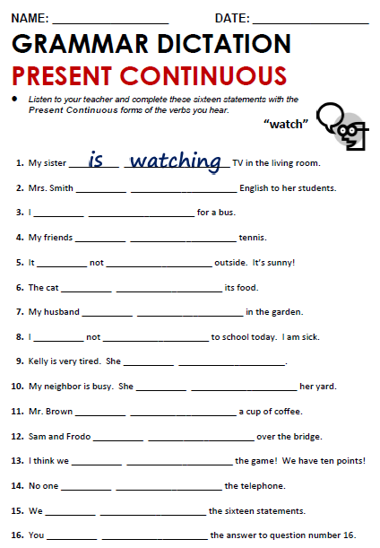
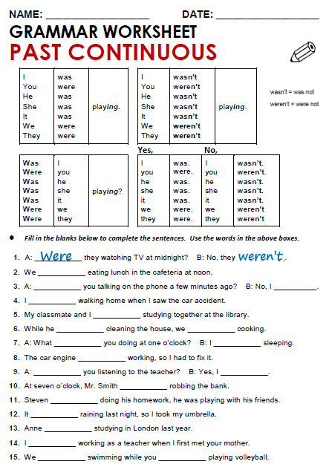

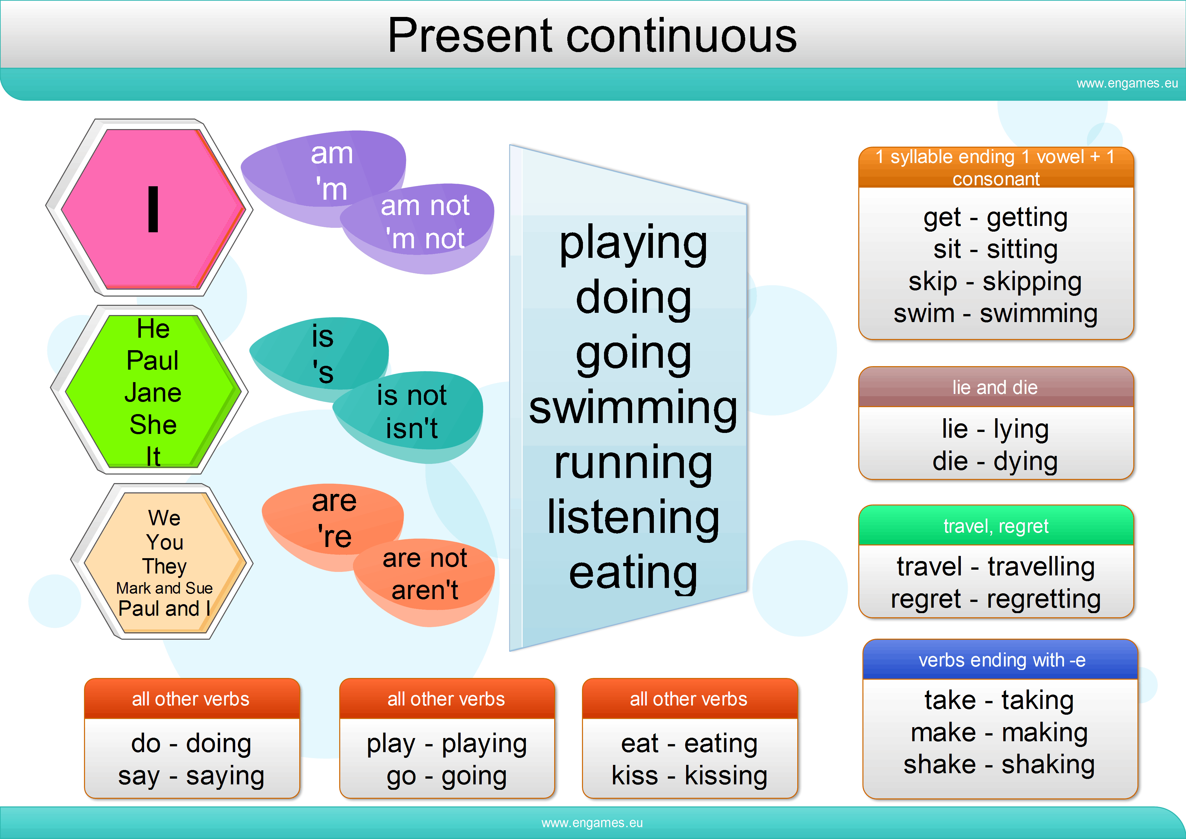

Бекітемін______
Lesson 4
Date:________
________
________

Grade: __ __ __

Unite:1 | MY COUNTRY IS KAZAKHSTAN
Theme:2 | We are the citizens of Kazakhstan
The Aim:  Vocabulary:  Org. moment:  Warm-up:  Checking up h/w:  The main part:  H/w: | The learner will Teaching pupils talking about Kazakhstan ,work with the new words ;  Citizens-азамат  Sovereign-егеменді  Independence-тәуелсіздік  Celebrate-тойлау  Mighty- күшті , күші көп  Patriots-потриот, ұлтшыл  Strategy-стратегия  Responsible-жауапты  Teenagers-жасөспірім  The procedure of the lesson:  T: Good morning, dear children! Sit down! Who is on duty today? What date is it today? Who is absent today?  How are you today? What’s the weather like today?  Exercises for Present Continuous and Past Continuous Tenses.  Today we are going to learn new words on the theme “We are the citizens of Kazakhstan ” .  Ex. I p. 15 read the poem “Eagles” , then answer the questions.  Ex. II. 3) p. 16 read the text and answer the question.  Example: whendidKazakhstan get its indepence?  Ex.III Reading and speaking “Nauryz”  Read the new words and write them down into your vocabularies consulting their meaning with the dictionary.  Read the sentences to know how to use these words.  Now write your own sentences using the new words  To teach poem “Eagles”  What was the theme of our lesson? What interesting things have you learnt today? Let’s review the new words.  The marks for the lesson are…  The lesson is over! Good-bye

Бекітемін______
Lesson 5
Date:________
________
________

Grade: __ __ __

Unite:1 | MY COUNTRY IS KAZAKHSTAN
Theme:2 | Our Environment
Grammar:  The Aim:  Vocabulary:  Org. moment:  Warm-up:  Checking up h/w:  The main part:  H/w: | Word formation:  The prefixes: un+, in+, im+, ir+  The learner will Teaching pupils talking about Kazakhstan ,work with the new words ;  Pollution - Ластану  to threaten- қауіп төндіруде  oxygen- оттегі  soil- топырақ  oil- май  tankers- танкерлер-  The procedure of the lesson:  T: Good morning, dear children! Sit down! Who is on duty today? What date is it today? Who is absent today?  How are you today? What’s the weather like today?  Answer the question about ecology.  Learn the poem “ Eagles”  Today we are going to learn new words on the theme “Our Environmet” .  Ex. II p. 19 read the text “Our Environmet”  Ex. II. 2) p. 20Complete the sentences:  Example: People can’t live without ……  Ex.III 3) p.22 Act out the dialogue about WWF and Greenpeace organization  Read the new words and write them down into your vocabularies consulting their meaning with the dictionary.  Read the sentences to know how to use these words.  Now write your own sentences using the new words  Ex.4 p. 22  Prepare a talk on the topic “Our Environment”  What was the theme of our lesson? What interesting things have you learnt today? Let’s review the new words.  The marks for the lesson are…  The lesson is over! Good-bye

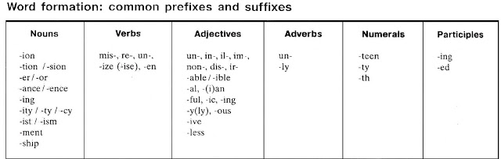

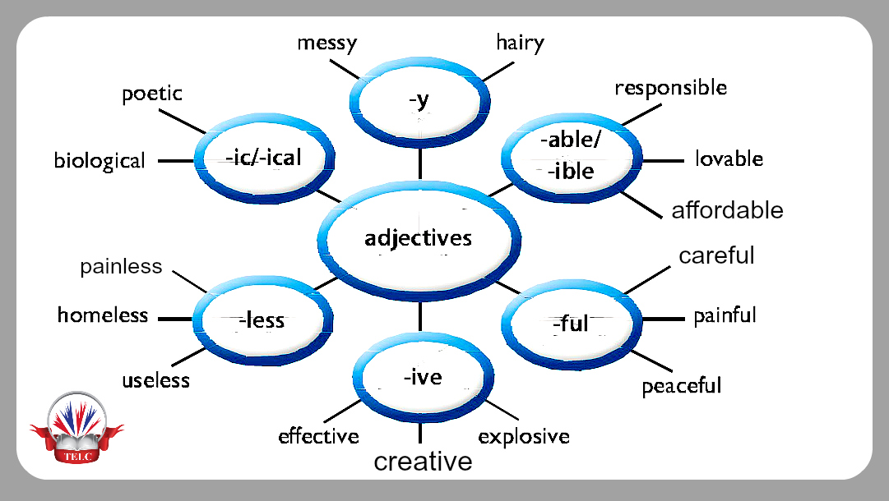

WORD FORMATION EXERCISES
Exercise 1
1. Detroit is renowned for the………….. of cars. PRODUCE
2. If you make a good……………… at the interview, you will get the job. IMPRESS
3. Teaching and medicine are more than…………………., they're professions. OCCUPY
4. My history teacher has a vast…………………. of past events. KNOW
5. You are never too old to go to college and gain some……………. QUALIFY
6. My greatest…………….. was graduating from the university. ACHIEVE
7. The weatherman said there is a strong…………… of rain today. POSSIBLE
8. Some old laws are no longer……………….. EFFECT
9. Athens is…………………. for its ancient buildings. FAME
10. He was caught shoplifting so now he has a……………….. record. CRIME
11. Despite her severe………….., she fulfilled her goals in life. DISABLE
12. Being……………. is the worst thing that can happen to someone. EMPLOY
13. If you buy presents in the summer your…………………… can be very high. SAVE
14. Due to the pilot's…………………, the copilot managed to land safely. GUIDE
15. It's important to also see the less………………… sides of the job. DESIRE
16. I was surprised at his………………… to give up. REFUSE
17. Children are by nature………………….. of danger. AWARE
18. She is always……………. towards her parents. RESPECT
19. The hospital has the best medical……………. and fast ambulances. EQUIP
20. You can relax in the comfortable………………….. of the hotel. SURROUND

Бекітемін______
Lesson 6
Date:________
________
________

Grade: __ __ __

Unite:1 | MY COUNTRY IS KAZAKHSTAN
Theme:2 | Step 7  Nature and Ecological Problems p.23
Grammar:  The Aim:  Vocabulary:  Org. moment:  Warm-up:  Checking up h/w:  The main part:  H/w: | Word formation:  The prefixes: un+, in+, im+, ir+  The learner will Teaching pupils talking about Kazakhstan nature and ecological problems,work with the new words ;  Area- Аудан  Region- Аймақ  Exhaustion- Шығару  Resource-ресурс  Strategy-стратегия  Priority- артықшылық,басымдылық  Rational-дөрыс, орынды  Safety-қауіпсіздік  well-being-әл ауқат  The procedure of the lesson:  T: Good morning, dear children! Sit down! Who is on duty today? What date is it today? Who is absent today?  How are you today? What’s the weather like today?  Answer the question about ecology.  Prepare a talk on the topic “Our Environment”  Today we are going to learn new words on the theme “Nature and Ecological Problems ” .  Ex. Ip.3) p.23 read the sentences and the words to know how to understand and use them  Ex. III. p.24 Match the words with their definitions :  Example: 1.strategy b)a plan or method for achieving something  Ex.VI p.25Word Formation  1.give the opposites by adding “un”, look up the meaning of the words in the dictionary . for example happy- unhappy  2.give the opposites by adding “im”, “in”, “ir”,  3.give the meaning of the compound words; consult a dictionary if necessary ;  4.form new verbs from the given one by adding the prefix “re”. Give their meaning;  Read the new words and write them down into your vocabularies consulting their meaning with the dictionary.  Read the dialogue  Ex.IV page 24. Read the text and discuss then answer the question.  What was the theme of our lesson? What interesting things have you learnt today? Let’s review the new words.  The marks for the lesson are…  The lesson is over! Good-bye

Бекітемін______
Lesson 7
Date:________
________
________

Grade: __ __ __

Unite:1 | MY COUNTRY IS KAZAKHSTAN
Theme:2 | Step 8  Natural Disaster p.26
Grammar:  The Aim:  Vocabulary:  Org. moment:  Warm-up:  Checking up h/w:  The main part:  H/w: | Word formation:  The prefixes: un+, in+, im+, ir+  The learner will Teaching pupils talking about Kazakhstan nature and ecological problems,work with the new words ;  Tornado-Торнадо  storm cellar-дауыл  squawking-қобалжу  barn-сарай  survive-аман қалу  alive - тірі  The procedure of the lesson:  T: Good morning, dear children! Sit down! Who is on duty today? What date is it today? Who is absent today?  How are you today? What’s the weather like today?  Practice reading and saying the words.  Ex.IV page 24. Read the text and discuss then answer the question.  Today we are going to learn new words on the theme “Natural Disaster ”  Ex. Ip.2)p.26 Read the text “Tonado coming” Part 1 Part 2  Ex. II. p.27 Grammar practice “Future continous Tense”  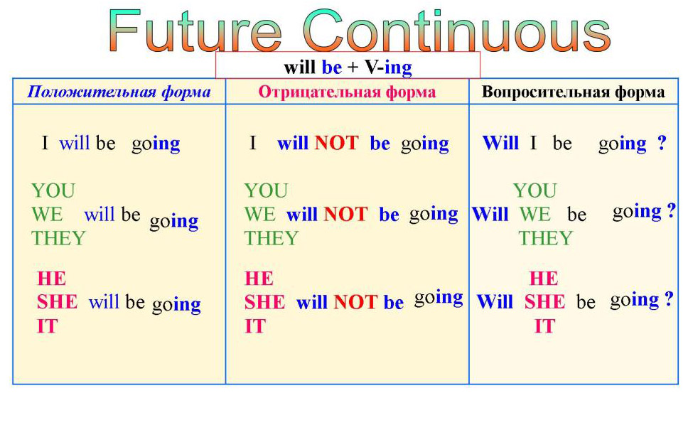  Do the exercise for future continuous tense  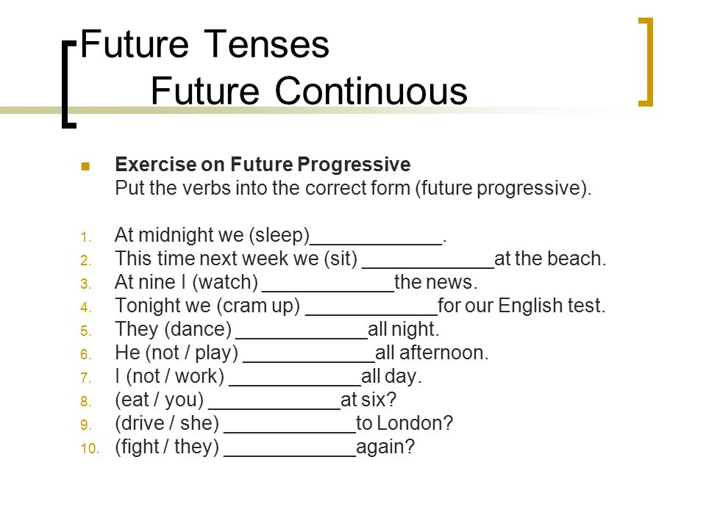  Read the new words and write them down into your vocabularies consulting their meaning with the dictionary.  Retelling the text “tornado coming”  What was the theme of our lesson? What interesting things have you learnt today? Let’s review the new words.  The marks for the lesson are…  The lesson is over! Good-by

Бекітемін________

Short term lesson plan 10
Unit 2: SCIENCE AND TECHNOLOGY PROGRESS (9 hours) – 7 hours |  |  | School: № 36 secondary school
Date:______.0_.2017  ______.0_.2017  ______.0_.2017 |  |  | Teacher’sname: Onggalieva L.
Grade : 8__8__8__ |  |  | Number present: |  | Number absent:
Theme of the lesson: |  |  | Step 2  The most important inventions in the history of mankind p.38
Lesson objectives |  | All learners will be able to:
- Comprehend information and recognize main details of the conversation while listening;
- Demonstrate the ability to write topic specific vocabulary;
- The learner will Teaching pupils talking about Science and Technology.Work with the new words ;
 |  | Most learners will be able to:
 |  | - Do the tasks with some minor mistakes.
 |  | Some learners will be able to:
 |  | - Do the tasks without any mistakes.
Useof ICT |  | Projector or Smart board to show a presentation.
Pastoral Care |  | Student centered teaching: respect, support and scaffolding. To create a friendly atmosphere for collaborative work. To promote a sense of self-esteem and self-respect and respect for others among all the learners.
Health and Safety |  | Everyday classroom precautions will ensure that safety measures are provided to prevent the exposure of electrical power cords.
Planned timings | Planned activities |  |  |  |  |  | Resources
5min  15min  15min | Greetings,  Good morning pupils! Who is on duty today? Who is absent?  1.Let us speak about the history of inventions  - Alexander Fleming  - Alexander Graham Bell  - James Watt  II.Reading Jigsaw  1.Answer the questions  What does the word microscope consist of and what does it mean?  Who and from what country was the inventor of a microscope?How did he do it?  When was the first microscope built ?  III.The phrasal verb “keep”  Task for phrasal verb “Keep”  Fill in the blanks using the words in the box below, then click the "Check" button to check your answers.  around away back down in off on out over up  1. There was a sign on the door that said, "Keep  !" 2. I ran the entire marathon, but I wasn't able to keep with the rest of the runners. In fact, I was the last to finish. 3. I don't have much shelf space, so I keep my books the television. 4. If you take the medicine on an empty stomach, you will have problems keeping it . 5. Watch out, there's a rattlesnake! Everybody keep !
  keep ahead | keep back | keep in | keep out
  keep at | keep down | keep off | keep to
  keep away | keep from | keep on | keep up
5 min. | Students reflect on the skills that they have received while studying the unit. What was the most and the least beneficial for them?  Home task: Ex. 1 p. 41Guess the meaning of the following word  Ex. 2 p. 41Read the sentences to know how to use the words
End  1min | Feedback: Teacher asks students what task was difficult to them and which pair worked well.
Additional information
Differentiation – how do you plan to give more support? How do you plan to challenge the more able learners? |  |  |  | Assessment – how are you planning to check learners’ learning? |  | Critical thinking
The teacher and co-teacher should circulate the room constantly offering support to weaker students and encouraging stronger students to write more complex, abstract thoughts.  Higher students can be encouraged to use more difficult writing structures, vocabulary etc. Weaker students can be supported by the teacher when writing, and the complexity of the tasks could be reduced or adapted. |  |  |  | Circulate about the room helping students with vocabulary and expressions. Monitor learners to check they can pick up main points from the text when answering the questions.  Following each pair or individual activity, ask questions that check for comprehension and understanding. |  | Critical thinking lies in skill of forming communicative vocabulary while listening and writing skills. The ability of learners to react, analyze, and choose the right answers.

Бекітемін________
Short term lesson plan
Unit 2: SCIENCE AND TECHNOLOGY PROGRESS (9 hours) – 7 hours |  |  | School: № 36 secondary school
Date:______.0_.2017  ______.0_.2017______.0_.2017 |  |  | Teacher’sname: Onggalieva L.
Grade : 8__8__8__ |  |  | Number present: |  | Number absent:
Theme of the lesson: |  |  | Step 3 Mass media in our life p.41
Lesson objectives |  | All learners will be able to:
- Comprehend information and recognize main details of the conversation while listening;
- Demonstrate the ability to write topic specific vocabulary;
- The learner will Teaching pupils talking about Mass media in our life.Work with the new words ;
 |  | Most learners will be able to:
 |  | - Do the tasks with some minor mistakes.
 |  | Some learners will be able to:
 |  | - Do the tasks without any mistakes.
Useof ICT |  | Projector or Smart board to show a presentation.
Pastoral Care |  | Student centered teaching: respect, support and scaffolding. To create a friendly atmosphere for collaborative work. To promote a sense of self-esteem and self-respect and respect for others among all the learners.
Health and Safety |  | Everyday classroom precautions will ensure that safety measures are provided to prevent the exposure of electrical power cords.
Planned timings | Planned activities |  |  |  |  |  | Resources
5min  15min  15min | Greetings,Good morning pupils! Who is on duty today? Who is absent? I’m glad to see you!What date is it today? Thank you!Sit down please  Today we are going to learn new theme, to learn new words, to do some exercise, to checking up your home work, answer the question, read and translate, work in groups.  I.Guess the meaning of the following words:  Mass media [mass'mi:dia]- Бұқаралық ақпарат құралдары  important [im'poitent] -маңызды  information [infa'meijn] ақпарат  relax [ri'laeks] (v) демалу  channel ['tfaenal] арна  television, satellite television теледидар, спутниктік теледидар  internet ['intanet] Интернет  programme f'prougram] бағдарлама  corruption[кэ'глр/эп] (n) сыбайлас жемқорлық  massive f'maesiv] массивті  economic crizis [ika'nomik'kraisis] экономикалық дағдарыс  diplomatic visits [dipb'mstik'vizits] дипломатиялық сапарлар  terrorism ['terarizml ]терроризм  traditions [tr3'dij(3)nz] дәстүрлер  technologies [tek'nolic^iz] технологиялар  II.Read the sentences to know how to use the words :  Viewer , FM, to provide, to supply, negotiation, corruption, coverage, the Media etc.  Questions for discussions.  1.What belongs to mass media? (What is mass media?)  2.How do we gt information that we need?  III. Read the text and discuss it in small groups : part1-group1. “Mass Media”  IV.  Present , Past or Future Passive  Present Simple  active voice: Somebody cooks dinner.  passive voice: Dinner is cooked by somebody.  to be + Past Participle ( washed, cooked, done )  Present Continuous  active voice: Somebody is cooking dinner.  passive voice: Dinner is being cooked by somebody.  am / is / are + being + Past Participle  Past Simple  active voice: Somebody cooked dinner.  passive voice: Dinner was cooked by somebody.  was / were + Past Participle  Future Simple  active voice: Somebody will cook dinner.  passive voice: Dinner will be cooked by somebody.  will + be + Past Participle |  |  |  |  |  | Worksheet 1
5 min. | Students reflect on the skills that they have received while studying the unit. What was the most and the least beneficial for them?  Home task: Ex. 4 p. 43  Give the English equivalents to the sentences  - Я думаю, что невозможно представить нашу жизнь без радио, телевидения и интернета.  - Радио и телевидение широко используются в современном мире.  - Радио и телевидение информируют нас о текущих событиях, о новых достижениях в науке, о политических событиях и предлагают большое количество программ — образовательных и развлекательных.  - Моя любимая радиостанция — “Европа плюс”.  - Мои любимые телевизионные каналы — “Дискавери” и “Евразия”, потому что они удовлетворяют мои интересы лучшим образом
End  1min | Feedback: Teacher asks students what task was difficult to them and which pair worked well.
Additional information
Differentiation – how do you plan to give more support? How do you plan to challenge the more able learners? |  |  |  | Assessment – how are you planning to check learners’ learning? |  | Critical thinking
Circulate about the room helping students with vocabulary and expressions. Monitor learners to check they can pick up main points from the text when answering the questions.  Following each pair or individual activity, ask questions that check for comprehension and understanding. |  |  |  | Critical thinking lies in skill of forming communicative vocabulary while listening and writing skills. The ability of learners to react, analyze, and choose the right answers.

Бекітемін________
Short term lesson plan
Unit 2: SCIENCE AND TECHNOLOGY PROGRESS (9 hours) – 7 hours |  |  | School: № 36 secondary school
Date:______.0_.2017  ______.0_.2017______.0_.2017 |  |  | Teacher’sname: Onggalieva L.
Grade : 8__8__8__ |  |  | Number present: |  | Number absent:
Theme of the lesson: |  |  | Step 4  Radio and TV in my life.44
Lesson objectives |  | All learners will be able to:
- Comprehend information and recognize main details of the conversation while listening;
- Demonstrate the ability to write topic specific vocabulary;
- The learner will Teaching pupils talking about radio and TV.Work with the new words ;
 |  | Most learners will be able to:
 |  | - Do the tasks with some minor mistakes.
 |  | Some learners will be able to:
 |  | - Do the tasks without any mistakes.
Useof ICT |  | Projector or Smart board to show a presentation.
Pastoral Care |  | Student centered teaching: respect, support and scaffolding. To create a friendly atmosphere for collaborative work. To promote a sense of self-esteem and self-respect and respect for others among all the learners.
Health and Safety |  | Everyday classroom precautions will ensure that safety measures are provided to prevent the exposure of electrical power cords.
Planned timings | Planned activities |  |  |  |  |  | Resources
5min  15min  15min | Greetings,Good morning pupils! Who is on duty today? Who is absent? I’m glad to see you!What date is it today? Thank you!Sit down please  Today we are going to learn new theme, to learn new words, to do some exercise, to checking up your home work, answer the question, read and translate, work in groups.  I. ex.1 Read and discuss the text.  Answer the questions .  1. Are radio and TV widely used in today`s world?  2. What role do radio and TV play in our lives?  3. Do you listen to the radio?  4. What are your favourite radio stations?  5. What are your favorite TV channels?  II.Speak about your favourite TV programmes in small groups.  IV. 1.Discuss the following text.  Lost of people pretend that they never read advertisements, but this is doubtful. It is hardly possible not to read advertisements these days. And what fun they often are! Just think what a railway station or a newspaper would be like without advertisements. A cheerful witty advertisement makes us happy. Advertisements perform a useful service to the community for instance, you can find a job, buy or sell a house , announce a birth, marriage or death in "Small ads" columns. No other item in a newspaper provides such entertaining reading or offers such a deep insight into human nature.  There are advertisements ptactically everywhere you look in the cite or a village.  V. Modal verbs : Could,Should  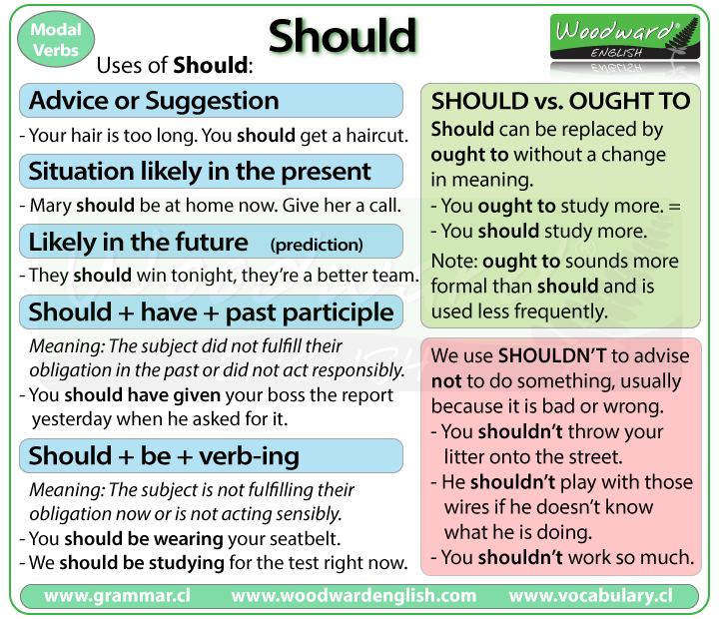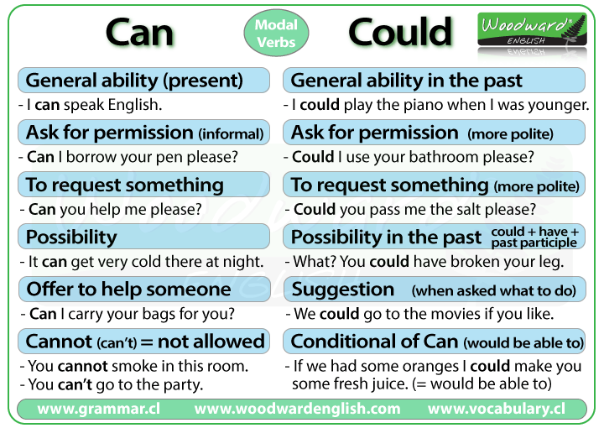 |  |  |  |  |  | Worksheet 1
5 min. | Students reflect on the skills that they have received while studying the unit. What was the most and the least beneficial for them?  Home task: Ex. 1 p. 46  Translate the sentences into English
End  1min | Feedback: Teacher asks students what task was difficult to them and which pair worked well.
Additional information
Differentiation – how do you plan to give more support? How do you plan to challenge the more able learners? |  |  |  | Assessment – how are you planning to check learners’ learning? |  | Critical thinking
Circulate about the room helping students with vocabulary and expressions. Monitor learners to check they can pick up main points from the text when answering the questions.  Following each pair or individual activity, ask questions that check for comprehension and understanding. |  |  |  | Critical thinking lies in skill of forming communicative vocabulary while listening and writing skills. The ability of learners to react, analyze, and choose the right answers.

Бекітемін________
Short term lesson plan
Unit 2: SCIENCE AND TECHNOLOGY PROGRESS (9 hours) – 7 hours |  |  | School: № 36 secondary school
Date:______.0_.2017  ______.0_.2017______.0_.2017 |  |  | Teacher’sname: Onggalieva L.
Grade : 8__8__8__ |  |  | Number present: |  | Number absent:
Theme of the lesson: |  |  | Step 5  Television and Children p.47
Lesson objectives |  | All learners will be able to:
- Comprehend information and recognize main details of the conversation while listening;
- Demonstrate the ability to write topic specific vocabulary;
- Work with the new words ;
- To enrich their knowledge concerning the theme, on the new words, to practice its pronunciation and teach them to use the words in their speech.
 |  | Most learners will be able to:
 |  | - Do the tasks with some minor mistakes.
 |  | Some learners will be able to:
 |  | - Do the tasks without any mistakes.
Useof ICT |  | Projector or Smart board to show a presentation.
Pastoral Care |  | Student centered teaching: respect, support and scaffolding. To create a friendly atmosphere for collaborative work. To promote a sense of self-esteem and self-respect and respect for others among all the learners.
Health and Safety |  | Everyday classroom precautions will ensure that safety measures are provided to prevent the exposure of electrical power cords.
Planned timings | Planned activities |  |  |  |  |  | Resources
5min  15min  15min | Greetings,Good morning pupils! Who is on duty today? Who is absent? I’m glad to see you!What date is it today? Thank you!Sit down please  Today we are going to learn new theme, to learn new words, to do some exercise, to checking up your home work, answer the question, read and translate, work in groups.  - Pronunciation  Read the words correctly (if necessary, consult your dictionary).  entertain [ents'tein], amusement [a'mjuizmsnt], magic box, rush [taJ], choose [tju:z], sandwich ['saenwidjj, interfere [inta'fia], quiet j'kwaist], glued [glu:d], civilization [siv(3)lai'zeij(a)n].  II. Read and discuss the following text. Express your opinion.  “Television is doing a great harm. It is a real monster.” How often we hear statements like this! Television hasn’t been with us all the time, but we are already beginning to forget what the world was like without it. What did we use to do before there was television? First of all, we never found it difficult to spend our free time. We used to enjoy civillized pleasures. For instance, we used to have hobbies, we used to entertain our friends and be entertained by them, we used to go outside for our amusements to theatres, cinemas, restaurants and sporting events. We even  used to read books and listen to music. All that belongs to the past. Now all our free time is regulated by the “magic box”. We rush home to be in time for this or that programme. A sandwich and a glass of tea will do — anything if only it doesn’t interfere with the programme.  •TIL Say what you think about the following.  Children and TV is a great problem.  Television must offer children instructive but not too difficult, entertaining but not thoughtless programmes.  On the one hand, television prevents children from spending their pastime in the street, on the other hand, it helps them to learn a lot about our world and develop their imagination. What is more important?  Children should watch only interesting and useful programmes, and not all the programmes for several hours running.  Television is not harmful, but if you let a child watch TV programmes without choice, he simply becomes a passive viewer.  Parents should give their children an opportunity to discuss with them what they have seen.  IV. Word study1. Learn Ihe following topical vocabulary  Magazine programme — programme which is a mixture of “hard” news and feature items;  Wild life programme — programme showing animals, birds, in their natural environment;  Quiz programme — programme on which members of the audience are asked questions, in case of correct answer they receive prizes; sitcom (situational comedy) — short film providing entertainment;  “Soap” opera-play (an afternoon television regular feature) — which originally appeared on the radio and was sponsoured by soap advisers, continuing from day to day, presenting emotinal and melodramatic situations like many operas of the 19-th centure (thus named “soap” operas);  Video clip — minifilm, about the length of a song, interpreting or dramatizing a song;  Western — uniquely American film presenting myth about pioneering, courageous Americans.  2. Which of the programmes do you like best. Why?  3. Fill in Television Questionnaire.  How many hours a week do you less than 5 hours spend watching television? 5—10 hours  10—15 hours more than 20 hours  What sort of programmes do you like watching?  Are there any sorts of programmes you like or dislike?  the news  discussion programmes  documentaries  plays  films  serials  What is your favourite programme?  Are there any educational programmes you would like to use?  Practise the following dialogue. Say what your opinion on the topic is.  Four university students discuss advantages and disadvantages of television. Michael and Ann are Russian students, John is an American student and Ruth is an English student.  John: I think television is one of the worst inventions the man ever made. It occupies all our ……..  V. Modal verbs : Should |  |  |  |  |  | Worksheet 1
  should (should not/shouldn’t) | We should (should not/shouldn’t)
  You should (should not/shouldn’t) | You should (should not/shouldn’t)
  He/She/It should (should not/shouldn’t) | They should (should not/shouldn’t)
5 min. | Students reflect on the skills that they have received while studying the unit. What was the most and the least beneficial for them?Home task: Ex. 2 p. 51  Express in one word
End  1min | Feedback: Teacher asks students what task was difficult to them and which pair worked well.
Additional information
Differentiation – how do you plan to give more support? How do you plan to challenge the more able learners? |  |  |  | Assessment – how are you planning to check learners’ learning? |  | Critical thinking
Circulate about the room helping students with vocabulary and expressions. Monitor learners to check they can pick up main points from the text when answering the questions.Following each pair or individual activity, ask questions that check for comprehension and understanding. |  |  |  | Critical thinking lies in skill of forming communicative vocabulary while listening and writing skills. The ability of learners to react, analyze, and choose the right answers.

Бекітемін________
Short term lesson plan
Unit 2: SCIENCE AND TECHNOLOGY PROGRESS (9 hours) – 7 hours |  |  | School: № 36 secondary school
Date:______.0_.2017  ______.0_.2017______.0_.2017 |  |  | Teacher’sname: Onggalieva L.
Grade : 8__8__8__ |  |  | Number present: |  | Number absent:
Theme of the lesson: |  |  | Step 5  Television and Children p.47
Lesson objectives |  | All learners will be able to:
- Comprehend information and recognize main details of the conversation while listening;
- Demonstrate the ability to write topic specific vocabulary;
- Work with the new words ;
- To enrich their knowledge concerning the theme, on the new words, to practice its pronunciation and teach them to use the words in their speech.
 |  | Most learners will be able to:
 |  | - Do the tasks with some minor mistakes.
 |  | Some learners will be able to:
 |  | - Do the tasks without any mistakes.
Useof ICT |  | Projector or Smart board to show a presentation.
Pastoral Care |  | Student centered teaching: respect, support and scaffolding. To create a friendly atmosphere for collaborative work. To promote a sense of self-esteem and self-respect and respect for others among all the learners.
Health and Safety |  | Everyday classroom precautions will ensure that safety measures are provided to prevent the exposure of electrical power cords.
Planned timings | Planned activities |  |  |  |  |  | Resources
5min  15min  15min | Greetings,Good morning pupils! Who is on duty today? Who is absent? I’m glad to see you!What date is it today? Thank you!Sit down please  Today we are going to learn new theme, to learn new words, to do some exercise, to checking up your home work, answer the question, read and translate, work in groups.  - Pronunciation  Read the words correctly (if necessary, consult your dictionary).  entertain [ents'tein], amusement [a'mjuizmsnt], magic box, rush [taJ], choose [tju:z], sandwich ['saenwidjj, interfere [inta'fia], quiet j'kwaist], glued [glu:d], civilization [siv(3)lai'zeij(a)n].  II. Read and discuss the following text. Express your opinion.  “Television is doing a great harm. It is a real monster.” How often we hear statements like this! Television hasn’t been with us all the time, but we are already beginning to forget what the world was like without it. What did we use to do before there was television? First of all, we never found it difficult to spend our free time. We used to enjoy civillized pleasures. For instance, we used to have hobbies, we used to entertain our friends and be entertained by them, we used to go outside for our amusements to theatres, cinemas, restaurants and sporting events. We even  used to read books and listen to music. All that belongs to the past. Now all our free time is regulated by the “magic box”. We rush home to be in time for this or that programme. A sandwich and a glass of tea will do — anything if only it doesn’t interfere with the programme.  •TIL Say what you think about the following.Children and TV is a great problem.  Television must offer children instructive but not too difficult, entertaining but not thoughtless programmes.  On the one hand, television prevents children from spending their pastime in the street, on the other hand, it helps them to learn a lot about our world and develop their imagination. What is more important?  Children should watch only interesting and useful programmes, and not all the programmes for several hours running.  Television is not harmful, but if you let a child watch TV programmes without choice, he simply becomes a passive viewer.  Parents should give their children an opportunity to discuss with them what they have seen.  IV. Word study1. Learn Ihe following topical vocabulary  Magazine programme — programme which is a mixture of “hard” news and feature items;  Wild life programme — programme showing animals, birds, in their natural environment;  Quiz programme — programme on which members of the audience are asked questions, in case of correct answer they receive prizes; sitcom (situational comedy) — short film providing entertainment;  “Soap” opera-play (an afternoon television regular feature) — which originally appeared on the radio and was sponsoured by soap advisers, continuing from day to day, presenting emotinal and melodramatic situations like many operas of the 19-th centure (thus named “soap” operas);  Video clip — minifilm, about the length of a song, interpreting or dramatizing a song;  Western — uniquely American film presenting myth about pioneering, courageous Americans.  2. Which of the programmes do you like best. Why?  3. Fill in Television Questionnaire.  How many hours a week do you less than 5 hours spend watching television? 5—10 hours  10—15 hours more than 20 hours  What sort of programmes do you like watching?  Are there any sorts of programmes you like or dislike?  the news  discussion programmes  documentaries  plays  films  serials  What is your favourite programme?  Are there any educational programmes you would like to use?  Practise the following dialogue. Say what your opinion on the topic is.  Four university students discuss advantages and disadvantages of television. Michael and Ann are Russian students, John is an American student and Ruth is an English student.  John: I think television is one of the worst inventions the man ever made. It occupies all our ……..  V. Modal verbs : Should |  |  |  |  |  | Worksheet 1
  should (should not/shouldn’t) | We should (should not/shouldn’t)
  You should (should not/shouldn’t) | You should (should not/shouldn’t)
  He/She/It should (should not/shouldn’t) | They should (should not/shouldn’t)
5 min. | Students reflect on the skills that they have received while studying the unit. What was the most and the least beneficial for them?Home task: Ex. 2 p. 51  Express in one word
End  1min | Feedback: Teacher asks students what task was difficult to them and which pair worked well.
Additional information
Differentiation – how do you plan to give more support? How do you plan to challenge the more able learners? |  |  |  | Assessment – how are you planning to check learners’ learning? |  | Critical thinking
Circulate about the room helping students with vocabulary and expressions. Monitor learners to check they can pick up main points from the text when answering the questions.Following each pair or individual activity, ask questions that check for comprehension and understanding. |  |  |  | Critical thinking lies in skill of forming communicative vocabulary while listening and writing skills. The ability of learners to react, analyze, and choose the right answers.

Бекітемін________
Short term lesson plan
Unit 2: SCIENCE AND TECHNOLOGY PROGRESS (9 hours) – 7 hours |  |  |  | School: № 36 secondary school
Date:____ __ 2017___ ___2017_____.2017 |  |  |  | Teacher’sname: Onggalieva L
Grade : 8__8__8__ |  |  |  | Number present: | Number absent:
Theme of the lesson: |  |  |  | Progress Test
Lesson objectives |  | All learners will be able to:
- educational: to practice oral speech; to check up the vocabulary; to revise learned sounds ; to fix learned them
- Check students' knowledge of this topic.
- Educate mindfulness.
- Develop proposal writing skills.
 |  | Developing: to revise previous theme; to develop mental activity of the pupils
 |  | Student centered teaching: respect, support and scaffolding. To create a friendly atmosphere for collaborative work. To promote a sense of self-esteem and self-respect and respect for others among all the learners.
 |  | Everyday classroom precautions will ensure that safety measures are provided to prevent the exposure of electrical power cords.
 |  | Planned activities
Useof ICT |  | Greetings,Good morning pupils! Who is on duty today? Who is absent? I’m glad to see you!What date is it today? Thank you!Sit down please  Today we are going to learn new theme, to learn new words, to do some exercise, to checking up your home work, answer the question, read and translate, work in groups.
Pastoral Care |  | Students reflect on the skills that they have received while studying the unit. What was the most and the least beneficial for them?
Health and Safety |  | Feedback: Teacher asks students what task was difficult to them and which pair worked well.
Planned timings | Planned activities |  |  |  |  |  | Resources
8 min  14 min  15 min | I.Translate the sentences  1) We should preserve natural resources. – Мы должны охранять натуральные ресурсы.  2) We should use less energy – petrol, electricity and gas. – нам следует использовать меньше энергии – бензина, электричества и газа.  3) We should use renewable energy such as solar power and wind power. – нам следует пользоваться возобновляемой энергией – солнечной энергией и энергией ветра.  4) We should not use so many chemicals on the land or in our food. – нам не следует использовать так много химикалий на земле (в почве) и в нашей еде.  II.  Choose the correct word.  1. It’s hot. You should/shouldn’t wear your sunhat.  2. They should do/should to do their exercises twice a week.  3. I think you should/shouldn’t be so aggressive.  4. She should/shoulds drink at least 2 liters of water a day.  5. I don’t think you should speak/speak should about that. It must be a secret.  6. The students should/shouldn’t cheat at the exam.  7. I believe you should/shouldn’t revise more or you won’t pass your tests.  Answers: 1.should, 2.should do, 3.shouldn’t, 4.should, 5.should speak, 6.shouldn’t, 7.should.  III . Complete these sentences below using either the present simple or present continuous.  - (Play) I  golf every weekend.  - (Play) The children outside at the moment.  - (Work) Haruka today.  - (Work) You can’t borrow my lawnmower because it doesn’t  - (Make) Smells good! What are you ?  - (Make) My husband never me breakfast.  - (Live) Pauline is in Hong Kong.  - (Live)Do you still with your parents?  Answers:1 play 2are playing 3 is working 4 work 5 making 6 makes7living 8 live
Additional information
Differentiation – how do you plan to give more support? How do you plan to challenge the more able learners? |  |  | Assessment – how are you planning to check learners’ learning? |  |  | Critical thinking
Circulate about the room helping students with vocabulary and expressions. Monitor learners to check they can pick up main points from the text when answering the questions.Following each pair or individual activity, ask questions that check for comprehension and understanding. |  |  | Critical thinking lies in skill of forming communicative vocabulary while listening and writing skills. The ability of learners to react, analyze, and choose the right answers.

Бекітемін________
Short term lesson plan
Unit 2: SCIENCE AND TECHNOLOGY PROGRESS (9 hours) – 7 hours |  |  |  | School: № 36 secondary school
Date:______ ______ ______ |  |  |  | Teacher’sname: Onggalieva Laura
Grade : 8__8__8__ |  |  |  | Number present: | Number absent:
Theme of the lesson: |  |  |  | Step 6The Internet Services. p.51  Step 7Computer. Hardware and Software p.54
Lesson objectives |  | All learners will be able to:
- Educate pupils to new theme and explain new words and to use in the sentences.
- to study new words connected with the Internet and to practice for talking about the Internet service.
- to improve work the students with grammar « Conditional sentences». improving speech and language skills, the ability to analyze and express their opinions, the ability to engage in dialogue, questioning, the ability to request additional information.
- to bring up the interest to the new technology.
 |  | Developing: to revise previous theme; to develop mental activity of the pupils
 |  | Student centered teaching: respect, support and scaffolding. To create a friendly atmosphere for collaborative work. To promote a sense of self-esteem and self-respect and respect for others among all the learners.
 |  | Everyday classroom precautions will ensure that safety measures are provided to prevent the exposure of electrical power cords.
 |  | Planned activities
Useof ICT |  | Greetings,Good morning pupils! Who is on duty today? Who is absent? I’m glad to see you!What date is it today? Thank you!Sit down please  Today we are going to learn new theme, to learn new words, to do some exercise, to checking up your home work, answer the question, read and translate, work in groups.
Pastoral Care |  | Students reflect on the skills that they have received while studying the unit. What was the most and the least beneficial for them?
Health and Safety |  | Feedback: Teacher asks students what task was difficult to them and which pair worked well.
Planned timings | Planned activities |  |  |  |  |  | Resources
9 min  3 min  12 min  10min  4 min  2 min | - I.Checking the homework.  - Game “ Find the words”  Camera- 3 1 13 5 18 1  Mobile phone- 13 15 2 9 12 5 16 815 14 5  Microwave- 13 9 3 18 15 23 1 22 5  Fridge- 6 18 9 4 7 5  Radio- 18 1 4 9 15  Computer- 3 15 13 16 21 20 5 18  Vacuum cleaner- 22 1 3 21 21 13 3 12 5 14 5 18  Washing machine – 23 1 19 8 9 14 5 13 1 19 9 14 5  Plane – 16 12 1 14 5  - Now answer the questions.  What do you use a camera for? Etc.  - II.Warm –up. Think the theme of the lesson. Use the first letter of each words  - 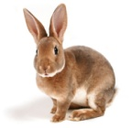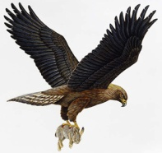  - III.Active vocabulary.  - Read the words with the translations. Pay your attention to the pronunciation of the words.  - Now write the words  - Reading and speaking about the Internet.  The Internet  The Internet is a huge network of computers. Public Internet began in the late 70’s. The Internet is very helpful, because it is a huge database of knowledge. Everyone should have the Internet as a means of communication. Besides data one can get from the Internet, we can also send and receive e- mail. This internet service is cheaper than ordinary mail and much quicker. It is becoming popular day by day. We can get some news from the Internet, because there are many informational services in the web. For this we can get use different search programmes such as the google search programme, rambler search programme, yandex search programme or yahoo search programme. They are very simple and popular networks of sites. ( 123 words)  Answer the questions:  - What is the Internet?  - When did public Internet appear?  - In what way can the Internet be useful to everyone?  - What can you say about advantages of the e- mail?  - What search programmes do you know? Which one do you use?  - IV.Grammar Revision. Conditional sentences.  Образуйте условные предложения I и II типа.  If you (to be) free, I (to come) to see you.  2. If I (to see) her, I (to be) glad.  3. If you (to be) busy, I (to leave) you alone.  4. If I (to live) in Moscow, I (to visit) the Tretyakov Gallery every year.  5. If she (to know) English, she (to try) to enter the university.  6. If mother (to buy) a cake, we (to have) a very nice tea part.  V. Conclusion of the lesson.  Cinquain Internet Helpful useful Search send receive Internet is useful for everyone.  Network homework learn new words and Ex. 7, p.54. Say three things you wish you had
  huge- громадный  network- сеть  database- база данных  e- mail-электронная почта  service- служба  search- искать  search programme- поисковая программа | - [ huj:dӡ]-  - [netwә:k]-  - [ databeize]-  - [ i: mail]-  - [ sә:vis]-  - [ sә:tᶘ]-  - [ sә:tᶘ prɔgrᴂm]-
Additional information
Differentiation – how do you plan to give more support? How do you plan to challenge the more able learners? |  |  | Assessment – how are you planning to check learners’ learning? |  |  | Critical thinking
Circulate about the room helping students with vocabulary and expressions. Monitor learners to check they can pick up main points from the text when answering the questions.Following each pair or individual activity. |  |  | Critical thinking lies in skill of forming communicative vocabulary while listening and writing skills. The ability of learners to react, analyze, and choose the right answers.

Бекітемін________
Short term lesson plan
UNIT 3. EDUCATION IN KAZAKHSTAN AND THE USA (14hours) |  |  |  | School: № 36 secondary school
Date:______ ______ ______ |  |  |  | Teacher’s name: Onggalieva Laura
Grade : 8a 8b 8ә |  |  |  | Number present: | Number absent:
Theme of the lesson: |  |  |  | Schools we get knowledge in
Lesson objectives |  | All learners will be able to:
- to talk about education and modern schools.
- To introduce pupils with the new words and how to use the words.
- To develop the abilities to speak English, creative abilities of pupils.
- To teach the pupils to be able to discuss, to find expressions in any situation.
- To develop pupil’s memory, logical thought, vocabulary.
 |  | Developing: to revise previous theme; to develop mental activity of the pupils
 |  | Student centered teaching: respect, support and scaffolding. To create a friendly atmosphere for collaborative work. To promote a sense of self-esteem and self-respect and respect for others among all the learners.
 |  | Everyday classroom precautions will ensure that safety measures are provided to prevent the exposure of electrical power cords.
 |  | Planned activities
Useof ICT |  | Greetings,Good morning pupils! Who is on duty today? Who is absent? I’m glad to see you!What date is it today? Thank you!Sit down please  Today we are going to learn new theme, to learn new words, to do some exercise, to checking up your home work, answer the question, read and translate, work in groups.
Pastoral Care |  | Students reflect on the skills that they have received while studying the unit. What was the most and the least beneficial for them?
Health and Safety |  | Feedback: Teacher asks students what task was difficult to them and which pair worked well.
Planned timings | Planned activities |  |  |  |  |  | Resources
9 min  3 min  12 min  10min  4 min  2 min | I.  New theme: Schools we get knowledge in  Let’s start our new lesson. Today we will speak about education and the role of knowledge in our life. Every one in our country has the right for education. It is said in our constitution. But it is not only a right, it is a duty, too. Every girl and every boy in our country must go to school to get education. There are thousands of schools in our country where pupils get knowledge in different subject. Nowadays schools have become different. What are modern schools?  Let’s study the types of modern schools. Let’s study about education. It’s our new theme “Schools we get knowledge in”.  Write down the today’s date and theme. At first, let’s learn the new words.  There are new words for you to learn. I’ll read and you’ll repeat after me.  Now, boys and girls look at the interactive board.  The more we learn – the more we know  The more we know – the more we forget  The more we forget – the less we know.  So why study?  So, “Why do you study? Why do you go to school?”, “Is education important?”  Pupils: I go to school, because we must get education school;  because secondary education is compulsory;  because it is interesting to study;  because I like to take part in social life;  because knowledge is power;  because I want to get an interesting profession;  because I want to enter a University;  because I want to succeed in life.  Why do you study?  Where do you study?  How many floors has your school got?  Which floor is your classroom located on?  What subjects do you study at your school?  What subjects you like best?  Speak on the proverbs  Now let’s remember proverbs about learning. Give the kazakh equivalents. Repeat it after me, please.  How do you understand it? The more a man knows, the more opportunities he has. Knowledge gives a man great power. Everybody must try to increase his knowledge. Knowledge is power, isn’t it?  Live and learn.  Knowledge is power.  A little learning is a dangerous .  Now, let’s read the poem.  Today is yours  Don’t wait till tomorrow  to reach out and grow,  To learn something interesting  you didn’t know.  Don’t wait till tomorrow  to find ways to share,  To make a new friend,  really show that you care.  Don’t wait till tomorrow  to follow your heart,  To savor the beauty  that life can impart.  Don’t wait till tomorrow  to let yourself start…  Take time to do it today!  What is the idea of the poem? (You shouldn’t waste time, should you? You should find ways to grow, to improve your knowledge. What is your main task now? It the most important time for you, isn’t it?  Now I suppose it’ll be interesting to see the slide show about British school. Do you want to know about their school life. Let’s look at the board. ( to show slide )  Let’s do the exercises:  Task 1.  Match the words with it’s translation.  Primary school ————— орта мектеп  Curriculum ———————міндетті  Secondary school————- бастауыш мектеп  Uniform————————–оқу бағдарламасы  Timetable———————–мектеп формасы  Сompulsary———————сабақ кестесі  Mark—————————–жәй, қарапайым  Ordinary————————баға  Task 2.  Translate the sentences using real conditional.  1.Егер мен мектептен жақсы білім алсам, мен университетте оқитын боламын.  Ауа-райы жақсы болса, балалар көшеде ойнайды.  Егер біз ағылшын тілін үйренсек, біз шет елдерге барамыз.  Егер барлық оқушылар мектеп формасын кисе, олар әдемі болады.  Task 3. What school subjects you are …..  I am good at —————- .  I am bad at —————– .  I am interested in ———– .  I ‘m bored with ————- .  I’m keen on —————- .  Home task: Ex6 p.106 and to write a composition “My school”.  Conclusion: Our lesson is over. Everybody was very active today, everybody tried to share his opinion today. So, I think I should give only good and excellent marks today.
  education –білім  knowledge – білім  timetable – сабақ кестесі  uniform – мектеп формасы  mark – баға  ordinary school – жәй, қарапайым мектеп | primary school – бастауыш мектеп  secondary school – орта мектеп  comprise – құрайды  compulsory –міндетті  last – созылу, жалғасу  curriculum – оқу бағдарламасы
Additional information
Differentiation – how do you plan to give more support? How do you plan to challenge the more able learners? |  |  | Assessment – how are you planning to check learners’ learning? |  |  | Critical thinking
Circulate about the room helping students with vocabulary and expressions. Monitor learners to check they can pick up main points from the text when answering the questions.Following each pair or individual activity. |  |  | Critical thinking lies in skill of forming communicative vocabulary while listening and writing skills. The ability of learners to react, analyze, and choose the right answers.

Бекітемін________
Short term lesson plan
UNIT 3. EDUCATION IN KAZAKHSTAN AND THE USA (14hours) |  |  |  | School: № 36 secondary school
Date:______ ______ ______ |  |  |  | Teacher’s name: Onggalieva Laura
Grade : 8a 8b 8ә |  |  |  | Number present: | Number absent:
Theme of the lesson: |  |  |  | Secondary education
Lesson objectives |  | All learners will be able to:
1) Repeat the studied and new vocabulary.
2) Help pupils to form the healthy way of life.
3) Teach pupils to work in pairs and groups.
 |  | Developing: to revise previous theme; to develop mental activity of the pupils
 |  | Student centered teaching: respect, support and scaffolding. To create a friendly atmosphere for collaborative work. To promote a sense of self-esteem and self-respect and respect for others among all the learners.
 |  | Everyday classroom precautions will ensure that safety measures are provided to prevent the exposure of electrical power cords.
 |  | Planned activities
Useof ICT |  | Greetings,Good morning pupils! Who is on duty today? Who is absent? I’m glad to see you!What date is it today? Thank you!Sit down please  Today we are going to learn new theme, to learn new words, to do some exercise, to checking up your home work, answer the question, read and translate, work in groups.
Pastoral Care |  | Students reflect on the skills that they have received while studying the unit. What was the most and the least beneficial for them?
Health and Safety |  | Feedback: Teacher asks students what task was difficult to them and which pair worked well.
Planned timings | Planned activities |  |  |  |  |  | Resources
7 min  3 min  12 min  10min  4 min  2 min | I.  New theme: Secondary education  school yard -мектеп ауласы  portrait -- портрет  computer - компьютер  discussion- талқылау  ground - жер  cloak-room- гардероб  assignment- тағайындау  famous - атақты  topic- Тақырып  III.Listen and read the text Ex.Vp.111  “Our school”  Our school is large. It is located not far from the centre of the city. If you come to our school you will see a wide school-yard around it and a sports ground behind the school. We usually have Physical Training lessons there when the weather is fine.  Our school has got three floors. There are several classrooms for the pupils of the primary school on the ground floor. There is a cloak-room, a dining room and a library there too. In the library you can find many interesting books. Our pupils often go there when they want to find something interesting for their home assignment or out-class activity. If you look around the library hall you will see many portraits of famous English, Kazakh and Russian writers on the walls.  When you enter and go to the right along the corridor you will see the dinning room, where teachers and pupils have their dinner. Near the dining room you will see the Gymnasium. The pupils like to go there because many.of them like PT lessons.  The classrooms for secondary forms and computer rooms for all pupils are on the first and the second floors. There we have two Kazakh class-rooms, English, Russian, Physics, Geography and other class-rooms. Every pupil of our school learns one of foreign languages: English, German or French. We learn English because at the present time it is the most widespread language in the world. At the English lessons we learn new words, grammar, poems, read texts, ask and answer questions. Most of all we like to speak English. During the English lessons we also do many exercises, listen to the topics for discussion.  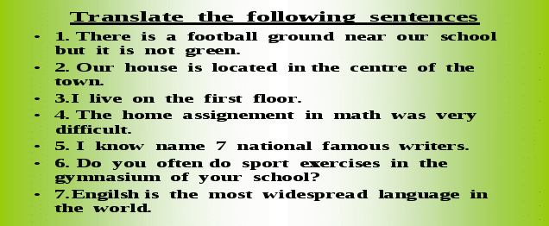  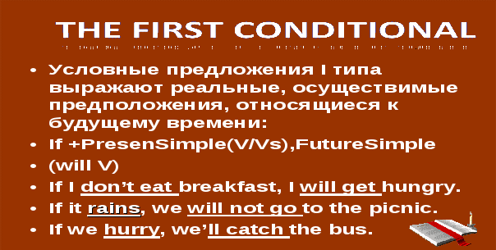    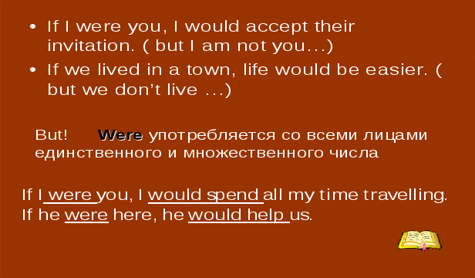
Additional information
Differentiation – how do you plan to give more support? How do you plan to challenge the more able learners? |  |  | Assessment – how are you planning to check learners’ learning? |  |  | Critical thinking
Circulate about the room helping students with vocabulary and expressions. Monitor learners to check they can pick up main points from the text when answering the questions.Following each pair or individual activity. |  |  | Critical thinking lies in skill of forming communicative vocabulary while listening and writing skills. The ability of learners to react, analyze, and choose the right answers.

Бекітемін________
Short term lesson plan
UNIT 3. EDUCATION IN KAZAKHSTAN AND THE USA (14hours) |  |  |  | School: № 36 secondary school
Date:______ ______ ______ |  |  |  | Teacher’s name: Onggalieva Laura
Grade : 8a 8b 8ә |  |  |  | Number present: | Number absent:
Theme of the lesson: |  |  |  | Step 8 My School Day.p.85
Lesson objectives |  | All learners will be able to:
1) Repeat the studied and new vocabulary.
2) Help pupils to form the healthy way of life.
3) Teach pupils to work in pairs and groups. Talk about the school day of British school children and about your typical school day
 |  | Developing: to revise previous theme; to develop mental activity of the pupils
 |  | Student centered teaching: respect, support and scaffolding. To create a friendly atmosphere for collaborative work. To promote a sense of self-esteem and self-respect and respect for others among all the learners.
 |  | Everyday classroom precautions will ensure that safety measures are provided to prevent the exposure of electrical power cords.
Planned timings | Planned activities |  |  |  |  |  | Resources
3 min  7 min  10 min  8 min  5 min  5min  2 min | I.  Greetings,Good morning pupils! Who is on duty today? Who is absent? I’m glad to see you!What date is it today? Thank you!Sit down please  Today we are going to learn new theme, to learn new words, to do some exercise, to checking up your home work, answer the question, read and translate, work in groups.  New theme: My School Day  I.Read the dialogue “Before the lesson”  Aidar:Hi.Nick!I have got something interesting to tell you.  Nick:Really?What is it?  Aidar:Well,I've got acquainted with an English boy of my age.  Nick:Who is he and from where?  Aidar:He is John Smith.His father has come to Astana from London as a businessman for several weeks.John came with him too.  Nick:It's really interesting.Are you going to introduce him to me?  Aidar:Not only to you.Let's invite him to our class.I thing he will agree.  Nick:If he agress we shall ask him to tell us something about English schools.  Asel:What are you talking about?  Aidar:It's a secret.It isn't for girls!  Asel:A secret?What kind of secret for girls?  Nick:No secret at all.Aidar has got a good idea.He proposes to invite an English boy John Smith to meet with our class.  Asel:Oh!It's really a good idea but first we should ask our English teacher for the permission to do it.  Aidar:Right.Let it be so!  II.Tell the class  When you get up  When you are at school  get away – избежать, удрать, ускользнуть, улизнуть, уходить, уезжать  get back – (брит.) вернуться к власти  get on – садиться на / в транспортное средство  get up – будить  get off – спастись, избежать ранения; (разг.) избежать наказания, выйти  get down – спуститься, опуститься; приказ: слезай, опустись, пригнись; вниз!  get through – справиться; выдержать экзамен  get on (with) – приступить к, или продолжить какое-л. дело  Get on to it. – Приступай(те)  get around – навещать, посещать, приводить (кого-л.) в гости  Do get your new boyfriend round to see us.  get along – уживаться, ладить  Does he get along with his mother-in-law?  Он находит общий язык со своей мачехой  1. Complete the sentences.  1.The dog get away from me and I could not catch it.  2.I get around by bicycle, but my brother gets around on foot.  3. It is time to stop talking and get on for our work.  Indirect speech  - Fred said: “I have invented a new computer program”. (Фрэд сказал: «Я изобрел новую компьютерную программу.»)  - Mary said: “I will help my sister.” (Мэри сказала: «Я помогу своей сестре.»)  - They told me: “We were really happy.” (Они сказали мне: «Мы были очень счастливы.»)  - She said: “I live in a big apartment.” (Она сказала: «Я живу в большой квартире.»)  - He told her: “I am going to the fish market.” (Он сказал ей: «Я собираюсь на рыбный рынок.»)  - Betty said: “I found my passport.” (Бетти сказала: «Я нашла свой паспорт.»)  - Mr. Ford said: “I don’t like pork.” (М-р Форд сказал: «Я не люблю свинину.»)  - Little Tim told his mother: “I am sleepy.” (Маленький Тим сказал маме: «Я хочу спать.»)  - Fred said (that) he had invented a new computer program.  - Mary said (that) she would help her sister.  - They told me (that) they had been really happy.  - She said (that) she lived in a big apartment.  - He told her (that) he was going to the fish market.  - Betty said (that) she had found her passport.  - Mr. Ford said (that) he didn’t like pork.  - Little Tim told his mother (that) he was sleepy.  Ex. 3 p. 87  Learn new information about a day at an English school
Additional information
Differentiation – how do you plan to give more support? How do you plan to challenge the more able learners? |  |  | Assessment – how are you planning to check learners’ learning? |  |  | Critical thinking
Circulate about the room helping students with vocabulary and expressions. Monitor learners to check they can pick up main points from the text when answering the questions.Following each pair or individual activity. |  |  | Critical thinking lies in skill of forming communicative vocabulary while listening and writing skills. The ability of learners to react, analyze, and choose the right answers.

Бекітемін________
Short term lesson plan
UNIT 3. EDUCATION IN KAZAKHSTAN AND THE USA (14hours) |  |  |  | School: № 36 secondary school
Date:______ ______ ______ |  |  |  | Teacher’s name: Onggalieva Laura
Grade : 8a 8b 8ә |  |  |  | Number present: | Number absent:
Theme of the lesson: |  |  |  | Step 9 Speaking about Schools.  p.90
Lesson objectives |  | All learners will be able to:
1) Repeat the studied and new vocabulary.
2) Help pupils to form the healthy way of life.
3) Teach pupils to work in pairs and groups. Talk about the school day of British school children and about your typical school day
 |  | Developing: to revise previous theme; to develop mental activity of the pupils
 |  | Student centered teaching: respect, support and scaffolding. To create a friendly atmosphere for collaborative work. To promote a sense of self-esteem and self-respect and respect for others among all the learners.
 |  | Everyday classroom precautions will ensure that safety measures are provided to prevent the exposure of electrical power cords.
Planned timings | Planned activities |  |  |  |  |  | Resources
3 min  7 min  8 min  10 min  10 min  2 min | I.  Greetings,Good morning pupils! Who is on duty today? Who is absent? I’m glad to see you!What date is it today? Thank you! Sit down please  Today we are going to learn new theme, to learn new words, to do some exercise, to checking up your home work, answer the question, read and translate, work in groups.  I.Put the words (Take, state , school , specialize , pass , secondary school , SUBJECTS , FAil , private schools , marks.)  Dan started his new school at the age of 11. There are many kinds of school from this age , but the general world for them is (a) __ . Dan s school is a government school , usually called a (b) __ . Some parents pay to send their children to a (c) __ . At first Dan will take a lot of different (d) __ ( history , chemistry etc) but , after a few years , he will begin to (e) ___ in things he is good at and interested in. Then he will (f) ___ some exams . If he can (g) ___ A number of exams with good (h)_____ (A.B.C) , it will help him to get a good job. Of course he hopes he doesn t (f)___  II.Put the correct prepositions from the following list:  from, in, with, between, of, at, to, on  - Harry started school at the age of five.  2. They have a holiday on Christmas.  3. There is a holiday in the summer, too.  4. The teachers in the school are very young.  5. Dan goes to a secondary school.  6. He ell probably pass at good marks.  7. Betty is a teacher of English.  8. Her pupils are between 12 and 18.  9. She is very strict to them.  Translate the sentences  1. Ол төрт жылдық бастауыш мектепті бітірген соң, орта мектепке барды. 2. Бастауыш және орта мектептерде он бір жыл оқиды 3. Оқу жылы тоғыз айға созылады. 4. Тоғыз жылдық оқу жалпыға бірдей міндетті. 5. Англияда міндетті оқу бес жастан басталады. 6. Балалар жеті жасқа толғанда бастауыш мектепке барады, онда олар он бір жыл оқиды. 7. Егер балалар грамматикалық мектепке барса, онда олар орта білім алады. 8. Ағылшын мектебіндегі басты пәндер-ағылшын тілі, математика және биология мен химия. 9. Ағылшын оқушылары мектеп формасын киеді. 10. Жекеменшік ағылшын мектептерінде ұлдар мен қыздар бірге оқымайды.  Начало формы  1. After four years of primary school you went to secondary school.  2. Primary and secondary schools together comprise eleven years of study.  3. The school year lasts nine months.  4. Nine years of classes are compalsary.  5. In Great Britain compulsary education begins at the age of five.  Белгісіз 14.03.2013 жауап берді  Пікір  6. When the children are seven they go to primary school and study there for eleven years.(балалар бастауыш мектепте 11 жыл оқымайды ғой, 4-ақ жыл оқиды.)  7. If they go to grammar school they will have secondary education.  8.In Great Britain English. Maths and Science are called "core" subjects.  9. It may be strange for you to know that English pupils have school uniform.  10. In privare school boys ans girls do not study together.  Answer the questions  1.Do children usually go to nursery schools?  2.At what age is education compulsory in the USA and your country?  3.What different kinds of secondary schools are there in the USA and Kazakhstan?  4.Are there many private schools in the USA and Kazakhstan?  5.Do you specialize in certain subjects at school? Which ones?  6.Did you take any exams? What were the results?  7.Are different kinds of secondary schools mixed?  8.When do you have holidays?  9.How long are they?  10.Do you do a lot of homework at school?  11.Do the pupils of your school behave well at school?  Ex. 7 p. 92  Translate the sentences into English Translate the sentences into English Конец формы
Additional information
Differentiation – how do you plan to give more support? How do you plan to challenge the more able learners? |  |  | Assessment – how are you planning to check learners’ learning? |  |  | Critical thinking
Circulate about the room helping students with vocabulary and expressions. Monitor learners to check they can pick up main points from the text when answering the questions.Following each pair or individual |  |  | Critical thinking lies in skill of forming communicative vocabulary while listening and writing skills. The ability of learners to react, analyze, and choose the right answers.

Бекітемін________

Short term lesson plan
UNIT 3. EDUCATION IN KAZAKHSTAN AND THE USA |  |  |  | School: № 36 secondary school
Date: 11.12 12.12 |  |  |  | Teacher’s name: Onggalieva Laura
Grade : 8a 8b 8ә |  |  |  | Number present: | Number absent:
Theme of the lesson: |  |  |  | Step 10 A Day at School
Lesson objectives |  | All learners will be able to:
1) Repeat the studied and new vocabulary.
2) Help pupils to form the healthy way of life.
3) Teach pupils to work in pairs and groups. Talk about the school day of British school children and about your typical school day
 |  | Developing: to revise previous theme; to develop mental activity of the pupils
 |  | Student centered teaching: respect, support and scaffolding. To create a friendly atmosphere for collaborative work. To promote a sense of self-esteem and self-respect and respect for others among all the learners.
 |  | Everyday classroom precautions will ensure that safety measures are provided to prevent the exposure of electrical power cords.
Planned timings | Planned activities |  |  |  |  |  | Resources
3 min  7 min  10 min  8 min  10 min  2 min | I.  Greetings,Good morning pupils!  Who is on duty today?  Who is absent? I’m glad to see you!  What date is it today? Thank you! Sit down please  Today we are going to learn new theme, to learn new words, to do some exercise, to checking up your home work, answer the question, read and translate, work in groups.  I.Discuss the following text.  Hi! My name is Debbie. I want to tell you something about a typical day at my school.  Come and spend a day at an English school. It is nearly 9 on a Monday morning and the boys and girls are coming to school again after Saturday and Sunday. Some of them walk to school, somecome on their bicycles and others who live far from the school come by bus.  It is eleven o'clock: time for the mid-morning break.The boys and girls go out into the play ground to collect their milk: every boy and girl at school in England is given milk every day. When they have drunk milk, they can play until it is time to go back inside for lessons.  After break there are more lessons. Then it is one o' clock. Time for lunch! Nearly  to their schoo, go home. The break for lunch lasts about an hour. After lunch, there is still time to go out and play.  At two o'clock lessons start again. In this school chindren do not do lessons lide history, geography and maths – the girls learn to type and sew and to cook and the boys do metalwork and woodwork.  At three o'clock it is time for games. At English schools girls usually play hockey in winter and tennis in summer; the boys play football in winter and cricket in summer.  Lessons finish at four. The children collect the books they need to do their homework and go home. Very soon after four o'clock the school is empty, except for a few children and teachers. One or two choldren have to stay behind as a punishment. Others are staying for a club or society which has its meeting after school. The they will go home too and the school will be empty – until tomorrow.  Модальные глаголы: Must и have to  Must — это очень «жесткий» глагол, который выражает обязанность или необходимость что-то сделать. Must сильнее, чем should. Если в случае should еще есть какой-то выбор (делать или не делать), то в случае must выбора нет! Это приказ.  Have to имеет такое же значение, как must.  1. Must и have to используются для выражения необходимости что-то сделать.  Пример  I must leave. — Я должен уйти.  I have to leave. — Я должен уйти.  В этой ситуации must и have to используются взаимозаменяемо.  2. Разница в использовании must и have to  Must носит более личностный характер. Must используется для выражения личных чувств и ощущений.  Пример  I must do my best. — Я должен сделать все возможное.  В данном случае говорящий выражает свои чувства по этому поводу.  Have to носит безличностный характер. Have to используется, когда речь идет о фактах, а не о личных ощущениях.  Пример  I have to visit my doctor. — Я должен посетить своего врача.  Видимо, со здоровьем не все в порядке, и это факт, с которым не поспоришь, а не какое-то там личное ощущение.  Примечание  Иногда разница в употреблении must и have to настолько тонка, что трудно определить, какой же глагол нужно использовать. В таких ситуациях лучше использовать have to.  3. Must — прошлого нет!  Запомните, глагол must не имеет формы прошедшего времени!  Поэтому его можно использовать для настоящего и будущего времени, но не для прошлого.  Пример  We must visit a doctor now. — Мы должны посетить врача сейчас.  We must visit a doctor tomorrow. — Мы должны посетить врача завтра.  4. Have to — для всех форм  В отличие от must, have to можно использовать для всех форм, в том числе и для прошедшего времени.  Пример  I had to visit my doctor. — Я должен был посетить своего врача.  Мы не можем здесь сказать must, потому что время прошедшее! Поэтому спокойно используем эквивалент must — have to!  5. Логическое умозаключение  Must используется, если говорящий делает вывод на основе имеющихся фактов. И хотя при этом у него полной уверенности, что его вывод — абсолютная истина, до этого недалеко. Русский аналог — конструкция «должно быть». А там, где должен, там и must!  Пример  The ground is wet. It must be raining. — Земля мокрая. Должно быть, идет дождь.  Земля мокрая — вот мы и сделали вывод о том, что идет дождь! И поскольку логика у нас железная, используем must! Ведь дождь должен идти, он просто не может не идти!  6 Mustn’t и don’t have to — две большие разницы  Mustn’t = не делай этого! Это приказ! (don’t do it)  Don’t’ have to = не нужно этого делать или необязательно (но в принципе можно)  Примеры  You mustn’t be late. — Ты не должен опоздать.  (Не опаздывай! Опаздывать нельзя!)  You don’t have to be on time. — Тебе необязательно приходить вовремя.  Т.е. ты можешь опоздать. Но в принципе можешь прийти и вовремя.  II. Вставьте must/have to  1. We really ......... do something about having this house decorate  2. We ........... pay this electricity bill by the end of the week  3. You .............. write and let us know you've arrived safely  4. I............... be at my desk by 9.00 every morning  5. We always .......... clock in when arrive at work  6. All visitors ........... report to the duty officer  7. .......... you always slam the door when you come in?  8. You really ............ come and see the new extension to our house some  1.must  2. must  3. have to  4.must  5/must  6.have to  7.Have  8.have to  Ex. 6 p. 94
  Exercise 1. 1-b, 2-c, 3-a, 4-d  Exercise 2.  1 – 3, 5 must  4, 6 — mustn’t  Exercise 5.  1, 3, 7 – must  2, 4, 5, 6 – mustn’t | Exercise 7.  2-H – Jill must have a drink.  3-A – Girls mustn’t go near it.  4-B – He must go to the optician's.  5-J – Friends mustn’t forget to send him a card.  6-I – Jill must tidy it.  7-D – She must hurry.  8-F – We mustn’t make any noise.  9- D – She must go to bed.  10-C – You must come.
Additional information
Differentiation – how do you plan to give more support? How do you plan to challenge the more able learners? |  |  | Assessment – how are you planning to check learners’ learning? |  |  | Critical thinking
Circulate about the room helping students with vocabulary and expressions. Monitor learners to check they can pick up main points from the text when answering the questions.Following each pair or individual activity. |  |  | Critical thinking lies in skill of forming communicative vocabulary while listening and writing skills. The ability of learners to react, analyze, and choose the right answers.

Бекітемін________

Short term lesson plan
UNIT 3. EDUCATION IN KAZAKHSTAN AND THE USA |  |  |  | School: № 36 secondary school
Date: 12.12 13.12 |  |  |  | Teacher’s name: Onggalieva Laura
Grade : 8a 8b 8ә |  |  |  | Number present: | Number absent:
Theme of the lesson: |  |  |  | Education
Lesson objectives |  | All learners will be able to:
1) Repeat the studied and new vocabulary.
2) Help pupils to form the healthy way of life.
3) Teach pupils to work in pairs and groups. Talk about the school day of British school children and about your typical school day
 |  | Developing: to revise previous theme; to develop mental activity of the pupils
 |  | Student centered teaching: respect, support and scaffolding. To create a friendly atmosphere for collaborative work. To promote a sense of self-esteem and self-respect and respect for others among all the learners.
 |  | Everyday classroom precautions will ensure that safety measures are provided to prevent the exposure of electrical power cords.
Planned timings | Planned activities |  |  |  |  |  | Resources
3 min  7 min  8 min  10 min  2 min | I.  Greetings,Good morning pupils!  Who is on duty today?  Who is absent? I’m glad to see you!  What date is it today? Thank you! Sit down please  Today we are going to learn new theme, to learn new words, to do some exercise, to checking up your home work, answer the question, read and translate, work in groups.  1 nursery a) a school for advanced education, especially in a particular profession  2 kindergarten b) a school in the US and Canada for children of 14 or 15 to 18 years old  3 primary c) a school for children aged two to five  4 secondary d) a school for children who are between three and five years old  5 junior high e) a school for children between the ages of 11 and 16 or 18  6 high school f) a school for children between five and 11 years old in England  7 elementary g) a school in the US and Canada for Children aged between 12 and 14 or 15  8 college h) a school in the US for the first six years of a child’s education  Teacher: Thank you. You know the vocabulary well.  Key: 1 d, 2 c, 3 f, 4 e, 5 g, 6 b, 7 h, 8 a.  School…  - is a place where you can make new friends,  - helps you make your own decisions,  - helps you understand yourself better,  - teaches you to be polite.,  - helps you get knowledge,  - prepare for a future occupation,  - teaches you about countries, culture and the world,  - teaches you to be honest, clever and educated person.  Ex. 4 p. 97
  realize  basic  instructions  computerize  vision  distance  electronics  method  talent  life-long | жүзеге асырады  негізгі  нұсқаулар  компьютерлендіру  көру  қашықтық  электроника  әдісі  талант  өмір бойы
Additional information
Differentiation – how do you plan to give more support? How do you plan to challenge the more able learners? |  |  | Assessment – how are you planning to check learners’ learning? |  |  | Critical thinking
Circulate about the room helping students with vocabulary and expressions. Monitor learners to check they can pick up main points from the text when answering the questions.Following each pair or individual activity. |  |  | Critical thinking lies in skill of forming communicative vocabulary while listening and writing skills. The ability of learners to react, analyze, and choose the right answers.

Бекітемін________

UNIT 3. EDUCATION IN KAZAKHSTAN AND THE USA |  |  |  | School: № 36 secondary school
Date: 19.12 20.12 |  |  |  | Teacher’s name: Onggalieva Laura
Grade : 8a 8b 8ә |  |  |  | Number present: | Number absent:
Theme of the lesson: |  |  |  | Education
Lesson objectives |  | All learners will be able to:
1) Repeat the studied and new vocabulary.
2) Help pupils to form the healthy way of life.
3) Teach pupils to work in pairs and groups. Talk about the school day of British school children and about your typical school day
 |  | Developing: to revise previous theme; to develop mental activity of the pupils
 |  | Student centered teaching: respect, support and scaffolding. To create a friendly atmosphere for collaborative work. To promote a sense of self-esteem and self-respect and respect for others among all the learners.
 |  | Everyday classroom precautions will ensure that safety measures are provided to prevent the exposure of electrical power cords.
Planned timings | Planned activities |  |  |  |  |  | Resources
3 min  7 min  8 min  10 min  2 min | I.  Greetings,Good morning pupils! Who is on duty today?  Who is absent? I’m glad to see you!  What date is it today? Thank you! Sit down please  Today we are going to learn new theme, to learn new words, to do some exercise, to checking up your home work, answer the question, read and translate, work in groups.  1.Read the text and answer the following questions.  1.What do you want to be in Future?  2. What field would you like to be in ?  3. What do you know about your future profession?  4. Is this profession now or old ?  5. What do you need to get this profession?  6. What do you think about new professions in our life?  7. ls education or training necessary to be successful in life?  2. Read and say what profession you would like to choose  Choosing a profession  Ecologists  Doctors  Geologists  Journalists  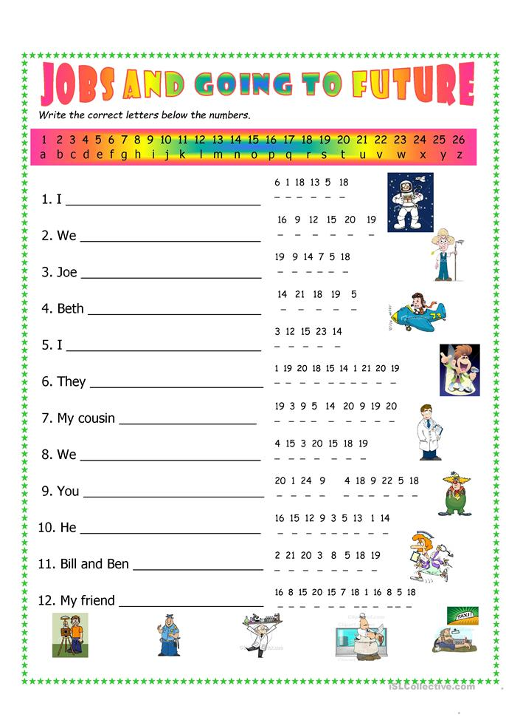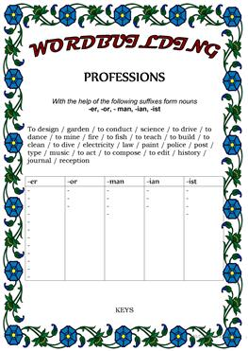  Write an essay “Education is our generation’s debt to the future”
  My future profession
  My name is Svetlana. I am in the 8th grade. There are many different professions in the world, but I want to become a doctor. After finishing school I am going to enter medical institute. It seems to me that it’s my vocation. I like to help people. To become a doctor I must be good at studies because a doctor is needed and responsible profession. We trust doctors the main what we have – our life and that’s why a doctor must be qualified specialist. He must help people at any time of the day. A doctor can’t make a mistake. Qualified specialist always diagnoses and institutes therapy correctly. Human life often depends on professionalism of a doctor. They must be very heedful and openhearted people. A doctor always must worry about a health of his patient. He must be able to inspire patients with faith. My mother and grandmother are doctors. They are proud of their profession and like it. I consider that a doctor is the best profession.
Additional information
Differentiation – how do you plan to give more support? How do you plan to challenge the more able learners? |  |  | Assessment – how are you planning to check learners’ learning? |  |  | Critical thinking
Circulate about the room helping students with vocabulary and expressions. Monitor learners to check they can pick up main points from the text when answering the questions.Following each pair or individual activity. |  |  | Critical thinking lies in skill of forming communicative vocabulary while listening and writing skills. The ability of learners to react, analyze, and choose the right answers.

Бекітемін________

UNIT 3. EDUCATION IN KAZAKHSTAN AND THE USA |  |  |  | School: № 36 secondary school
Date: 19.12 20.12 |  |  |  | Teacher’s name: Onggalieva Laura
Grade : 8a 8b 8ә |  |  |  | Number present: | Number absent:
Theme of the lesson: |  |  |  | Progress test
Lesson objectives |  | All learners will be able to:
1) Repeat the studied and new vocabulary.
2) Help pupils to form the healthy way of life.
3) Teach pupils to work in pairs and groups. Talk about the school day of British school children and about your typical school day
 |  | Developing: to revise previous theme; to develop mental activity of the pupils
 |  | Student centered teaching: respect, support and scaffolding. To create a friendly atmosphere for collaborative work. To promote a sense of self-esteem and self-respect and respect for others among all the learners.
 |  | Everyday classroom precautions will ensure that safety measures are provided to prevent the exposure of electrical power cords.
Planned timings | Planned activities |  |  |  |  |  | Resources
3 min  10 min  10 min  2 min | I.  Greetings,Good morning pupils! Who is on duty today?  Who is absent? I’m glad to see you!  What date is it today? Thank you! Sit down please  Today we are going write Progress test, to checking up your home work.  1.Have you ever been to Europe?  Yes, I have  2.John is watching a TV programme about animals in South America.  What is John watching a TV programme about?  3.George speaks Russian very well.  George speaks Russian?  4.She always buys black coffee without sugar.  Does she buys always black coffee or with sugar?  5.She is learning French because she wants to leave for France.  Why does she want to leave for France?  6.Вы придёте завтра к нам? - Да!  Will you come to our place tomorrow? - Yes, I will !  7.Сколько стоит этот телефон? - 500 долларов!  How much this phone? - 500 dollars.  8.You can`t postpone your wedding, ... ?  can you  9.Don`t be late for the meeting, ... ?  Ok  Get across – түсіндіру Alan is really intelligent but sometimes he has problems getting his ideas across. &  Get along – тіл табысу Why can't you and your sister get along?  Get away – кетіп қалу I’ll be getting away.  Get away with – жазасын өтеу құтылу You won’t get away with the robbery.  Get back – кері оралу When are they planning to get back?  Get down to – бір іске кірісу Get down to work!  Get in – ішке кіру She just got in her car and drove away.  Get on – транспортқа отыру , міну She got on the plane about 20 minutes ago.  Get off – транспорттан шығу When you get off the bus, cross the street.  Get out of – шығып кету You'll have to get out of the car.  Get over – жазылу аурудан айығу She thought she would never get over feeling so stupid.  Get through (to) – байланысу You should get through to the manager.  Get up – ояну You'll have to get up much earlier than usual tomorrow.  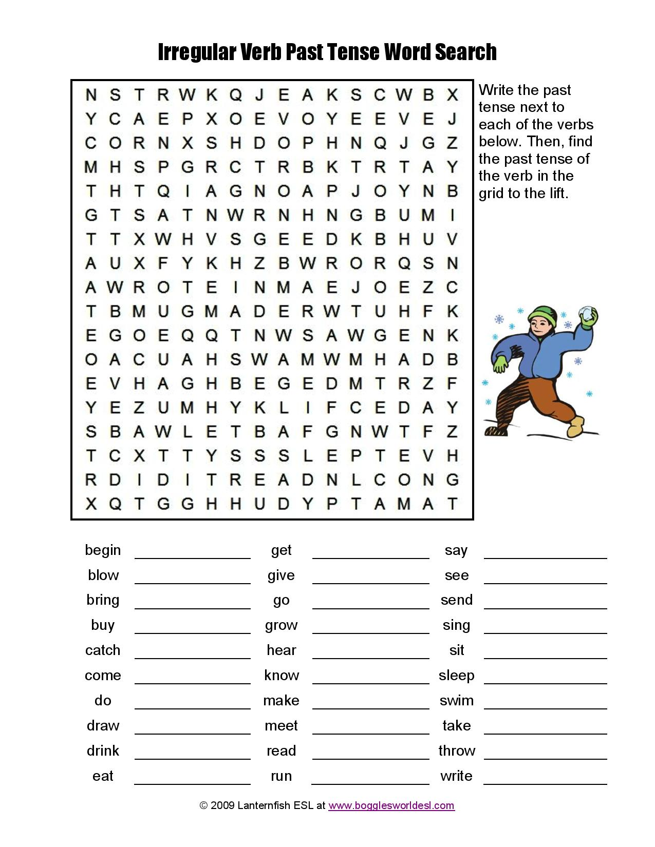
  Began  Blew  Brought  Bought  Caugch  Came  Did  Drew  Drunk  Ate | Got  Gave  Went  Grown  Heard  Known  Made  Met  Read  Run | Said  Saw  Sent  Sank  Sat  Slept  Swam  Took  Throught  Wrote
Additional information
Differentiation – how do you plan to give more support? How do you plan to challenge the more able learners? |  |  | Assessment – how are you planning to check learners’ learning? |  |  | Critical thinking
Circulate about the room helping students with vocabulary and expressions. Monitor learners to check they can pick up main points from the text when answering the questions.Following each pair or individual activity. |  |  | Critical thinking lies in skill of forming communicative vocabulary while listening and writing skills. The ability of learners to react, analyze, and choose the right answers.

Бекітемін________

Diagnostic test |  |  |  | School: № 36 secondary school
Date: 08.01 09.01 |  |  |  | Teacher’s name: Onggalieva Laura
Grade : 8a 8b 8ә |  |  |  | Number present: | Number absent:
Theme of the lesson:
Lesson objectives |  | All learners will be able to:
1) Repeat the studied and new vocabulary.
2) Help pupils to form the healthy way of life.
3) Teach pupils to work in pairs and groups. Talk about the school day of British school children and about your typical school day
 |  | Developing: to revise previous theme; to develop mental activity of the pupils
 |  | Student centered teaching: respect, support and scaffolding. To create a friendly atmosphere for collaborative work. To promote a sense of self-esteem and self-respect and respect for others among all the learners.
 |  | Everyday classroom precautions will ensure that safety measures are provided to prevent the exposure of electrical power cords.
Planned timings | Planned activities |  |  |  |  |  | Resources
3 min  40 min | I.  Greetings,Good morning pupils! Who is on duty today?  Who is absent? I’m glad to see you!  What date is it today? Thank you! Sit down please  Today we are going write Diagnostic test.  8 grade 1 variant  1. You look so serious. What ………….you …………..about?  3. are / thinking  2. – It’s rather hot in here, isn’t it?  - Yes. You’re right. I ………….a window.  4. will open  3. David ………….lunch when the phone …………….  1. was making / rang  4. The students ……………finished the exam yet.  3. haven’t finished  5. Andrew is angry because he …………..a long time for Claire.  1.has been waiting  6. This restaurant is very, very good. It’s …………restaurant in London.  3. the best  7. Why are you so …………..? You’ve eaten all the ice cream. There are other people in this family.  2. selfish  8. At the moment, my father is designing a hospital. He’s an …………..  3. architect  9. In the morning I usually eat ………….eggs.  1. boiled  10. They are people who I work with. They are my …………….  4. colleagues  Part 1. Reading  Read the texts about famous women.  For questions 1- 5, put the correct letter (A-H) on your answer sheet.  - Florence Nightingale was impatient with a life without meaningful purpose. By age 24, Florence rejected a marriage proposal and decided to be a nurse. For several years Florence pleaded with her parents, with God and suffered a near nervous breakdown, but never considered disobeying her parents’ wish. At last, in 1851 her parents permitted her to study nursing at an institution in Germany. Two years later, she was appointed superintendent of the institution. Her administration was very successful and so were the changes made to the institution.  - Louisa May Alcott lived most of her life in Boston and Concord. She worked as a teacher for a short time. Next, she worked as a housekeeper and finally began writing. Her first books were written quickly. Then, Alcott volunteered to be a Civil War nurse, where she caught typhoid and was sent home. But, from this experience her book Hospital Sketches became famous. Soon, her stories were chosen for the Atlantic Monthly. Her most popular book was Little Women. It described her own childhood, as many of her other books: Aunt Joe’s Scrap Bag, Little Men, Eight Cousins and others.  - Marie Curie was born Maria Sklodowska as the fifth and youngest child of Bronislava Boguska, a pianist, singer and teacher and Wladislaw Sklodowski, a professor of mathematics and physics. From young she was remarkable for her prodigious memory and at the age of 16 she won a gold medal on a competition of her secondary education at Russian lycee. In 1891, she went to Paris. She worked late hours and virtually lived bread and butter and tea. In 1904 she was placed the second in the license of mathematical sciences. It was then that she married Pierre Curie, a famous scientist.  - Valentina Tereshkova was born in Yaroslavl region of the former USSR. Soon after starting work in a textile mill at the age of 18, Valentina joined an amateur parachuting club. She was a hard worker. Later, at the age of 24, she applied to become a cosmonaut. On June 16, 1963 Tereshkova was launched into space aboard Vostok 6. She became the first woman to travel in space. Her flight lasted 48 orbits totaling 70 hours 50 minutes in space. She spent more time in orbit than all the US Mercury astronauts combined. Valentina received the Order of Lenin and Hero of the Soviet Union awards for her historic flight.  - Margaret Thatcher was born in England in the family of grocer and dressmaker. Her father was involved in local politics. Early in her life she decided to be a member of the Parliament. In 1950 Margaret married Denis Thatcher, got her degree from Oxford and worked there as a research chemist. In 1959 she won a seat in Parliament. In 1970 to 1974 she served as the Minister of Education and Science. In 1979 general elections Mrs. Thatcher became the first woman to be elected Prime Minister of Great Britain. She resigned in 1990. She was awarded an Order of Merit award by her Majesty Queen Elizabeth II.  Who  - was a bright pupil? _C_  - was honored with the title of Hero for her historic deed? _____  - waited for her parental permission to realise her dream to become a nurse? ____  - succeeded as a leader and was awarded the order for her remarkable work for the country? ____  - worked as a nurse at war? ____  - was an outstanding scientist? ___  8 grade 2 variant  1.I... glasses since I was a child,  d) have been wearing.  2. When the phone rang, I... dinner.  b) was cooking.  3. He usually had dinner at 4 p.m., ... ?  d) didn't he.  4. He works ... and makes good progress.  a) hard.  5. He reminds me ... someone I knew in the army.  a) of  6. Mary is here. Where are ... ?  c) the others  7. What ... bad weather we are having today!  d) — .  8. Did you read ... English books at school?  b) many  9. I want to know what ...,  d) you are doing.  10. I've made ... mistakes now than I made last time.  c) fewer,  Use of English
  1 | 2 | 3 | 4 | 5 | 6 | 7 | 8 | 9 | 10
  D | B | D | A | A | C | D | B | D | C
Additional information
Differentiation – how do you plan to give more support? How do you plan to challenge the more able learners? |  |  | Assessment – how are you planning to check learners’ learning? |  |  | Critical thinking
Circulate about the room helping students with vocabulary and expressions. Monitor learners to check they can pick up main points from the text when answering the questions.Following each pair or individual activity. |  |  | Critical thinking lies in skill of forming communicative vocabulary while listening and writing skills. The ability of learners to react, analyze, and choose the right answers.

Бекітемін________

FLORA AND FAUNA OF THE USA AND KAZAKHSTAN (18 hours) |  |  |  | School: № 36 secondary school
Date: 09/01 10/01 |  |  |  | Teacher’s name: Onggalieva Laura
Grade : 8a 8b 8ә |  |  |  | Number present: | Number absent:
Theme of the lesson: |  |  |  | The Discovery of America  The geographical position of the USA
Lesson objectives |  | All learners will be able to:
1) Repeat the studied and new vocabulary.
2) Help pupils to form the healthy way of life.
3) Teach pupils to work in pairs and groups. Talk about the FLORA AND FAUNA OF THE USA AND KAZAKHSTAN
 |  | Developing: to revise previous theme; to develop mental activity of the pupils
 |  | Student centered teaching: respect, support and scaffolding. To create a friendly atmosphere for collaborative work. To promote a sense of self-esteem and self-respect and respect for others among all the learners.
 |  | Everyday classroom precautions will ensure that safety measures are provided to prevent the exposure of electrical power cords.
Planned timings | Planned activities |  |  |  |  |  | Resources
3 min  20 min  15 min  2 min | I.  Greetings,Good morning pupils! Who is on duty today?  Who is absent? I’m glad to see you!  What date is it today? Thank you! Sit down please  Today we are going write Diagnostic test.  Read and speaking . The Discovery of America (2)  Christopher Columbus discovered America in 1492. He was born in Italy. His father and both grandfathers were cloth makers. Columbus was a seaman and made many sea voyages.  Most people in Columbus's days thought that the earth was flat and they did not believe that beyond the Atlantic Ocean lay India. In 1492 the King and the Queen of Spain gave him money to go to India. He decided to sail west as he was sure that our planet was round. There were 3 caravels: the Santa Maria, the Nina and the Pinta. After sailing 4000 miles he reached some land.  The crew saw something like a white cliff and cried out: "Tierra! Tierra!". Columbus thought 'that it must be India but it was not. It was a new land — a new continent. It was America. Columbus named the land they had reached San Salvador ("Holy Saviour"). People began to speak about the land as "The new World".  European people came to the New World for many reasons. Some hoped to find gold and silver. Priests and missionaries came to bring the Christian religion to the Indians. Among those who came for freedom was a small group of English people called Pilgrims. They wanted to start a new life and to have no religious problems they had in England.  In 1620 on the ship "Mayflower" they landed in the north-east of America. They set up a colony and called that part of the country "New England"  Answer the Questions:  1. Who discovered America?  2. King and Queen of what country gave Columbus money for voyage?  3. How many caravelas were there?  4. How did Columbus name the land he had reached?  5. What reasons did European come to New Land for?  6. What do you know about Pilgrims?  Turn up (2) – прибывать, появляться в определенном месте.  Turn out (2) – оборачиваться, оказываться, случаться.  Turn over –переворачивать  TURN INTO = change from one form to another, transform--изменение из одной формы в другую, преобразование  Turn inside out--Вывернуть наизнанку  They've turned everything upside down here!  turn everything upside down - перевернуть всё вверх ногами  2) What made him turn up here so unexpectedly?  (make) turn up - (заставить) появиться  3) I'll turn her into a frog.  turn into - превратить  4) Turn your pockets out now!  turn out - вывернуть (карманы); выключить (другое значение)  5) I turned around and saw my brother's face in the window.  turn around - оборачиваться; полностью изменить (другое значение)  6) Mary was turning over the pages of her book without reading.  turn over - перевернуть (страницу)  II. Read the text The Geographical Postion of the USA  Answer the question .  Ex. 5 p. 112  Match the words with their definitions  Ex. 4 p. 116  Express the same in English
Additional information
Differentiation – how do you plan to give more support? How do you plan to challenge the more able learners? |  |  | Assessment – how are you planning to check learners’ learning? |  |  | Critical thinking
Circulate about the room helping students with vocabulary and expressions. Monitor learners to check they can pick up main points from the text when answering the questions.Following each pair or individual activity. |  |  | Critical thinking lies in skill of forming communicative vocabulary while listening and writing skills. The ability of learners to react, analyze, and choose the right answers.

