МБОУ «Гимназия №31» г.Кургана

План-конспект
Новогоднего мероприятия
Новогодний футбол
«Рождество в англоговорящих странах»
6 класс

Подготовил:
учитель английского языка
Ключникова О.Н.

2017 г.

Цели:
-актуализация материала по теме «Рождество в англоговорящих странах»;
-развитие лексических и графических навыков;
- тренировка навыков чтения и письменной речи.

Оборудование:
-карточки с текстами “Christmas Day in Ireland, Australia,Canada, the UK”;
-аудиозапись песни “We Wish You a Merry Christmas”и “Jingle, Bells”;
-картинки по теме «Новый год» и «Рождество».

Ход мероприятия

Hello, my dear friends! There are many holidays in our country and English-speaking countries. But the holidays we like most of all are New year’s Day and Christmas Day. People prepare for these holidays beforehand: they send greeting cards, buy presents, make fancy dresses and decorate their houses. And when the holiday comes they congratulate each other singing songs and reciting the poems. Now we can see how people celebrate Christmas in English speaking countries. We are going to travel to the UK, Australia, Canada and Ireland and learn about their Christmas traditions.

Учитель приветствует детей, предлагает им рассказать стихи и исполнить песни по теме мероприятия.

Father Frost or Santa Claus, please, this way!
Funny Hare, with your paws come to play!
There are pretty decorations in the hall.
We have sent the invitations to you all.

Wear, please, your mask or cloak with joy.
We’ll dance and sing, and joke to enjoy.
Santa Claus likes to be present at the ball.
And gives his gifts and presents to us all.
All the time we are having fun – there is no pause.
Welcome here everyone and Santa Claus!

Merry, Merry Christmas
Is likely to come.
Merry, Merry Christmas,
You are welcome!
Snow in the window,
Much confetti.
Bright-blue, red and yellow
Lights on the tree.
Smiling eyes and faces,
Sweet music in the hall.
I think someone places
Happiness here for all.
Merry, Merry Christmas
Is likely to come.
Merry, Merry Christmas
You are welcome!

Football is a national British game. In Great Britain people who are fond of sport like to play football on New Year’s Day and Christmas Day. Now we shall play football at our
gymnasia. We have two teams today. I hope you are ready to start. At first we shall sing a song “Jingle, Bells” and then we shall start to play football.

Dashing through the snow
In a one-horse open sleigh
Over the fields we go,
Laughing all the way.
Bells on bobtail ring
Making spirit bright
What fun it is to ride and sing
A sleighing song tonight!
Jingle, bells! Jingle, bells!
Jingle all the way!
Oh, what fun it is to ride
In a one-horse open sleigh! Hey!
Jingle, bells! Jingle, bells!
Jingle all the way.
Oh! What fun it is to ride
In a one-horse open sleigh!

После хорового исполнения песни учитель объясняет детям правила игры в новогодний футбол: каждый вид игроков команды получает свое задание. Если с заданием не справляется нападающий, возможность выполнить задание переходит
к полузащитникам; если не справляются полузащитники, то свой вариант ответа дают защитники. Последним может выполнить задание вратарь.
На выполнение заданий игроки получают по 5 минут, нападающие- 7–10 минут. Проверка заданий осуществляется в следующем порядке: сначала свое задание представляют полузащитники, затем защитники, затем вратарь и в последнюю
очередь нападающие. Команда забивает гол соперникам, если выполняет задание лучше и грамматически правильно. Если обе команды выполнили задание правильно, то гол не забивается никому.

There are 6 players in our football team. So each team has 1 goal-keeper, 2 backs, 2 half-backs, and 1 forwards. Now the pupils will have their tasks and in 5 minutes we shall start the game

Задание для вратаря (на карточке)
Christmas in the UK

Задание для защитников (на карточке)
Christmas in Ireland

Задание для полузащитников (на карточке)
Christmas in Canada

Задание для нападающих (на карточке)
Christmas in Australia

I wish you a merry Christmas and a happy New Year! Let us
sing a song “We Wish You a Merry Christmas”.

Учитель вместе с учениками исполняет песню “We Wish
You a Merry Christmas” и прощается с детьми.

We wish you a merry Christmas,
We wish you a merry Christmas,
We wish you a merry Christmas
And a happy New Year.


Christmas in the United Kingdom
In the UK (or Great Britain), families often celebrate Christmas together. Most families have a  in their house for Christmas. They decorate the tree with different decorations such as: glass , , paper chains or candies. 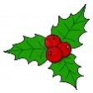, ivy and  are also sometimes used to decorate homes or other buildings. On December the 24th people decorate their houses and put up their and it is the last day to go shopping. People can also go to 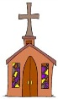 for a midnight mass. The evening of this day is called the Christmas Eve. On Christmas Eve, 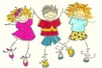 hang up their 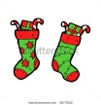 by the 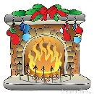 or by their 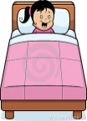. They believe that Father Christmas or  leaves 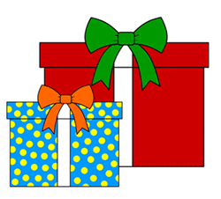 in their stockings. sometimes leave out 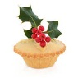 and  for Father Christmas to eat and drink when he visits them. believe that Father Christmas comes down the and fills the with .
On December the 25th – on Christmas day, wake up in the morning and find their filled with . This is the day when families are together, they exchange gifts and cards. They also prepare a special meal. The Christmas meal consists of 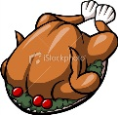 , potatoes and  . After the main course, Christmas 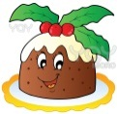 is eaten.
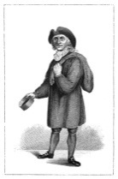
Boxing Day falls on December the 26th. It is a public holiday and the tradition is that in the past lords and rich people gave  with small to their servants to thank them for their work and service. Therefore it is called Boxing Day. Nowadays people give tips and some to the milkmen, dustmen, coalmen, newspaper boys, postmen…..etc.
- Christmas in Ireland
- I Put the following verbs into the text
- 1 light 2 delivers 3 relax 4 visit 5 celebrate 6 go 7 put 8 open 9 cooking
- 10 enters 11 burn
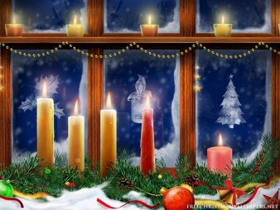
In Ireland, people …………………..Christmas in much the same way as people in the UK, but they also have many of their own Christmas traditions and customs.
On Christmas Eve, people in Ireland …………. candles and …………. them on windows (to welcome Joseph and Mary). The candles may …………. during the whole night. Families ……………to the church for a Christmas mass together.
Santa Clause is a popular figure in Ireland. He ………….. the house through the chimney and………………. gifts. Children ………………these gifts in the morning on the next day.
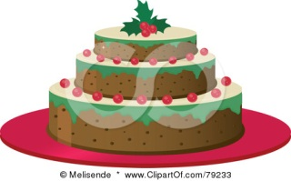
On Christmas day, the Irish have Christmas dinner which is goose or stuffed turkey followed by a Christmas pudding or Christmas cake.
One day after Christmas, Ireland also celebrates St. Stephen´s Day – families ……………..the local church and celebrate.
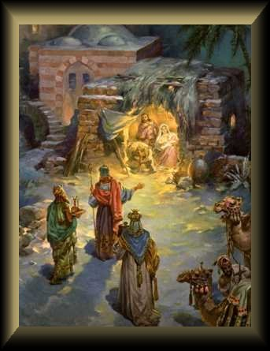
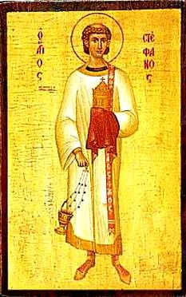
On the 6th of January, the Feast of Epiphany is celebrated. It is Women´s Christmas, because at this time, the men in the family do the household tasks such as ……………..and cleaning and the women take a holiday and visit each other and talk and …………………….

II Answer the questions 1What do the Irish people do on Christmas Eve? 2 How does Santa Claus come to Irish houses? 3 What food do the Irish eat on Christmas day? 4 What do the Irish families do on St.Stephen´s Day? 5 What do women do on the Feast of Epiphany?

Christmas in Canada 
- There are lots of different Christmas traditions in Canada, because it is a large country.
- Mummering is a tradition and it takes place in the provinces of Newfoundland and Nova Scotia, in small towns and villages. People dress up in costumes and knock on someone's door and say: "Are there any Mummers in the night?" or "Any mummers 'loud in?'", meaning 'are mummers allowed in the house?' Then they sing and dance and have Christmas cake and a cup of something nice.
- People in Canada send Christmas cards to their friends and family.
- In northern Canada, some people plan a Taffy Pull. It is a party for single women so that they can meet single men!
- Many Canadians open their gifts on Christmas Eve. Some only open their stocking on Christmas Eve. Others choose one gift to open, then save the rest until Christmas Day.
- Canadian children also believe in Santa Claus.
- "Sinck Tuck" is a festival started by the Inuit. People dance and exchange gifts.
- In some Canadian families, they have cookie-baking parties. They bake Christmas cookies, and then exchange them with the members of their family. At the end of the party, each family goes home with different cookies.
- Christmas Canadians eat roast turkey and potatoes and cranberry sauce. They also eat special sweets called Barley Candy and Chicken Bones (creamy milk chocolate)

A)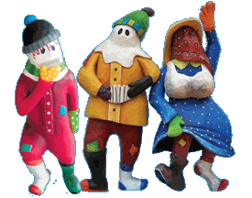 B) 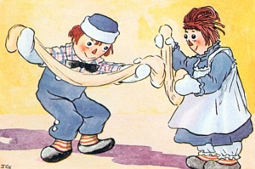 C) 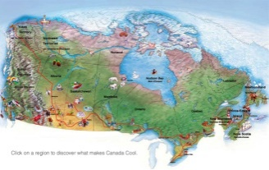
D) 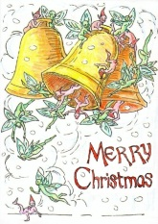 E) 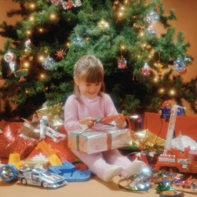 F) 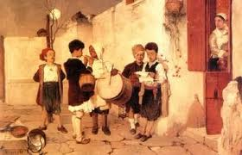 G) 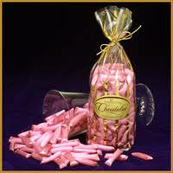
H)
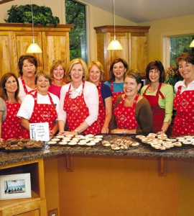
Decide if the statements are true or false 1During mummering people make cakes and cookies. 2 Canadians send Christmas cards to their relatives and friends. 3 Taffy pull is a party for women who are not married. 4 Children in Canada think that Jesus Christ bring presents. 5 Sinck Tuck is a festival when the Inuit people meet their relatives. 6 Some Canadian families bake cookies together and exchange them with their relatives.

- Christmas in Australia 

I Match the numbers and the pictures.
In Australia, Christmas comes in the middle of the summer holidays! Children have their summer holidays from early to mid December to early February.
- Australians hang wreaths on their front doors and sometimes go out Christmas carol singing on Christmas eve. People also decorate their houses and gardens with Christmas Trees and Christmas lights. Australians also decorate their houses with bunches of 'Christmas Bush', a native Australian tree with small green leaves
- In each State capital city there is a large Carols by Candlelight service. Famous Australian singers like help to sing the carols. These carol services are broadcast on TV.
- In many towns and cities there are festivals and parades. In some places, there is a fireworks display too. When Santa gets to Australia, he gives the reindeer a rest and uses kangaroos or 'six white boomers' (a popular Australian Christmas song!). He also changes his clothes for less 'hot' ones!
- On Christmas day children receive presents – they are in their stockings or under the Christmas tree.
- On Boxing Day most people go and visit their friends and often have barbecues at the beach. A famous Yacht race from Sydney to Hobart in Tasmania is also held on Boxing Day.
- The Flying Doctor Service has to work all though-out Christmas. On Christmas Day the people who live in the outback send Christmas greetings to each other over the radio network.
- Most families are at home together for Christmas and they eat the main meal at lunch time. Most people now have a cold Christmas dinner, or a barbecue. On Christmas Eve, fish-markets are often full of people because they want to buy seafood. Australians often have Christmas Crackers at Christmas meal times.
- 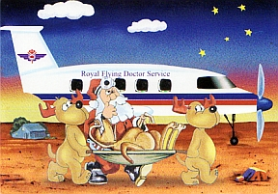 B) 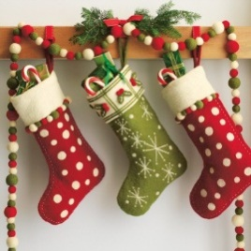 C) 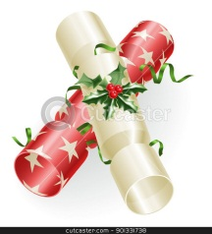
D) 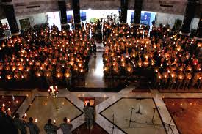 E)  G) 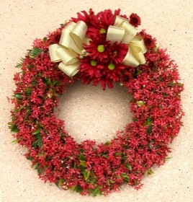
H) 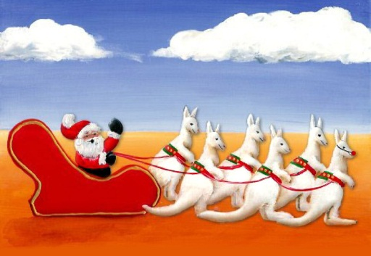
II Use the pictures and talk about Christmas in Australia

