Unit of a long term plan: Unit 2: Living things |  |  |  |  |  | School: № 29
Date: 18.10.2017 |  |  |  |  |  | Teacher’s name: Kissykova Zhazira
CLASS: 5 |  |  |  |  |  | Number present: 15 |  | absent: 0
Lesson title |  |  |  | Human being (2-lesson)
Learning objectives(s) that this lesson is contributing to |  |  |  |  | 5.S1 provide basic information about themselves and others at sentence level on an increasing range of general topics  5.W8 Spell most high-frequency words accurately for a limited range of general topics  5.UE1 use appropriate countable and uncountable nouns, including common noun phrases describing times and location, on a limited range of familiar general and curricular topics  5.C6 organize and present information clearly to others
Lesson objectives
All learners will be able to:
Match the pictures with sentences
 |  |  |  |  | Most learners will be able to: distwingish the countable and uncountable
 |  |  |  |  | Some learners will be able to: Students will write parts of the body (singular and plural form)
Assessment criteria |  |  |  |  | - Give basic information about themselves and others at sentence level.  - Write topic related words correctly  - Identify and apply countable and uncountable nouns in the given sentences correctly.  - Express ideas clearly
Values links |  |  |  |  | successful development of the national education system, health care and culture
Cross-curricular links |  |  |  |  | Biology
Previous learning |  |  |  |  | Parts of the body
Plan
Planned timings | Planned activities (replace the notes below with your planned activities) |  |  |  |  |  |  |  | Resources
2 min  5 min  5 мин | Greeting .  T: Good morning, students! I am glad to see you. How are you today? I hope you are well.  Psychology training  They will give hands to each other and say wishes such (I’m glad to see you, be wealthy, be happy,have a good marks,be active)  Example: I wish you have a good day, be active  I divide your two groups  - Countable  - Uncountable  II. Warmup  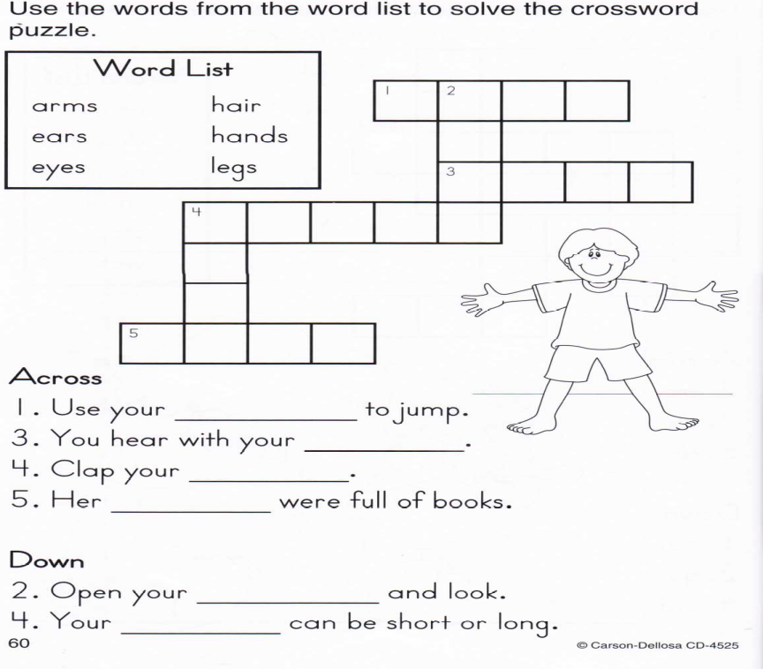  III.Checking hometas  Descripter a learner  Look and write  - -says them |  |  |  |  |  |  |  |   Pictures
Middle  15 min  3 min  5 min | UE1.New theme. Grammar:  A noun can be countable and uncountable.Countable noun You can use one/two/three……countable noun (you can count them)  for example: an eye- two eyes , a face-two faces, an ear –ears, an arm –two arms, a shoulder- two shoulders leg,  Uncountable noun  for example: nose , mouth, hair , neck ,  You can`t say one/ two/thee……..+ this things:  Irregular noun: foot-feet, tooth-teeth  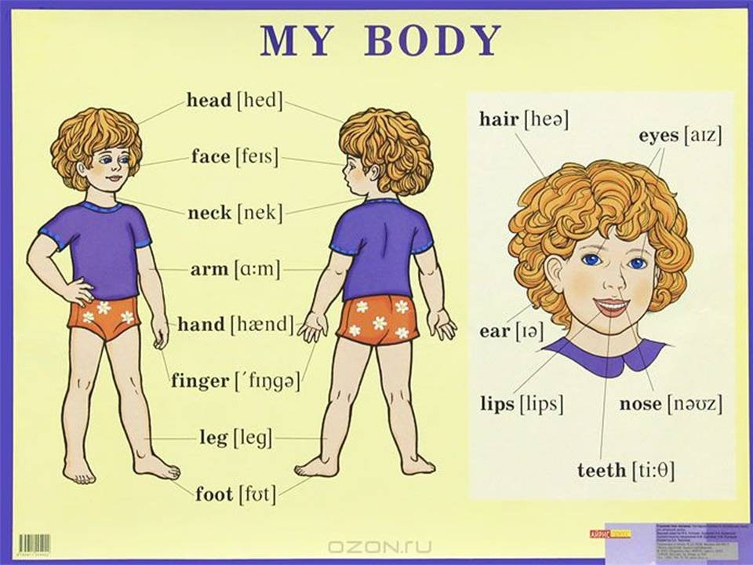  W8. Task 1 group work  Students will write parts of the body (singular and plural form)  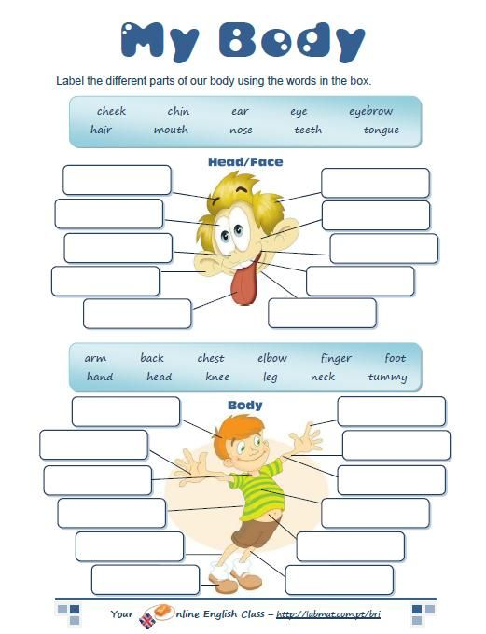  Ph. Training  Learners listen to the song about parts of the body and dance a little.  W8. Task 2 group work  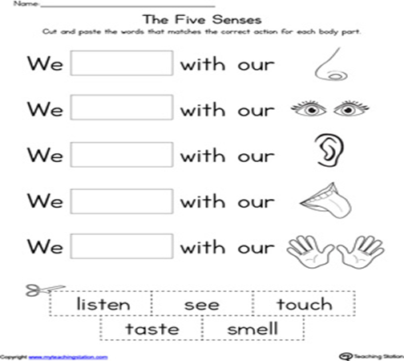  Students will write parts of the body (singular and plural form)  Descriptor learners  • Choose a right verb  • Read the sentences  S1.Task:2 pair work  Fill in the gap, put necessary verbs with group  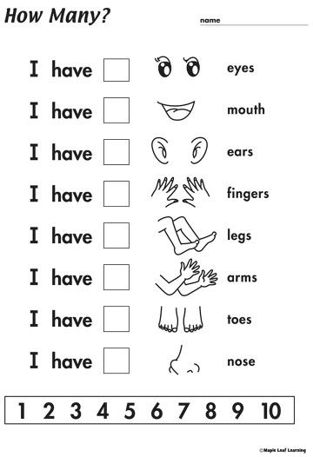  Descriptor a learner:Write names of parts of the body (singular and plural) |  |  |  |  |  |  |  | Flashcards, active board  Worksheet 1  Flashcards, active board  blackboard  Worksheet 2  Flashcards, active board  Worksheet 2
End  5 min | Evaluation list  I can complete: all / most of / some of the worksheets correctly.  I can understand: all / most of / some of the words when I heard them.  I can say all/most of/ some of body parts correctly |  |  |  |  |  |  |  | stickers
Additional information
Differentiation – how do you plan to give more support? How do you plan to challenge the more able learners? |  |  | Assessment – how are you planning to check learners’ learning? |  |  |  | Cross-curricular links  Health and safety check  Values links
All learners will be able to: Match the pictures with sentences,  Most learners will be able to: distinguish the countable and uncountable  Some learners will be able to: Write short story about your friend use new words |  |  | -by giving feedback  - by observing  - by smiling  I`ll give 3 different picture  -by fingers |  |  |  | Lesson is connected with Biology,
Reflection  Were the lesson objectives/learning objectives realistic?  What did the learners learn today?  What was the learning atmosphere like?  Did my planned differentiation work well?  Did I stick to timings? What changes did I make from my plan and why? |  | Use the space below to reflect on your lesson. Answer the most relevant questions from the box on the left about your lesson.  From my point of view, learning objectives were realistic. They’ve studied an active vocabulary and were able to describe animals according to the pictures. It was funny to watch a video and do warm-up activities, some of shy students surprised me with their active participation.
Summary evaluation
1:What two things went really well (consider both teaching and learning)?
2:What two things would have improved the lesson (consider both teaching and learning)?
3:What have I learned from this lesson about the class or individuals that will inform my next lesson?

