Form 6 TEST 3 1 variant
1.Fill in the gaps with CAN or CAN`T.

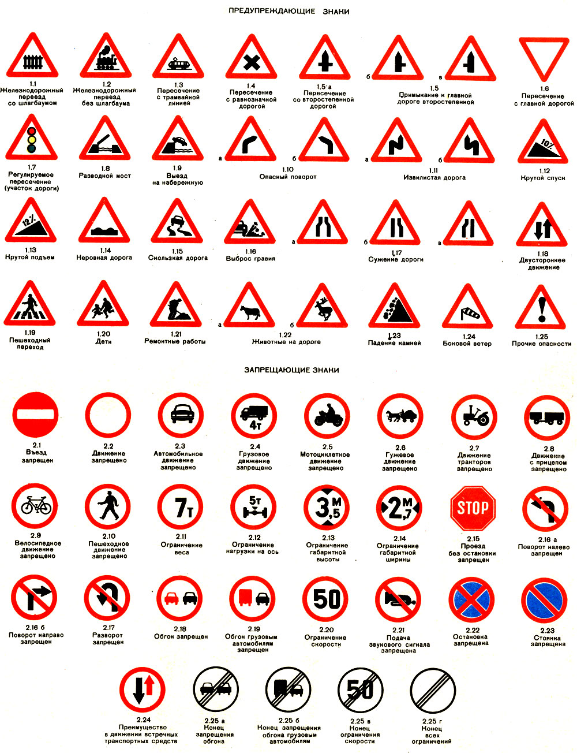
- You _________ stop here.
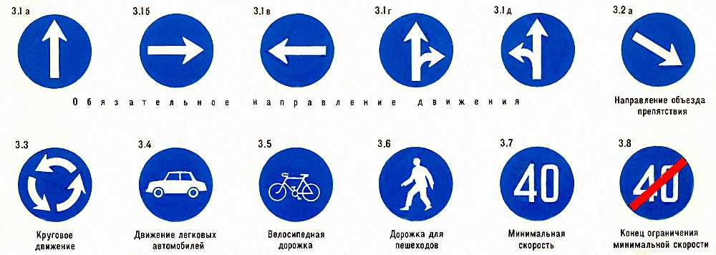
- Pedestrian ________ walk here.
- You ________ turn right.
- You _____ go there.
2.Complete the sentences with these words.
seat belt pavement lights handgrips ride
plane bike car boat lights left road
1.Bob and Mary can ______ a bike.
2.Stop at the traffic _____ .
3.Use the ____ when there are no free seats on the bus.
4.Always wear a __________ when you travel by car.
- Walk on the ____________, not the road.
- That man is a pilot. He can fly a ...
- My little sister can't ride a ...
- His brother is very young. He can't drive a ...
- Can your father sail a ...
- Always stop at the traffic ... when they're red.
- Turn ...... into Green street.
- Don't run onto the ...
3.Fill in: ON, BY
1.I go to school ______ foot.
2.She prefers travelling _____ plane.
3.Be careful ____ the roads.
4. Choose the correct response.

1.Excuse me, how can I get to the sports centre?
2.Thank you very much.
3.Are you ready, Brian?
4.I can`t find the way to the post office.
5.Is there anything I can do for you?

- Oh, that`s easy. The post office is round the corner.
- You`re welcome.
- Oh, you`re very kind. I`ve got a problem you can help me with.
- Yes! Let`s go now!
- Go down Apple Street and turn right into Park Avenue

5.Guess the words.
1._ _ _ _ _ _ _ sign
2.lean out of the _ _ _ _ _ _
3._ _ _ _ _ _ _ zone
4.look both _ _ _ _
6.Translate the words.
1.Водитель-2.Пешеход-3.Шлем-4.Тротуар-5.Идти прямо-6.Метро-7.Поверни направо-

Form 6 TEST 3 2 variant
1.Fill in the gaps with CAN or CAN`T.

- You _____ go there.

- You ________ turn right.
- You _________ stop here.

- Pedestrian ________ walk here.

2.Complete the sentences with these words.
seat belt pavement lights handgrips ride
plane bike car boat lights left road
1. Always stop at the traffic ... when they're red.
2.Turn ...... into Green street.
3.Don't run onto the ...
4.Always wear a __________ when you travel by car.
5.Walk on the ____________, not the road.
6.That man is a pilot. He can fly a ...
7.My little brother can't ride a ...
8.His sister is very young. She can't drive a ...
9.Can your father sail a ...
10.Bob and Mary can ______ a bike.
11.Stop at the traffic _____ .
12.Use the ____ when there are no free seats on the bus.
3.Fill in: ON, BY
1.We go to school ______ foot.
2.Denis prefers travelling _____ plane.
3.Be careful ____ the roads.
4. Choose the correct response.

1.Excuse me, how can I get to the sports centre?
2.Thank you very much.
3.Are you ready, Brian?
4.I can`t find the way to the post office.
5.Is there anything I can do for you?

- Oh, that`s easy. The post office is round the corner.
- You`re welcome.
- Oh, you`re very kind. I`ve got a problem you can help me with.
- Yes! Let`s go now!
- Go down Elton Street and turn left into Park Venus

5.Guess the words.
1._ _ _ _ _ _ _ sign
2.lean out of the _ _ _ _ _ _
3._ _ _ _ _ _ _ zone
4.look both _ _ _ _
6.Translate the words.
1.Идти прямо-2.Шлем-3.Тротуар-4.Пешеход-5.Водитель-6.Метро-7.Поверни налево-

