Short-term plan 30
Unit: 7.2 Holidays and Travel |  |  | School: Gymnasium # 41
Date: 12.11-16.11 |  |  | Teacher name: Kazanzhidi O.F.
Grade: Grade 7 B, V, G |  |  | Number present: | absent:
Theme of the lesson: |  |  | The landmarks of the world
Learning objectives(s) that this lesson is contributing to |  | 7.L4 understand with little support some of the implied meaning in extended talk on a limited range of general and curricular topics
Lesson objectives
 |  | - Identify the main idea in extended talks with little support
Success criteria |  | - writes appropriate words to complete sentences;  - chooses the correct answer.
Value links |  | patience, respect
Cross curricular links |  | Geography, History
Previous learning |  | Students have studied technology-related vocabulary and the present perfect
Intercultural awareness |  | Learners will be able to understand that every person, family and country has their own values.
Kazakh culture |  | Learners will be able to differentiate kinds of festivals people celebrate in Kazakh culture
Pastoral Care |  | Learners aware about the importance of festivals
Health and Safety |  | Everyday classroom precautions
Plan
Planned timings |  |  |  |  | Resources
Beginning  18 min | Warm-up  - Do you like travelling?  - What places in Kazakhstan we can visit?  - Have you ever visited ....?  Start up  (I) Task 1 Listen to the recording and fill in the gaps.  Travelling gives you many 1______________ experiences you cannot find in your own country. You meet local people and get to understand 2_____________ cultures. It’s so exciting. I love planning trips and doing some research on the country or countries I want to visit. Sometimes I like to plan everything in advance, my flights, hotels and tours, etc. For me, the most 3 _____________ thing is arriving in a country with no hotel reservation and no fixed plans. I prefer staying in hostels and guest houses. You get to meet and talk to different and 4_______________ people and share information. I also like to visit places that are off the beaten track. Being 5 _____________ with thousands of other tourists? It’s not my cup of tea.  Task 2  Listen and mark sentences True or False.  A) Travelling is very important for a person because of new ideas. _________  B) Speaker does not love planning trips. _________  C) Speaker likes to visit famous places. _________  Answer keys:  Task1: 1. wonderful;2. different; 3.exciting;4. interesting; 5.somewhere .  Task 2: A) True; B) False; C) False.  Descriptor A learner  Task 1 • writes appropriate words to complete sentences;  Task 2 • chooses the correct answer. |  |  |  | audio, worksheets
Middle  20 min | (W) Now, let's play the game "Agree or disagree". Listen to my sentences, please. Repeat my statement if you agree with me and correct it if you disagree with me.  Учащиеся играют в игру "Согласись или не согласись". Ученик повторяет утверждение учителя, если он согласен с ним, и исправляет утверждение, если он не согласен с ним.  T: London is the capital of Great Britain.  P: I agree with you. London is the capital of Great Britain.  T: Big Ben is in London.  P: I agree with you. Big Ben is in London.  T: The Queen lives in the Tower of London.  P: I disagree with you. The Queen lives in Buckingham Palace.  T: Westminster Abbey was built by King Edward.  P: I agree with you. Westminster Abbey was built by King Edward.  T: The Queen has two birthdays.  P: I agree with you. The Queen has two birthdays.  T: Nelson's column is in Trafalgar Square.  P: I agree with you. Nelson's column is in Trafalgar Square.  (P) Match definitions with pictures.  It is very old. It has a long and cruel history. You can see it from the river Thames. It is not just one building. Many years ago the Kings and the Queens of Britain lived in this place. (The Tower of London)  It stands near the Houses of Parliament. It is really a bell. It weighs 13,720 kilograms. It has a deep tone and you can hear it on the radio. It is a famous clock. (Big Ben)  London's largest and most famous cathedral, built by Sir Christopher Wren. (St. Paul's Cathedral)  They stand beside the river Thames. You can also see them from Westminster Abbey. The country's leaders speak at this place. The famous clock Big Ben stands near them. (The Houses of Parliament)  London residence of the Queen, the principal seat of the monarchy. (Buckingham Palace)  It is not far from the Houses of Parliament. It is a symbol of England. It was founded by St. Peter and built by King Edward in 1065. Some famous people are buried there. (Westminster Abbey)  Homework: Project work. “Landmarks of he world” |  |  |  | cards with text  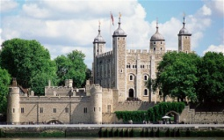  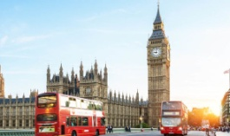  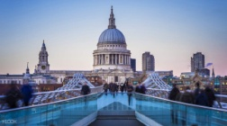  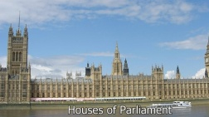  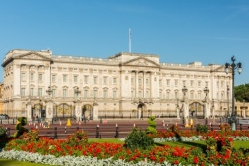  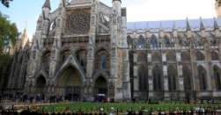
2 min | Reflection (I)  Teacher asks students to write a reflection of the lesson.  3 – new words  2 – adjectives to describe the lesson  1 – one activity you like
Listen to the recording and fill in the gaps.
Travelling gives you many 1______________ experiences you cannot find in your own country. You meet local people and get to understand 2_____________ cultures. It’s so exciting. I love planning trips and doing some research on the country or countries I want to visit. Sometimes I like to plan everything in advance, my flights, hotels and tours, etc. For me, the most 3 _____________ thing is arriving in a country with no hotel reservation and no fixed plans. I prefer staying in hostels and guest houses. You get to meet and talk to different and 4_______________ people and share information. I also like to visit places that are off the beaten track. Being 5 _____________ with thousands of other tourists? It’s not my cup of tea.

Listen and mark sentences True or False.
A) Travelling is very important for a person because of new ideas. ________
B) Speaker does not love planning trips. _________
C) Speaker likes to visit famous places. _________

Listen to the recording and fill in the gaps.
Travelling gives you many 1______________ experiences you cannot find in your own country. You meet local people and get to understand 2_____________ cultures. It’s so exciting. I love planning trips and doing some research on the country or countries I want to visit. Sometimes I like to plan everything in advance, my flights, hotels and tours, etc. For me, the most 3 _____________ thing is arriving in a country with no hotel reservation and no fixed plans. I prefer staying in hostels and guest houses. You get to meet and talk to different and 4_______________ people and share information. I also like to visit places that are off the beaten track. Being 5 _____________ with thousands of other tourists? It’s not my cup of tea.

Listen and mark sentences True or False.
A) Travelling is very important for a person because of new ideas. ________
B) Speaker does not love planning trips. _________
C) Speaker likes to visit famous places. _________

Listen to the recording and fill in the gaps.
Travelling gives you many 1______________ experiences you cannot find in your own country. You meet local people and get to understand 2_____________ cultures. It’s so exciting. I love planning trips and doing some research on the country or countries I want to visit. Sometimes I like to plan everything in advance, my flights, hotels and tours, etc. For me, the most 3 _____________ thing is arriving in a country with no hotel reservation and no fixed plans. I prefer staying in hostels and guest houses. You get to meet and talk to different and 4_______________ people and share information. I also like to visit places that are off the beaten track. Being 5 _____________ with thousands of other tourists? It’s not my cup of tea.

Listen and mark sentences True or False.
A) Travelling is very important for a person because of new ideas. ________
B) Speaker does not love planning trips. _________
C) Speaker likes to visit famous places. _________

Match definitions with pictures.
It is very old. It has a long and cruel history. You can see it from the river Thames. It is not just one building. Many years ago the Kings and the Queens of Britain lived in this place. (The Tower of London)

It stands near the Houses of Parliament. It is really a bell. It weighs 13,720 kilograms. It has a deep tone and you can hear it on the radio. It is a famous clock. (Big Ben)

London's largest and most famous cathedral, built by Sir Christopher Wren. (St. Paul's Cathedral)

They stand beside the river Thames. You can also see them from Westminster Abbey. The country's leaders speak at this place. The famous clock Big Ben stands near them. (The Houses of Parliament)

London residence of the Queen, the principal seat of the monarchy. (Buckingham Palace)

It is not far from the Houses of Parliament. It is a symbol of England. It was founded by St. Peter and built by King Edward in 1065. Some famous people are buried there. (Westminster Abbey)
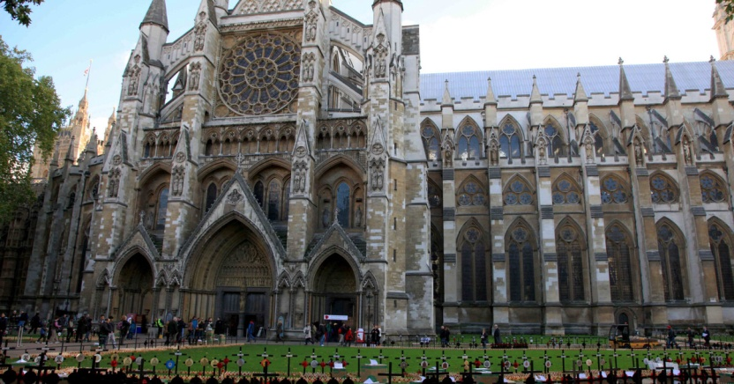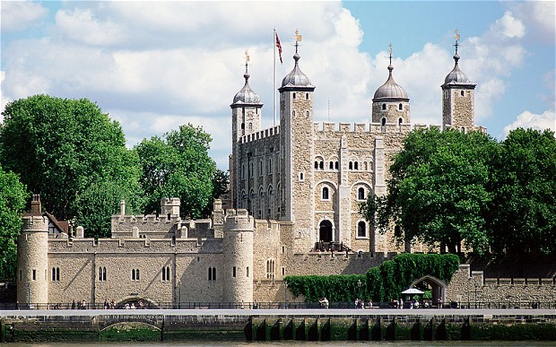
2
1
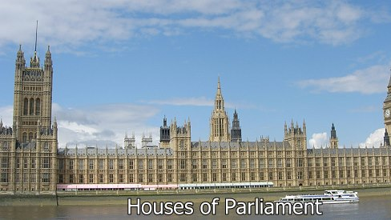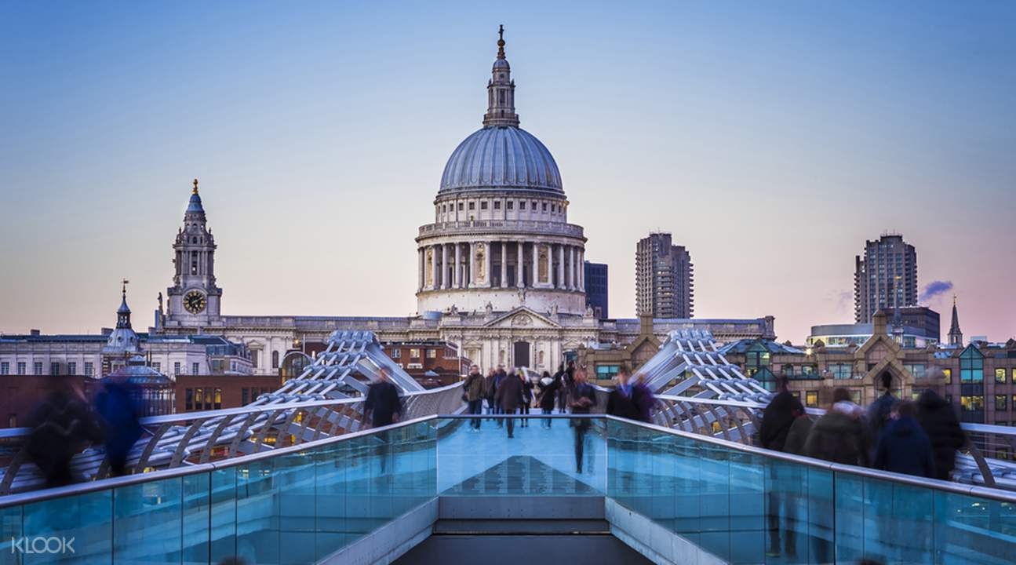
4
3
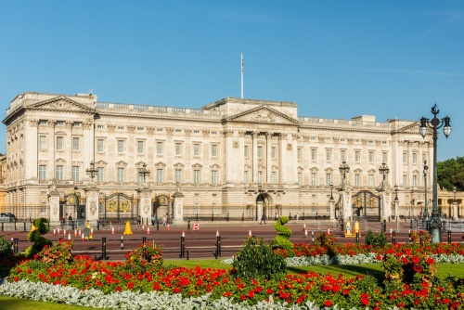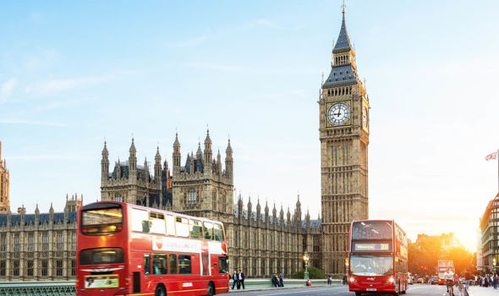
6
5

