LESSON 12 : Unit 2  MY SCHOOL.DESCRIBING  ORGANIZATION MOMENT  - Greet learners and ask them take their places;  - Have speech drill asking daily questions;  - Sing “can you help me” song as a class, create positive and friendly atmosphere.  ORGANIZATION MOMENT  - Greet learners and ask them take their places;  - Have speech drill asking daily questions;  - Sing “can you help me” song as a class, create positive and friendly atmosphere.  THINGS. |  |  |  |  | School: № 148 school-gymnasium
Date: |  |  |  |  | Teacher name: Bekkalieva Fariza
CLASS: 1 A |  |  |  |  | Number present: |  | absent:
Learning objectives(s) that this lesson is contributing to |  |  | 1.S1 make basic personal statements and simple statements about objects  1.UE3 use basic adjectives and colours to say what someone/something is or has
Lesson objectives |  |  | All learners will be able to:
- listen and repeat two adjectives and seven colours of six classroom objects
- Listen to simple songs.
 |  |  | Most learners will be able to:
 |  |  | - recognise and describe six classroom objects
 |  |  | Some learners will be able to:
 |  |  | - recognise and describe ten classroom objects
Previous learning |  |  | Classroom objects, numbers , colors
Value links: |  |  | Respect, Cooperation
Cross-Curricular Link |  |  | Science, Maths, Art
Use of ICT |  |  | PPT, video
Intercultural awareness |  |  | Classroom objects in different countries
Kazakh culture |  |  | Classroom objects in Kazakhstan and Almaty
Pastoral Care |  |  | Assure you met all learners’ emotional, mental and physical needs
Health and Safety |  |  | Make sure power cords/outlets are not a tripping hazard  Everyday classroom precautions
Plan
Planned timings | Planned activities (replace the notes below with your planned activities) |  |  |  |  |  |  | Resources
Beginning  5-10 min  (W) | ORGANIZATION MOMENT  - Greet learners and ask them take their places;  - Have speech drill asking daily questions;  - Sing “can you help me” song as a class, create positive and friendly atmosphere. |  |  |  |  |  |  | https://www.youtube.com/watch?v=5P-89FdwlGc
Middle  15 -25  minutes | DEMONSTRATION  1. Teacherdemonstrates long/short using projected visual images.  2. Teacher models: ‘It’s a long/short ...’ e.g.It’s a long green pencil.  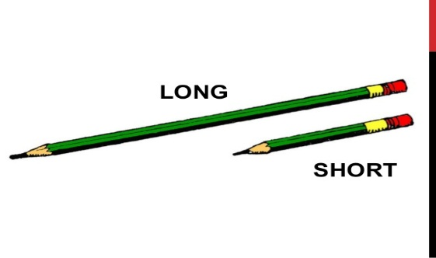  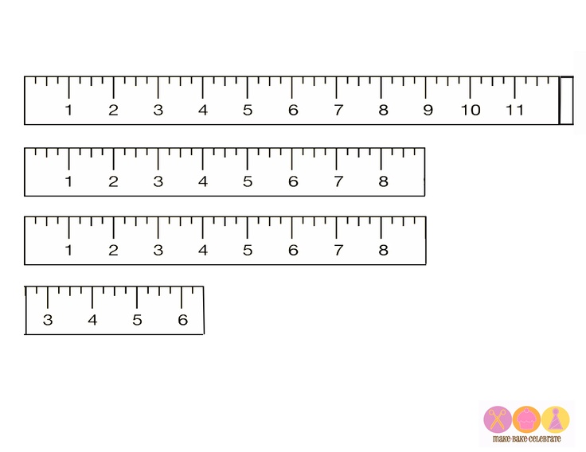  It’s a long ruler  It’s a short ruler.  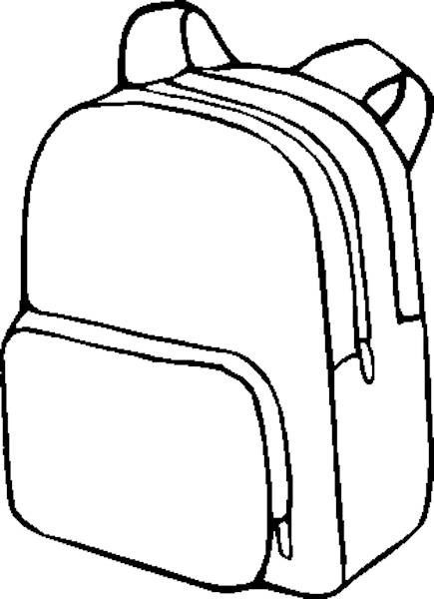It’s a big bag.  It’s a small bag.  - Teacher nominates a learner to say what projected image is.  - Pass out things description worksheet to write whether the things big/small/long/short;  Short ruler is yellow;  Big ball is blue and yellow  Small ball is blue  Long ruler is red.  - Show classroom objects and encourage learners to name things using colors, adjectives  - Listening:  - Pass out listening worksheet;  - Ask learners to listen and follow the instructions:  - Short ruler is yellow;  - Big bag is blue;  - Small chair is pink  - Long ruler is green..  Differentiation by support:less confidentstudents work with teacher’s assisstance |  |  |  |  |  |  | https://www.youtube.com/watch?v=gOeEVx9QREg  PPT  Worksheet 1  Listening worksheet
End  3-5  minutes | REFLECTION  Teacher gives comments about learners work and awards learners.  You are clever!!!  You are excellent!!!  Be active !!!
Additional information
Differentiation – how do you plan to give more support? How do you plan to challenge the more able learners? |  |  |  | Assessment – how are you planning to check learners’ learning? |  | Cross-curricular links  Health and safety check  ICT links  Values links
- Create mixed ability groups for speaking activity. |  |  |  | - through observation group work  - through assessment game |  | - Music
Reflection  Were the lesson objectives/learning objectives realistic?  What did the learners learn today?  What was the learning atmosphere like?  Did my planned differentiation work well?  Did I stick to timings? What changes did I make from my plan and why? |  | Use the space below to reflect on your lesson. Answer the most relevant questions from the box on the left about your lesson.
Summary evaluation
What two things went really well (consider both teaching and learning)?
1:
2:
What two things would have improved the lesson (consider both teaching and learning)?
1:
2:
What have I learned from this lesson about the class or individuals that will inform my next lesson?

