Тема: «Natural Disasters».
Природные бедствия
Цели урока:
Образовательная: совершенствовать лексику по теме «Стихийные бедствия», формировать коммуникативную культуру школьников, тренировать учащихся в говорении, чтении, письме.
Развивающая: создавать условия для развития памяти, лексических и коммуникативных навыков, формировать мотивацию у школьников к изучению иностранного языка, умение получать информацию из учебника.
Воспитательная: формировать системное представление учащихся о стихийных бедствиях, выявить наиболее важное и характерное.
Языковой материал: лексические единицы по теме стихийные бедствия.
Необходимое оборудование и материалы: учебник, компьютер, видео по теме.
Класс 9 «А»
Ход урока
1.Организационный момент.
Good afternoon, dear guests and students. I’m glad to see you. Today I divided our group into 2 teams. And today our students are not only students but they are members of the international weather camp. At our lesson we’ll discuss weather, climate and natural disasters and watch some videos about them. Teams will do some tasks and get points for the correct answers. Whose team will get more points that team won. Good luck. Let’s beginning.
Students tell topic WEATHER AND CLIMATE.
- Guess the definitions. The first team read definitions to the second team.

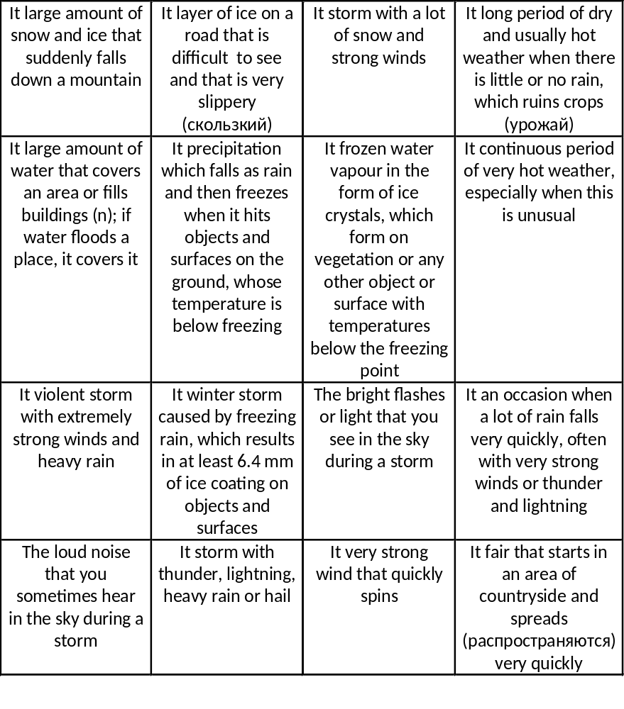
- Weather forecast. Every team should do weather forecast for London and for Minsk.
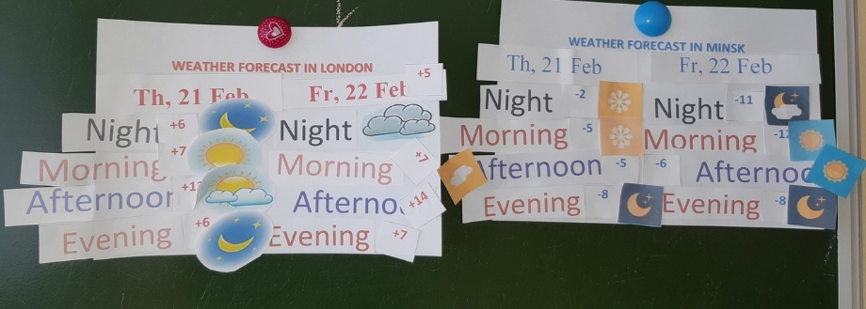
- Guess what is the natural disaster in the video and tell what do you know about it.
- Video about British Weather http://learnenglishteens.britishcouncil.org/uk-now/video-uk/british-weather

- Let’s relax a little bit.
Snowball game

Let’s relax a little bit. Pupils listen nature’s sounds

6.Now fill in the blanks. Use the words in the box.
Destructive, damage, destroyed, damaged
1. A powerful winter storm caused (…) to trees and power lines.
2. The floods in China during the summer (…) 5 millions houses.
3. The hurricane did a lot of (…) to houses in the area.
4. The last earthquake in the USA was very (…).
1- damage; 2- destroyed; 3- damage; 4- destructive;

7.Рефлексия.
Let’s do cinquain.
Disaster (noun)
Natural, dangerous (2 adj)
Damage, cause, destroy (3 verbs)
Natural disasters unite people more than they divide them. (phrase)

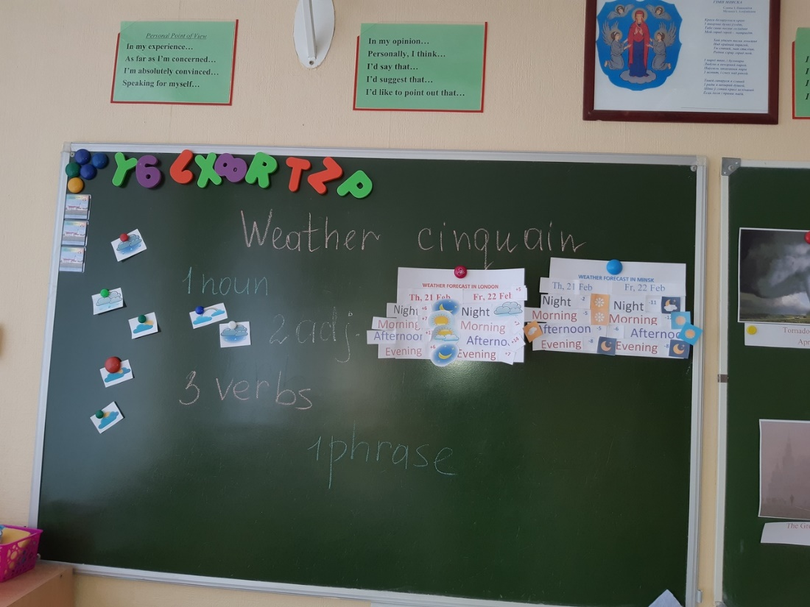

8. Подведение итогов.
Well, dear students let’s count your points. The winner is….
You have shown your excellent knowledge today.
I thank you for the lesson. You may go. Good-bye!

