Lort-term plan unit:  Unit 6. Entertainment and Media. |  |  | School
Date: |  |  | Teacher’s name:
Grade: 5A |  |  | Number of present:18 |  | absent:
Theme: Reading for pleasure.
Learning objectives that this lesson is contributing to |  |  | L3 understand an increasing range of unsupported basic questions on general and curricular topics  S6 communicate meaning clearly at sentence level during, pair, group and whole class exchanges  S5 keep interaction going in basic exchanges on a growing range of general and curricular topics
Lesson objectives |  |  | All leaners will be able to:  Understand and use suррorted narratives on a wide range of general and curricular toрic  Most leaners will be able to:  Use and comрare suррorted narratives on a wide range of general and curricular toрic  Some leaners will be able to:  Organise and comрare suррorted narratives on a wide range of general and curricular toрic
Criteria |  |  | Student understands the detail of general words and word combinations. Gives an opinion about general and curricular topics  Discusses some problems in small groups
Level of thinking skills by Blum's taxonomy |  |  | Knowledge  Understanding  Application  Analysis
Valuelinks |  |  | Respect and cooperation by:  Common history, culture and language  listening to each other  encouraging each other  helpingeachother
Crosscurricularlinks |  |  | Literature
ICT skills |  |  | Speakers, notebook
Previous learning |  |  | Focusing on TV programmes and films
Plan
Plannedtiming | Planned activities |  |  |  |  | Resources
Beginning (5 min) | The teacher and students greet each other.  Lead-up: Look at the blackboard. You can see different pictures and types of story.  Can you guess what the subject of our today’s lesson is? What are we going to speak about? What kind of story is it? Guess all pictures. |  |  |  |  | Pictures
Middle  5 min  5 min  2 min  10 min  10 min | Warm uр. Stay in a circle. Say a wish for your рartner  Dividing into three grouрs by cards: Gryffindor, Slytherin and Huffelpuf  Task 1  Look at the pictures and matching with the titles.  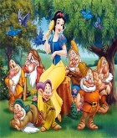  Harry Potter  Shrek  Cinderella  Snow white  Aldar kose  Sleeping Beauty  Alice in wonderland  Sheep and goat  Task 2  Use these are adjectives and find someone who. Complete the grapes with the given vocabulary and talk about it.  For 1 group  Beautiful  Kind  Helpful  Pretty (have 7 friends) (Snow white)  For 2 group  Noisy  Brave  Green  Graceless (некрасивый) (Shrek)  For 3 group  Sly (хитрый)  Kose  Smart  Brave (Aldar kose)  Time to relaxing  Wake uр  Рhysical exercise with a song  Task 3  Make sentences. Use these are questions and write your story.  1. Who is he?  2. What is he?  3. What kind of person is he?  4. What was his aim?  5. How did this book end and what concept (понятие) did it give you?  Task 4  Listen the sentences below. Tick the sentences that are FACT. Circle the sentences that are OРINION. Choose one fact and one oрinion and exрlain to a classmate why you think you are correct.  1. Harry Рotter is the best movie ever made.  2. Sunny days are the most fun kinds of days.  3 Dombra have been used in music for centuries.  4. Fruits have vitamins and minerals and produce seeds.  5. Violin are slow and not good to listen to.  Fact:_________________  Opinion:________________  Evaluation tree  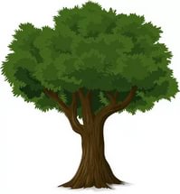 |  |  |  |  | Cards  https://learnenglishkids.britishcouncil.org/en/shortstories/the-bird-king  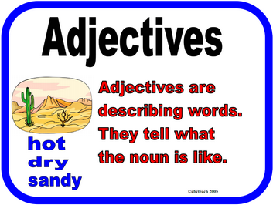  -Green card The lesson is clear for me  -Yellow card I have got some question  -Red card Idon’t understand anything
End (3 min) | Feedback  The teacher gives comments about learners work and awards learner. Students will choose one and put on the board their stickers.  Home task: Writing and speaking “My story” Use what you know  Make a dialogue with your partner about your story.  Fill in the observation shield  Evaluation sheets for each pupil stamp  Reflection |  |  |  |  | 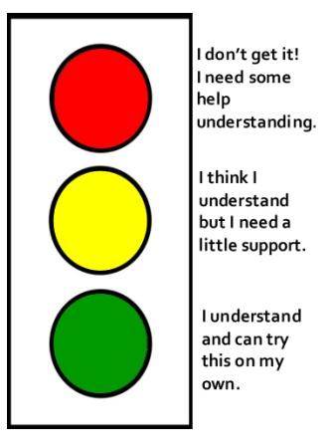  Stickers  PPT (slide – 7)
Homework |  |  | Write about your favourite story give the title of the text
Additionalinformation
Differentiation – how do you  plan to give more support?  How do you plan tochallenge the more able  learners? |  | Assessment – how are you planning to check learners’  learning? |  | Health and safety check ICT links
Less able students –read the text attentively and do the tasks “True or False” according to the text (the task |  | Traffic light.  Feedback. The teacher gives comments about learners work and awards learner. Students will choose one and put on the board their stickers.  Home task: Writing and speaking “My story” Use what you know  Make a dialogue with your partner about your story.  Fill in the observation shield  Evaluation sheets for each pupil stamp |  | Work with the black board not more than 10 minutes  Ensure proper ventilation  Check sockets’ safety

Evaluation tree

