Краевое государственное автономное профессиональное образовательное учреждение
«Добрянский гуманитарно-технологический техникум им. П.И.Сюзева»

Внеклассное мероприятие по английскому языку о вреде курения

Разработано преподавателем английского языка Рычаговой О.В.

Добрянка 2016г.

Lesson Plan
Smoking Stinks
Состояние здоровья подрастающего поколения - важнейший показатель благополучия общества и государства. Ухудшение здоровья подростков в России, распространение вредных привычек стало не только медицинской, но и серьезной педагогической проблемой. Этим определяется актуальность выбора темы для классного часа. Здоровьесберегающие технологии являются составной частью и отличительной особенностью всей образовательной системы. Это совокупность всех используемых принципов, методов и приёмов обучения и воспитания, которые, дополняя традиционные технологии, наделяют их признаками здоровье сбережения, цель которого - не только оберегать здоровье обучающегося и преподавателя от неблагоприятных факторов образовательной среды, но и способствовать воспитанию у студентов культуры здоровья, борьбе с вредными привычками, в том числе и с курением.
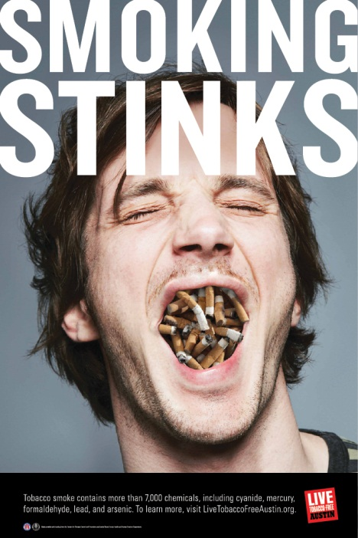
Topic
Reasons not to smoke/to give up smoking. This lesson could be used in conjunction with the World Health Organization’s No Tobacco Day on 31st May each year.
Aims
•Raise awareness of the many reasons not to smoke, or to give up smoking.
• Extend students’ vocabulary to talk about health risks and other issues connected with smoking. E.g. bad breath, anxiety, blood pressure.
• Develop students’ writing skills through writing a paragraph (using vocabulary) about one negative aspect of smoking.
• Encourage peer feedback and correction on writing.
• As an optional final task, develop students’ oral fluency as well as their ability to work together to design a poster and present it to their peers.
The lesson begins by focusing on some anti-smoking posters, and students discuss the message and effectiveness of each one. They then learn some vocabulary to talk about four key reasons not to smoke: (health, cost, the impact on your attractiveness, and the impact on others). Then students choose one of these reasons and write a paragraph about it, using the vocabulary as appropriate.
As an optional final activity, the students design their own anti- smoking poster and present it to another pair or to the class.


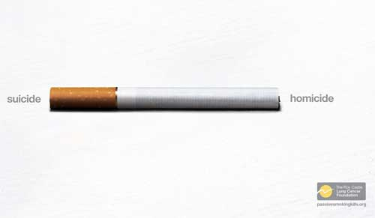

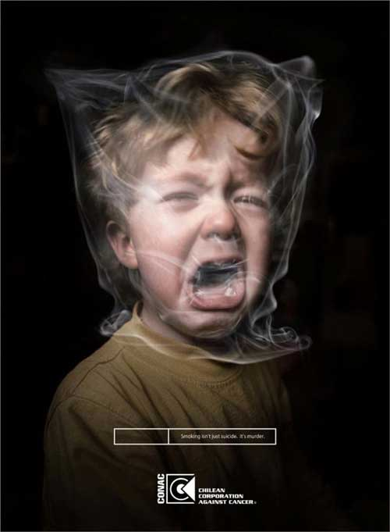


1. Lead-in (3-4 minutes)
• Write the title of the lesson ‘smoking stinks’ on the board. Explain the double meaning – that smoking smells bad and that smoking is a bad or unpleasant thing.
• See if everyone agrees (they may not!) and elicit some ways in which both meanings might be true.
• If relevant, explain that 31st May is the World Health Organization (WHO) No Tobacco Day. Each year the WHO encourages people to give up for at least that day, and tries to raise awareness of the negative effects of smoking.
2. Speaking (5 minutes)
• Show your students the anti-smoking images (see materials above) and ask them to discuss the message and which they find most/least effective and why.
• Briefly feedback as a class. You could also ask students:
- what other posters or adverts they have seen which they thought were effective.
- whether they think cigarettes should be sold in plain packaging.
3. Vocabulary focus (10- 15 minutes)
Give out worksheet 2 and ask students to work together to categorise the words and phrases under the four headings given. Students might need to use dictionaries for some of the words (wrinkles, asthma, lungs, stains).
This is a relatively subjective task, but suggested answers are:
A: anxiety (some people think it relieves anxiety, but it actually causes it as the withdrawal symptoms start) asthma, lungs, cancer, heart disease, blood pressure, addiction, colds and flu (you are likely to catch more of these), pregnant (smoking can damage the baby and make you less likely to get pregnant in the first place).
B: wrinkles, bad breath, yellow stains (on fingers and teeth)
C: expensive addiction (you have to buy them), save (you could save a lot of money by giving up)
D: passive smoking, second-hand smoke, asthma (children of smokers have much higher levels of asthma)
• As you carry out feedback, encourage students to explain why they chose to put the words and phrases under each heading. This should push them to use all the language they have at their disposal.
• Make notes of good points and any other useful topic-related language which comes up.
4. Writing/further vocabulary practice(15-20 minutes)
• In pairs, ask students to choose one of the four headings and write a paragraph about it, using the vocabulary from the previous stage.
You could give them a completely free choice, or you could allocate different areas to different pairs.
Monitor and help students with the language they need.
• Put pairs into groups of four, and ask them to read each other’s paragraphs and comment on both the content and the language.
• Give students a little longer to re-draft and make any changes.
• At this stage, you could put the paragraphs up on the wall for students to go around and read (this will work better if they have written about different aspects)
You could end the lesson here at about 40-45 minutes or continue to the group work.
5. Group work (15-20 minutes)
• Remind students about the posters they looked at early and ask them to work in pairs or small groups to design their own poster, using the guiding questions on the worksheet.
To finish, let students present their ideas to either another pair/group or to the class.
For students:
1. Work in pairs or small groups. Check the meaning of the words and phrases in the box and decide together which heading they should go under. Some words and phrases may go under more than one heading.
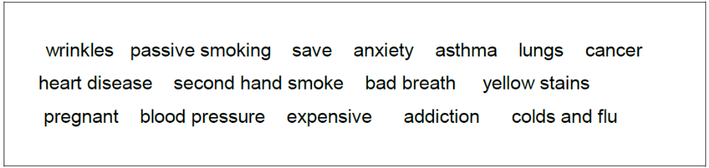
A. How smoking affects health
B. How smoking affects how attractive you are
C. How smoking affects your finances
D. How smoking affects others

2. Work in pairs. Choose one of the headings (A-D) on the other side of the worksheet and write a paragraph with that heading. Try to use the vocabulary you selected.
3. Show your paragraph to another pair. Can they add any more ideas, or help with any corrections?
4. Work in small groups. You are going to create an anti -smoking poster. Follow the instructions.
A. Decide together how you are going to persuade people to stop smoking, or not to start. You could look at:
- the health problems it causes
- the unpleasant effects like wrinkles and bad breath
- the cost of smoking (you could also look at the cost to the country as a whole)
- the impact on children and other non-smokers?
- something else (for example how quickly your health improves when you give up)
5. Express your point of view to the following facts.
-In Russia smoking kills 332 thousand people a year, or 15% of all deaths.
-240 thousand (231 thousand males + 9 thousand females) or 72% of them are still in middle age when they die.
-Men in Russia smoke more and are more severely affected by smoking hazard than women.
-One fourth of all deaths at all ages and one third at middle age are associated with tobacco smoking.
-For women, smoking causes 3% of all annual deaths.
-Significantly less – 3.5 thousand women vs. 47 thousand men (by a factor of 13) yearly die from lung cancer.

201 группа, специальность «Дошкольное образование»


