Short plan

Long-term plan: Unit 1 “Home and away” |  | Gymnasium № 41
Date: |  | Teacher’s name: Chirkova L.A.
Grade: |  | Present: | Absent:
Theme of the lesson: Homes
Learning objectives(s) that this lesson is contributing to | 5.S2 ask simple questions to get information about a limited range of general topics  5.W1 plan, write, edit and proofread work at text level with support on a limited range of general and curricular topics  5.S1 Provide basic information about themselves and others  at sentence level on an increasing range of general topics
Lesson objectives | All learners will be able to  Use prepositions of place in the sentences, write sentences with There is…\There are, label the pictures, draw bedroom.
Lesson objectives | Most learners will be able to  Use prepositions of place in the sentences correctly, write sentences with There is…\There are, label the pictures, draw a bedroom.
Lesson objectives | Some learners will be able to  Use prepositions of place in the sentences correctly, write sentences with There is…\There are, label the pictures, draw and describe bedroom.
Success criteria | • works cooperatively in a group;  • draws a picture of his/her room;  • describes the room using topic vocabulary;  • uses prepositions correctly.
Value links | Values are instilled by/through discussion activities, answering the questions, respecting each other, sharing opinions.
Cross curricular links | Science
ICT skills | Learners use online dictionaries if necessary, no ICT skills are focused on this lesson
Previous learning | prepositions
Plan
Planned timings | Planned activities (replace the notes below with your planned activities) | Resources
 | 1. Warm up  (W)  Learners give one word they remember from the previous lesson.  2. Prepositions of place  (W, D) Teacher shows pictures, learners do gests.  3. Activity 1  (W, P, f) Learners look at words written on board: in, on, under, above, between, behind, in front of, next to, opposite, near. Divide class into three teams. They decide on a team name. In turn, a learner from each team says a sentence about any object in classroom using a preposition.  4. Work in the copy books.   (W, I, f) Learners write sentences into their copy books.  5. Introduction of new vocabulary  (D, W, I) Learners label the pictures.  Dining room, bed room, living room, kitchen, bathroom  Do you live in the house or in the apartment?  How many rooms are there in your house?  Name them.  Have you got a favourite room?  What things are there in your favourite room?  Is bedroom your favourite room? Why? Why not?  6. Activity 2  (P,f) In the pictures there are rooms of Sponge Bob and Mickey Mouse. Draw a similar plan of your room. Describe your room to your partner.  Home task work with new vocabulary , draw the plan of the bedroom  7.Reflextion | 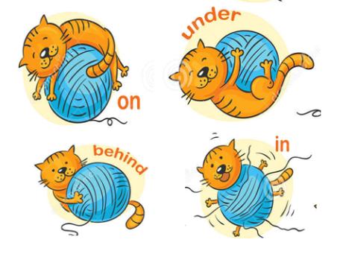  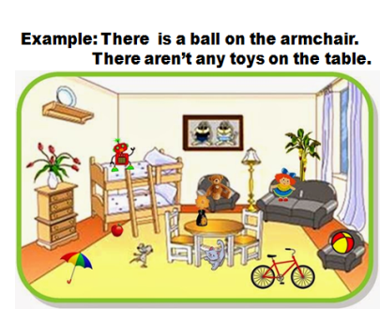  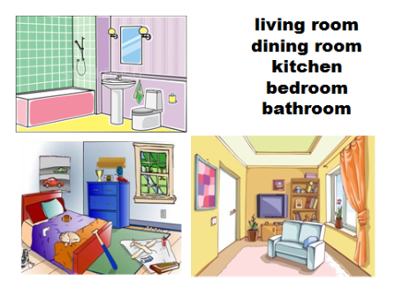  Cards with formative task for each pair.

