Short plan № 21

Long-term plan: Unit 2 “Living things” |  | Gymnasium № 41
Date: |  | Teacher’s name: Chirkova L.A.
Grade: 5 |  | Present: | Absent:
Theme of the lesson: Living things. Flora
Learning objectives(s) that this lesson is contributing to | 5.C4 evaluate and respond constructively to feedback from others  5.L3 understand an increasing range of unsupported basic questions on general and curricular topics  5.UE3 Use a growing variety of adjectives and regular and irregular comparative and superlative adjectives on a limited range of familiar general and curricular topics
Lesson objectives | All learners will be able to  label the pictures, write 3-5 new words correctly, compare living things using regular and irregular adjectives
Lesson objectives | Most learners will be able to  label the pictures, write 5-7 new words correctly, compare living things using regular and irregular adjectives speak about what he\she has learnt during this lesson
Lesson objectives | Some learners will be able to  label the pictures, write 7-9 new words correctly, compare living things correctly using regular and irregular adjectives speak about what he\she has learnt during this lesson
Success criteria | - Labels the pictures  - Name and guess the new words  - Writes 3 sentences (compare living things)  - Writes degrees of comparison of adjectives  - Speaks about what he\she has learnt during this lesson
Value links | Values are instilled by/through discussion activities, answering the questions, respecting each other, sharing opinions.
Cross curricular links | Biology
ICT skills | Learners use online dictionaries if necessary, no ICT skills are focused on this lesson
Previous learning | Degrees of comparison of adjectives
Plan
Planned timings | Planned activities (replace the notes below with your planned activities) | Resources
4 min  12 min  9 min  10 min  1 min  4 min | 1. Warm up  (W, f) Teacher demonstrates the pictures and plants vocabulary, learners label the pictures.  2. Activity 1  (G) Learners complete the plants vocabulary using cards: mushrooms, berries, coconut, dandelion [dandlˌīən ] одуванчик, birch [ bɜːtʃ ] береза, strawberry, current [ ˈkʌrənt ] текущий, cereals- хлопья, poppy-мак, raspberry, oak [ əʊk ] дуб, pine-сосна  3.Activity 2  (G, f) Write about the things in the pictures. Use the comparative and superlative forms of the adjectives.  4. Work in the copy books.   (P, I, f)  Learners write degrees of comparison of adjectives.  long short beautiful old young favourite modern tasty big funny comfortable cold hot fashionable  Home task: work in vocabulary  5. Reflection  Tell me three things...  • you have learnt today  • you have done well  • the group has done well  • you would like to find out more about  • you know now that you didn’t know 40 minutes ago | Pictures + plants vocabulary  Cards with letters for each group  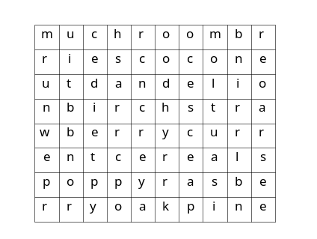  Sheet with task for each group  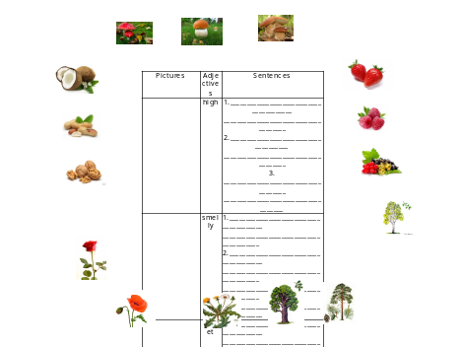  Card with words for each pair  