Lesson plan

Unit: Music and Film |  |  |  | School: secondary school №11, Kostanai
Date: |  |  |  | Teacher name: Kadirshinova Nazym Tanatkhanovna
CLASS: 9 |  |  |  | Number present: |  |  | absent:
Lessоn title |  | Music
Learning objectives |  | 9.2.1.1. understand the main points in unsupported extended talk on a wide range of general and curricular topics;  9.3.2.1. ask complex questions to get information on a range of general and curricular topics;  9.5.3.1. use a variety a compound adjectives and adjective as participles and a variety of comparative structures to indicate degree on a range of familiar general and curricular topics.
Lesson objectives |  | All learners will be able to recognize the main points of the given information in 5-6 sentences on topic “Music” using active vocabulary and a variety of compound adjectives and adjective as participles  Most learners will be able to discuss in 6-7sentences on topic “Music” using active vocabulary and a variety of compound adjectives and adjective as participles  Some learners will be able to make a project in 7-8 sentences on topic “Music” using active vocabulary and a variety of compound adjectives and adjective as participles
Assessment criteria |  | Learners can recognize the main points of the given information on topic “Music” using active vocabulary and a variety of compound adjectives and adjective as participles
Values links |  | Life-long learning, appreciation of the arts, respect, cooperation
Cross-curricular links |  | Music, Art
Previous learning |  | -
Plan
Planned timings | Planned activities (replace the notes below with your planned activities) |  |  |  |  | Resources
Start  5 min | Organization moment.  Learners answer to the teacher’s greetings.  Activity 1 .Warm-up (Hangman method)  Learners play the game “Hangman”. They called the correct letters and find a new topic with the help of phrase the author H.Longfellow.  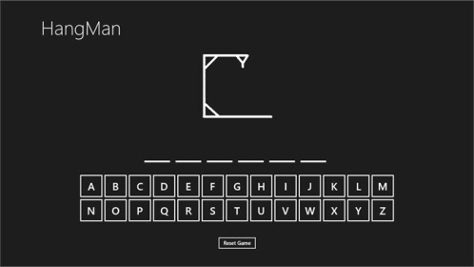  ----- is the universal language of mankind.(key: MUSIC)  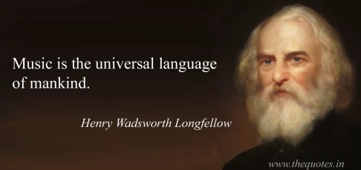  Learners are introduced with the theme of the lesson and speak own opinions about Music.  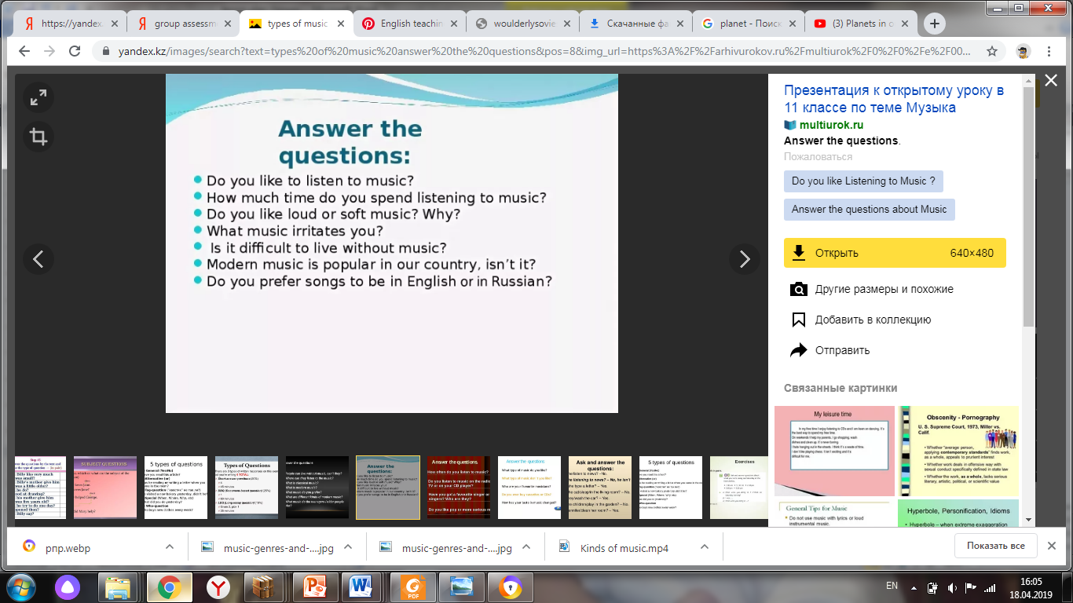  Activity 2. Question-answer method  Learners answer the questions. |  |  |  |  | http://exchange.smarttech.com/details.html?id=7704d7bf-44c6-4880-ae1e-0a91740d0a42  PPT1  https://medium.com/@edwardwong_61578/the-universal-language-of-mankind-4733fae40b  PPT2
Middle  5 min  3min  10min  2min  10min | Activity 2. New vocabulary  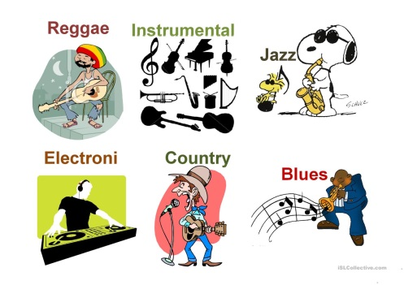  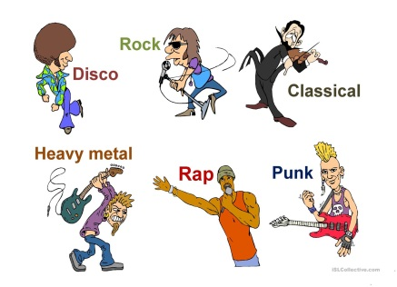  Learners look at the active board and introduce with new vocabulary  Activity 3. Listening (Matching method)  Division into group: by musical instruments  First group: dombra  Second group: guitar  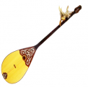    Task 1.  Listen to different pieces of music for some seconds and match the tunes with the styles.  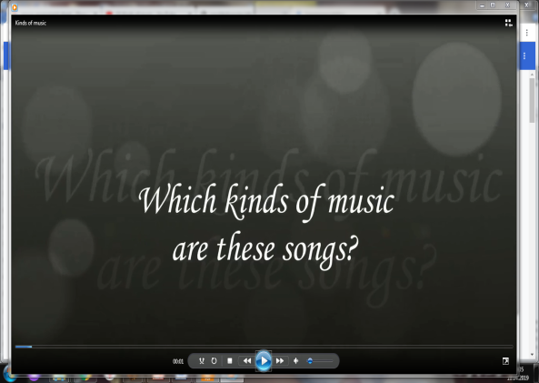  - Pop  - Rock  - Hip Hop  - Country  - Classical  Descriptor: Learners  - listen and guess the name of music  - match the tunes with the styles  Self assessment  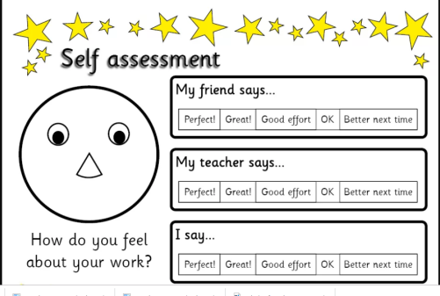  Activity 4. UE. Explanation of Grammar reference  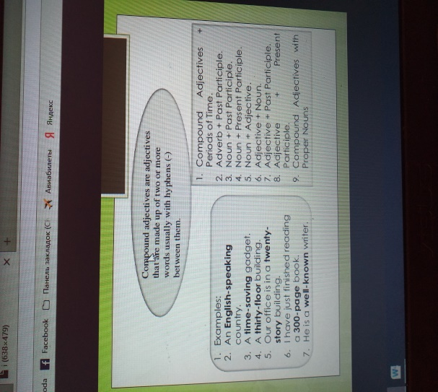  Learners look at the active board and introduce with grammar theme  Task 2. Grammar discussion  Discuss the questions below with your partner using new grammar  Grammar discussion  -“ED” and “ING”  Learner A  - What kinds of music are you interested in?  - What makes you feel relaxed?  - Do you feel tired after class? Why? or why not?  - Talk about a time you were terrified.  - Talk about a time you were worried.  - Talk about a time you were very surprised  Grammar discussion  -“ED” and “ING”  Learner B  - What kinds of music do you think are boring?  - What school subjects do you think are interesting?  - What kinds of activities do you think are exciting?  - What kinds of activities do you do that are relaxing?  - Talk about something you think is fascinating.  - Talk about some surprising news you heard or read about  Descriptor: Learners  - answer the questions  - use grammar theme  - work in a pair  Pair assessment  Dynamic pause.  “I am the Music Man”  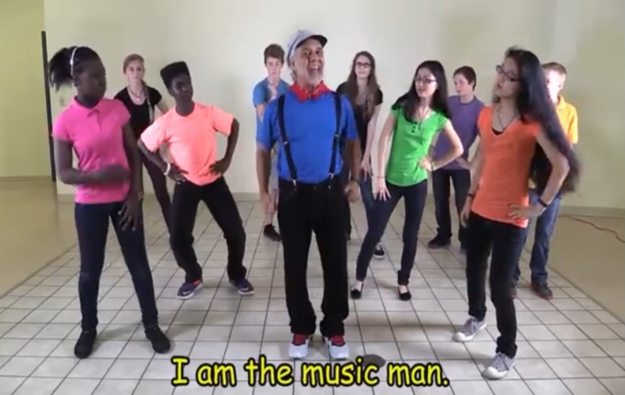  Activity 5. Speaking (Project method)  Task 3  Learners collect information about your favourite kind of music. Present it to class.  Descriptor : A learner  - tells about favourite music  Group assessment  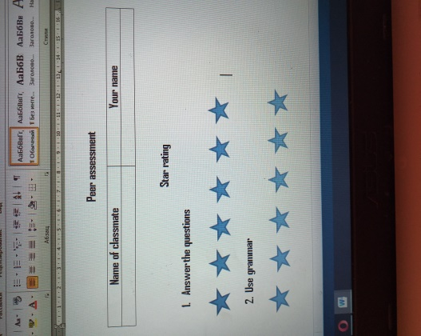 |  |  |  |  | PPT3  https://en.islcollective.com/resources/projectables/powerpoints_ppt_pptx/music_genres_and_vocabulary/music/77569  Cards with pictures musical instruments  https://kz.all.biz/dombra-g254824  https://ru.dreamstime.com/%D1%81%D1%82%D0%BE%D0%BA%D0%BE%D0%B2%D0%BE%D0%B5-%D1%84%D0%BE%D1%82%D0%BE-rf-quitar-image40564695  https://www.youtube.com/watch?v=gOngnDZ2wk0  Handout1  Handout2  https://yandex.kz/images/search?pos=0&img_url=https%3A%2F%2Fi.pinimg.com%2Foriginals%2F81%2F13%2Fb8%2F8113b8c3b88fe3707cc747d6dcdd7c07.jpg&text=self%20assessment%20my%20friend%20says&rpt=simage  PPT4  https://yandex.kz/images/search?pos=241&p=8&img_url=https%3A%2F%2Fimage.slidesharecdn.com%2Fcompoundadjectives-150720144118-lva1-app6892%2F95%2Fcompound-adjectives-2-638.jpg%3Fcb%3D1437403316&text=adjective%20as%20participle&rpt=simage  PPT 5  Handout 3  Handout 4  https://store.learningstationmusic.com/brain-breaks-action-songs-lets-move-download.aspx  Poster, marker  Handout 5
   | Yes | No
  Learners used learned vocabulary properly
  Learners used adjectives as participle
  Learners spoke without long stopping
End  5 min | Feedback.  Cinquain method (rhyming word)  Learners will be able to write the theme , then two adjectives describing the theme, three verbs characterizing the action, four words phrase contains the main idea and a synonym for the topic.  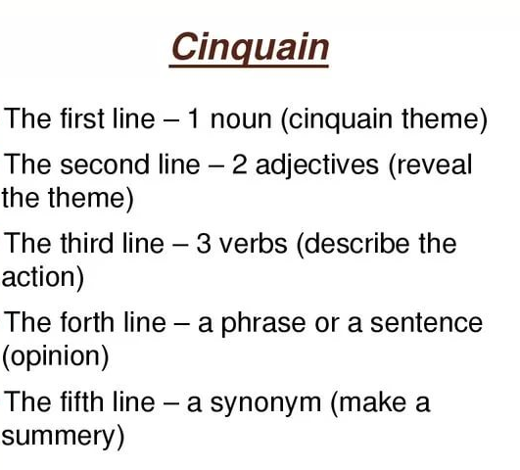  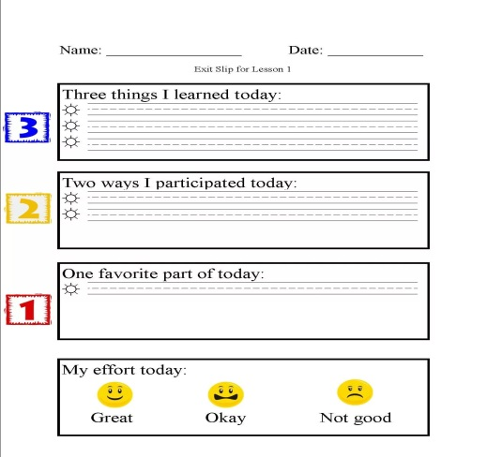  Reflection. “Exit ticket” |  |  |  |  | PPT 6  https://yandex.kz/images/search?pos=13&img_url=https%3A%2F%2Fds04.infourok.ru%2Fuploads%2Fex%2F1069%2F00055410-59cca032%2F640%2Fimg4.jpg&text=cinquain&rpt=simage  Handout 6
Additional information
Differentiation |  |  | Assessment |  | Health and safety check
By outcome(according to the Lesson Objectives)  By ability is contained in the individual task. It includes three levels:  Low –level learners Middle-level learners High-level learners  By task (according to learner’s ability) |  |  | Self assessment “Somebody says”  Pair assessment “Star rating”  Group assessment “Yes\No” |  | ICT technologies no more than 15 minutes  In order to give some relax we have used dynamic pause

