Видео «Заставка»
Good afternoon, ladies and gentlemen! Welcome to my stand up show!
My name is Evgeniy Tolstih and I’m the cadet of the 11th form of the Stavropol Presidential cadet school. Well, I have been studying here for 7 years and I can say that our studying is like an … obstacle course in the army. …And you should be prepared for different surprises starting from a common test and finishing a great event like this conference that is taking place at the level of the Ministry of Defense.
Well, I think I should start from the beginning… When I was at the 5th form our teacher announced that we were going to the zoo and we were so happy, but it wasn’t a common excursion…of course she made us speak English…
Видео в зоопарке (на слайде)
My second year at our school and the next obstacle was the irregular verbs. Why all the verbs just can’t end with –ed, who decided to make our life harder. How should we learn them?! You know, we have found the way.
1)6 Г песня – неправильные глаголы – видео “Lear and speak English irregular verbs”
I didn’t know then that it is just a beginning… when I was at the 7th I got to know about punishment. I’m not speaking about simple bad marks, (as you see we are innovated cadets) I’m talking about a trial, a real trial. Now I know all the peculiarities of this process… you know judges, accused, lawyers, victims… And how do you think who was the victim?
2) Суд над человечеством (кадеты 7,9 курсов)
COURT:  The 1 judge(Романько):  People of the planet! Will you stand up?  (All the participants stood up)  Listen to....! Listen to…! Tears everywhere! Planet is in danger, she is crying. We must help her now! We must help her now! Do you want to…? Do you want to…? We must help her now! I hope that all are present. Let’s start…  The Earth: I came here to be a Plaintiff. I want you to stop people. As for me, I lost my temper… I’m dying!!  The Senior judge(Рыбин): We gathered here to listen to you. Attention, please, the Earth lodged a complaint to the Humanity! But, first of all, I want to introduce the members of our process. They are: The Lawyer, Witnesses: The Earth, Children from the Earth, the Ecologist. Accused: Mankind, which is presented by: A Military Man; An Oil Magnate.  You see, we have a lot of work! It’s high time for you, Earth, to tell us about the subject of your complaint. | 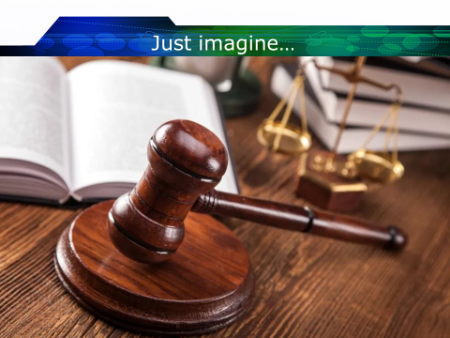
The Earth: For millions years I multiplied the treasures in my bowels, I kept fresh water, air, soil, maintained the balance of the nature.  One day, not happy for me a Man, appeared, he called himself A Sensible Human-being. He began to use my treasures. But he didn’t think about future generations. Your Lordship, I have a lot of evidence for my words, may I demonstrate them to the Court? (slides. The Earth describes them)  Once, he turned the rivers. Here it is the result!!! (slides)  He became very clever and built a lot of plants and factories, but he wasn’t so clever to think of the ways of utilization of their wastes. (slides)  He throws litter on the ground. (slides)  He starts wars, kills all living-beings, destroys natural and historic monuments. (slides 12-18 быстро)  Tell me, please, Your Lordship, can a sensible man do such things? |     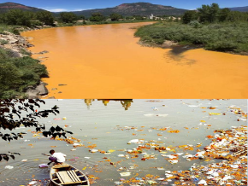  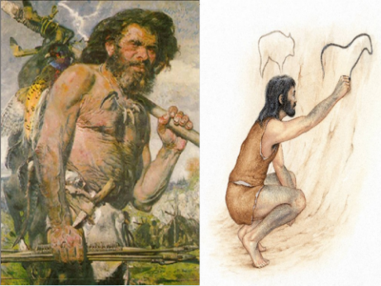    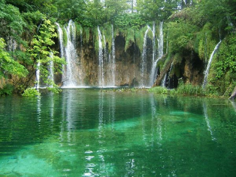  
The 2 judge(Дмитриев):  It’s really terrible! Now, we shall listen to the arguments of the Defendants… A Military Man is invited to the tribune… What will you tell us in your justification? Please, comment the shown slides.  A Military Man(Прокопенко): People fight from their appearing on the planet. So, I’m not guilty.  The 2 judge(Дмитриев): But what are you lack of? You have everything in excess! Why are you so greedy? There is a very old Indian proverb: “Only when the last tree has died and the last river, been poisoned and the last fish, been caught will you realize that we can’t eat money?” | 
A Military Man(Прокопенко): People need new territories, need more money than they have. It’s the people’s nature.  The Senior judge(Рыбин): But you kill people similar to you…! Even animals never do such things! You kill children, you leave them without parents, they die of cold and hunger! | 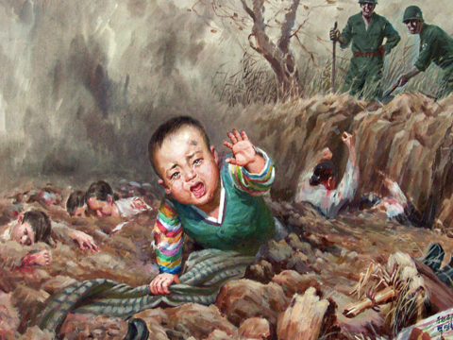
The 1 judge(Романько): It’s the turn of the Oil Magnate, come here to the tribune! Tell us, how do you allow oil to the seas and oceans?  The Oil Magnate(Саломатов): Try to imagine your life without oil! What will you do if I stop its production?!! People can’t live without oil. |   
Ecologist(Ларионов): You think only about yourself and about money! Try to think about the future generations!  because  It's significant for me  To live in peace and harmony.  Minding further generation,  We must stop deforestation.  To prevent the global warming,  Heating must be economic.  What to do to save the Earth?  To be rescued it is worth!  Waste debris is extremely large.  Who is to blame? Who is in charge?  I'm sure, all of us  Must reduce it. It’s a must! | Слайд 23 – перевод стиха
Children:  Poem “A CHILD’S WISH” | Слайд 24 перевод стиха
The Senior judge (Рыбин): The Verdict is being announced!! Attention, please!!  - Mankind will be given an opportunity to revise their lives.  - Mankind must begin to work over the problems of their planet.  - Mankind must prove that the MAN sounds proudly.  Thanks to all participants of the Court. Good Luck to you, People of the Earth!! | Слайд 25 вердикт

You know, we like such cooperation. Oh, Oh, it not a cooperation now, do you know what is it? ??? COLOBARATION (we are innovative, you remember)… because we have a great opportunity to meet new friends….. (smiling)… girl-friends…
And we are so thankful to our teachers that they give us such an opportunity. But sometimes it seems to me that our English teachers are spys (spies). They try to find out everything about our families, the places we live in, our hobbies. They usually ask us about our music preferences, whether we love cinema or theatre and even if we don’t love it they try to persuade us that we love theatre, because we become the part of school play or musical.
3) Усенко – песня из мюзикла Видео – песня4
Speaking about our military lessons… Their main aim, to my mind, is to improve our vocabulary. But our teachers again act like recruiters of the Ministry of Defense. They show us videos about the USA weaponry, we read texts about Armed Forces leadership and Structure of different countries. However, sometimes they behave in a strange way. It strikes me that they simulate their lack of information. May be they don’t want to be revealed…- слайд 26
4) Сценка с учителем на уроке по ВК. – слайд 27-самолет по-русски
You see, we can find a lot of adjectives to describe our English lessons and after school activities. I’ll call them wonderful, interesting, amazing, exciting, breathtaking, sometimes stressful (THEY MADE ME SAY IT)
(Слайд 30-37 быстро)
but BORING, no way! I have just shown you a few examples, and I don’t even tell you about the great amount of different quests and quizzes. We were asked a lot of tricky questions, so I feel like I would be able to sweep a mine if I could do it answering the questions. What about you? Could you ask some of such questions?
- - Which president has its memorial in the center of Washington that symbolizes that people should be free?
- What is the difference between howitzer and cannon?
- What is the surname of the Queen Elisabeth?
Слайд 38-39
To sum up, it should be mentioned that our English Obstacle Course is really hard but quite interesting. We have experienced unforgettable lessons, events, concerts. I tried myself as a doctor, a lawyer, a chef, an actor, a dancer, a soldier. I feel I am able to perform a lot of different tasks. Who knows which one I will need in future? And it goes without saying that I’m just A UNIVERSAL CADET.

