I Reading (3 класс)
Good friends.

Mike is nine. He is a pupil. He has a lot of friends.
On Sundays the friends walk, play football, or go to the Zoo. Football is Mike’s favourite sport.
On Mondays they like to play. But they are pupils. They must do their homework. They do it every day. On Tuesdays they listen to music.
And on Wednesdays they often play computer games. Thursdays are for reading funny fairy tales. On Fridays they watch wonderful TV programmes. And on Saturdays they like to go to a birthday party. And they help their mothers to clean the rooms.
They are good friends.

Задание A
Прочитай текст. Отметь утверждения как верные (Т) или неверные (F).

  - Mike has got a lot of friends.________
  - Football is the friends’ favourite sport.________
  - They play on Mondays.__________

Задание B
1. Выбери правильный ответ.

1. On Tuesdays they have some time….
- to listen to music
- to play football
- to do homework

2.The TV programmes on Fridays are…..
- nice
- wonderful
- good

3. On Saturdays the friends help their mothers…..
- to work and rest
- to go to the birthday party
- to clean the rooms

  - Use of English
1. Вставь вместо точек глагол is или are.
- There is a playground in my village.
1. Тhere … a playground in my village.
2. Тhere … lots of trees in the park.
3. Тhere … a tree in the playground.
4. Тhere … a river near my house.
2. Подчеркни правильный ответ
- The giraffe is/are eating.
1. The camels is/are playing.
2. The hippo is/are sleeping.
3. The birds aren`t/ isn`t swimming.
4. The lion isn`t/aren`t watching TV.
3. Выбери и подчеркни can/can`t , чтобы утверждения были верными
- The parrots can/can`t speak.
1. The cat can/ can`t run.
2. The tiger can/can`t jump.
4. The fish can/can`t swim.
5. The penguins can/can`t fly.
4. Найди лишнее слово и подчеркни его.
1. bathroom, school, living room, bedroom
2. dress, nose, leg, ear, arm,
3. in, on, under, behind, are
4. chicken, pizza, salad, like, cheese
5. Подбери к картинкам предложения и укажи время на часах. 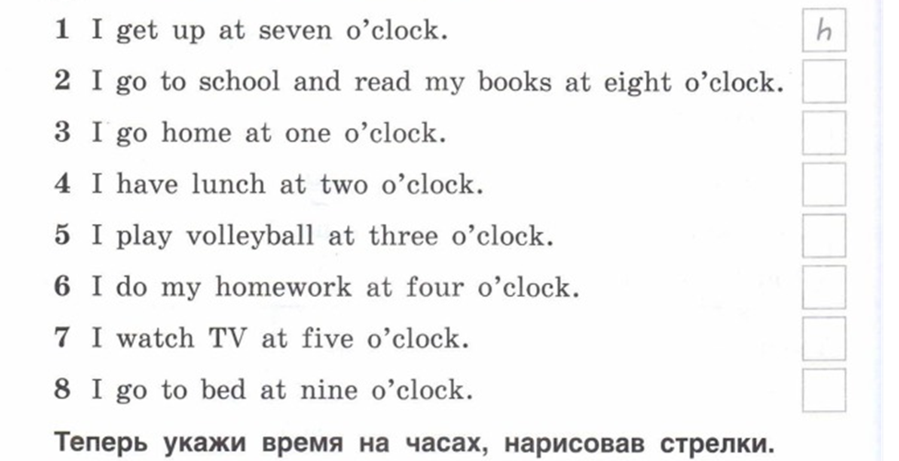
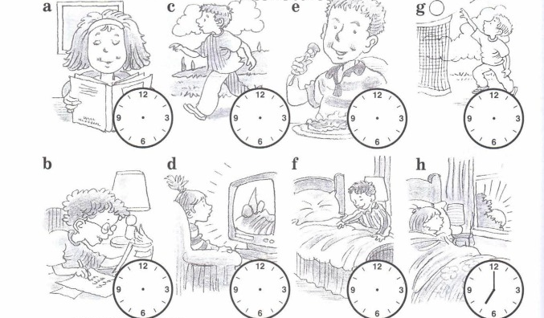

Ключи:
I Reading
A
1.T
2. F
3.T

B
1.a
2. b
3. c

II.Use of English
1. 1. Is
2. are
3. is
4. is
2. 1. are
2. is
3. aren`t
4. isn`t
3. 1. can
2. can
3. can
4. can`t
4. 1. school
2. dress
3. are
4. like
5. 1.h
2. a
3. c
4. e
5. g
6. b
7. d
8. f

