Hand-out
Practical English
Academic year 2019-2020
Subject: Outstanding people Teacher: Sabirdinova Sabina Adilkhanovna
Level: Intermediate
Group: 8

Procedure of the lesson:
At this lesson we are going to:
- to be able to speak about the Kazakh famous people;
- to enlarge our vocabularies, to develop our communicative skills;
- to feel ourselves as a proud citizen of Kazakhstan.

II. Evocation.
 | At the beginning of the lesson | At the end of the lesson
The degree of the knowledge of this theme
The attitude to the theme of the lesson
The atmosphere in the class

III. Before speaking on the new theme let’s review the previous materials. At the previous lessons we spoke about theatre, cinema and music, travelling, clothes you made your own opinions concerning these themes, spoke about your idols, etc. Please tell me once again:
- What is your hobby?
- What kind of music do you like?
- Who is your favourite actor or actress?
- What films do you like best of all?
- What is your favourite film?
- Do you prefer going to the cinema or watching films at home?
- Have you been to the theatre?
- Do you like shopping?
- How often do you travel?
IV. Brainstorming. T: What spheres of society come into your mind when you hear about the outstanding people?
Policy Education

Outstanding People

Music Outstanding people Theatre

Sport Literature Art

Pupils name the spheres of the society where there is so numerous numbers of people, who has the role of the individual in the history.
V. Boys and girls, at the beginning of the lesson I’ve said that our today’s theme is Outstanding People, and now we’ll take some information about some personalities from the different spheres, you named.
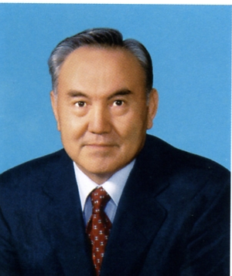
Nursultan Abishuly Nazarbayev is the first President of Kazakhstan, the great politician of not only Kazakhstan, but one of the outstanding figures of the world. He has been the country's leader since 1989, when he was named First Secretary of the Communist Party of the Kazakh SSR, and was elected the nation's first president following its independence from the Soviet Union in December 1991. In April 2011, Nazarbayev was re-elected to another five-year term.

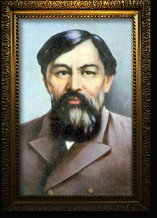
Ibray Altynsarin was a famous Kazakh educator and teacher of the 19th century. He was born in 1841 in Torghai region. Altynsarin started a Cyrillic alphabet for the Kazakh language. He opened many Kazakh-Russian schools and schools for girls. He translated books and textbooks. He wrote the first Kazakh Grammar book. Altynsarin travelled a lot and visited many countries. He liked children and wrote poems for them. A lot of streets, institutes and schools are named after Altynsarin. There is an Altynsarin museum in Kostanay.
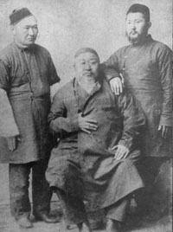
Abay Kunanbayev is a famous writer and poet. He was born in 1945in Abay region. Grandmother Zere told him tales and sang songs. He went to school in Semipalatinsk. Abay wrote many books and poems. His main book is The Book of Words. He translated Pushkin, Krylov and Lermontov into Kazakh. He lived a long life and did a lot for people. Many streets, squares, theatres are named after Abay. People in many countries know Abay and his works. There are monuments to Abay in many cities.
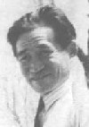
Abylkhan Kasteyev, People's Artist of Kazakhstan, winner of the Ch.Valikhanov Kazakh SSR State Prize, was born on January 1,1904 in the settlement of Chizhin (Panfilov district, Taldy-Korgan region). Studied at N.G.Khludov's studio in Almaty.One of the founders of painting art in Kazakhstan. Died on November 2,1973. The name of A.Kasteyev is assigned to the largest in the Republic State museum of Fine Arts of the Republic of Kazakhstan.The building that houses a gallery of the famous printer has a long history. Previously, it served as a military commissariat, offices for the Communist Party committee and a House of Pioneers.In 1936 200 works of painting and graphic arts from the reserves of the Tretyakov Gallery, the State Russian Museum and the Pushkin State Museum of Fine Arts were presented to the State Museum of Arts of Kazakhstan, which later was named after Abylkhan Kasteyev.
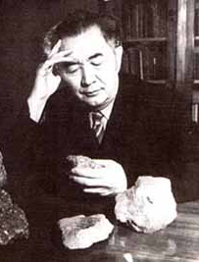
Kanysh Satbayev was the prominent Kazakh geologist, a founder and the first President of the Kazakhstan Academy of Sciences, Professor, Doctor of Geology and Mineralogy, Member of the USSR Academy of Sciences and Member of the Presidium, the State and Lenin prize-winner. The great learning, the important contribution to the Victory in the Great Patriotic War, remarkable geological, scientific and industrial achievements together with social and political activities made Kanysh Satpayev as famous as Abai Kunanbayev, Chokan Valikhanov and Mukhtar Auezov - great sons of the Kazakh people.

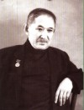
Shamshi Kaldayakov was a Kazakhstani composer. In 1956, he composed the music to the patriotic song My Kazakhstan. It was adopted in 2006 to be the Kazakhstan national anthem by Kazakh President Nursultan Nazarbayev after a few modifications in the lyrics, gone down in history.

Kazhimukan — an outstanding Kazakh wrestler and circus artist. He repeatedly (in 1908, 1909, 1911, 1913, 1914) won in the world championships in Graeco-Roman wrestling among the professionals. He is the first Kazakh, who gained the title of the champion in French wrestling, and repeatedly won in the world, Russian, regional, also in All-Union championships among the heavy-weights. Kazhimukan is a holder of about fifty different rewards and medals.
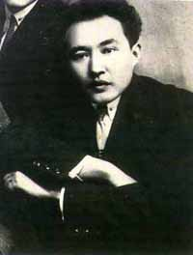
Auezov Muhtar Omarhanovich(1897-1961) – the great writer, known in many countries.The first and earliest Auezov’s work was the play "Enlik-Kebek" based on the national legend about tragical destiny of two young people, dared to put the feelings above patrimonial conflicts. The play "Enlik-Kebek" for the first time was put in yurt of Abai’s wife Aigerim and since then didn’t descend from the Kazakh stage. The completion of Auezov’s creative researches was found in a novel-epopee "Abai’s Path", consisting of four books.
- Dear friends! I think you have more information about the life and activities of some Kazakh famous people. What have you learnt from these materials?

VI. It’s time to give you the home task. Your home task will be:
- to prepare a topic on the theme “The most outstanding people”

VII. Reflection.
 | At the beginning of the lesson | At the end of the lesson
The degree of the knowledge of this theme
The attitude to the theme of the lesson
The atmosphere in the class

VIII. Glossary
English | Russian | Kazakh
politician | политик | саясаткер
educator | воспитатель | тәрбиеші
settlement | поселок | кент, ауыл
military commissariat | военный комиссариат | әскери комиссариат
prominent | видный | көрнекті
geologist | геолог | геолог
contribution | вклад | үлес
modification | модификация | түрлендіру
wrestler | борец | балуан
gain | получать | алу
descend | спускаться | түсу
anthem | гимн | әнұран

