Lesson plan

Theme |  | Jobs and Life
Date: |  | Teacher’s name: Nurzhakhan Amankulova
Class: 7«V»

Aim |  | developing pupils’ reading, speaking, writing, listening and thinking abilities
Lesson objectives |  | Learners will be able to:  - predict the contents with the help of the film;  - use the vocabulary during speaking material;  - describe the jobs
Expected  results |  | Learners will be able to:  - speak about jobs and works;  - read for main information;  - understand and use the lexical
Type of the lesson |  | Combined
Resourses |  | An interactive board, an internet, a DVD film, CDs, the text «First Jobs», sheets of paper, felt-tip pens, the picture of the tree, stickers, the answer form, paper fans, paper planes, a test, pictures.
Stages | Planned activities | Resources | Aim of  the stage
Warm-up activity  3 min | T: Good morning, students. I’m glad to see you.  Greeting, duty’s report (teacher → Class)  Watching a DVD  After the greeting, watching the film. The pupils predict the lesson with the help of film and guess the name of the theme of the lesson.  T: Answer the question “What is it about?” (Pupils’ answers)  The theme of our lesson is “Jobs and Life”. Today we are talking about work and jobs. |  DVDs  Presentation | to guess the name of the lesson
Start - up activity  2 min | On the Board Дерево предсказаний  (Tree of Foretelling)  T: What do you want to do, want to foretell and want to know in our lesson?  (The pupils write their wishes and stick them to the tree) | Board  Picture of the tree  Stickers | to know pupils’  opinion
Let’s play a game!  7 min | T: Look at the pictures of the different jobs people do. Using  - Vocabulary  - Adjectives  (vet, firefighter, doctor, factory worker, chauffeur, zoo keeper, pilot, shop assistant, actor, babysitter) and ask questions. Answers: Yes/ No, … .  Possible questions:  - Is her job allowed to?  - Is her work varied?  - Is her work dangerous?  - Is her job well-paid or badly-paid?  - Does she wear an uniform?  - Has she got a special hat?  - Is her uniform white?  - Does she help people?  - Does she first aid kit?  - Is this a doctor? | Presentation  Pictures of the different jobs | to use the vocabulary  and  adjectives
Plan

Which person:
- helps animals?
- works outside?
- wears a uniform?
- works long hours?
- helps people?
- works in the same place?

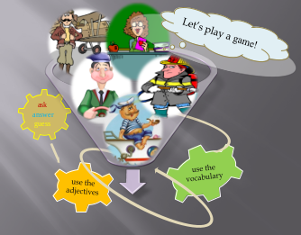

Listening  2min | Teacher: Children, listen and choose a job for the speakers  (1 firefighter, 2- vet, 3- pilot)  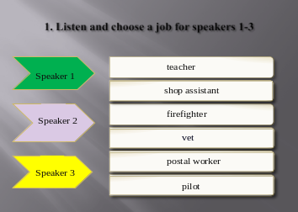 |  | CDs  Presentation | to develop students’  listening skills
Test  10min | T: Children, connect to the internet and choose the correct answers (the names of jobs) Self-assessment - 10/10 – “5”  9-8/10 – “4”  7/10 – “3”  6/10 - “2” |  | Test  Internet  Answer form  Sheet of paper  Extra  material #1 | to check the pupils’  assimilation
TPR  2 min | Are you tired? Let’s have a rest! |  | CDs | to relax
Speaking  3min | T: Look at the pictures of famous people.  Do you know these famous people?  Possible answers:  This is Madonna. She is a singer…  This is Tom Cruise. He is an actor…  People often do lots of different jobs. Look at the jobs these famous tried!  Before the beginning the students are divided into two groups.  The Rules of work in groups  - We must be friendly.  - We have to listen to each other.  - We shouldn’t speak loudly.  - We have to work together.  - We must do all exercises.  - We should respect our opinion.  - If we are ready, we clap our hands. |  | Presentation  The Rules of work in groups | to form students’ oral  speech
“Speaking Walls”  8 min | - Reading  - Memory  - Speaking  - Writing  Work at the text ”First Jobs”. Everyone in the group reads one sentence and should tell the content of the text another pupils in the group. Somebody of the group should write the sentences.  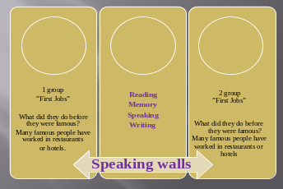  Success criteria: Group-assessment for the contents of the text |  | Presentation  Extra  material #2  Extra  material #3 | to develop students’  reading,  memory,  speaking and  writing skills
Reading  Speaking  Writing  5 min | Read the text about first jobs of famous people.  Ask and answer questions and write  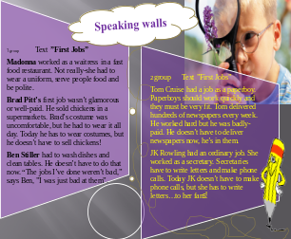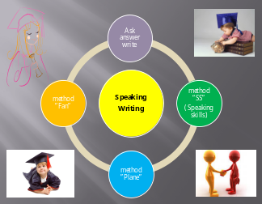  - 1 group - method ”Fan”  - 2 group - method “SS”  ( Speaking skills)  method ”Plane” |  | Presentation  Paper fans, Paper Speaking skills  Paper planes | to develop students’  writing and speaking skills
Wrap-up 2min | Conclusions of the lesson  The teacher asks students to distinguish the main parts of the lesson, write their progress or what students have done in the lesson and stick to the tree. |  | Picture of the tree  Stickers | to know pupils’  opinion
Hometask  1min | Describe someone’s job that you like. |  |  | to prepare a project

