1. Прочитайте и устно переведите текст.
Muscle is a contractile tissue (сокращающаяся ткань) and is derived from the mesodermal layer (мезодермальный слой) of embryonic cells. Muscle cells contain contractile filaments (нити) that move past each other and change the size of the cell. They are classified as skeletal, cardiac, or smooth (гладкие) muscles. Their function is to produce force and cause motion. There are three types of muscle tissue recognized in vertebrates (позвоночные):
Skeletal muscle or “voluntary muscle” (произвольно сокращающаяся мышца) is anchored
(закреплена) by tendons (сухожилия) to bone and is used to effect skeletal movement such as locomotion (передвижение) and in maintaining posture (осанка). Though this postural control is generally maintained as an unconscious (бессознательный) reflex, the muscles responsible react to conscious control like non-postural (непостуральный) muscles. An average adult male is made up of 42% of skeletal muscle and an average adult female is made up of 36%.
Smooth muscle or “involuntary muscle” is found within the walls of organs and structures such as the esophagus (пищевод), stomach, intestines, bronchi, uterus, urethra, bladder, blood vessels. Unlike skeletal muscle, smooth muscle is not under conscious control.
Cardiac muscle is also an “involuntary muscle” but is more akin (схожа) in structure to skeletal
muscle, and is found only in the heart.
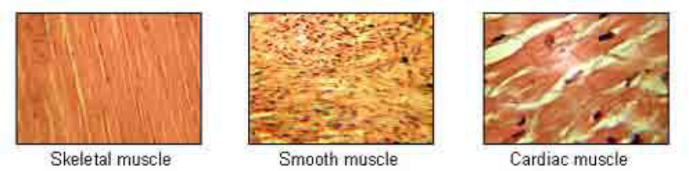
2. Ответьте на вопросы письменно.
1. Give the definition of the word ‘muscle’.
2. What do muscle cells contain?
3. How are they classified?
4. What is a skeletal muscle?
5. What is a smooth muscle?
6. What is a cardiac muscle?
3. Составьте словосочетания, соединив слова в колонке A и B. Переведите их на русский язык.
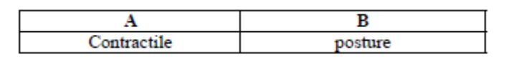
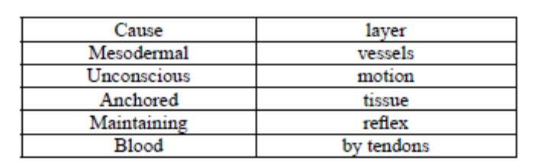

4. Назовите тип мышц в следующих органах.
1. Heart
2. Esophagus
3. Skeletal bone
4. Intestines
5. Bladder
6. Bronchi
7. Uterus
8. Stomach

