School No 7 by V.Komarov
Theme of the lesson: |  | Holiday activities
Date: 24.04.2019. |  | Teacher name: Zhamila Kaziyeva
Grade: 5 A |  | Number present: 13 absent:
Learning objectives thatthis lesson is  Contributing to |  | 5.W4 Write with support a sequence of extended sentences in a paragraph to give basic personal information.  5.R2 Understand with little support specific information and detail in short, simple texts on a limited range of general and curricular topics.
Lesson objectives |  | All learners will be able to:  understand conjunctions and new words, work actively
Most learners will be able to:
give an opinion about interesting places to go, using new words.
Some learners will be able to:
work without any support.
Success criteria |  | Learners have met the learning objective (R1) if they canWrite answers for personal questions connecting extended sentences into a paragraph;
Value links |  | Friendship, positive behavior
Cross-curricular links
ICT skills |  | melody
Previous learning
Plan
Planned  timings | Planned activities |  |  |  | Resources
Beginning  5 mins | ORGANIZATION MOMENT: teacher greets students; students respond to greeting and take their places. Students get familiar with the lesson objectives  Brainstorming  Imagine tomorrow is your holiday. Make holiday plans. You should provide information about:  1.Where will you go? Why?  2.Who will you go with?  3. What will you do there ...?  4.What places do you visit there?
30mins | Vocabulary:  Meetwith friends – достармен кездесу  Go on a picnic – пикникке бару  Go to the beach – жағажайға бару  Go hiking- жаяу жүру  Go to the mountains- тауға шығу  Eat in a restaurant- мейрамханада тамақтану  Sunbathe- күнге күю  Task 1. Write the different types of holidays  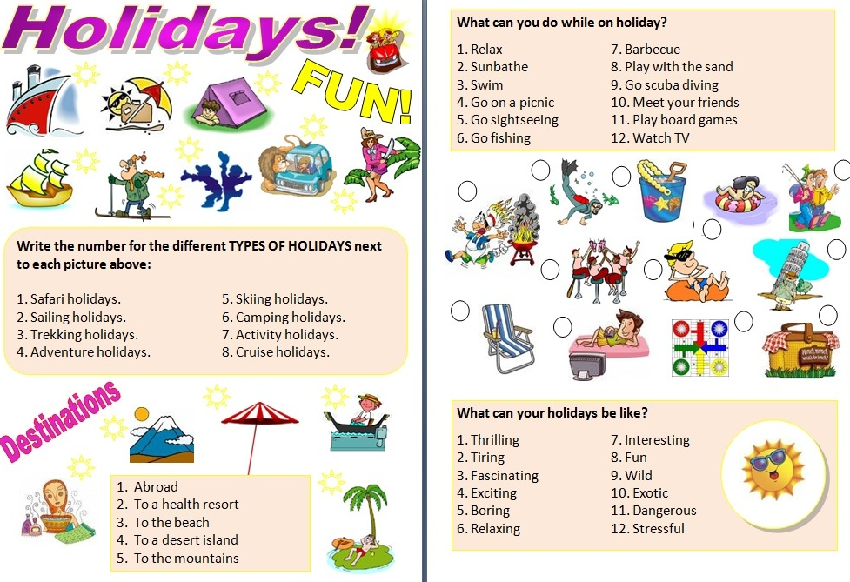  Task 2.  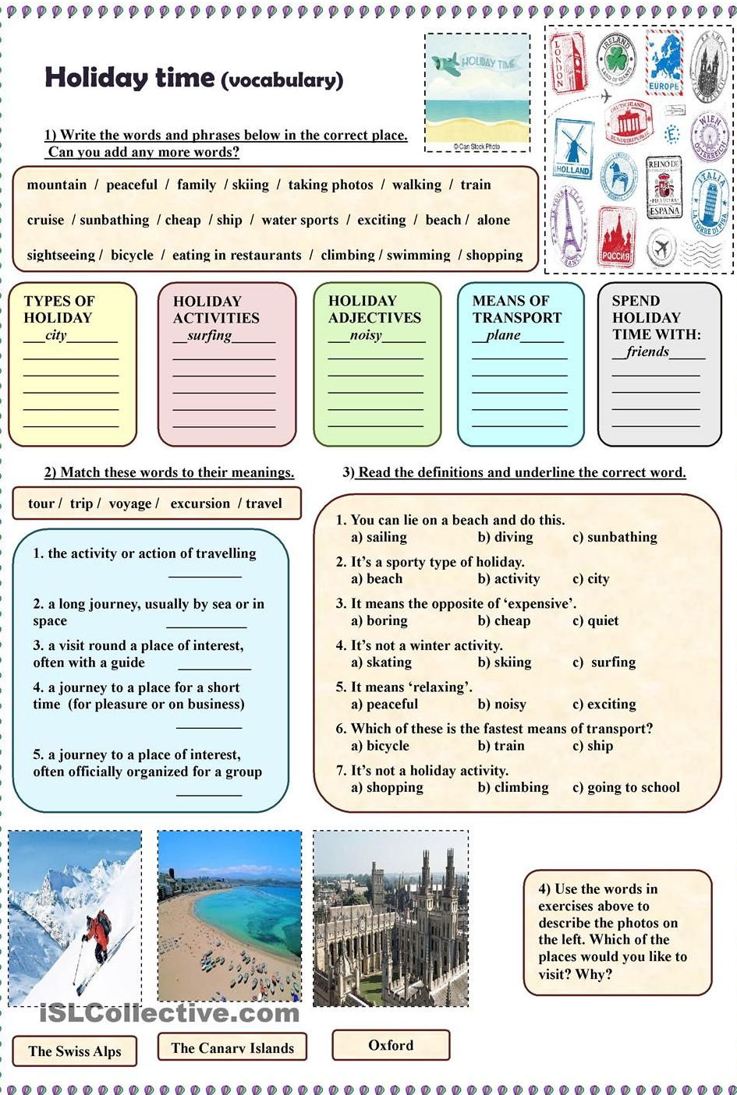  Task 3  It’s nearly the school holidays! Close your eyes for a moment and think about the school holidays. Then write the words or draw the pictures of the things you thought of here: (within 2 minute) |  |  |  | flashcards  Worksheets  Worksheets  Make a poster
End  5 mins | Reflection  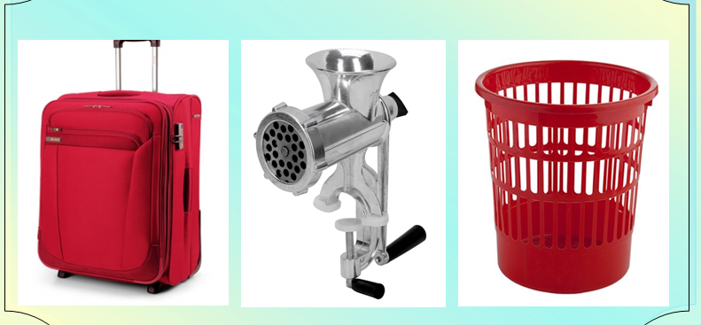 |  |  |  | stickers
Additionalinformation
Differentiation – how do youplan to give more support?How do you plan tochallenge the more ablelearners? |  |  | Assessment – how  are you planning tocheck learners’learning? | Health and safety check  ICT links
Less able students – greater support by means of prompts, visuals or writing difficult words on the blackboard  More able students – independent work on definite tasks with little/no support |  |  | Through observation using cards,smiles | Music  Art
Reflection
Were the lesson objectives/learning objectives realistic?
What did the learners learn today?
What was the learning atmosphere like?
Did my planned differentiation work well?
Did I stick to timings? What changes did I make from my plan and why?
Summary evaluation
What two things went really well (consider both teaching and learning)?
1:
2:
What two things would have improved the lesson (consider both teaching and learning)?
1:
2:
What have I learned from this lesson about the class or individuals that will inform my next lesson?

«В. Комаров атындағы жалпы орта мектебі»
Коммуналдық мелекеттік мекемесі

Ашық сабақ
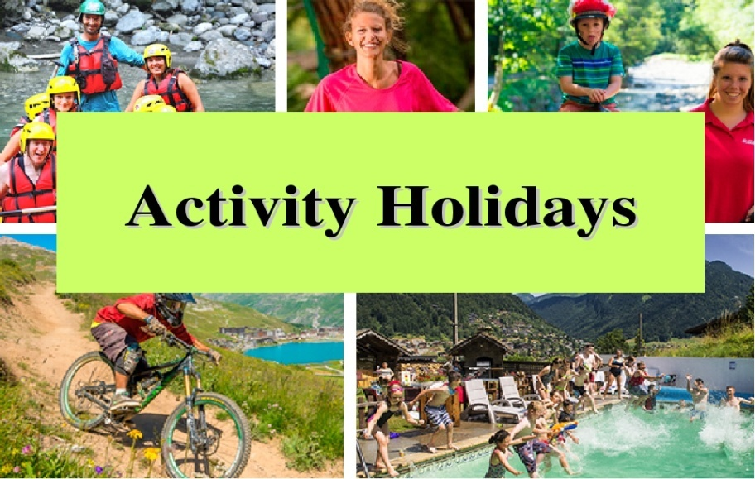

Ағылшын тілі пән мұғалімі
Казиева Ж.К.

2018-2019 оқу жылы

