TEST 5
(Module 5 “World animals”)

Listening
1. Listen and for questions 1-5 tick the correct response.
e.g. What animal does Pete like to see at the zoo?
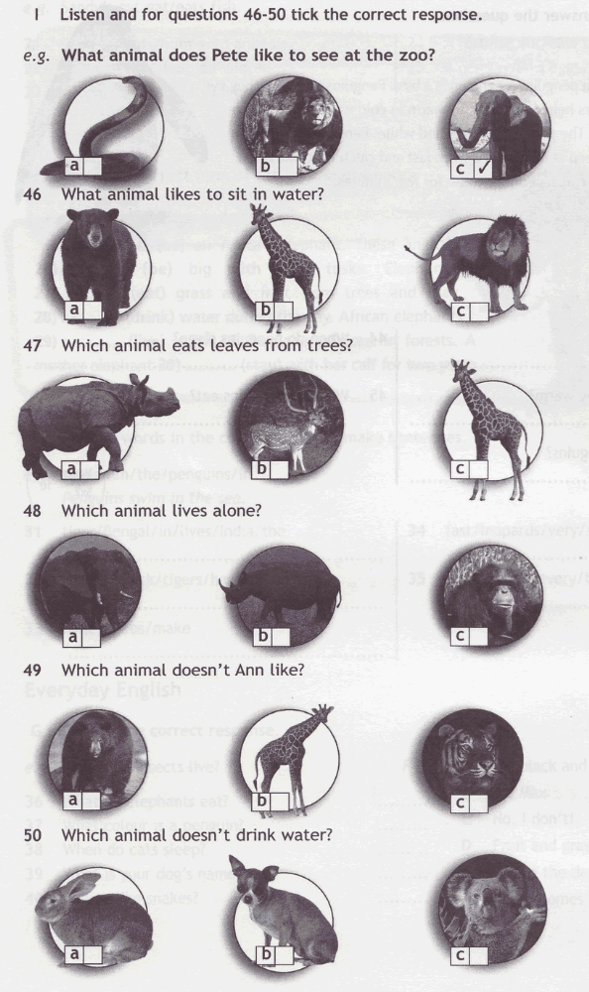

1. What animal likes to sit in water?

2. Which animal eats leaves from trees?

3. Which animal lives alone?

4. Which animal doesn’t Ann like?

5. Which animal doesn’t drink water?

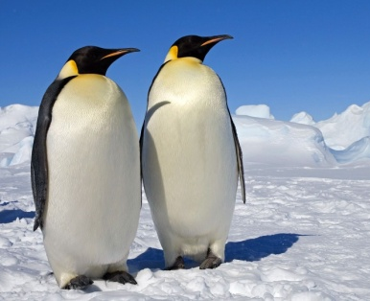
Reading
2. Read the text and answer the questions.

This is a picture of a penguin. A penguin is a bird. Penguins can’t fly. They live in the Antarctic. Feathers help penguins stay warm in cold weather. Their size helps too. They are fat! The penguin is black and white. Penguins don’t sleep during the day. They sleep at night. They swim fast and catch food in the sea. They eat small fish and can stay under water for five minutes.

e.g. What is a penguin?
It’s a bird that can’t fly.

1. Where does it live?
2. What helps them stay warm?
3. What colour are penguins?
4. When do penguins sleep?
5. What do penguins ear?

Grammar
3A. Put the words in the correct order to make sentences.

e.g. sea / swim / the / penguins / in. - Penguins swim in the sea.

- tiger / Bengal / in / lives / India / the.
- stripes / black / tigers / have.
- honey / bees / make.
- fast / leopards / very / run.
- go / zoo / I / to / every / the / Saturday.

3B. Choose the correct item.

e.g. I love koalas. They are ……. Australia. A from B by C to

- Lions ………. during the day. | A doesn’t sleep | B sleeps | C sleep
- Koalas ………. water. | A drinks | B don’t drink | C doesn’t drink
- Insects ………. gardens clean. | A keeps | B doesn’t keep | C keep
- Humans ……….. in trees. | A don’t live | B doesn’t live | C lives
- A giraffe ………. leaves from trees. | A eat | B don’t eat | C eats

Vocabulary
4. Circle the odd one out.

e.g. neck – cobra – paws – fur

- peacock – hen – duck – tortoise
- penguin – sheep – caw – deer
- rabbit – dog – parrot – crocodile
- leg – insect – break – tail
- goldfish – tiger – lion – leopard

Everyday English
5. Choose the correct response.

e.g. Where do insects live? | F | A It’s black and white.
1 What do elephants eat? | ……. | B It’s Max.
2 What colour is the penguin? | ……. | C No, I don’t!
3 When do cats sleep? | ……. | D Fruit and grass.
4 What is your dog’s name? | ……. | E During the day.
5 Do you like snakes? | ……. | F In our homes and gardens.


Module 5 “World animals”
Ответы:
№1
1 | 2 | 3 | 4 | 5
A | С | B | А | C

№2
in the Antarctic
Their feathers/ They are fat
Black and white
at night
small fish

№3A
The Bengal tiger lives in India.
Tigers have black stripes.
Bees make honey.
Leopards run very fast.
I go to the zoo every Saturday.

№3B
1 | 2 | 3 | 4 | 5
C | B | C | A | C

№4
tortoise
penguin
crocodile
insect
goldfish

№5
1 | 2 | 3 | 4 | 5
D | A | E | B | C

Критерии оценивания:

«5» - 30 – 28 баллов
«4» - 27 – 24 баллов
«3» - 23 – 18 баллов
«2» - 17 и менее баллов

