Тема: Модальные глаголы must/should or mustn’t/shouldn’t

1 Прочитайте предложения с модальными глаголами must (должен)/should (следует) or mustn’t (нельзя)/shouldn’t (не следует), обращая внимание на их употребление и выполните задание второй презентации по образцу

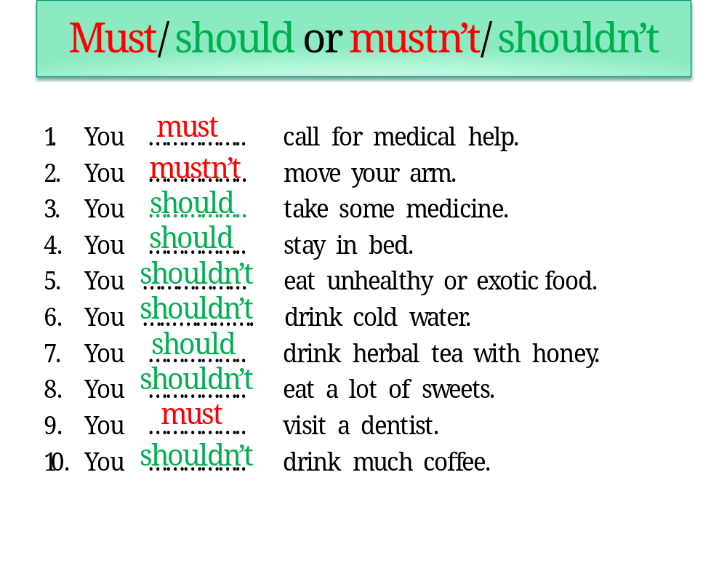
Образец: You should get up early and go to bed early. You shouldn’t smoke.


2 Соотнесите фразы
1 I have a horrible headache.  2 My back hurts.  3 I have a sore throat.  4 I’ve got a stomachache.  5 Take a short break.  6 I have a high temperature. | a Have a cup of tea with honey.  b You’ll work better after it.  c I ate something bad.  d Take an aspirin.  e I’ll down.  f I worked too much yesterday.

3 Запишите в словарь новые слова syrup- сироп, capsules- капсулы, herbal remedies- лекарственные травы, tablets- таблетки и запомни их.
When I have flu, I always have herbal remedies.

4 Выполните упр.4, с. 103. Прочитайте биографию Даниэля Дефо и отрывок из его произведения. Ответьте на вопроcы в нескольких предложениях
What happened to the main hero?
What did he do to get better?

5 Дом. задание: Do the following tasks
1 Choose the right spelling:
1.
- component
- componennt
- comtonent

2.
- dieteary
- dietary
- dietari

3.
- liquid
- liquide
- liqkuid
2
Write the correct translation of the words. Don’t use ‘to’ with the verbs:

1. здоровая еда, 2. Избегать, 3. Беспокоиться, 4. Улучшать, 5.. Чудо, 6 развитие

3 Read the text and do the task given after it.

Surfing is popular all over the world. It's practised on lakes and rivers, seas and oceans — anywhere with good wind.

Some people think that it's a new kind of sport. But it is not. It was first reported by the British explorer Captain Cook in 1778. It became popular with the introduction of mass-produced, lightweight boards made of fibreglass in the 1960s. The birthplace of surfing is Hawaii and today it's home of the most famous surfing competition. Huge waves crash along mile after mile of beautiful sand, and every surfer dreams of experiencing surfing in Maui or Oahu.

The best time for surfing is when the waves are high. Serious surfers must be very brave, love adventure and have lots of energy. Once they've experienced the excitement of a ride on top of the waves, they never want to stop.

It takes time to learn to catch a wave at the right moment, stand up on your board and stay there. But during a hot summer day, who minds practising?

Сhoose the right sentence:

1.
- It was first reported by the British explorer Captain Cook in 1798.
- It was first reported by the British explorer Captain Cook in 1778.
- It was first reported by the British explorer Captain Cook in 1728.

2.
- Huge waves crash along mile after mile of beautiful sannd, and every surferes dreams of experiencing surfing in Maui or Oahu.
- Huge waves crash along miles after mile of beautiful sand, and every surfer dreams of experincing surfing in Maui or Oahu.
- Huge waves crash along mile after mile of beautiful sand, and every surfer dreams of experiencing surfing in Maui or Oahu.

3.
- But during a hot summer day, who mind practising?
- But during a cold summer day, who minds practising?
- But during a hot summer day, who minds practising?

