Short plan

Long-term plan Unit 7.The natural environment |  | Gymnasium № 41
Date: 01.04 - 02.04. |  | Teacher’s name: Meirambai S.M.
Grade: 2 “A” |  | Present: | Absent:
Grade: 2 “V” |  | Present: | Absent:
Grade: 2 “D” |  | Present: | Absent:
Theme of the lesson: “What’s the weather like”
Learning objectives(s) that this lesson is contributing to | S3 use a limited range of basic words, phrases and short sentences to describe objects, activities and classroom routines;  2.UE3 use common adjectives in descriptions and to talk about simple feelings
Lesson objectives | - Learn the new words and phrases about weather;  - Practice new words and phrases;  - Answer the questions;  - Respect each other
Success criteria
Value links | Values are instilled by/through discussion weather, answering the questions, respecting each other, sharing opinions.
Cross curricular links | Geography
ICT skills | Learners learn online using Zoom
Previous learning | Revision
Plan
Planned timings | Planned activities (replace the notes below with your planned activities) | Resources
1 min  5 min  10 min  10 min  3 min  7 min  2 min  3 min | Warm up (D, W) Teacher demonstrates a number of pictures and asks the students to guess the topic.  -Look at the pictures and guess the theme of our lesson.  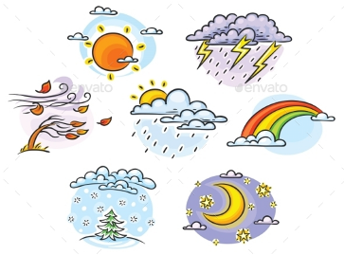  -Today we are going to speak about “Weather”.  Activity 1. Teacher introduces to the learners with new phonemes “ou”, “ow” which sounds like [aʊ].  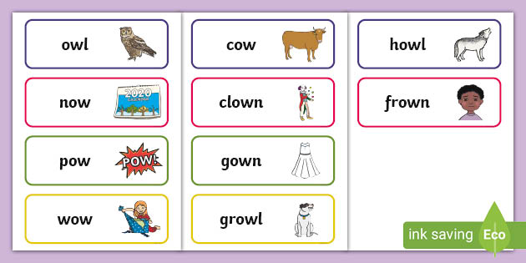  Presentation. Activity 2. Learners name kinds of weather.  - What is the weather like today?  - Let’s learn more words on this topic. Listen and repeat.  Weather [ˈwɛðə] погода  sunny [ˈsʌni] солнечный  rainy [ˈreɪni] дождливый  windy [ˈwɪndi]ветряный  snowy [ˈsnəʊi] снежный  cloudy [ˈklaʊdi] облачный  hot [hɔt] жаркий  warm [wɔːm] теплый  cold [kəʊld] холодный  stormy [ˈstɔːmi] грозовой  How’s the weather?-какая сегодня погода?  It’s…. – сегодня погода…  Practice. Activity. Learners working in pairs do formative task.  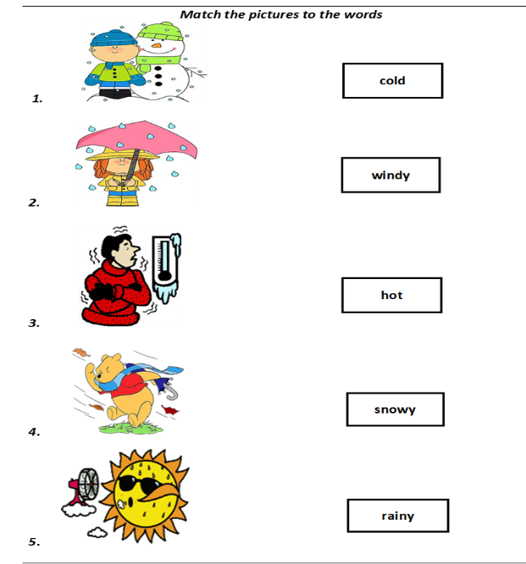  Activity 4. Learners sing a song “How’s the weather” and repeat the actions  Activity 5. Learners fill missing letters according to the new words.  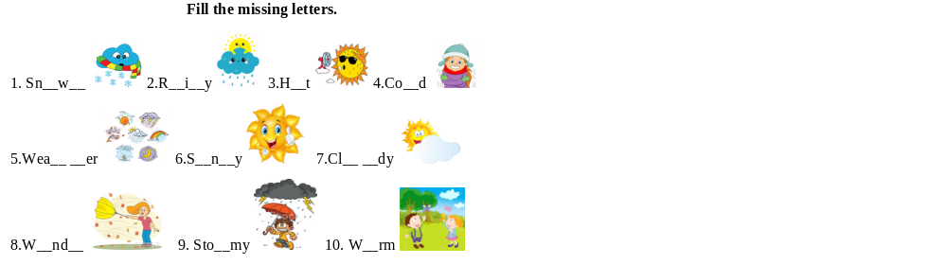  Home task.  -Learn the new words and phrases by heart.  5. Reflection  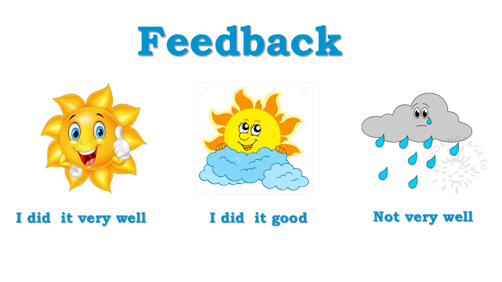 | presentation  presentation, copybooks  Presentation PPT  Cards for each learner with new words  Sheet with the table for each group  https://youtu.be/XcW9Ct000yY  Sheet with task for each learner

