План-конспект урока по теме «Travelling. The sights of London»
Цели урока: систематизировать и обобщить знания по темам «Путешествие» и «Достопримечательности Лондона».
Практическая: совершенствование речевых умений и навыков (не)подготовленной речи по темам “Путешествие”, “Лондон”.
Задачи урока: Учебные:
- • развитие умений в монологической и диалогической речи;
- • активизация изученных лексических единиц и речевых образцов;
- • развитие понимания иноязычной речи на слух;
- • умение систематизировать и обобщать полученные знания.
- • формирование умения коллективного (группового) речевого взаимодействия;
- • развитие речевой активности;
- • формирование лингвистической и социокультурной компетенций;
- • умение аргументировать свою точку зрения с целью формирования
единого мышления;
• воспитание культуры учащихся средствами иностранного языка.
Оборудование:
1. Компьютер, видеопроектор, экран. 2. Презентация в Power Point.
3. Карты Лондона
4. Видео “Lоndon: top attractions”
Ход урока 1.Организационный момент.
1.T: Good morning! Take your seats, please, and get ready for the lesson. Today the theme of our lesson is «Travelling». It is a revision lesson. We have spoken a lot how to spend free time. Travelling is considered to be one of the ways of spending holidays and it plays an important part in the entertainment of people.
2.Речевая разминка.
As you know, each country has its own proverbs. Proverbs make language more beautiful and more alive. Look at the blackboard.
Here you can see some English proverbs.
1.В гостях хорошо, а дома лучше | a)My home is my castle
2.Мой дом – моя крепость | b)There is no place like home
3.Нет места лучше дома родного | c)East or West home is best

Now I say Russian equivalents of these proverbs, and you say me the English one.
(key-1c,2a,3b)
3.Развитие речевых навыков.
T: Why do people travel? Give your reasons... what words do you associate the
word “Traveling” with? We should together form this cluster
”Ttaveling Why?”( ученики по очереди выходят к доске и пишут свой вариант)
to discover new places to know customs, traditions to see the sights
to make friends to make friends
to learn a language to meet
Traveling WHY? to visit new places
Traveling WHY?
to know thе history, culture
to visit new places
to meet to learn a language
4.Teacher: Well done. Boys and girls, a postman has brought the letter to us.
Let's read it.
Dear Russian students,
My name's John Smith. I live in London. It's one of the most famous & interesting cities in Europe. There are lot's of places to visit.
I'd like to invite you to visit my country. I'll show many attractions: museums, Art galleries, theaters...Hope to see you soon.
Best wishes, John
5.Игра «Before I go to London...»
Your task is to continue the phrase «Before I go to London, I should...»
Ученики должны докончить фразу «Перед поездкой в Лондон, мне следует....» бросить мяч другому ученику. «Снежный ком».
Примерные ответы:
Before I go to London, I should... -get a visa, buy tickets,
-make a hotel reservation
-read leaflets about the country,
-take a camera,
-don’t forget to take a passport, check the airline schedule, -pack many things
-visit travel agency,
-fill in customs declaration.
5.T: Your hometask was to read information about sightseeings in London. It was up to you to decide what sources to choose
T:And now What places of interest would you like to see? And why?
(По модели ,учащиеся составляют свои предложения, используя список достопримечательностей Лондона. и домашние заготовки)
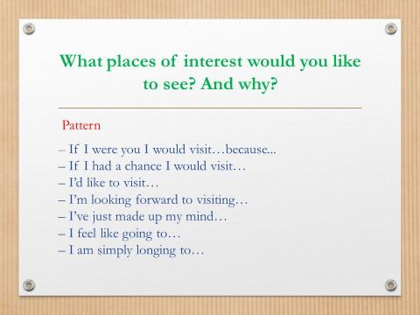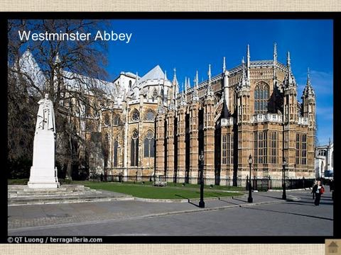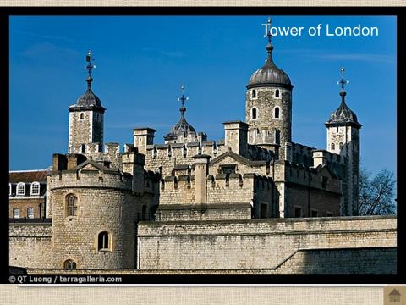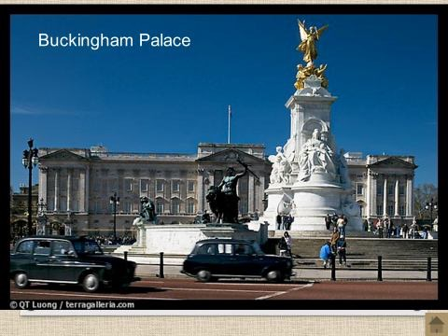
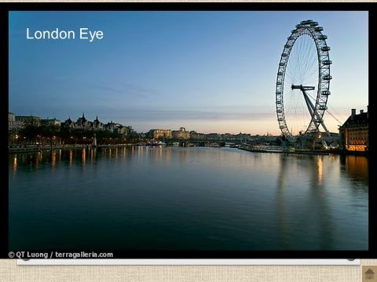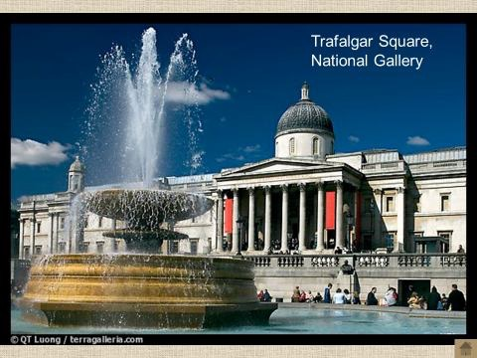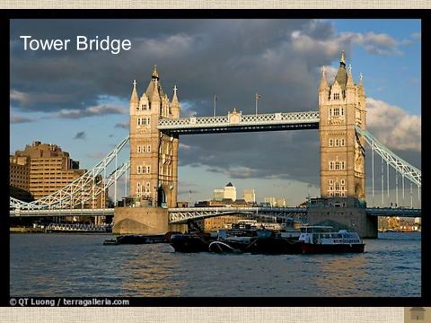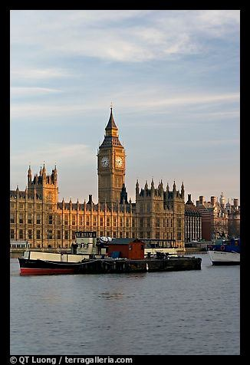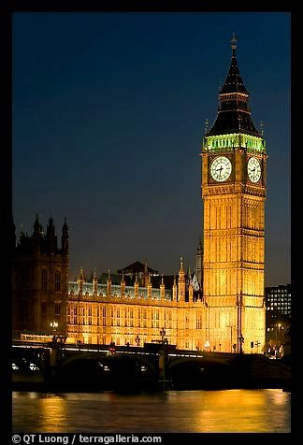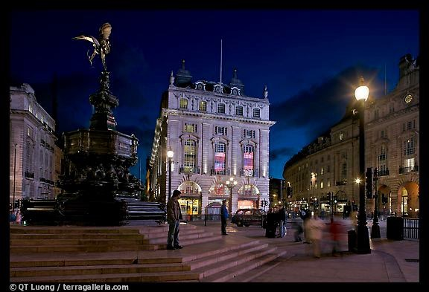
(Westminster Abbey, The Houses of Parliament, Trafalgar Square, Nelson Column, Big Ben, White hall, St.Paul’s Cathedral, Tower of London, Hyde Park, Backingham Palace.)
6. Exercise for your eyes.(Зарядка для глаз)
1,2,3,4.
Look at the window, look at the door, Look at the ceiling, look at the floor. 1,2,3,4.
Look left, look right,
Look up, look down, look around. Close your eyes.
Open, wink, open and smile.
Your eyes are happy again.
6.T: Now we know a lot about London. A map of this city is in front of you. - Now we will work in 4 groups and develop a route of a trip. You will have 5 minutes to do the task
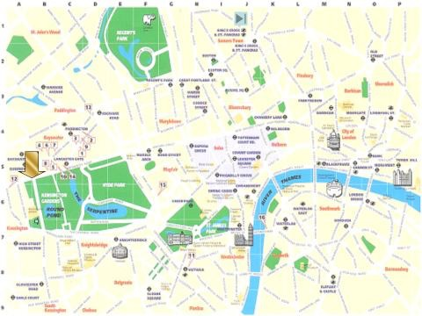
Then we will listen to your variants. (Ученики работают в своих группах)
-You time is up. Let's check it.
Один из маршрутов, написанный группой школьников.
From Charming Cross go down Whitehall to Big Ben, near you can see Westminster Abbey. Across Victoria Street and you will be in St James’s Park. There you can visit Buckingham Palace. Then go up the street round St James’s Park and you must find Nelson’s column on Trafalgar Square. Then go up Regent Street, turn left in Oxford Street, go down to Baker Street, go up and soon you will see Sherlock Holmes’s House.
7.Систематизация знаний по теме «Путешествуя в Лондон».
Look at the presentation and answer the questions:
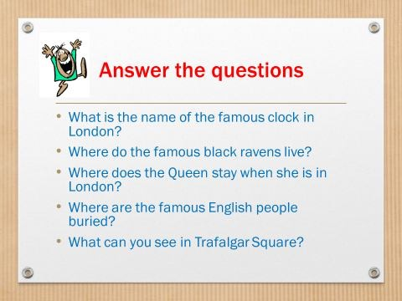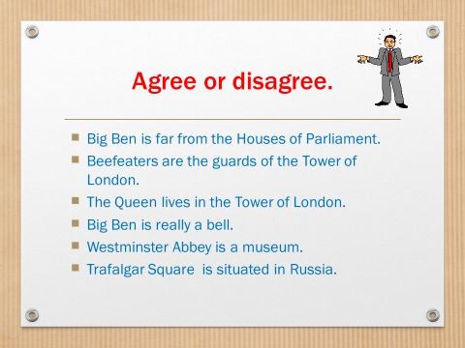
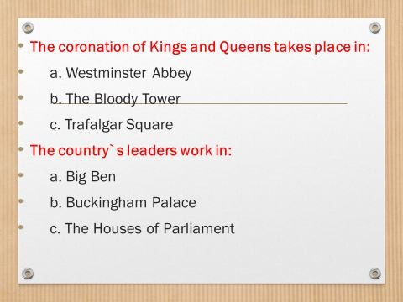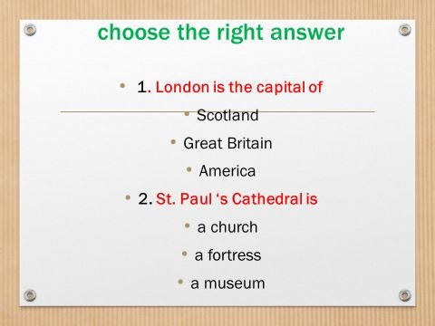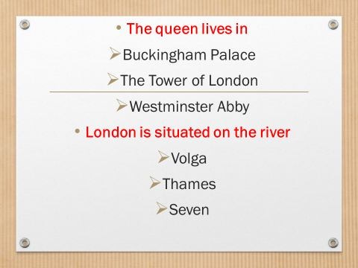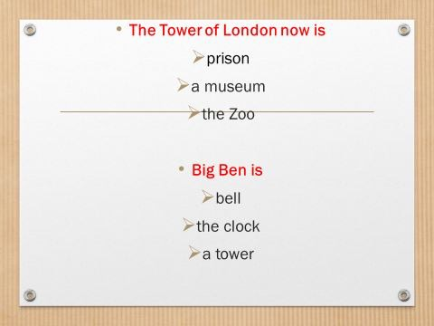
8.Домашнее задание. - Open your daybooks and write down homework:
По желанию некоторые учащиеся выбирают задание: сделать свой собственный маршрут путешествия. -Who makes your own route of a trip? And tell us some facts about the place you go along.
По желанию учащиеся выбирают задание: сделать более полную презентацию в любом виде о какой-нибудь достопримечательности Лондона. -Who wants to make more a full presentation of any famous place of London? ...Well, do it.
Подведение итогов урока:
1.Traveling (London) 2.attractive, enjoyable
3.visit, watch, admire 4.it's our life experience 5. Dream
Оценивание работы учащихся на уроке. – Thank you for your work at the lesson today.
– You were active.
– That’s all for today. Good-bye, my friends.

