[ai]
The kite went higher and higher in the bright blue sky.
[au] 
How would Brown work that
problem out?
[b]
Barbara is a beautiful blond with
bright blue eyes.
[ei] 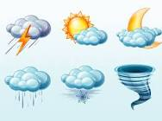
Rain, rain go to Spain!
Never come back again!

[ υ]
Don’t go home alone. Nobody knows how lonely the road is.
[f] 
Fine fellows met at five on the first Friday of February.
[h]
Henry has a bad habit of being behind time.

[k] 
Ickle-pickle, huckle-buckle,
Snuckle in my shoe.
Mickle-muckle,
Nickle-nuckle,
Out go you!

[n]
Ned’s numerous neighbours are nice persons.

[o:] 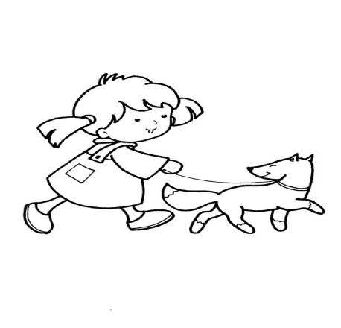
Your daughter is
fond of walking
on warm
autumn mornings.

[oυ]
Don’t poke your nose into things you don’t know.

[s] 
Sue is sixteen this summer and Cecil as seventeen last Sunday.

[v] 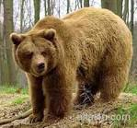
If you ever ever ever meet a grizzly bear,
You should never never never
ask him where
He is going.
For if you ever ever dare
to stop a grizzly bear,
You will never meet another grizzly bear.

[w]
Whether the weather be fine
Whether the weather be not
Whether the weather be cold
Whether the weather be hot.

