Write the types of shops.
1 2  3 4 5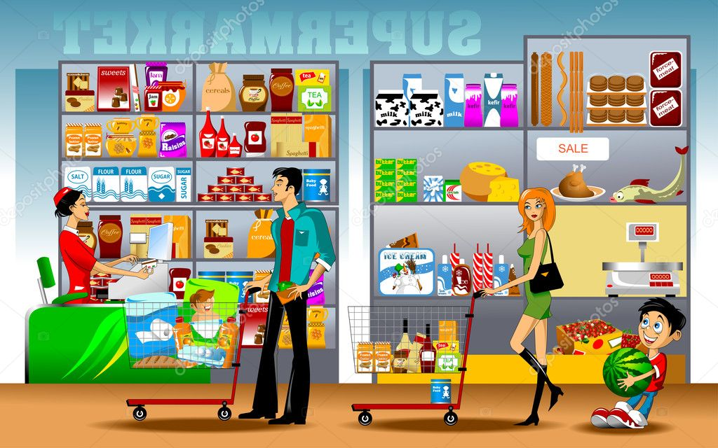
________________________ _________________________ __________________________ ______________________________ __________________________
6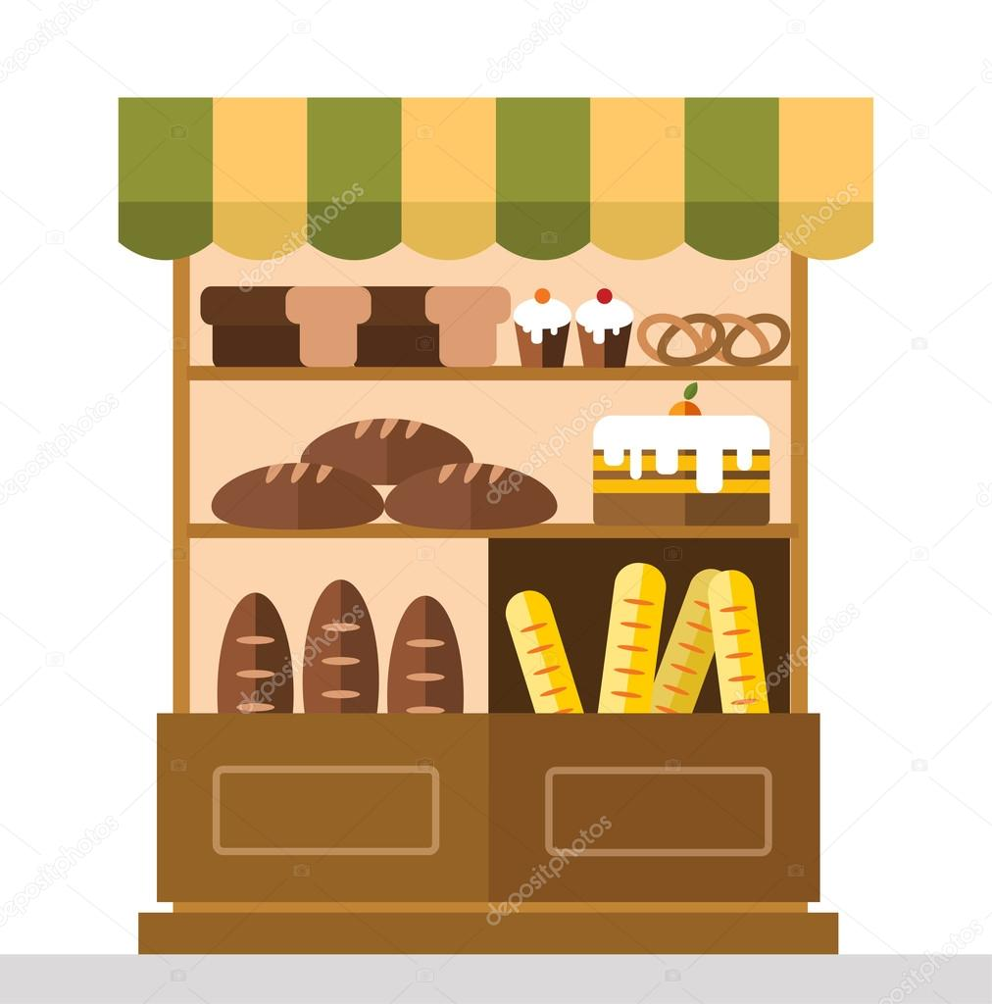 7 8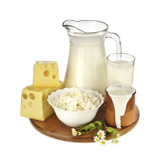 9 10
_______________________ ________________________________ ______________________ _______________________________ ___________________________

Writethe types of shops.
1 2 3 4 5
________________________ _________________________ __________________________ ______________________________ __________________________
6 7 8 9 10
_______________________ ________________________________ ______________________ _______________________________ ___________________________

