Тема урока: «День и ночь – сутки прочь»
Тип урока: урок повторения и закрепления
Цели урока: повторение времени Present Simple
1.Warm up –
Hello, my dear pupils! Take your seats, please
How are today? Now find your partner across from you and say - Hello! Ask your partner – How are you? Great! -Nice to see you! Excellent!
Are you ready to start our lesson? Let’s get started!
Look on my screen please and write your predictions about this place (предположения)
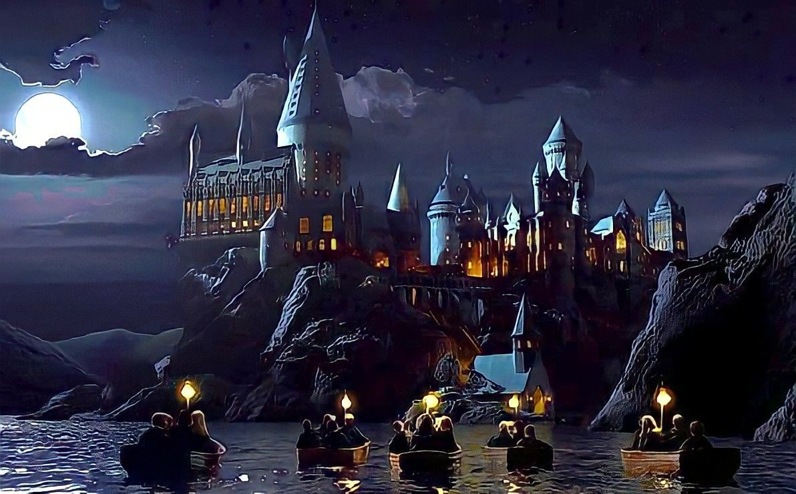
I see | I think | I wonder (?)

Write your ideas all together and choose one interesting. Can you read your predictions about this place?
Yes, you are right. It magic school Hogwarts! And today we will visit it.
Do you like magic? Super! I advise you to repeat some phrases about magic daily routines. You should answer all together with your team, OK?
https://wordwall.net/ru/resource/25736418

2. Main stage
Do you know where this castle is located? Yes? In GB and Today we also will go to GREAT Britain.
Look at my screen, please and try to guess, Who is the owner of these things?
Photos of magic things
Yes, you are right. He is Harry Potter! And today we will speak about his activities at school.
T: Super! Now Let`s go to Hogwarts! (школа Хогвартс)
Now we are at school. The first thing now is to choose the faculties where we’ll study/ What are the faculties? Take the cards from the hat and find your classmates.
(Из магической шляпы вытягивают карточки -Slytherin; Raven, claw; Gryffindors; Hufflepuff)
T: The first lesson is the Magic Grammar. Первый урок – Волшебная грамматика. So, can you tell me, when we do something often, always, every day – what are these activities? Yes, they are daily routines. And when we speak about daily routines, we use Present Simple, right?
Давайте сейчас вспомним правила образования предложений в этом времени.
Look at my screen, please!

(на экране моя таблица) СНАЧАЛА Я ПРОГОВАРИВАЮ ПРАВИЛА, ЗАТЕМ ДАЮ ИНСТРУКЦИЮ ДЕТЯМ!
Numbers 1 – show me your left hand! Good, you are the first speaker in your team. You will start to tell about the Present Simple. You can use your table. Say about affirmative, negative and interrogativeСначала номера 1 рассказывают всем номерам, затем номера 2, 3 и 4. Когда команда закончит обсуждать правила, дайте мне знать. У вас всего 5 минут. Поехали!
(дети рассказывают в командах правила образования предложений
OK. Now, please, do ex.4 p. 37.
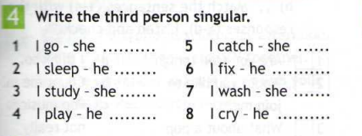
You can work all together with your team. When your team will finish the task, let me know. You have only 5 minutes for the task. The team, which will be the first, gets medals.
Let’s check your answers. (on the board) на доске написаны эти фразы, от каждой команды выходит 1 человек и дописывает окончания, где они нужны. Затем обсуждаем и читаем вслух вместе правильный вариант.

Взлет-посадка
Now I will read you some sentences. If my sentence is correct you should stand up, if my sentence is not correct, you don’t need to stand up. Are you ready?
- Harry goes to school every day.
- Lessons at Hogwarts start at 9.00 a.m.
- Harry study Herbology at the greenhouse three times a week.
- Harry lives with Ron and Hermione.
- Harry play Broomflights every Sunday
- Harry and Ron do the magic tricks after dinner.
T: Let’s start our next magic lessons. The second lesson is the Harry Potter’s Quiz. Третий урок – поттероведение. How much do you know about the most famous young magician of our times? Open your books at the page 36, listen to the text and choose the correct answer.
(Затем ученики по очереди достают вопросы из волшебной шляпы и отвечают на них. Правильно ответившим – медаль).
1. Who does Harry Potter live with?
A – His parents B – The Dursley family C – Ron and Hermione
2. Which school does Harry go to?
A – Muggles’ School B – Azkaban C – Hogwarts
3. Where does Harry usually have breakfast?
A – In the Great Hall B – in the tower dormitory C – in the Forbidden Forest
4. Harry studies Herbology at the greenhouse … a week.
A – three times B – twice C- once
5. Harry studies the night skies …
A – every Monday morning. B – every Wednesday at midnight. C – in the evening
6. What does Harry often play in his free time?
A – Broomfights B – Quidditch C – Hide and seek
7. What do Harry and his friends usually do after dinner?
A - They meet in the common room. B – They go straight to bed. C – They do magic tricks.
8. Where does Harry always sleep?
A – in his house dormitory B – in his own room C – in a dungeon.

T: The next lesson is the Magic Chat. Четвертый урок – волшебный чат.
T: Now you should stand up. You will listen to the music. You can go here, but when I’ll stop the music, you must find your partner. Let’s start. Звучит музыка, дети передвигаются по классу. Музыка заканчивается, образуются пары. Задание для пар:
(Заранее все семь предложений из задания 6 со стр. 37 учебника разрезаются на карточки в двойном экземпляре, а класс разбивается на пары)
You should put the words in the correct order. If you are ready, let me know:
- Harry/never/goes/to/school.
Let’s try once more time. Listen to music and go around here.
- Usually/students/spend/free time/in/the/common/room.
Let’s try once more time. Listen to music and go around here.

3.Hermione/always/studies/a lot.

Great! Let thank each other – Great job! Take your seats, please/

T: Now imagine that Harry Potter, is coming to our school. Get ready to ask him about his daily routine. You must write 5 questions for Harry. You have only 5 minutes for this task:
1. What time do/does you get up?
2. Do/does you go jogging in the morning?
4. What do/does you usually do in your free time?
5. Do/does you watch films?
7. What time do/does you go to sleep?

Let me know if you are ready. Great!
Who wants to be Harry Potter? Come here, please! (один ученик становится Гарри Поттером, остальные задают ему по одному вопросу)
T: The next lesson is the Hogwarts' Final Exam. Пятый урок – финальный тест.
Your last task in our magic lessons is to find as many words as you can in this grid. This game’s name is “Mysterious letters” – филворд. Print out this word search and try to find Harry's friends, teachers and etc.
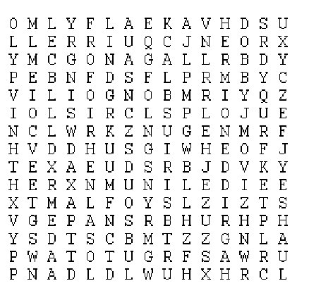
DOBBY | DUMBLEDORE | DURSLEY | FILCH
HAGRID | HEDWIG | HERMIONE | LOCKHART
MALFOY | MCGONAGALL | PEEVES | QUIRRELL
RON | SIRIUSBLACK | SNAPE | VOLDEMORT

Answers:-
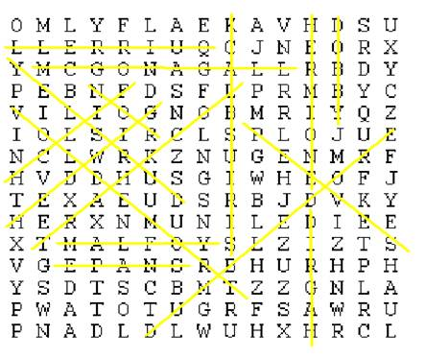
(За каждые верно отмеченные 4 слова дается медаль.)
3. Рефлексия
T: . Fill in the paper:
Я запомнил 3 слова:__________________________________________________
Я могу/Не могу описывать ежедневные действия.
Я запомнил 1 интересный факт о времени Present Simple.__________________________________________________________________________________________

4. Заключительный этап
T: Thank you for your good job. My dear magic peoples, count your points, please. And now let’s know the winners. Last question: “Do You Believe In Wizardry?”. Great!

5. Подведение итогов урока.

T: Now I would like to finish our lesson. You have done a good job. Your mark for today is 5.I want to say good bye. And let’s clap your hands to each other. Thank you very much. Bye!

