"Fighting Girlfriend" | Soviet women performed an immortal feat for the Motherland.  SPOTLIGHT ON RUSSIA tells you about a female tanker who stood up for the defense of the Motherland on an equal basis with men.
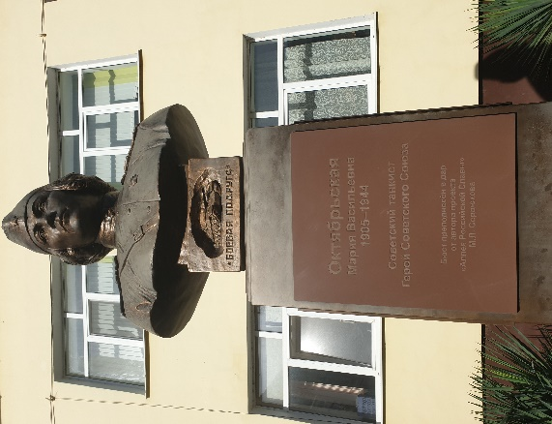  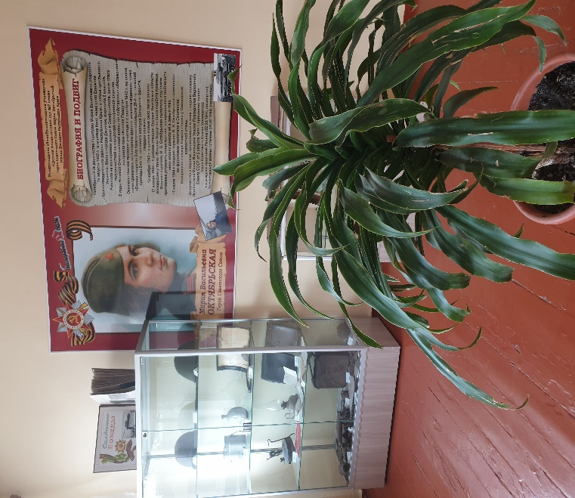 | Mariya Vasilyevna Oktyabrskaya was a Soviet tank driver and mechanic who fought on the Eastern Front during World War II.  After her husband was killed fighting in 1941, Oktyabrskaya sold her possessions to donate a tank for the war effort, and requested that she be allowed to drive it. She received and was trained to drive and fix a T-34 medium tank, which she named "Fighting Girlfrie  nd" ("Боевая подруга"). Oktyabrskaya proved her ability and bravery in battle, and was promoted to the rank of sergeant. After she died of wounds from battle in 1944, she was posthumously made a Hero of the Soviet Union. She was the first female tank driver to be awarded the title.  In memory of the fearless Crimean woman, school No. 7 in the city of Dzhankoy bears her name. The school museum carefully preserves a few materials and relics about this brave woman who gave her life for the freedom and independence of our Motherland.
  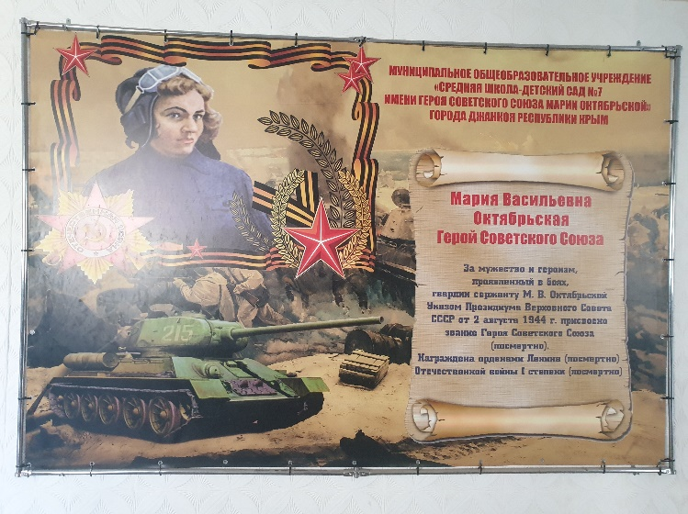
  Discussion
  Have you heard about Mariya Vasilyevna Oktyabrskaya?
  What traits of character did he have?
  What can you say about Mariya Oktyabrskaya?
  Activities
  Are there any places in your city named after hero of the Soviet Union?
  Are there any monuments of women hero?
  Find out some information about one of them.

