План-конспект учебного занятия по английскому языку в 11 классе
Учитель: Усова Екатерина Ивановна
Тема: «Социокультурный портрет Великобритании, Австралии и Новой Зеландии»
Коммуникативная ситуация: «Киноиндустрия в странах изучаемого языка»
Цель: формирование коммуникативной компетенции учащихся в рамках коммуникативной ситуации урока «Киноиндустрия в странах изучаемого языка»
Прогнозируемый результат:
Предполагается, что к окончанию учебного занятия учащиеся смогут составить план посещения локаций, используемых в фильме «Властелин колец» и пояснить свой выбор (не менее 15 фраз)
Задачи:
- способствовать развитию коммуникативной компетенции в рамках заданной темы;
- способствовать развитию логики и памяти у обучаемых и овладению основными способами мыслительной деятельности (сравнение, анализ, обобщение);
- способствовать развитию творческого отношения к учебной деятельности
Формы работы:
- фронтальная
- индивидуальная
- парная
Оборудование: учебник, раздаточный материал, магнитофон

I Организационно-мотивационный этап
Good morning! I am glad to see you! I hope you are fine today. Let’s start our lesson. I want you to answer some questions. (Учитель раздает карточки с вопросами) (Приложение 1)
I think you have understood that we are going to speak about cinema.
II Операционно-познавательный этап
Look at the pictures. Can you name the films in which these locations were used (page 151, ex. 1). You can the answers on page 157. (1. Scenes from the first two Harry Potter films were filmed at Alnwick Castle 2. Castle Ward was made famous as the setting for Winterfell in Game of Thrones. 3. Thor: Ragnarok made use of the Tamborine National Park in Queensland 4. Sydney’s BT Tower on Market Street was the setting of the helicopter crash scene in The Matrix)
Can you think of a film which is hugely popular worldwide and has been shot in New Zealand? Use the words below as a clue. (page 152, ex. 2a)
Let’s match the names with their pictures (приложение 2)
Complete the epigraph to The Lord of the Rings. Use the words from ex. 2a. (page 152, ex. 2c)
Three Rings for the Elven-kings under the sky,
Seven for the Dwarf-lords in their halls of stone,
Nine for Mortal Men doomed to die,
One for the Dark Lord on his dark throne
In the Land of Mordor where the Shadows lie.
One Ring to rule them all, One Ring to find them,
One Ring to bring them all and in the darkness bind them
In the Land of Mordor where the Shadows lie.
Read the plot summary. (page 152, ex. 2d).
Физкультминутка
Are the statements true or false? If it is true go to the corner with a table «True» if it is false go to the corner with the table «False» and correct the false statements (page 152, ex. 2e).
1. The Lord of the Rings is a fantasy novel and film. (true)
2. The story is about chasing one ring that has all the powers. (true)
3. Those who have the Ring become immortal. (false)
4. The Dark Lord managed to collect all the rings except one. (true)
5. Mount Doom is where hobbits live. (false)
6. Bilbo Baggins is the best friend of Frodo the elf. (false)
7. Frodo is afraid of the long and risky journey and stays home. (false)
8. In the end, the Ruling Ring is destroyed. (true)
III Операционно-деятельностный этап
These are a few of the 250 New Zealand places that have been used as film locations for The Lord of the Rings. Let’s remember how some of them look. Read the name of the location and find the picture (учащиеся читают название, выходят к доске и находят картинку с изображением). (page 153, ex. 3a). (Приложение 3)
Work in pairs. Plan your trip to Middle Earth. Explain why you want to visit these locations. Remember that you have enough money and two weeks in New Zealand. (page 153, ex. 3a)
Write an email to the tour guide in New Zealand. Explain what your plan is, and ask for recommendations.
IV Рефлексивно-оценочный этап
Present your ideas to the class.
Thank for your work.
Your marks are …
Your home task is page 153, ex. 4. Use the Internet. Find information about other filming locations in the UK, Australia, New Zealand or Belarus. Present information to the class.
Good-bye!

Приложение 1
What kind of movies do you like? Why?
(e.g. action, horror, sci-fi)
Who’s your favourite actor or actress?
Why do you like them?

What’s the best movie you have ever seen?
Explain why.
What’s the name of the last film you saw?
What was it about?

What kind of snacks or drinks do you have when you go to the movies?

Do you prefer to watch movies at home or in the cinema? Why?

Do you like horror movies?
Why (not)?
Would you like to be a famous film star?
Why or why not?

Do you watch movies in English or your language? Which do you prefer?
What is the worst movie you have ever seen?
Why was it so bad?

When you watch an English movie, do you prefer it dubbed or subtitled? Why?
Give as many ‘movie words’ as you know.
(e.g. film, director, set)

Movie stars are often paid millions of dollars. Do you think they deserve (заслуживают) this? Explain.

Приложение 2
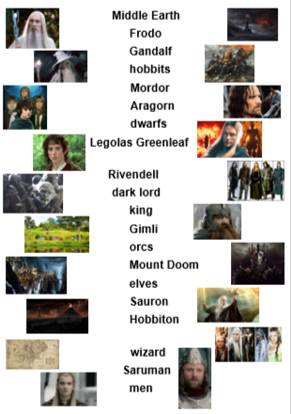

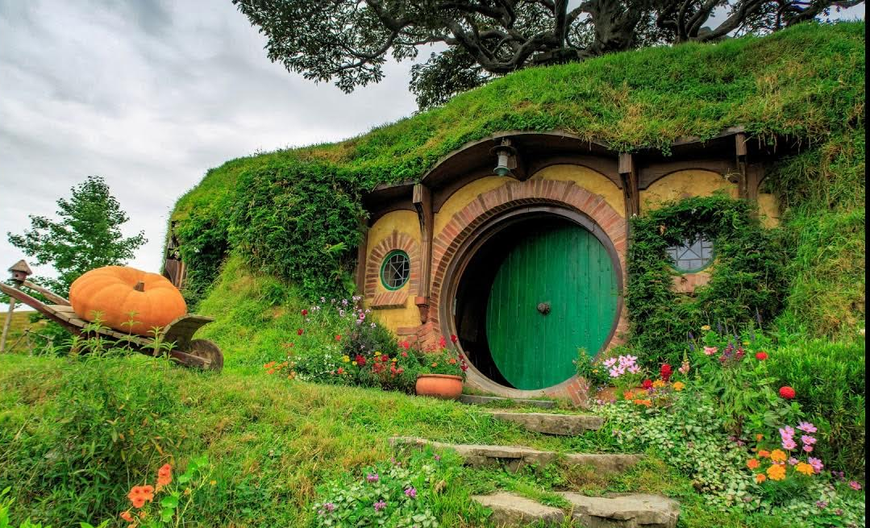
Приложение 3

