Государственное учреждение образования
«Средняя школа №7 г.Могилева»

Внеклассное мероприятие для 10, 11 классов

Лаврова И.В.

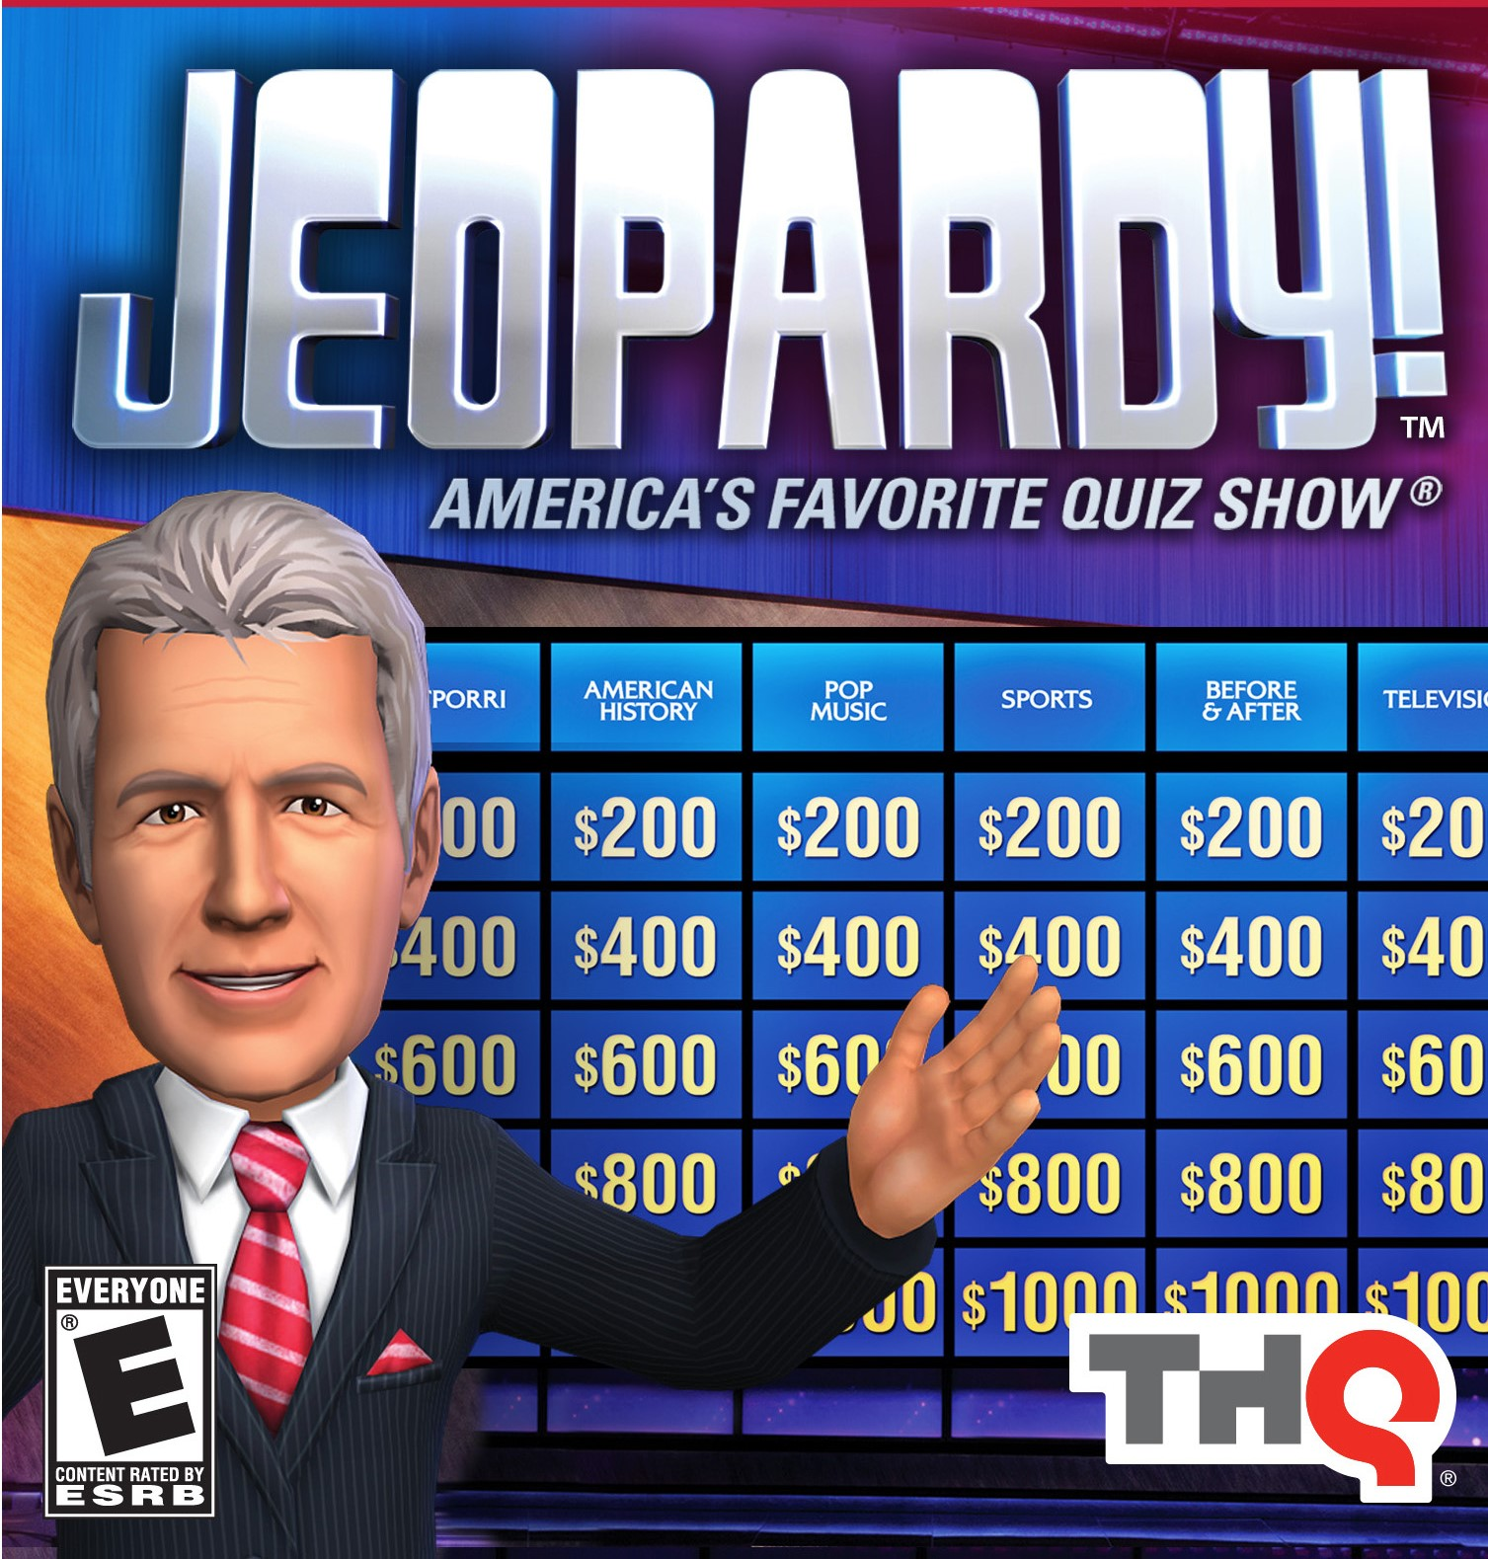

Могилёв, 2023

Урок-игра.
Английский язык для 10-11 классов.

Игра – первая деятельность, которой принадлежит особенно
значительная роль в развитии личности, в формировании ее свойств
и обогащении ее внутреннего содержания.
Цель: проверить знания о стране изучаемого языка.
Урок-игра сделан по типу телевизионной передачи «Своя игра» игра включает в себя 3 раунда, специальную категорию «Кот в мешке» и «Аукцион».
Материал к проведению игры: карточки, доска, картинки

ROUND 1.
THE UNITED KINGDOM

1.What is the difference between the United Kingdom and Great Britain?
2.What is the capital of UK? (Лондон)
3. How many parts are there in UK? What are their capitals?(4 Лондон, Кардиф, Эдинбург, Белфаст)
4.Which flag isn’t represented in the Union Flag? (Уэльс)
5. A PIG IN A POKE

Customs and traditions
1.What is the most popular English holiday? (Christmas)
2.What do people celebrate on the 14th of February? (St. Valentine's Day)
3.When is boxing day? (26.12)
4.What are the Britain's national flowers? (rose, shamrock, thistle, daffodil)
5.What is Guy Fawkes Night? (Bonfire Night, Firework night)

Food and drink

1.What is the most popular drink in Britain? What do the people like to drink it with? (tea with milk)
2. A PIG IN A POKE
3. How often do they have a meal? What are the meals? (4 times breakfast, lunch, dinner, supper)
4. What is traditional Christmas meal? (turkey, pudding)
5. What is the difference between can and tin? (Amer. Brit)

British and American English

- Квартира (Flat – Apartment)
- Почтовый ящик (Postbox – Mailbox)
- Фамилия (surname – Last name)
- Тротуар (sidewalk – path)
- Водопроводный кран (faucet – tap)

Interesting places
1.Why is Big Ben so called?(It was named after Benjamin Hall, the Chief)
2. How old is Stonehenge? (5 000 years ago)
3. Auction.
4. What is and what was the Tower of London? (museum of gun – prison)
5. What is Speaker's corner? (a corner in Hyde Park, where public speeches are made)

Вопросы для кота в мешке и аукциона

1.Who are the most popular British writers? (name 5 ofthem) (кот) (Шекспир, Агата Кристи, Диккенс, Киплинг, Дэфо)
2. Who is the author of Harry Potter? (кот) (JK Rowling)
3. What is Baker Street famous for? 9 (аукцион) (a home of Sherlock Holms)
4. What is the most popular British airport? (Heathrow)
5. What is the name of Queen's husband?(Philip)

ROUND 2.
Sport and transport

1.What is the most popular English sport? (soccer)
2. What is public transport called? (double Decker bus)
3. What is the English for – стрельбаизлука? (archery)
4.A PIG IN A POKE
5. When did the Olympic Games take place in London?(1908, 1948)
Education

- At what age do children go to school in Britain? (5)
- What are 2 main British Universities? (Oxford – Cambridge)
- What is GCSE? (general certificate of secondary education)
- What is the sport competition between Oxford and Cambridge students? (Rowing)in March
5.What is one of the most interesting facts about Cambridge University?(Graduator was 105 years old)

Politics

- The name of the queen. Her address. (Elizabeth II) (Buckingham Palace)
- Tell the name of Prime Minister of GB? What's his address? (George Brown – 10 Downing Street)
- How many houses are there in the British Parliament? What are they? (House of Lords and House of Commons)

- Who in the royal family died in the car crash in 1997? (Princes Diana)
- What is the surname of the royal family? (Windsor)

Australia

- What is the capital of Australia? (Canberra)
- Who are the Australian natives? (Aborigines)
- Australia is not a(n)
- Country
- Island
- City !
- Continent
- When did the Europeans settle in Australia? (1788)
- Which two animals can you see on the Australian coat of arms? (Kangaroo and Emu)

Grammar

1.Put the sentence into indirect speech:

He said: “Why didn’t you buy any flowers?

2.Form the future perfect passive of the verb – to interrupt
- In which case we don’t use – to-

I expect you be on time.
I make him learn this.

- The order of adjectives in the sentence.
- Auction

ROUND 3
`Вопросы финального раунда

1.When does England have national day? (23 April St. George's Day)
2. What is Pancake Day? (41days before Easter)
3. When did Queen Victoria rule? (1837 – 1901)
4. What are the national parks?(Hyde Park
5. Who is next in line to the British crown after Prince Charles? (Prince William)

Интернет ресурсы:
http://www.tolearnenglish.com/free/civi/facts.php
http://www.allsoch.ru/english/552.shtml
Литература:
Учебник “Happy English 2” под редакцией Т.Б. Клементьевой
Учебник “Happy English 3” под редакцией Т.Б. Клементьевой

